Third Sunday of Lent Year A
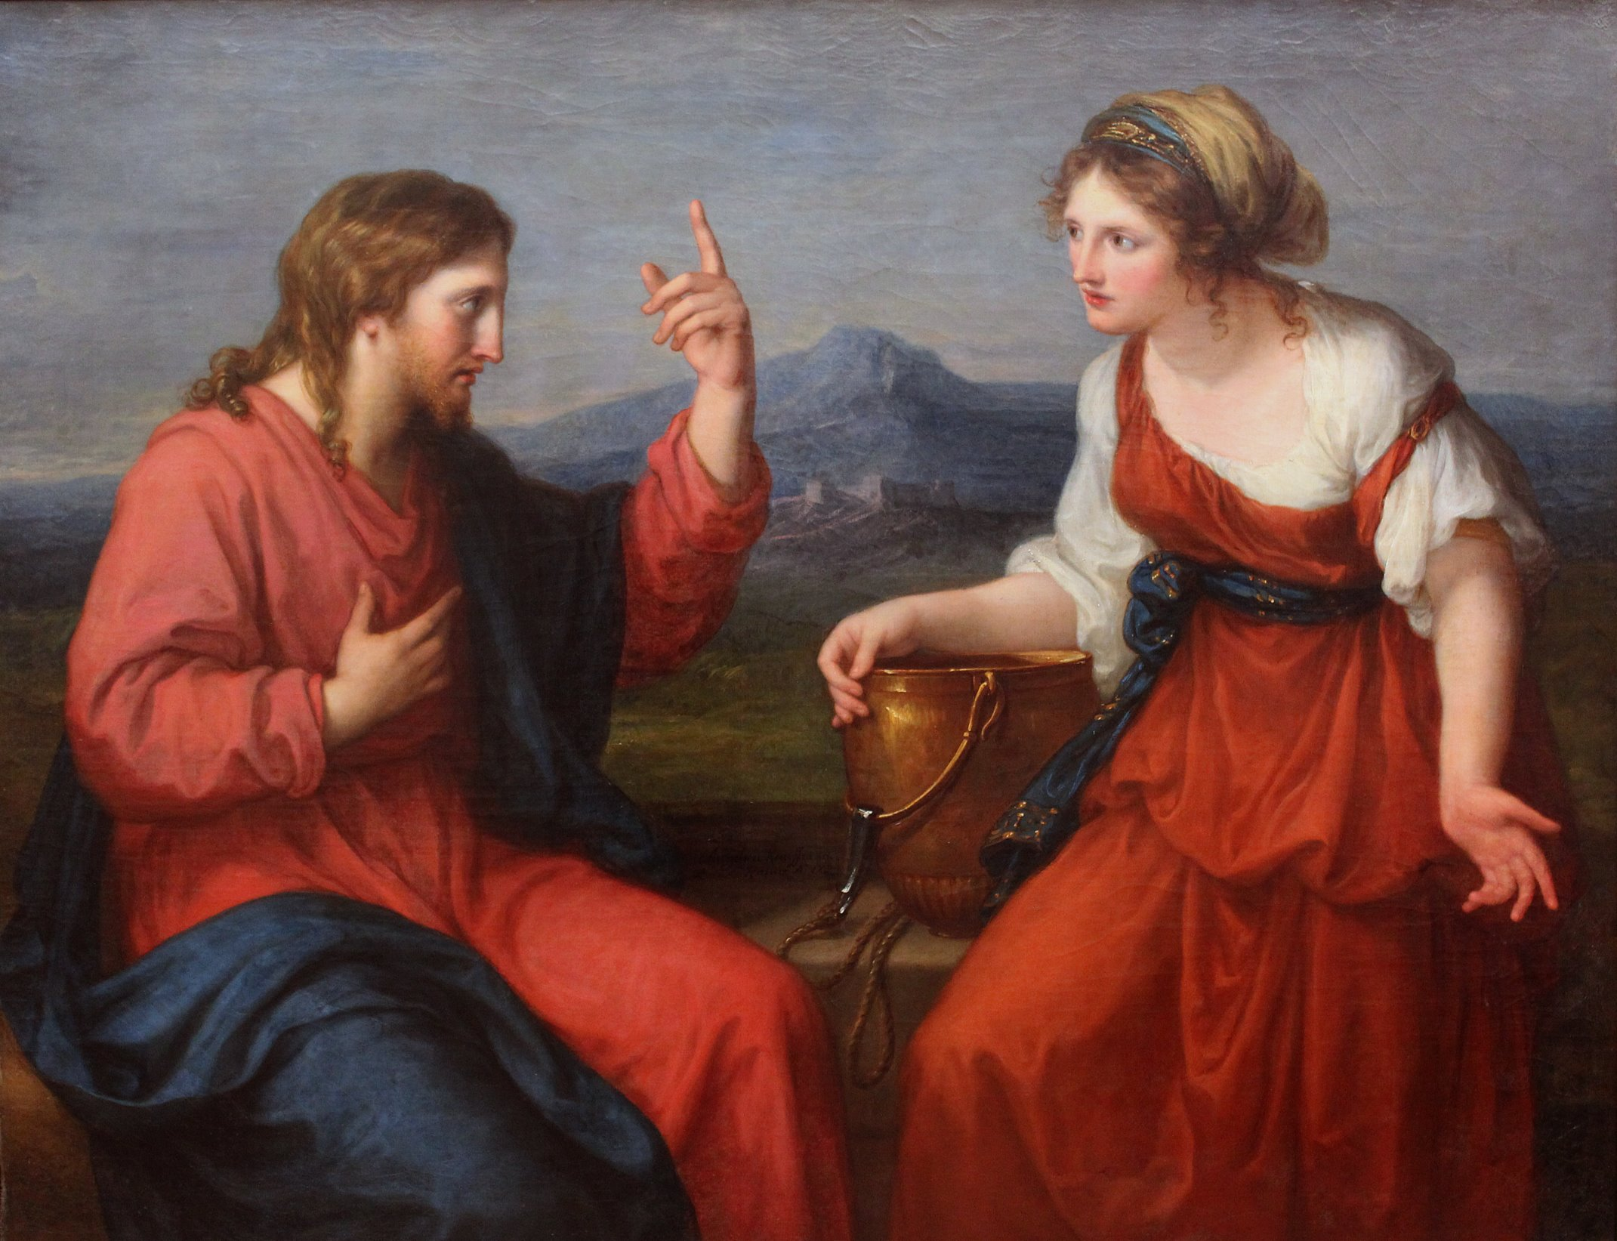
(Gospel, continued)
that is the kind of worshipper the Father wants.
God is spirit, and those who worship
must worship in spirit and truth.’
The woman said to him, ‘I know that Messiah — that is, Christ — is coming; and when he comes he will tell us everything.’ ‘I who am speaking to you,’ said Jesus ‘I am he.’
At this point his disciples returned, and were surprised to find him speaking to a woman, though none of them asked, ‘What do you want from her?’ or, ‘Why are you talking to her?’ The woman put down her water jar and hurried back to the town to tell the people, ‘Come and see a man who has told me everything I ever did; I wonder if he is the Christ?’ This brought people out of the town and they started walking towards him.
Meanwhile, the disciples were urging him, ‘Rabbi, do have something to eat’; but he said, ‘I have food to eat that you do not know about.’ So the disciples asked one another, ‘Has someone been bringing him food?’ But Jesus said:
‘My food is to do the will of the one who sent me,
and to complete his work.
Have you not got a saying:
Four months and then the harvest?
Well, I tell you:
Look around you, look at the fields;
already they are white, ready for harvest!
Already the reaper is being paid his wages,
already he is bringing in the grain for eternal life,
and thus sower and reaper rejoice together.
For here the proverb holds good:
one sows, another reaps;
I sent you to reap a harvest you had not worked for.
Others worked for it; and you have come into the rewards of their trouble.’
Many Samaritans of that town had believed in him on the strength of the woman’s testimony when she said, ‘He told me all I have ever done’, so, when the Samaritans came up to him, they begged him to stay with them. He stayed for two days, and when he spoke to them many more came to believe; and they said to the woman, ‘Now we no longer believe because of what you told us; we have heard him ourselves and we know that he really is the saviour of the world.’

The Gospel of the Lord.
Praise to you, Lord Jesus Christ!

Page 4
Sunday Bulletin



Christ and the Samaritan Woman at the Well, Angelika Kauffmann, 1796, oil on canvas, Neue Pinakothek, Munich.

Entrance Antiphon ‡ Psalm 25 (24): 15-16
My eyes are always on the Lord, for he rescues my feet from the snare. Turn to me and have mercy on me, for I am alone and poor.

First Reading ‡ Exodus 7:3-7
Give us water to drink.
Tormented by thirst, the people complained against Moses. ‘Why did you bring us out of Egypt?’ they said. ‘Was it so that I should die of thirst, my children too, and my cattle?’ Moses appealed to the Lord. ‘How am I to deal with this people?’ he said. ‘A little more and they will stone me!’
The Lord said to Moses, ‘Take with you some of the elders of Israel and move on to the forefront of the people; take in your hand the staff with which you struck the river, and go. I shall be standing before you there on the rock, at Horeb. You must strike the

Communion Antiphon ‡ John 4:13-14
For anyone who drinks it, says the Lord, the water I shall give will become in him a spring welling up to eternal life.

Gospel Acclamation ‡ cf. John 4:42, 15.
Glory to you, Word of God, Lord Jesus Christ!
Lord, you are truly the Saviour of the world;
give me living water, that I may never thirst again.
Glory to you, Word of God, Lord Jesus Christ!

Gospel ‡ John 4: 5-42
The water that I shall give will turn into a spring of eternal life.
Jesus came to the Samaritan town called Sychar, near the land that Jacob gave to his son Joseph. Jacob’s well is there and Jesus, tired by the journey, sat straight down by the well. It was about the sixth hour. When a Samaritan woman came to draw water, Jesus said to her, ‘Give me a drink.’
His disciples had gone into the town to buy food. The Samaritan woman said to him, ‘What? You are a Jew and you ask me, a Samaritan, for a drink?’ — Jews, in fact, do not associate with Samaritans. Jesus replied:
‘If you only knew what God is offering
and who it is that is saying to you:
Give me a drink,
you would have been the one to ask,
and he would have given you living water.’
‘You have no bucket, sir,’ she answered ‘and the well is deep: how could you get this living water? Are you a greater man than our father Jacob who gave us this well and drank from it himself with his sons and his cattle?’
Jesus replied: ‘Whoever drinks this water will get thirsty again; but anyone who drinks the water that I shall give will never be thirsty again: the water that I shall give will turn into a spring inside him, welling up to eternal life.’
‘Sir,’ said the woman ‘give me some of that water, so that I may never get thirsty and never have to come here again to draw water.’
‘Go and call your husband’ said Jesus to her ‘and come back here.’
The woman answered, ‘I have no husband.’ He said to her. ‘You are right to say, “I have no husband”; for although you have had five, the one you have now is not your husband. You spoke the truth there.’
‘I see you are a prophet, sir’ said the woman. ‘Our fathers worshipped on this mountain, while you say that Jerusalem is the place where one ought to worship.’
Jesus said:
‘Believe me, woman, the hour is coming
when you will worship the Father
neither on this mountain nor in Jerusalem.
You worship what you do not know;
we worship what we do know;
for salvation comes from the Jews.
But the hour will come — in fact it is here already —
when true worshippers will worship the Father in spirit and truth:
Page 3
Page 2
rock, and water will flow from it for the people to drink.’
This is what Moses did, in the sight of the elders of Israel. The place was named Massah and Meribah because of the grumbling of the sons of Israel and because they put the Lord to the test by saying, ‘Is the Lord with us, or not?’
The word of the Lord.
Thanks be to God.

Responsorial Psalm ‡ Psalm 94:1-2, 6-9

R. If today you hear his voice, harden not your hearts.

Come, ring out our joy to the Lord;
hail the rock who saves us.
Let us come before him, giving thanks,
with songs let us hail the Lord. R.

Come in; let us bow and bend low;
let us kneel before the God who made us
for he is our God
and we the people who belong to his pasture,
the flock that is led by his hand. R.

O that today you would listen to his voice!
‘Harden not your hearts as at Meribah,
as on that day at Massah in the desert
when your fathers put me to the test;
when they tried me,
though they saw my work.’ R.

Second Reading ‡ Romans 5:1-2, 5-8
The love of God has been poured into our hearts by the Holy Spirit which has been given us.
Through our Lord Jesus Christ by faith we are judged righteous and at peace with God, since it is by faith and through Jesus that we have entered this state of grace in which we can boast about looking forward to God’s glory. This hope is not deceptive, because the love of God has been poured into our hearts by the Holy Spirit which has been given us. We were still helpless when at his appointed moment Christ died for sinful men. It is not easy to die even for a good man — though of course for someone really worthy, a man might be prepared to die — but what proves that God loves us is that Christ died for us while we were still sinners.
The word of the Lord.
Thanks be to God.

https://yanchepcatholic.wordpress.com/wp-admin/admin.php?pag

