Second Sunday of Lent Year A
Insert church notices here.
Page 4
Sunday Bulletin
The Transfiguration of Christ, Raphael, 1518-1520, Pinacoteca Vaticana, Vatican City.

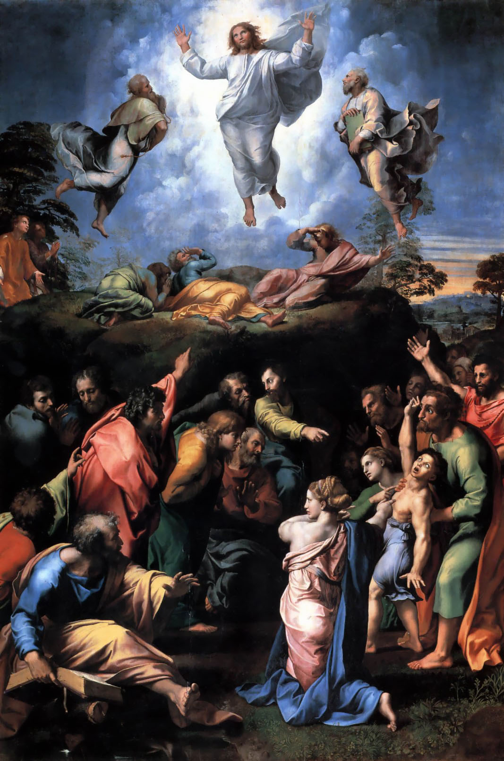



Entrance Antiphon ‡ Psalm 25 (24): 6, 2, 22.
Remember your compassion, O Lord, and your merciful love, for they are from of old. Let not our enemies exult over us. Redeem us, O God of Israel, from all our distress.

Communion Antiphon ‡ Matthew 17:5
This is my beloved Son, with whom I am well pleased; listen to him.

(continued)
People think the Old Testament is a book about salvation for the Jews. This is incorrect. The Old Testament is universal in scope. It is about the means of blessing for all of humanity, for all the “families of the earth” (the NAB’s “communities of the earth” is inexplicable). This means of blessing is Abram and his descendants—ultimately, one descendant in particular. Abram is only chosen that he may ultimately restore blessing to the rest of humanity. Anytime anyone of us is chosen, it is always for the benefit of others.
First Reading ‡ Genesis 12:1-4
The call of Abraham, the father of God’s people.
The Lord said to Abram,
‘Leave your country, your family and your father’s house,
for the land I will show you.
I will make you a great nation;
I will bless you and make your name so famous
that it will be used as a blessing.

Gospel ‡ Matthew 17:1-9
His face shone like the sun.
Jesus took with him Peter and James and his brother John and led them up a high mountain where they could be alone. There in their presence he was transfigured; his face shone like the sun and his clothes became as white as the light. Suddenly Moses and Elijah appeared to them; they were talking with him. Then Peter spoke to Jesus. ‘Lord,’ he said ‘it is wonderful for us to be here; if you wish, I will make three tents here, one for you, one for Moses and one for Elijah.’
He was still speaking when suddenly a bright cloud covered them with shadow, and from the cloud there came a voice which said, ‘This is my Son, the Beloved; he enjoys my favour. Listen to him’. When they heard this, the disciples fell on their faces, overcome with fear. But Jesus came up and touched them. ‘Stand up,’ he said ‘do not be afraid.’ And when they raised their eyes they saw no one but only Jesus.
The Gospel of the Lord.
Praise to you, Lord Jesus Christ!

Page 3
Page 2
‘I will bless those who bless you:
I will curse those who slight you.
All the tribes of the earth shall bless themselves by you.’
So Abram went as the Lord told him.

The word of the Lord.
Thanks be to God.

Responsorial Psalm ‡ Psalm 32:4-5, 18-20, 22.

R. Lord, let your mercy be on us, as we place our trust in you.

The word of the Lord is faithful
and all his works to be trusted.
The Lord loves justice and right
and fills the earth with his love. R.

The Lord looks on those who revere him,
on those who hope in his love,
to rescue their souls from death,
to keep them alive in famine. R.

Our soul is waiting for the Lord.
The Lord is our help and our shield.
May your love be upon us, O Lord,
as we place all our hope in you. R.

Second Reading ‡ 2 Timothy 1:8-10
God has saved us, and called us to be holy.
With me, bear the hardships for the sake of the Good News, relying on the power of God who has saved us and called us to be holy — not because of anything we ourselves have done but for his own purpose and by his own grace. This grace had already been granted to us, in Christ Jesus, before the beginning of time, but it has only been revealed by the Appearing of our saviour Christ Jesus. He abolished death, and he has proclaimed life and immortality through the Good News.
The word of the Lord.
Thanks be to God.

Gospel Acclamation ‡ Matthew 17:5
Glory and praise to you, Lord Jesus Christ!
From the shining cloud the Father’s voice is heard:
this is my beloved Son, hear him.
Glory and praise to you, Lord Jesus Christ!

https://yanchepcatholic.wordpress.com/wp-admin/admin.php?pag
Commentary on the Gospel by Dr John Bergsma
http://www.thesacredpage.com/2017/03/beginning-journey-of-faith-2nd-sunday.html#more
Journeying by faith will become a motif throughout salvation history. Generations later, Abram’s descendants the Israelites will journey by faith into the wilderness in the hopes of arriving at the same Promised Land to which Abram himself journeyed, in an event we call the Exodus. Generations later still, the people of Judah will be forced to journey to Babylon, where they will struggle to keep faith for seventy years, before being allowed to journey back to that same Promised Land. As Lent is still young, we continue to hear God’s call on our own lives to begin a spiritual journey with him over these forty days, to a destination we don’t know, but God will show us.
Abram is promised to become a Great Nation—this is fulfilled at Sinai, when the multitudes of Abram’s descendants are formed into a nation by receiving, as it were, a constitution for a national polity, the Mosaic Covenant.
Abram is promised a Great Name—a concept associated with royalty, which finds fulfillment in the Davidic Covenant (2 Samuel 7:8-17, esp. v. 9; Psalm 89), in which one line of Abram’s descendants (David and his heirs) is established as kings over Israel (and the whole world, if one reads carefully) forever.
Finally, Abram is promised that through him will come Universal Blessing—literally, “in you all the tribes of the earth will be blessed” (I prefer taking the niphal of Hebrew b-r-k here as a simple passive, as does the LXX, rather than the reflexive of the RSV or the NAB’s circumlocution). This looks forward to the New Covenant, when Abraham’s descendant Jesus of Nazareth (Matt 1:1) will become the conduit of divine blessing to all the Gentile “families”—which, by the way, are listed just two chapters earlier in Genesis, namely, in Genesis 10. (continued over page)

