Eighth Sunday in Ordinary Time Year A
Insert church notices here.
Page 4
Sunday Bulletin
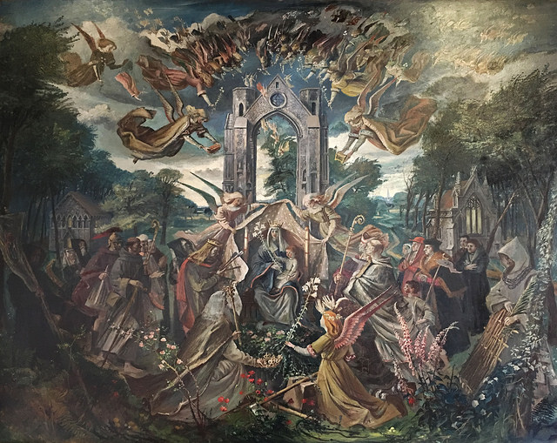

Communion Antiphon ‡ Psalm 13 (12): 6
I will sing to the Lord who has been bountiful with me, sing psalms to the name of the Lord Most High.

(continued)
Worry about material needs is one of the most common “spoilers” of the success of various church ministries. Many people dedicate themselves to the work of the Church as idealist young people, who have nothing and do not desire anything. Later, though, the desire for material goods, for honors, for power, creeps in, and individuals find themselves in the ridiculous position of trying to accumulate worldly riches or comfort while working for the Church. This can lead to great unhappiness and bitterness, a complaining spirit that is a counter-witness to the Gospel, a kind of “kakangelism” (“bad news”) of Satan. Periodically we need an examination of conscience to remind ourselves of our real goal in life and our real mission. Sometimes adversity—such as sickness, financial reverses, political pressure, even persecution and imprisonment—are sent our way by God to shake us out of a too-easy pursuit of Mammon.

The Readings this week are calling us to renew a life of trust in a God who knows our needs and will supply them, but also knows many of our “needs” are really just “wants” which wouldn’t be good for us anyway. This trusting, confident relationship with God is really necessary if we are to maintain our joy as we follow Jesus through the trials of this present life.

Our Lady of Walsingham and English Saints, mural, hall outside Slipper Chapel Shrine, Walsingham. Photo by Norman Servais.
Entrance Antiphon ‡ Psalm 18 (17): 19-20
The Lord became my protector. He brought me out to a place of freedom; he saved me because he delighted in me.

First Reading ‡ Isaiah 49:14-15
Even these may forget, says the Lord God, yet I will not forget you.
Zion was saying, ‘The Lord has abandoned me,
the Lord has forgotten me.’
Does a woman forget her baby at the breast,
or fail to cherish the son of her womb?
Yet even if these forget,

Gospel ‡ Matthew 6:24-34
Do not worry about tomorrow.
Jesus said to his disciples: ‘No one can be the slave to two masters: he will either hate the first and love the second, or treat the first with respect and the second with scorn. You cannot be the slave both of God and of money.
‘That is why I am telling you not to worry about your life and what you are to eat, nor about your body and how you are to clothe it. Surely life means more than food, and the body more than clothing! Look at the birds in the sky. They do not sow or reap or gather into barns; yet your heavenly Father feeds them. Are you not worth much more than they are? Can any of you, for all his worrying, add one single cubit to his span of life? And why worry about clothing? Think of the flowers growing in the fields; they never have to work or spin; yet I assure you that not even Solomon in all his regalia was robed like one of these.
Now if that is how God clothes the grass in the field which is there today and thrown into the furnace tomorrow, will he not much more look after you, you men of little faith?
So do not worry, do not say, “What are we to eat? What are we to drink? How are we to be clothed?” It is the pagans who set their hearts on all these things. Your heavenly Father knows you need them all. Set your hearts on his kingdom first, and on his righteousness, and all these other things will be given you as well. So do not worry about tomorrow: tomorrow, will take care of itself. Each day has enough trouble if its own.’

The Gospel of the Lord.
Praise to you, Lord Jesus Christ!
Page 3
Page 2

I will never forget you.
The word of the Lord.
Thanks be to God.

Responsorial Psalm ‡ Psalm 61: 2-3, 6-9.

R. Rest in God alone, my soul.

In God alone is my soul at rest;
my help comes from him.
He alone is my rock, my stronghold,
my fortress: I stand firm. R.

In God alone be at rest, my soul;
for my hope comes from him.
He alone is my rock, my stronghold,
my fortress: I stand firm. R.

In God is my safety and glory,
the rock of my strength.
Take refuge in God all you people.
Trust him at all times.
Pour out your hearts before him. R.

Second Reading ‡ 1 Corinthians 4:1-5
The Lord will bring light to all that is hidden in darkness.
People must think of us as Christ’s servants, stewards entrusted with the mysteries of God. What is expected of stewards is that each one should be found worthy of his trust. Not that it makes the slightest difference to me whether you, or indeed any human tribunal, find me worthy or not. I will not even pass judgement on myself. True, my conscience does not reproach me at all, but that does not prove that I am acquitted: the Lord alone is my judge. There must be no passing of premature judgement. Leave that until the Lord comes: he will light up all that is hidden in the dark and reveal the secret intentions of men’s hearts. Then will be the time for each one to have whatever praise he deserves, from God.
The word of the Lord.
Thanks be to God.
Gospel Acclamation ‡ Hebrews 4:12
Alleluia, alleluia!
The word of God is living and active;
it probes the thoughts and motives of our heart.
Alleluia!

https://yanchepcatholic.wordpress.com/wp-admin/admin.php?pag

Commentary on today’s readings by Dr John Bergsma http://www.thesacredpage.com/2017/02/trusting-god-for-all-we-need-readings.html
In today’s Gospel, Jesus makes clear that the Kingdom of Heaven is not characterized by external wealth and the acquisition of material goods. Ironically, throughout the Old Testament, the acquisition of wealth tended to lead to the undoing of the Kingdom of David, as the people of Jerusalem grew proud and turned away from dependence on the LORD. This is a constant theme of the Prophets, especially Isaiah and Jeremiah.
The “finest hours” of the Kingdom of David occurred when King and people humbled themselves in total dependence on God (see Isaiah 37; 2 Chronicles 20:5-30). The lifestyle prescribed for kingdom citizens in today’s Gospel is just that. We must absent ourselves from the “rat race” that characterizes the rest of our culture, and make our priority not the acquisition of wealth and status, but the development of the “righteousness” of the Kingdom of God, which can probably be summarized by the virtues of the beatitudes: poverty of spirit, contrition, meekness, desire for holiness, mercy/forgiveness, purity of heart, peacefulness, and acceptance of persecution.
(Continued over page.)

