Sixth Sunday in Ordinary Time Year A
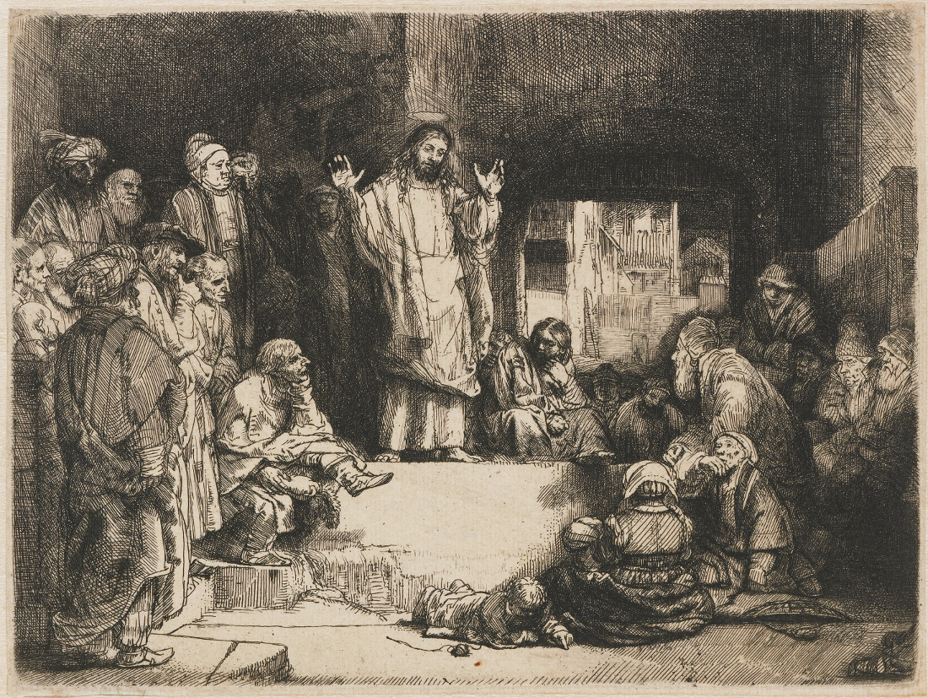
Insert church notices here.
Page 4
Sunday Bulletin

Communion Antiphon ‡ Psalm 78 (77): 29-30
They ate and had their fill, and what they craved the Lord gave them; they were not disappointed in what they craved.

Commentary by Dr John Bergsma at http://www.thesacredpage.com/2014/02/the-surpassing-righteousness-of-new-law.html#more
The Problem: How does Jesus fulfill the law? In Matthew 5:17–20 we find Jesus affirming the validity of the law and the prophets in the strongest possible terms: I have come not to abolish but to fulfill. This solemn affirmation of the Torah’s value is then immediately followed by a series of sayings in which Jesus compares his teachings with the standards of the law. This section is conventionally referred to as the “six antitheses” (cf. Matt 5:21–48). Here Jesus cites a passage from the Torah and then offers a teaching which begins with “but I say to you” (5:22, 28, 32, 34, 39, 44).
Controversy surrounds the exact implications of Jesus’ language. Does this language of “but I say to you” signal a rejection of the Torah? Given Jesus’ insistence on the enduring value of the law in 5:17–20 in the immediately preceding verses, it is probably not surprising that many are hesitant to make that case. In fact, the Greek word used by Jesus for “but” (de not alla) suggests something other than outright rejection is in view.[4] Moreover, as many have noted, the hinge between the two sections seems to be Jesus’ call for a “better righteousness” in 5:20. Here scholars have recognized the rationale for the antitheses that follow in 5:21–48: Jesus is coming to bring about a new kind of righteousness. (Continue reading at The Sacred Page.)

Jesus Preaching, Rembrandt Harmenszoon van Rijn, ca. 1567, Rembrandthuis, Amsterdam.
Entrance Antiphon | Psalm 31 (30): 3-4.
Be my protector, O God, a mighty stronghold to save me. For you are my rock, my stronghold! Lead me, guide me, for the sake of your name.

First Reading ‡ Sirach 15:15-20
He never commanded anyone to be godless.
If you wish, you can keep the commandments,
to behave faithfully is within your power.
He has set fire and water before you;
put out your hand to whichever you prefer.
Man has life and death before him;
whichever a men likes better will be given him.
For vast is the wisdom of the Lord;
he is almighty and all-seeing.
His eyes are on those who fear him,

Gospel ‡ Matthew 5: 17-37
Such was said to your ancestors; but I am speaking to you.
Jesus said to his disciples: ‘Do not imagine that I have come to abolish the Law or the Prophets. I have come not to abolish them but to complete them. I tell you solemnly, till heaven and earth disappear, not one dot, one little stroke, shall disappear from the Law until its purpose is achieved. Therefore, the man who infringes even one of the least of these commandments and teaches others to do the same will be considered the least in the kingdom of heaven; but the man who keeps them and teaches them will be considered great in the kingdom of heaven.
‘For I tell you, if your virtue goes no deeper than that of the scribes and Pharisees, you will never get into the kingdom of heaven.
‘You have learnt how it was said to our ancestors: You must not kill; and if anyone does kill he must answer for it before the court. But I say this to you: anyone who is angry with his brother will answer for it before the court; if a man calls his brother “Fool” he will answer for it before the Sanhedrin; and if a man calls him “Renegade” he will answer for it in hell fire. So then, if you are bringing your offering to the altar and there remember that your brother has something against you, leave your offering there before the altar, go and be reconciled with your brother first, and then come back and present your offering. Come to terms with your opponent in good time while you are still on the way to the court with him, or he may hand you over to the judge and the judge to the officer, and you will be thrown into prison. I tell you solemnly, you will not get out till you have paid the last penny.
‘You have learnt how it was said: You must not commit adultery. But I say this to you: if a man looks at a woman lustfully, he has already committed adultery with her in his heart. If your right eye should cause you to sin, tear it out and throw it away; for it will do you less harm to lose one part of you than to have your whole body thrown into hell. And if your right hand should cause you to sin, cut it off and throw it away; for it will do you less harm to lose one part of you than to have your whole body go to hell.
‘It has also been said: Anyone who divorces his wife must give her a writ of dismissal. But I say this to you: everyone who divorces his wife, except for the case of fornication, makes her an adulteress; and anyone who marries a divorced woman commits adultery.
‘Again, you have learnt how it was said to our ancestors: You must not break your oath, but must fulfil your oaths to the Lord. But I say this to you: do not swear at all, either by heaven, since that is God’s throne; or by the earth, since that is his footstool; or by Jerusalem, since that is the city of the great king. Do not swear by your own head either, since you cannot turn a single hair white or black. All you need say is “Yes” if you mean yes, “No” if you mean no; anything more than this comes from the evil one.’

The Gospel of the Lord.
Praise to you, Lord Jesus Christ!
Page 3
Page 2
he notes every action of man.
He never commanded anyone to be godless,
he has given no one permission to sin.
The word of the Lord.
Thanks be to God.

Responsorial Psalm ‡ Psalm 118: 1-2, 4-5, 17-18, 33-34.

R. Happy are they who follow the law of the Lord!

They are happy whose life is blameless,
who follow God’s law!
They are happy those who do his will,
seeking him with all their hearts. R.

You have laid down your precepts
to be obeyed with care.
May my footsteps be firm
to obey your statutes. R.

Bless your servant and I shall live
and obey your word.
Open my eyes that I may consider
the wonders of you law. R.

Second Reading ‡ 1 Corinthians 2: 6-10.
God in his wisdom predestined our glory before the ages began.
We have a wisdom to offer those who have reached maturity: not a philosophy of our age, it is true, still less of the masters of our age, which are coming to their end. The hidden wisdom of God which we teach in our mysteries is the wisdom that God predestined to be for our glory before the ages began. It is a wisdom that none of the masters of this age have ever known, or they would not have crucified the Lord of Glory; we teach what scripture calls: the things that no eye has seen and no ear has heard, things beyond the mind of man, all that God has prepared for those who love him.
These are the very things that God has revealed to us through the Spirit, for the Spirit reaches the depths of everything, even the depths of God.
The word of the Lord.
Thanks be to God.

Gospel Acclamation ‡ Matthew 11: 25
Alleluia, alleluia!
Blessed are you, Father, Lord of heaven and earth;
you have revealed to little ones the mysteries of the kingdom.
Alleluia!

https://yanchepcatholic.wordpress.com/wp-admin/admin.php?pag

