Fifth Sunday in Ordinary Time Year A
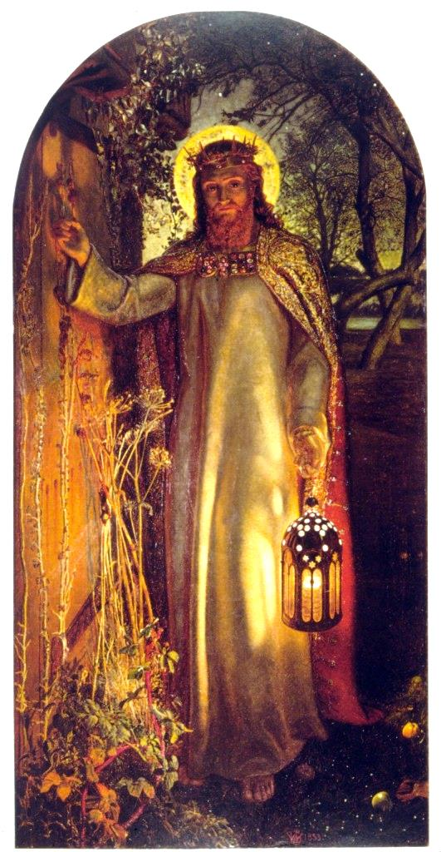
Insert church notices here.
The Light of the World, William Holman Hunt, 1851, Oil on canvas on wood, Keble College, Oxford.
Page 4
Sunday Bulletin



Entrance Antiphon | Psalm 95 (94): 6-7.
O come, let us worship God and bow low before the God who made us, for he is the Lord our God.

First Reading ‡ Isaiah 58:7-10
Your light will shine like the dawn.

Thus says the Lord:
Share your bread with the hungry,
and shelter the homeless poor,
clothe the man you see to be naked
and do not turn from your own kin.
Then will your light shine like the dawn
and your wound be quickly healed over.

Your integrity will go before you
and the glory of the Lord behind you.
Cry, and the Lord will answer;
call, and he will say, ‘I am here.’

Communion Antiphon ‡ Matthew 5:5-6
Blessed are those who mourn, for they shall be consoled. Blessed are those who hunger and thirst for righteousness, for they shall have their fill.

Explanation of the art on the front cover …

The Light of the World (1853–54) is an allegorical painting by William Holman Hunt representing the figure of Jesus preparing to knock on an overgrown and long-unopened door, illustrating Revelation 3:20: "Behold, I stand at the door and knock; if any man hear My voice, and open the door, I will come in to him, and will sup with him, and he with Me". According to Hunt: "I painted the picture with what I thought, unworthy though I was, to be by Divine command, and not simply as a good Subject." The door in the painting has no handle, and can therefore be opened only from the inside, representing "the obstinately shut mind". Hunt, 50 years after painting it, felt he had to explain the symbolism.
http://en.wikipedia.org/wiki/The_Light_of_the_World_(painting)

If you do away with the yoke,
the clenched fist, the wicked word,
if you give your bread to the hungry,
and relief to the oppressed,
your light will rise in the darkness,
and your shadows become like noon.
The word of the Lord.
Thanks be to God.

Page 3

‘You are the light of the world. A city built on a hill-top cannot be hidden. No one lights a lamp to put it under a tub; they put it on the lamp-stand where it shines for everyone in the house. In the same way your light must shine in the sight of men, so that, seeing your good works, they may give the praise to your Father in heaven.’

The Gospel of the Lord.
Praise to you, Lord Jesus Christ!
Page 2
Responsorial Psalm ‡ Psalm 111:4-9

R. A light rises in the darkness for the upright!

He is a light in the darkness for the upright:
he is generous, merciful and just.
The good man takes pity and lends,
he conducts his affairs with honour. R.

The just man will never waver:
he will be remembered for ever.
He has no fear of evil news;
with a firm heart he trusts in the Lord. R.

With a steadfast heart he will not fear;
open-handed, he gives to the poor;
his justice stands firm for ever.
His head will be raised in glory. R.

Second Reading ‡ 1 Corinthians 2:1-5.
I came to you to proclaim Christ crucified.
When I came to you, brothers, it was not with any show of oratory or philosophy, but simply to tell you what God had guaranteed. During my stay with you, the only knowledge I claimed to have was about Jesus, and only about him as the crucified Christ. Far from relying on any power of my own, I came among you in great ‘fear and trembling’ and in my speeches and the sermons that I gave, there were none of the arguments that belong to philosophy; only a demonstration of the power of the Spirit. And I did this so that your faith should not depend on human philosophy but on the power of God.

The word of the Lord.
Thanks be to God.

Gospel Acclamation ‡ John 8:12
Alleluia, alleluia!
I am the light of the world, says the Lord;
the man who follows me will have the light of life.
Alleluia!

Gospel ‡ Matthew 5: 13-16
You are the light of the world.
Jesus said to his disciples: ‘You are the salt of the earth. But if salt becomes tasteless, what can make it salty again? It is good for nothing, and can only be thrown out to be trampled underfoot by men.

Commentary by Dr John Bergsma at http://www.thesacredpage.com/2017/02/church-temple-lighthouse-fifth-sunday.html#more

St. Paul was not a trained Greek orator, but the Greeks placed high value on the art of rhetoric, especially in ancient and wealthy seats of Greek culture like the city of Corinth. In this passage, the Apostle defends himself against those who ridiculed him and his message because his Greek was common and his thought shaped by Jewish rather than Hellenic standards of argument.

St. Paul points out that the power of the Good News of Jesus is not dependent on rhetoric or literary devices, but on reality. The Holy Spirit has the power to transform lives, to forgive sins, to heal sickness of body and soul, to lead us into eternal life with God. These are realities, facts, not word-pictures or theatrical oratory.

Those who seek a show may not be impressed with the cross of Christ, which is a sorry spectacle when viewed with the eyes of entertainment. This applies also to our modern forms of worship. Great preaching and great music are well and good, and by all means let’s try to honour the Mass with the best possible, but they cannot be the basis of our faith. Preachers and musicians come and go.

The reason for our attendance at worship should be to witness again the miracle of the cross and resurrection, enacted before our eyes in the Holy Eucharist. It’s not impressive by the world standards. You can see a better show on television or in the local theatre or stadium. But it is a “demonstration of the power of the Spirit” when bread and wine is transformed into the Body and Blood of Christ, and it does have real transformative power in our lives provided we receive it in faith and not disbelief.

Sunday Mass may not be as “exciting” perhaps as the presentation put on by the mega-church down the road, but Mass is real, a brute fact, not just words. Preaching and music may be more impressive somewhere else, but the crucified Christ is really present here under the form of bread and wine, for those who wish to receive him.

https://yanchepcatholic.wordpress.com/wp-admin/admin.php?pag

