Fourth Sunday in Ordinary Time Year A
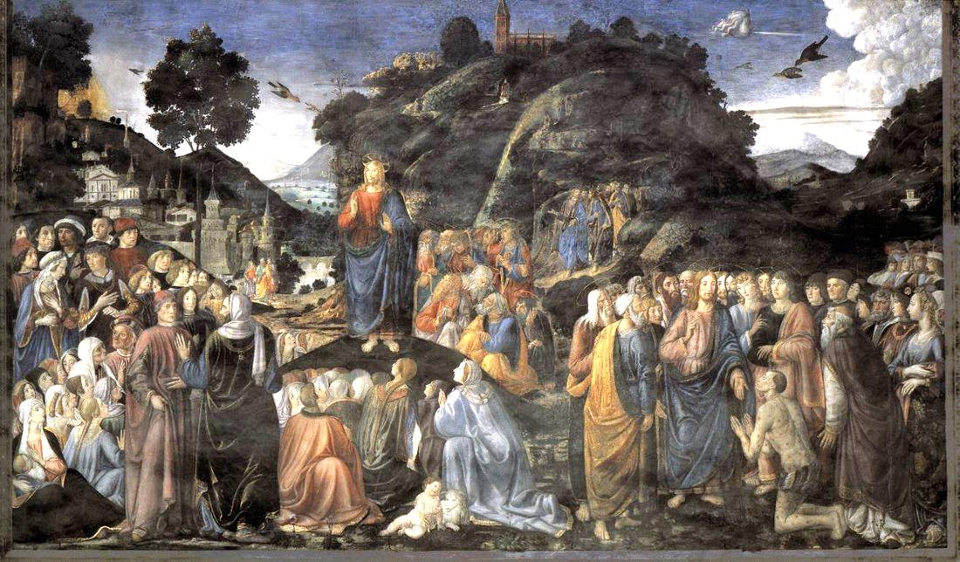
Insert church notices here.
Page 4
Sunday Bulletin

Communion Antiphon ‡ Matthew 5:3-4
Blessed are the poor in spirit, for theirs is the kingdom of heaven. Blessed are the meek, for they shall possess the land.

(continued)
Finally, we should note that the beatitudes are not a simple grab-bag of random virtues, but there is a certain progression as we move through them. They are all inter-related, and to a certain extent they move from one to the next.
The primary reference is poverty of spirit, which is a recognition of one’s spiritual bankruptcy and need to be infilled with God’s spiritual riches, i.e. his Spirit, granted by faith through the sacraments. Nonetheless there is a relationship with material poverty. Material riches can be a great distraction to the spiritual life, sidetracking us to pursue goals other than God. So elsewhere Jesus will warn about seed that is choked by the “cares and riches” of this world. For this reason, many saints have understood “poor in spirit” to be “poor for the sake of the Spirit,” that is, temporally poor for the sake of spiritual ends. Thus, those who go into religious life take a radical vow of poverty. But even we lay people should practice restraint in material wealth. How do we practice it? The principle of St. Josemaria was “have nothing unnecessary.” He encouraged lay people to pare their belongings down to what they really needed for their vocation, and then to take care of those things so that they would not constantly be wasting money by replacing them.
Thus, “poor in spirit” refers to spiritual poverty, but nonetheless is tied to living a form of temporal poverty as well, because temporal indulgence is incompatible with spiritual poverty.
“Blessed are those who mourn, for they shall be comforted.
This refers to those who mourn for their spiritual poverty, for their nothingness, for their emptiness, for their sins. Thus, recognizing that you are “poor in spirit” leads to contrition (sorrow for sins), but that is good, because God will comfort the contrite.
Continue reading at
http://www.thesacredpage.com/2017/01/kingdom-of-humble-poor-4th-sunday-in-ot.html.

The Sermon on the Mount, Cosimo Rosselli, 1481-82. fresco, Sistine Chapel, Vatican.

Entrance Antiphon | Psalm 106 (105): 47.
Save us, O Lord our God! And gather us from the nations, to give thanks to your holy name, and make it our glory to praise you.

First Reading ‡ Zephaniah 2: 3, 3: 12-13
In your midst I will leave a humble and a lowly people.
Seek the Lord all you,
the humble of the earth,
who obey his commands.
Seek integrity, seek humility:
you may perhaps find shelter
on the day of the anger of the Lord.
In your midst I will leave a humble and lowly people,
and those who are left in Israel
will seek refuge in the name of the Lord.
They will do no wrong,
will tell no lies;

Gospel ‡ Matthew 5: 1-12
Happy are the poor in spirit.
Seeing the crowds, Jesus went up the hill. There he sat down and was joined by his disciples. Then he began to speak. This is what he taught them:

‘How happy are the poor in spirit;
theirs is the kingdom of heaven.
Happy the gentle:
they shall have the earth for their heritage.
Happy those who mourn:
they shall be comforted.
Happy those who hunger and thirst for what is right:
they shall be satisfied.
Happy the merciful:
they shall have mercy shown them.
Happy the pure in heart:
they shall see God.
Happy the peacemakers:
they shall be called sons of God.
Happy those who are persecuted in the cause of right:
theirs is the kingdom of heaven.
‘Happy are you when people abuse you and persecute you and speak all kinds of calumny against you on my account. Rejoice and be glad, for your reward will be great in heaven.’

The Gospel of the Lord.
Praise to you, Lord Jesus Christ!
Page 3
Page 2
and the perjured tongue will no longer
be found in their mouths.
But they will be able to graze and rest
with no one to disturb them.
The word of the Lord.
Thanks be to God.

Responsorial Psalm ‡ Psalm 145: 7-10.

R. Happy the poor in spirit; the kingdom of heaven is theirs!

It is the Lord who keeps faith for ever,
who is just to those who are oppressed.
It is he who gives bread to the hungry,
the Lord, who sets prisoners free. R.

It is the Lord who gives sight to the blind,
who raises up those who are bowed down,
the Lord, who protects the stranger
and upholds the widow and orphan. R.

It is the Lord who loves the just
but thwarts the path of the wicked.
The Lord will reign for ever,
Zion’s God, from age to age. R.

Second Reading ‡ 1 Corinthians 1:26-31.
God has chosen what is weak by human reckoning.
Take yourselves, brothers, at the time when you were called: how many of you were wise in the ordinary sense of the word, how many were influential people, or came from noble families? No, it was to shame the wise that God chose what is foolish by human reckoning, and to shame what is strong that he chose what is weak by human reckoning; those whom the world thinks common and contemptible are the ones that God has chosen — those who are nothing at all to show those who are everything. The human race has nothing to boast about to God, but you, God has made members of Christ Jesus and by God’s doing he has become our wisdom, and our virtue, and our holiness, and our freedom. As scripture says: if anyone wants to boast, let him boast about the Lord.
The word of the Lord.
Thanks be to God.

Gospel Acclamation ‡ Matthew 5:12
Alleluia, alleluia!
Rejoice and be glad; your reward will be great in heaven.
Alleluia!

https://yanchepcatholic.wordpress.com/wp-admin/admin.php?pag

Reflection by Dr John Bergsma at http://www.thesacredpage.com/2017/01/kingdom-of-humble-poor-4th-sunday-in-ot.html.

First, we should recognize that when Jesus “goes up on a mountain” to teach, it is a Mosaic motif. Moses was the great teacher of Israel, who climbed Mt. Sinai to teach the Law of God. Jesus is recapitulating this motif. Jesus is the New Moses, who will teach a better law, and correct some of the compromises that Moses introduced into Israel’s legislation (Matt. 5:21-48).
Now, with respect to the Beatitudes (which are just the introduction to the Sermon on the Mount and not synonymous with the entire Sermon, which lasts from Matt 5-7), we should note that there are eight main ones, vv. 3-10, followed by an epilogue on persecution (vv. 11-12). The first and eighth beatitude promise the blessing of the “kingdom of heaven.” That is a literary device called an “inclusio” (beginning and ending on the same topic) which highlights the main point. So the Beatitudes are about the kingdom of heaven, specifically, they are the virtues that are required of kingdom citizens.

