Third Sunday in Ordinary Time Year A
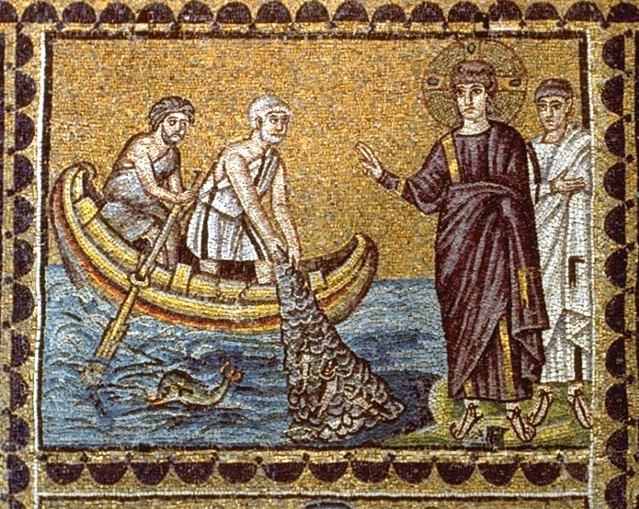
Insert church notices here.
Page 4
Sunday Bulletin

Communion Antiphon ‡ John 8:12
I am the light of the world, says the Lord; whoever follows me will not walk in darkness, but will have the light of life.

(continued)
The four fishermen Jesus calls are two pairs of brothers: Peter and Andrew, James and John. Although the way the story is presented in Matthew causes it to appear as if the four men drop their nets to follow a total stranger, there is good reason to believe, on the basis of information in the other Gospels, that these four men and already encountered Jesus before and had some interaction with him. Jesus is not calling to total strangers, but he is calling the men to commit whole-heartedly to what up to that time had been a casual relationship with him. Having said all that does not reduce the drama of the scene and the radical nature of their decision: they walk away from their nets (i.e. their livelihood) and (in the case of James and John) their very own father (i.e. their family) in order to begin a new life with Jesus.
In Judaism, it was only permissible to cease the practice of one’s livelihood and break family ties for the sake of the study of God’s Word, the Torah, “The Law.” In calling his disciples to abandon everything, not to study the Law but to “follow me,” Jesus is placing himself in the role of the Law of God. He is God’s Word incarnate. Imitating him is a form of studying God’s Law.
Although the word “joy” is not found in this Gospel text, the whole story is infused with joy and light. Peter, Andrew, James, and John were men “walking in darkness” who see the “great light” striding along the shore of the Sea of Galilee. Unlike the Rich Young Ruler who is called to leave everything and “goes away sad” because he cannot abandon his wealth, these four disciples “go away happy” with Jesus. They let nothing hold them back.
This Gospel reminds us of Pope Francis’ emphasis on the joy of the Gospel. Life would truly be depressing without Jesus. Among all the world’s philosophers and religious founders, Jesus stands out as a light, telling us of a God wants us to be his children, showing us the way to live a life of love in relationship with such a Father, teaching us that the sufferings of this life are the very means to draw closer to God.

The Calling of Peter and Andrew, Mosaic, Basilica of Sant’Apollinare Nuovo, Ravenna, Italy.

Entrance Antiphon | Psalm 96 (95):1, 6.
O sing a new song to the Lord; sing to the Lord, all the earth. In his presence are majesty and splendour, strength and honour in his holy place.

First Reading ‡ Isaiah 8:23-9:3
In the Galilean country, the people have seen a great light.
In days past the Lord humbled the land of Zebulun and the land of Naphtali, but in days to come he will confer glory on the Way of the Sea on the far side of Jordan, province of the nations.
The people that walked in darkness has seen a great light;
on those who live in a land of deep shadow a light has shone.
You have made their gladness greater,

Gospel Acclamation ‡ Matthew 4:23
Alleluia, alleluia!
Jesus preached the Good News of the kingdom and healed all who were sick.
Alleluia!
Gospel ‡ Matthew 4:12-23
He went to Capernaum, that the prophecy of Isaiah be fulfilled.
Hearing that John had been arrested Jesus went back to Galilee, and leaving Nazareth he went and settled in Capernaum, a lakeside town on the borders of Zebulun and Naphtali. In this way the prophecy of Isaiah was to be fulfilled:
Land of Zebulun! Land of Naphtali!
Way of the sea on the far side of Jordan,
Galilee of the nations!
The people that lived in darkness has seen a great light;
on those who dwell in the land and shadow of death a light has dawned.
From that moment Jesus began his preaching with the message,
‘Repent, for the kingdom of heaven is close at hand’.
As he was walking by the Sea of Galilee he saw two brothers, Simon, who was called Peter, and his brother Andrew; they were making a cast in the lake with their net, for they were fishermen. And he said to them, ‘Follow me and I will make you fishers of men.’ And they left their nets at once and followed him.
Going on from there he saw another pair of brothers, James son of Zebedee and his brother John; they were in their boat with their father Zebedee, mending their nets, and he called them. At once, leaving the boat and their father, they followed him.
He went round the whole of Galilee teaching in their synagogues, proclaiming the Good News of the kingdom and curing all kinds of diseases and sickness among the people.
The Gospel of the Lord.
Praise to you, Lord Jesus Christ!
Page 3
Page 2
you have made their joy increase;
they rejoice in your presence as men rejoice at harvest time,
as men are happy when they are dividing the spoils.
For the yoke that was weighing on him,
the bar across his shoulders,
the rod of his oppressor,
these you break as on the day of Midian.
The word of the Lord.
Thanks be to God.

Responsorial Psalm ‡ Psalm 26:1, 4, 13-14.

R. The Lord is my light and my salvation.

The Lord is my light and my help;
whom shall I fear?
The Lord is the stronghold of my life;
before whom shall I shrink? R.

There is one thing I ask of the Lord,
for this I long,
to live in the house of the Lord,
all the days of my life,
to savour the sweetness of the Lord,
to behold his temple. R.

I am sure I shall see the Lord’s goodness
in the land of the living.
Hope in him, hold firm and take heart.
Hope in the Lord! R.

Second Reading ‡ 1 Corinthians 1:10-13, 17.
I appeal to you, my brothers and sisters, make up the differences between you.
I appeal to you, brothers, for the sake of our Lord Jesus Christ, to make up the differences between you, and instead of disagreeing among yourselves, to be united again in your belief and practice. From what Chloe’s people have been telling me, my dear brothers, it is clear that there are serious differences among you. What I mean are all these slogans that you have, like: ‘I am for Paul’, ‘I am for Apollo’, ‘I am for Cephas’, ‘I am for Christ’. Has Christ been parcelled out? Was it Paul that was crucified for you? Were you baptised in the name of Paul? For Christ did not send me to baptise, but to preach the Good News, and not to preach that in the terms of philosophy in which the crucifixion of Christ cannot be expressed.
The word of the Lord.
Thanks be to God.

https://yanchepcatholic.wordpress.com/wp-admin/admin.php?pag

Reflection by Dr John Bergsma at http://www.thesacredpage.com/2017/01/joy-in-dropping-everything-to-follow.html#more
The reign of David over the Twelve Tribes had been destroyed long ago, broken by schism already in 1 Kings 12. But now Jesus comes to re-unify and re-establish.
He calls fishermen to follow him and become “fishers of men.” Although Matthew doesn’t call attention to the fact, this is actually a fulfillment of an oracle of the prophet Jeremiah:
Jer. 16:16 “Behold, I am sending for many fishers, says the LORD, and they shall catch them; and afterwards I will send for many hunters, and they shall hunt them from every mountain and every hill, and out of the clefts of the rocks.
In the original context, Jeremiah’s words were set in the context of a larger prophecy promising the restoration of the people of Israel (Jer 16:14-15). Nonetheless, his words sound ominous: God will hunt down his people for their iniquity (Jer 16:17-18). Yet as fulfilled in Christ, the oracle takes on a different sense: the “fishers” will “hunt down” the survivors of Israel in order to offer them not merely punishment but a remedy for their sins.

(continued overleaf)

