Second Sunday in Ordinary Time Year A
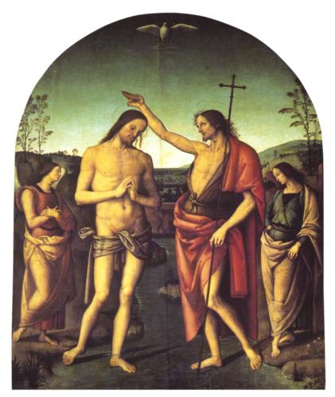
Insert church notices here.
Page 4
Sunday Bulletin
The Baptism of Christ (detail), Pietro Perugino, 1520, Cathedral of Citta della Pieve, Umbria, Italy.

Communion Antiphon ‡ Psalm 23 (22):5
You have prepared a table before me, and how precious is the chalice that quenches my thirst.

(continued)
Thomas Aquinas offers this explanation:
. . . for John had lived in the desert from boyhood. And although many miracles happened during the birth of Christ, such as the Magi and the star and so on, they were not known to John: both because he was an infant at the time, and because, after withdrawing to the desert, he had no association with Christ. In the interim between his birth and baptism, Christ did not perform any miracles, but led a life similar to any other person, and his power remained unknown to all. (Super Evangelium S. Ionnis Lectura, 1:263).
The coming of the Spirit in terms of a dove has been explained in multiple ways. However, it seems to me to be most likely linked with the new creation imagery of the Gospel. From the first verse of the Gospel, John is evoking Genesis: "In the beginning. . "Of course, the dove is also associated with the story of Noah and the Flood. To that end, it is worth noting that the story of the flood is portrayed in terms of a kind of "new creation". In light of this, it would make sense for an image of the flood to appear in the story; Jesus is bringing about a new creation. Baptism thus brings about a new creation.
Jesus' baptism also reveals his identity as "Son of God". Of course, in the Old Testament this was a title given to Israel (cf. Exod. 4:22) and the Davidic King (cf. Ps. 2:7). Jesus is the Son of God and it is through him that we become "sons of God"--particularly, through baptism. Moreover, we might note how this dovetails (pun intended!) with the commentary above on the Servant who is both a figure who comes to save Israel and who also is somehow Israel.
In our baptism we come to the Son of God, the one upon whom the Spirit rests, and we are taken up into his mission. Let us prepare for that mission (Latin: missa--, i.e., where we get the term "mass") as we enter into this Sunday's liturgy.
(Read more at http://www.thesacredpage.com/2014/01/the-baptism-of-servant.html#more.)

Entrance Antiphon | Psalm 66 (65):4
All the earth shall bow down before you, O God, and shall sing to you, shall sing to your name, O Most High!

First Reading ‡ Isaiah 49:3, 5-6.
I will make you the light of the nations so that my salvation may reach to the ends of the earth.
The Lord said to me, ‘You are my servant, Israel,
in whom I shall be glorified’;
I was honoured in the eyes of the Lord,
my God was my strength.

And now the Lord has spoken,
he who formed me in the womb to be his servant,
to bring Jacob back to him,
to gather Israel to him:

Gospel Acclamation ‡ John 1:14. 12.
Alleluia, alleluia!
The Word of God became flesh and dwelt among us.
He enabled those who accepted him to become the children of God.
Alleluia!
Gospel ‡ John 1:29-34.

This is the Lamb of God who takes away the sins of the world.
Seeing Jesus coming towards him, John said, ‘Look, there is the lamb of God that takes away the sin of the world. This is the one I spoke of when I said: A man is coming after me who ranks before me because he existed before me. I did not know him myself, and yet it was to reveal him to Israel that I came baptising with water.’ John also declared, ‘I saw the Spirit coming down on him from heaven like a dove and resting on him. I did not know him myself, but he who sent me to baptise with water had said to me, “The man on whom you see the Spirit come down and rest is the one who is going to baptise with the Holy Spirit.” Yes, I have seen and I am the witness that he is the Chosen One of God.’

The Gospel of the Lord.
Praise to you, Lord Jesus Christ!
Page 3
Page 2

‘It is not enough for you to be my servant,
to restore the tribes of Jacob and bring back the survivors of Israel;
I will make you the light of the nations
so that my salvation may reach to the ends of the earth.’
The word of the Lord.
Thanks be to God.

Responsorial Psalm ‡ Psalm 39:2. 4. 7-10.

R. Here I am, Lord. I come to do your will.

I waited, I waited for the Lord
and he stooped down to me;
he heard my cry.
He put a new song into my mouth,
praise of our God. R.

You do not ask for sacrifice and offerings,
but an open ear.
You do not ask for holocaust and victim.
Instead, here am I. R.

In the scroll of the book it stands written
that I should do your will.
My God, I delight in your law
in the depth of my heart. R.

Your justice I have proclaimed
in the great assembly.
My lips I have not sealed;
you know it, O Lord. R.

Second Reading ‡ 1 Corinthians 1:1-3
The grace and peace of God our Father and the Lord Jesus Christ be with you.
I, Paul, appointed by God to be an apostle, together with brother Sosthenes, send greetings to the church of God in Corinth, to the holy people of Jesus Christ, who are called to take their place among all the saints everywhere who pray to our Lord Jesus Christ; for he is their Lord no less than ours. May God our Father and the Lord Jesus Christ send you grace and peace.
The word of the Lord.
Thanks be to God.

https://yanchepcatholic.wordpress.com/wp-admin/admin.php?pag

Commentary on the Gospel by Dr Michael Barber, Professor of Theology and Scripture at John Paul the Great Catholic University. (http://www.thesacredpage.com/2014/01/the-baptism-of-servant.html#more.)

John's baptism in the Synoptics is said to be for "repentance" of sin. While that exact language is not used here, John the Baptist is clearly also clearly portrayed as longing for the day the "sin of the world" is taken away.
By identifying him as "Lamb of God", John seems to identify Christ as the one who will do this. Moreover, given the fact that the lamb is frequently tied to sacrifice--particularly in the Passover--it seems to suggest that Christ will deliver his people from their sins through a sacrificial act. All of this imagery, as is well known, comes together later in the Passion Narrative of the Fourth Gospel, where Christ is depicted as a kind of New Passover sacrifice.
Of course, one key aspect of the Passover sacrifice was that it must be eaten. In John 6, Jesus thus describes how believers must eat his flesh and drink his blood in order to be saved.
In the Gospel of Luke, Jesus is identified as the cousin of Jesus. So how does John say that he does not know him?
(continued overleaf)

