4th Sunday Advent Year A
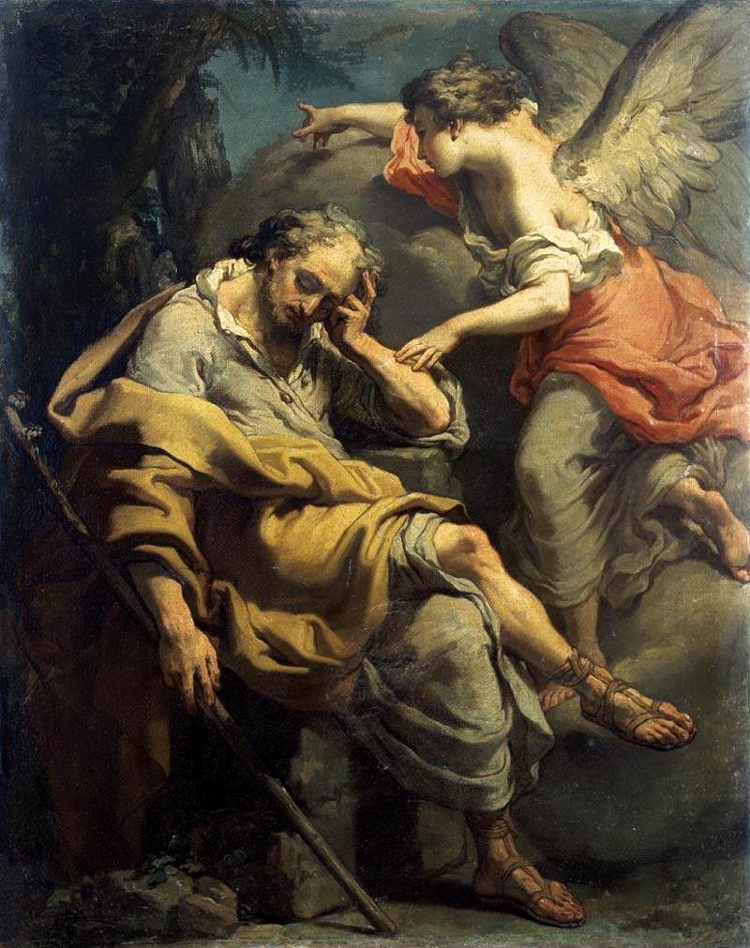
Insert Parish notices here.
Joseph’s Dream, Gaetano Gandolfi, c. 1790, oil on canvas, private collection.
Page 4
Sunday Bulletin
Page 1

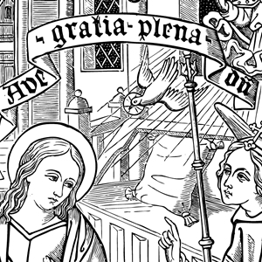

Entrance Antiphon ‡ cf. Isaiah 45:8
Drop down dew from above, you heavens, and let the clouds rain down the Just One; let the earth be opened and bring forth a Saviour.

Communion Antiphon ‡ cf. Isaiah 7:14
Behold, a Virgin shall conceive and bear a son; and his name will be called Emmanuel.
.


(continued)
conception of divinity (a classic traditional view). Mary and Joseph’s hopes to be just an average middle-class couple living the “Israelite dream” are dashed. Their lives are not going to be normal and typical. The angel guides Joseph to his next step—completing his marriage to Mary. We know that the coming months will involve more strain and stress—a long journey to Bethlehem in the late stages of pregnancy, followed by a midnight flight from Bethlehem to Egypt to get away from persecution.
Mary and Joseph’s lives would never again be “average” and “comfortable,” because when God “invades” our lives, he incorporates us into his plan of salvation for the world, and we have to partake of the suffering of the man named “Salvation” (see Romans 8:17).
At Mass, we prepare to receive the “divine invasion” of the Eucharist, when God again will enter into our lives and our bodies, “body and blood, soul and divinity.” Are we ready for that? Are we ready to let our lives go off course, off into a new direction, perhaps even an uncomfortable direction, because God is now living in us?
Read more at http://www.thesacredpage.com/2016/12/letting-god-in-4th-sunday-of-advent.html#more

First Reading ‡ Isaiah 7:10-14
The virgin will conceive.
The Lord spoke to Ahaz and said, ‘Ask the Lord your God for a sign for yourself coming either from the depths of Sheol or from the heights above.’
‘No,’ Ahaz answered ‘I will not put the Lord to the test.’
Then Isaiah said:
‘Listen now, House of David:
are you not satisfied with trying the patience of men
without trying the patience of my God, too?
The Lord himself, therefore,
will give you a sign.

Gospel ‡ Matthew 1:18-24
Jesus was born of Mary, the betrothed of Joseph, a son of David.
This is how Jesus Christ came to be born. His mother Mary was betrothed to Joseph; but before they came to live together she was found to be with child through the Holy Spirit. Her husband Joseph, being a man of honour and wanting to spare her publicity, decided to divorce her informally. He had made up his mind to do this when the angel of the Lord appeared to him in a dream, and said ‘Joseph son of David, do not be afraid to take Mary home as your wife, because she has conceived what is in her by the Holy Spirit. She will give birth to a son and you must name him Jesus, because he is the one who is to save his people from their sins.’
Now all this took place to fulfil the words spoken by the Lord through the prophet:
The virgin will conceive
and give birth to a son
and they will call him Emmanuel,
a name which means ‘God-is-with-us’.
When Joseph woke up he did what the angel of the Lord had told him to do: he took his wife to his home.
The Gospel of the Lord.
Praise to you, Lord Jesus Christ!

It is this: the maiden is with child
and will soon give birth to a son
whom she will call Emmanuel,
a name which means “God-is-with-us”.’
The Word of the Lord.
Thanks be to God.

Responsorial Psalm ‡ Psalm 23:1-6

R. Let the Lord enter; he is king of glory.

The Lord’s is the earth and its fullness,
the world and all its peoples.
It is he who set it on the seas;
on the waters he made it firm. R.

Who shall climb the mountain of the Lord?
Who shall stand in his holy place?
The man with clean hands and pure heart,
who desires not worthless things. R.

He shall receive blessings from the Lord
and reward from the God who saves him.
Such are the men who seek him,
seek the face of the God of Jacob. R.

Second Reading ‡ Romans 1:1-7
Jesus Christ, a descendant of David, is the Son of God.
From Paul, a servant of Christ Jesus who has been called to be an apostle, and specially chosen to preach the Good News that God promised long ago through his prophets in the scriptures.
This news is about the Son of God, who, according to the human nature he took, was a descendant of David: it is about Jesus Christ our Lord who, in the order of the spirit, the spirit of holiness that was in him, was proclaimed Son of God in all his power through his resurrection from the dead. Through him we received grace and our apostolic mission to preach the obedience of faith to all pagan nations in honour of his name. You are one of these nations, and by his call belong to Jesus Christ. To you all, then, who are God’s beloved in Rome, called to be saints, may God our Father and the Lord Jesus Christ send grace and peace.
The Word of the Lord.
Thanks be to God.
Gospel Acclamation ‡ Matthew 1:23
Alleluia, alleluia!
A virgin will give birth to a son;
his name will be Emmanuel: God is with us.
Alleluia!

Page 2
Page 3

Reflection by Dr John Bergsma at http://www.thesacredpage.com/2016/12/letting-god-in-4th-sunday-of-advent.html#more
As Christians, we tend to assume that the idea of God coming into ones’ life is always an attractive concept. However, that’s a bit naïve. Having the almighty creator of the universe come into one’s reality could also be an upsetting prospect. When doing evangelism, I have encountered people who understood the concept of “letting Jesus into your life” very well, but didn’t want that to happen, because it might upset the apple cart, so to speak. A God living within you might want to change things. He might want to take over. Are we ready for that?
When we step back an meditate on these Readings, we see a common theme is the invasion of God’s presence into the lives of people. God offers to intervene in the life of Ahaz, and his response is “thanks, but no thanks.” God processes liturgically into Jerusalem, and the people greet him with acclamation in Psalm 24. In the Gospel, God “invades” the lives of Mary and Joseph with his presence. Perhaps their aspirations were nothing more than to lead quiet and peaceful lives, trying to raise a family in Nazareth while awaiting the fulfilment of God’s promises to their ancestors through the prophets. Little did they know that God would use their lives to fulfil all those promises they had read or heard.
But the presence of God in their lives means an end to “business as normal” and the typical comfort of ordinary life. Joseph is disturbed to find his fiancée pregnant, and fears to marry her; either because he suspects wrongdoing on her part (a more modern view) or because he is hesitant to espouse a woman so holy as to be set apart for the

