3rd Sunday Advent Year A
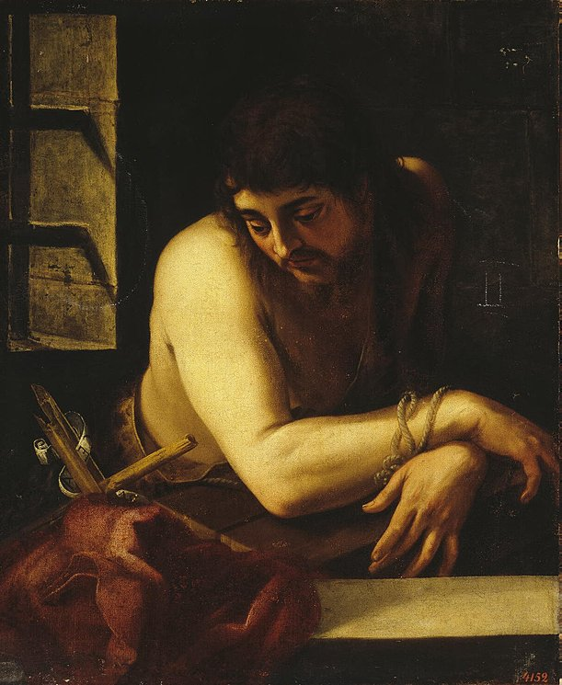
Insert Parish notices here.
St John the Baptist in Prison, Juan Fernández de Navarrette, 1565-70, Oil on canvas, 80 x 72 cm
The Hermitage, St. Petersburg, Russia.
Page 4
Sunday Bulletin
Page 1

Communion Antiphon ‡ cf. Isaiah 35:4
Say to the faint of heart: Be strong and do not fear. Behold, our God will come, and he will save us.
.



(continued)
It seems to me that John’s imprisonment was putting his faith to the test. It is true that John had encountered and experienced Jesus in happier times, when he was preaching at the Jordan and all the crowds were coming to him. At that time, it seemed that the kingdom of heaven would appear at any time in power. But things had not worked out exactly that way. Why was John now imprisoned for speaking the truth? And if Jesus was the one who had been anointed to “preach good news to the poor … to proclaim liberty to captives, and the opening of prison to those who are bound,” could he uses some of that liberating power to get John released?
Even great saints can go through a dark night and experience trials of faith. Such is not incompatible with holiness. As John suffers in the physical and spiritual darkness of Herod’s dungeon, he reaches out to Jesus for consolation: “Are you the one who is to come? Don’t you know I’m imprisoned? For speaking up for marriage!?”
Jesus sends back a message of consolation to John: “Go tell him that the signs of the Messianic age according to Isaiah 35 and 61 are being fulfilled visibly in your sight. John will understand the implications. Blessed is the one who is not offended that my way of bringing in the kingdom of God is other than they had expected.”
Isaiah’s prophecies about the blind, lame, deaf, etc. were, as we saw, actually speaking about spiritual realities. But condescending to our weak nature, that needs tangible, visible signs (Jn 4:48), Jesus literally enacts prophecies that were intended in a spiritual sense. If the primary problems with humanity were physical handicaps, Jesus would have founded a hospital, to heal people’s bodies. But instead he founded a Church, to heal people’s souls. That Church has gone on to found hospitals, too, because she realizes with Jesus that we need tangible signs of God’s love. But the physical healing should point us toward a deeper healing, otherwise it is only temporary and ultimately meaningless.

Entrance Antiphon ‡ Phil 4:4-5
Rejoice in the Lord always; again I say, rejoice. Indeed, the Lord is near.



First Reading ‡ Isaiah 35:1-6, 10.
God himself will come and save us.
Let the wilderness and the dry-lands exult,
let the wasteland rejoice and bloom,
let it bring forth flowers like the jonquil,
let it rejoice and sing for joy.
The glory of Lebanon is bestowed on it,
the splendour of Carmel and Sharon;
they shall see the glory of the Lord,
the splendour of our God.
Strengthen all weary hands,

The Word of the Lord.
Thanks be to God.
Gospel Acclamation ‡ Isaiah 61:1
Alleluia, alleluia!
The Spirit of the Lord is upon me;
he sent me to bring Good News to the poor.
Alleluia!
Gospel ‡ Matthew 11:2-11
Are you the one who is to come, or must we wait for someone else?
John in his prison had heard what Christ was doing and he sent his disciples to ask him, ‘Are you the one who is to come, or have we got to wait for someone else?’ Jesus answered, ‘Go back and tell John what you hear and see; the blind see again, and the lame walk, lepers are cleansed, and the deaf hear, and the dead are raised to life and the Good News is proclaimed to the poor; and happy is the man who does not lose faith in me.’
As the messengers were leaving, Jesus began to talk to the people about John: ‘What did you go out into the wilderness to see? A reed swaying in the breeze? No? Then what did you go out to see? A man wearing fine clothes? Oh no, those who wear fine clothes are to be found in palaces. Then what did you go out for? To see a prophet? Yes, I tell you, and much more than a prophet: he is the one of whom scripture says: Look, I am going to send my messenger before you; he will prepare your way before you. I tell you solemnly, of all the children born of women, a greater than John the Baptist has never been seen; yet the least in the kingdom of heaven is greater than he is.’
The Gospel of the Lord.
Praise to you, Lord Jesus Christ!

steady all trembling knees and say to all faint hearts,
‘Courage! Do not be afraid.
‘Look your God is coming,
vengeance is coming,
the retribution of God;
he is coming to save you.’
Then the eyes of the blind shall be opened,
the ears of the deaf unsealed,
then the lame shall leap like a deer
and the tongues of the dumb sing for joy,
for those the Lord has ransomed shall return.
They will come to Zion shouting for joy,
everlasting joy on their faces;
joy and gladness will go with them
and sorrow and lament be ended.
The Word of the Lord.
Thanks be to God.

Responsorial Psalm ‡ Psalm 145:6-10

R. Lord, come and save us.

It is the Lord who keeps faith for ever,
who is just to those who are oppressed.
It is he who gives bread to the hungry,
the Lord, who sets prisoners free. R.

It is the Lord who gives sight to the blind,
who raises up those who are bowed down,
the Lord, who protects the stranger
and upholds the widow and orphan. R.

It is the Lord who loves the just
but thwarts the path of the wicked.
The Lord will reign for ever,
Zion’s God, from age to age. R.

Second Reading ‡ James 5:7-10
You also must be patient; do not lose heart, the Lord’s coming will be soon.
Be patient, brothers, until the Lord’s coming. Think of a farmer: how patiently he waits for the precious fruit of the ground until it has had the autumn rains and the spring rains! You too have to be patient; do not lose heart, because the Lord’s coming will be soon. Do not make complaints against one another, brothers, so as not to be brought to judgement yourselves; the Judge is already to be seen waiting at the gates. For your example, brothers, in submitting with patience, take the prophets who spoke in the name of the Lord.

Page 2
Page 3

Reflection by Dr John Bergsma at http://www.thesacredpage.com/2016/12/waiting-while-everything-goes-wrong-3rd.html
I always take consolation from the example of saints who faced death in the middle of a historical situation that offered little in the way of hope. Three in particular come to mind: St. Augustine died with the Arian Goths surrounding Hippo in what looked like the end for Western Christian civilization. St. Thomas More was executed at a time when it looked like all was lost for the Church in England. St. Maximillian Kolbe was killed when it looked like German Fascism was going to triumph over Christianity in Europe. All these men kept their faith in a moment when faith seemed impossible.
It’s hard to wait for salvation, especially when everything around you seems to be getting worse, not better. That was the case for two figures that we encounter in this Sunday’s readings: Isaiah and John the Baptist. Together, these two prophets teach us how to wait with faith and courage, even when the winds of history seem to be thrashing us and threatening to collapse everything around our ears.
(continued overleaf)

