34th Sunday Our Lord Jesus Christ, King of the Universe Year C
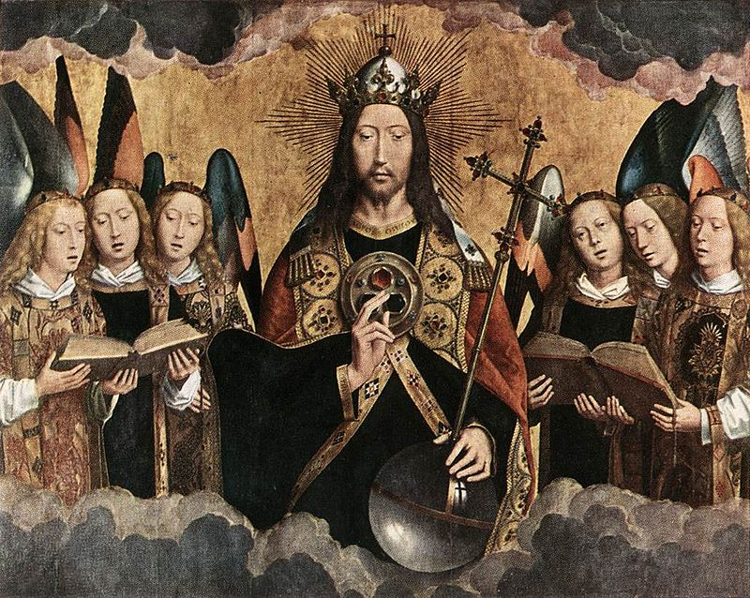
Insert Parish notices here.
Page 4
Sunday Bulletin
Page 1

Communion Antiphon ‡ Ps 29 (28): 10-11
The Lord sits as King for ever. The Lord will bless his people with peace.

(continued) relationship exists between the two parties. Adam is declaring Eve to be his family. In other words, he is taking her as his wife at the end of Genesis 2. That is why the text immediately goes on to discuss the practice of marriage in human society thereafter.
Based on the echo of Genesis 2 in 2 Samuel 5, we can say that there is a nuptial aspect to the covenant that is formed between David and the people of Israel. The people of Israel present themselves as David’s “bone and flesh”, that is, as Eve to his Adam, as Bride to his Groom. Notice that they do not “claim” David as their bone and flesh, but “offer” themselves as his bone and flesh. Thus, they adopt the bridal role, desiring to be claimed by David as their bridegroom-king. This introduces a subtle nuptial dynamic in the relationship between David and the people of Israel that will continue through Scripture (cf. 2 Sam 17:3), influencing the reading of the Song of Songs, and culminating with the frequent bridegroom images that are applied to Jesus Christ, the successor of David, in the Gospels, the Book of Revelation, and other parts of the New Testament.
We should also note that the people of Israel make a covenant with David that he should be their king. This is the only kingdom in the Bible or in the ancient Near East (at least of which we are aware) that was formed on the basis of a covenant. This is not an inconsequential fact! This reality of a kingdom established on the basis of a covenant resonates through Scripture, and finds expression during the drama of the Last Supper, where Jesus says to the apostles:
Luke 22:²⁸ “You are those who have continued with me in my trials; ²⁹and I covenant(Gk: diatithemi) to you, as my Father covenanted (Gk: diatithemi) to me, a kingdom, ³⁰that you may eat and drink at my table in my kingdom, and sit on thrones judging the twelve tribes of Israel.
In the Septuagint and the New Testament, the Greek verb diatithemi typically means “to make a covenant.” Most English translations of Luke 22, however, do not so render it in v. 29, probably because translators cannot make sense of the idea of “covenanting a kingdom.” However, in light of the reality of the Davidic Kingdom, which was established on the basis of a covenant, the passage becomes intelligible: Jesus is establishing on the shoulders of the Apostles the Kingdom of David, which is also the Kingdom of God, because the two have become united in the person of Christ, Son of David and Son of God.


Christ surrounded by Musician Angels, Hans Memling (c.1480), Royal Museum of Fine Arts, Antwerp, Belgium.

Entrance Antiphon ‡ Rev. 5:12, 1:6
How worthy is the Lamb who was slain, to receive power and divinity, and wisdom and strength and honour. To him belong glory and power for ever and ever.

First Reading ‡ 2 Samuel 5:1-3
They anointed David King of Israel.

All the tribes of Israel came to David at Hebron. ‘Look’ they said ‘we are your own flesh and blood. In days past when Saul was our king, it was you who led Israel in all their exploits; and the Lord said to you, “You are the man who shall be shepherd of my people Israel, you shall be the leader of Israel.”’ So all the elders of Israel came to the king at Hebron, and King David made a pact with them at Hebron in the presence of the Lord, and they anointed David king of Israel.
The Word of the Lord.
Thanks be to God.

Gospel Acclamation ‡ Mark 11: 9, 10
Alleluia, alleluia!
Blessed is he who inherits the kingdom of David our Father;
blessed is he who comes in the name of the Lord.
Alleluia!
Gospel ‡ Luke 23:35-43
Lord, remember me when you come into your kingdom.
The people stayed before the cross watching Jesus. As for the leaders, they jeered at him. ‘He saved others,’ they said ‘let him save himself if he is the Christ of God, the Chosen One.’ The soldiers mocked him too, and when they approached to offer him vinegar they said, ‘If you are the king of the Jews, save yourself.’ Above him there was an inscription: ‘This is the King of the Jews.’
One of the criminals hanging there abused him. ‘Are you not the Christ?’ he said. ‘Save yourself and us as well.’ But the other spoke up and rebuked him. ‘Have you no fear of God at all?’ he said, ‘You got the same sentence as he did, but in our case we deserved it: we are paying for what we did. But this man has done nothing wrong. Jesus,’ he said ‘remember me when you come into your kingdom.’ ‘Indeed, I promise you,’ he replied ‘today you will be with me in paradise.’

The Gospel of the Lord.
Praise to you, Lord Jesus Christ!
Responsorial Psalm ‡ Psalm 121:1-5
R. Let us go rejoicing to the house of the Lord.

I rejoiced when I heard them say:
‘Let us go to God’s house.’
And now our feet are standing
within your gates, O Jerusalem. R.

Jerusalem is built as a city
strongly compact.
It is there that the tribes go up,
the tribes of the Lord. R.

For Israel’s law it is,
there to praise the Lord’s name.
There were set the thrones of judgment
of the house of David. R.

Second Reading ‡ Colossians 1:12-20
He has taken us into the kingdom of his beloved Son.
We give thanks to the Father who has made it possible for you to join the saints and with them to inherit the light.
Because that is what he has done: he has taken us out of the power of darkness and created a place for us in the kingdom of the Son that he loves, and in him, we gain our freedom, the forgiveness of our sins.
He is the image of the unseen God
and the first-born of all creation;
for in him were created
all things in heaven and on earth:
everything visible and everything invisible,
Thrones, Dominions, Sovereignties, Powers —
all things were created through him and for him.
Before anything was created, he existed,
and he holds all things in unity.
Now the Church is his body,
he is its head.
As he is the Beginning,
he was first to be born from the dead,
so that he should be first in every way;
because God wanted all perfection to be found in him
and all things to be reconciled through him and for him,
everything in heaven and everything on earth,
when he made peace by his death on the cross.

The Word of the Lord.
Thanks be to God.

Page 2
Page 3

Commentary by Dr John Bergsma on today’s readings http://www.thesacredpage.com/2016/11/vote-for-monarchy-solemnity-of-christ.html#more
The Readings focus heavily on the theme of the kingdom of Christ, which was typified or foreshadowed by the Kingdom of David in the Old Testament.
The first reading is 2 Samuel 5:1-3.
Here is recorded one of the pivotal points in the history of salvation, indeed, a pivotal point in the history of human civilization. David had been Saul’s son-in-law and commander of the army. Upon Saul’s death, David was made king of the sprawling southern tribe of Judah, but the northern tribes remained loyal to Saul’s son Ish-ba’al (a.k.a. Ishbosheth). Ish-ba’al was assassinated by his own men, however, making David the last viable successor to Saul. The northern ten tribes then came to David and make him their king.
We want to observe several features of this text and the historical events it narrates. First we note the phrase the Israelites use to approach David: “Here we are, your bone and flesh.” Literally: “Look here! Your bone and your flesh we are.”
These words recall the statement of Adam to Eve in Genesis 2: “Bone of my bone and flesh of my flesh, she shall be called woman, because she was taken out of man.”
The parallel is not accidental, nor is it without significance. Many scholars agree that the phrase “Bone of my bone and flesh of my flesh” (or variants thereof) was a performative utterance used in covenant making rituals. It was not so much a recognition of a physical relationship as a declaration that from now on a kinship

