1st Sunday Advent Year A
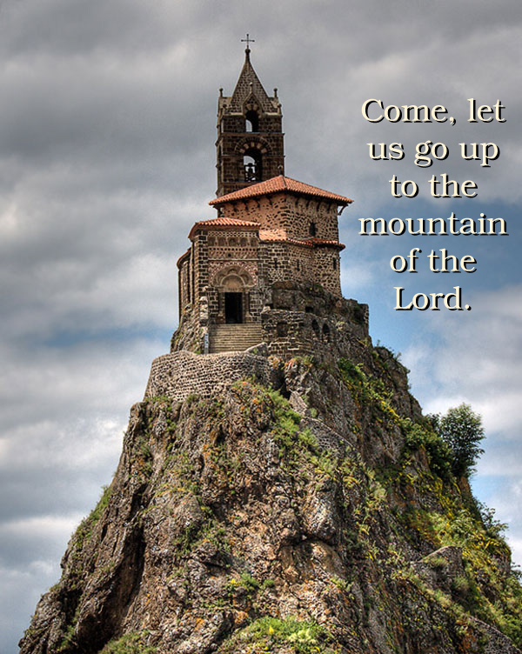
Insert Parish notices here.
Chapelle Saint Michel d’Aiguilhe, (Chapel of St Michael of the Needle), Le Puy-en-Velay, Auvergne, France

Page 4
Sunday Bulletin
Page 1

Communion Antiphon ‡ Ps 85 (84): 13
The Lord will bestow his bounty, and our earth shall yield its increase.
.

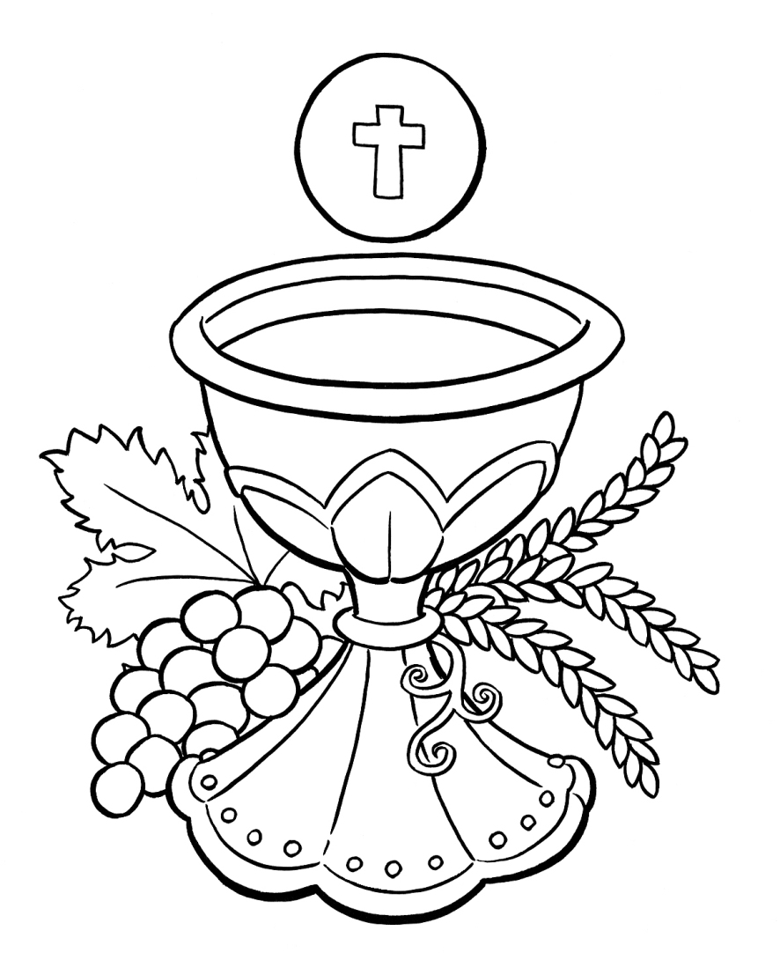

(continued)
Has the prophet’s word been fulfilled, or do we still await a fulfilment?
It is essential to recognize that Jesus celebrated the Last Supper and instituted the Eucharistic sacrifice and covenant at Mt. Zion in the year of his death. Every time we celebrate Mass, we are taken sacramentally into the Upper Room on Mt. Zion, in order to renew there our covenant with the LORD, who has shown his face to us in the man Jesus of Nazareth, the “Word of the LORD” of whom Isaiah speaks in our Reading.
Thus, the Mass makes Mt. Zion present. As people from all nations stream to Mass this weekend, there is a fulfilment of Isaiah’s words, that “many peoples shall come and say: Come, let us climb the LORD’s mountain!” The Church is the New Zion, as the Book of Hebrews makes clear (Heb 12:22-24).
The way God has fulfilled Isaiah’s prophecy through the Church is a superior fulfilment than if a literal, physical shrine had been established in Jerusalem where everyone had to go to learn the Ten Commandments. A physical fulfillment of the prophet’s words would have limited our interaction with God to those times when we were able to afford plane fare to Israel, but by making Zion sacramentally present to every place on the planet—“from the rising of the sun even to its setting, they bring a pure offering to my name” (Mal 1:11)—God has facilitated the education of the nations in the Law of God. Zion is as close as the local parish. And for those who may feel discouraged because it seems like many nations that once streamed to the LORD have now turned aside to follow a secular mindset—let us take heart! The secular worldview of modernity is so literally sterile that its adherents cannot muster the joy and courage to raise enough children to replace themselves. The culture of death is quickly killing itself. In the meantime, let us take every opportunity to lay new foundations for Zion, for the time will come when the winds will change.
Read more here: http://www.thesacredpage.com/2013/11/happy-new-year-1st-sunday-of-advent.html#more.

Entrance Antiphon ‡ Ps 25(24):1-3
To you, I lift up my soul, O my God. In you, I have trusted; let me not be put to shame. Nor let my enemies exult over me; and let none who hope in you be put to shame.



First Reading ‡ Isaiah 2:1-5
The Lord will gather all nations in eternal peace in the kingdom of God.
The vision of Isaiah son of Amoz, concerning Judah and Jerusalem.
In the days to come the mountain of the Temple of the Lord shall tower above the mountains and be lifted higher than the hills.
All the nations will stream to it,
peoples without number will come to it; and they will say:
‘Come, let us go up to the mountain of the Lord,
to the Temple of the God of Jacob
that he may teach us his ways
so that we may walk in his paths;

The Word of the Lord.
Thanks be to God.

Gospel Acclamation ‡ Psalm 84:8
Alleluia, alleluia!
Lord, show us your mercy and love,
and grant us your salvation.
Alleluia!
Gospel ‡ Matthew 24:37-44
Stay awake, you must be ready.
Jesus said to his disciples: ‘As it was in Noah’s day, so will it be when the Son of Man comes. For in those days before the Flood people were eating, drinking, taking wives, taking husbands, right up to the day Noah went into the ark, and they suspected nothing till the Flood came and swept all away. It will be like this when the Son of Man comes. Then of two men in the fields one is taken, one left; of two women at the millstone grinding, one is taken, one left.
‘So stay awake, because you do not know the day when your master is coming. You may be quite sure of this that if the householder had known at what time of the night the burglar would come, he would have stayed awake and would not have allowed anyone to break through the wall of his house. Therefore, you too must stand ready because the Son of Man is coming at an hour you do not expect.’

The Gospel of the Lord.
Praise to you, Lord Jesus Christ!
since the Law will go out from Zion,
and the oracle of the Lord from Jerusalem.’
He will wield authority over the nations
and adjudicate between many peoples;
these will hammer their swords into ploughshares,
their spears into sickles.
Nation will not lift sword against nation,
there will be no more training for war
O House of Jacob, come,
let us walk in the light of the Lord.
The Word of the Lord.
Thanks be to God.

Responsorial Psalm ‡ Psalm 121:1-2, 4-5, 6-9.
R. Let us go rejoicing to the house of the Lord.

I rejoiced when I heard them say:
‘Let us go to God’s house.’
And now our feet are standing
within your gates, O Jerusalem. R.

It is there that the tribes go up,
the tribes of the Lord. For Israel’s law it is,
there to praise the Lord’s name.
There were set the thrones of judgement
of the house of David. R.

For the peace of Jerusalem pray:
‘Peace be to your homes!
May peace reign in your walls,
in your palaces, peace!’ R.

For love of my brethren and friends I say:
‘Peace upon you!’
For love of the house of the Lord
I will ask for your good. R.

Second Reading ‡ Romans 13:11-14
The time has come, our salvation is near.
You know ‘the time’ has come: you must wake up now: our salvation is even nearer than it was when we were converted. The night is almost over, it will be daylight soon — let us give up all the things we prefer to do under cover of the dark; let us arm ourselves and appear in the light. Let us live decently as people do in the daytime: no drunken orgies, no promiscuity or licentiousness, and no wrangling or jealousy. Let your armour be the Lord Jesus Christ.

Page 2
Page 3

Commentary by Dr John Bergsma on today’s readings http://www.thesacredpage.com/2013/11/happy-new-year-1st-sunday-of-advent.html#more
Isaiah 2 occurs near the beginning of the Book of Isaiah, and in many ways summarizes the prophet’s hopes for the restoration of Jerusalem in the coming age. For much of the period when Isaiah was writing in the 700’s BC, northern Israel was near to being annihilated, or already had been (c. 722 BC), and southern Judah had been reduced by the Assyrians to a rump state consisting of the area around the capital, Jerusalem. In Judah itself, sincere worshipers of the LORD (YHWH) were few in number, and the culture was dominated by hypocritical or “cultural” Yahwism and/or syncretism with paganism. It was a very discouraging period for those wholly devoted to the the LORD, God of Israel, who found themselves outnumbered, powerless, and culturally impotent in the face of forces that seemed ready to extinguish any witness to the true God from the face of the earth.
Nonetheless, in this time period, Isaiah sees a vision of hope: against all odds, the day will come when the nations of the earth will seek out the LORD and come to Mt. Zion to learn his law, and the Word of the LORD will judge nations and bring them peace.
(Continued next page.)

