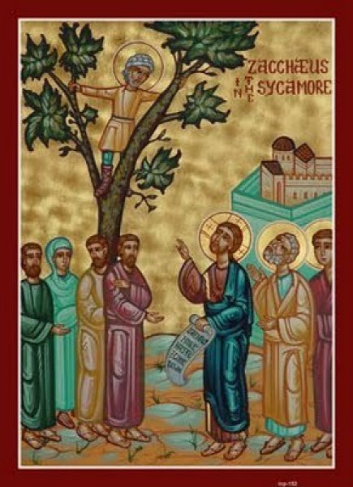
MASS TIMES (insert your Parish notices here)

Year C
31st Sunday in Ordinary Time
Page 4
Sunday Bulletin
Zacchaeus in the Sycamore, Icon.



Communion Antiphon ‡ Psalm 16 (15): 11
You will show me the path of life, the fullness of joy in your presence, O Lord.

Commentary (continued).
that remains in Zacchaeus despite the evil that he has done. And his visit with Zacchaeus leads to repentance, and not just repentance but reparation.
It is key that Zacchaeus vows to make good his wrongs.
Years ago God gave me the grace to experience a serious wrong at the hands of a Christian, who at a later time pontificated to me at some length about the wonders of the forgiveness of Jesus for those who have faith—a forgiveness that he obviously thought I had never experienced because I was a Catholic who believed in earning my salvation through works.
I say it was a grace to go through that experience, because it opened my eyes to just how grating on the nerves it is to listen to Christians (Catholic, Protestant, or otherwise) speak of the forgiveness of God when you are a person who has been wronged by them. It is not hard at all to imagine why such an experience could alienate a person permanently from the Christian faith: it makes it seem as though Christians appeal to the forgiveness of God through Jesus Christ as an easy way to avoid actually having to apologize and make right the offenses they have committed against others. Jesus eases their conscience while they refuse to confront their own wrongdoing.
We have to exercise care: if we are going to speak to others of the forgiveness of God, let us first do what Zachaeus did, and ensure that we have made all things right with those we have wronged. This is what we call making reparation. Reparation is the demonstration that our repentance is real. Until we make reparation, our religiosity is hollow talk. On the other hand, reparation touches hearts. Apologies and concrete acts—including money and goods, where appropriate—toward those who have been wronged can often soften hearts and break down barriers that otherwise seemed permanent.

Entrance Antiphon ‡ Ps 38 (37): 22-23
Forsake me not, O Lord, my God; be not far from me! Make haste and come to my help, O Lord, my strong salvation!

First Reading ‡ Wisdom 11:22 – 12:2
You have mercy on all things because you love everything that exists.
In your sight, Lord, the whole world is like
a grain of dust that tips the scales,
like a drop of morning dew falling on the ground.
Yet you are merciful to all,
because you can do all things
and overlook men’s sins so that they can repent.
Yes, you love all that exists,
you hold nothing of what you have made in abhorrence,
for had you hated anything,
you would not have formed it.

Day of the Lord has already arrived.
The word of the Lord.
Thanks be to God.
Gospel Acclamation ‡ John 3:16
Alleluia, alleluia!
God loved the world so much, he gave us his only Son,
that all who believe in him might have eternal life.
Alleluia!
Gospel ‡ Luke 19:1-10
The Son of Man came to seek and to find that which was lost.
Jesus entered Jericho and was going through the town when a man whose name was Zacchaeus made his appearance; he was one of the senior tax collectors and a wealthy man. He was anxious to see what kind of man Jesus was, but he was too short and could not see him for the crowd; so he ran ahead and climbed a sycamore tree to catch a glimpse of Jesus who was to pass that way. When Jesus reached the spot he looked up and spoke to him: ‘Zacchaeus, come down. Hurry, because I must stay at your house today.’ And he hurried down and welcomed him joyfully. They all complained when they saw what was happening. ‘He has gone to stay at a sinner’s house’ they said. But Zacchaeus stood his ground and said to the Lord, ‘Look, sir, I am going to give half my property to the poor’ and if I have cheated anybody I will pay him back four times the amount’ And Jesus said to him, ‘Today salvation has come to this house, because this man too is a son of Abraham; for the Son of Man has come to seek out and save what was lost.’
The Gospel of the Lord.
Praise to you, Lord Jesus Christ!
Page 3
And how, had you not willed it, could a thing persist,
how be conserved if not called forth by you?
You spare all things
because all things are yours, Lord, lover of life,
you whose imperishable spirit is in all.
Little by little, therefore, you correct those who offend,
you admonish and remind them of how they have sinned,
so that they may abstain from evil and trust in you, Lord.
The word of the Lord.
Thanks be to God.

Responsorial Psalm ‡ Psalm 144:1-2, 8-11, 13-14.
R. I will praise your name for ever, my king and my God.

I will give you glory, O God my King,
I will bless your name for ever.
I will bless you day after day
and praise your name for ever. R.

The Lord is kind and full of compassion,
slow to anger, abounding in love.
How good is the Lord to all,
compassionate to all his creatures. R.

All your creatures shall thank you, O Lord,
and your friends shall repeat their blessing.
They shall speak of the glory of your reign
and declare your might, O God. R.

The Lord is faithful in all his words
and loving in all hid deeds.
The Lord supports all who fall
and raises all who are bowed down. R.

Second Reading ‡ 2 Thessalonians 1:11-2:2
The name of our Lord Jesus Christ will be glorified in you and you in him.
We pray continually that our God will make you worthy of his call, and by his power fulfil all your desires for goodness and complete all that you have been doing through faith; because in this way the name of our Lord Jesus Christ will be glorified in you and you in him, by the grace of our God and the Lord Jesus Christ.
To turn now, brothers, to the coming of our Lord Jesus Christ and how we shall all be gathered round him: please do not get excited too soon or alarmed by any prediction or rumour or any letter claiming to come from us, implying that the
Page 2

Commentary on the Gospel by John Bergsma, extract from http://www.thesacredpage.com/2016/10/making-things-right-31st-sunday-of-ot.html#more.
Zacchaeus tends to be sentimentalized in contemporary Christianity, probably because of Sunday school songs and flannelgraphs where he looks short, cute, and appealing. But Zacchaeus should not be sentimentalized. He was a wealthy tax collector, a social oppressor and collaborator with an oppressive and dictatorial foreign government. How do we feel about drug dealers riding by in black Lexuses and pulling out rolls of $50 bills? How do we feel about former Enron executives now comfortably retired in Aspen? How do we feel about shady political compaign operatives taking millions in donations from foreign governments while manipulating a domestic election? The emotions would be similar for the Jews with respect to Zacchaeus. We can understand why they were frustrated and put off by the fact that Jesus chose to have dinner with him rather than anyone else in town. Why not have dinner with the some of the righteous poor that had been victims of Zacchaeus’ extortion?
Jesus sees things through a broader frame of reference. He sees the created goodness
(Continued next page.)

