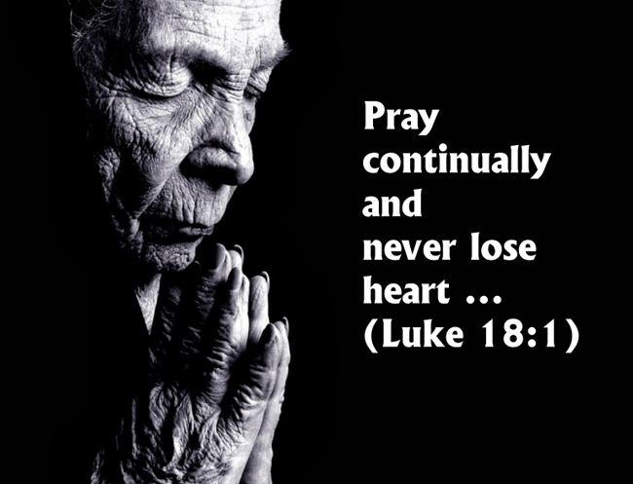
MASS TIMES (insert your Parish notices here)

Year C
29th Sunday in Ordinary Time
Page 4
Sunday Bulletin

Communion Antiphon ‡ Psalm 33 (32): 18-19
Behold, the eyes of the Lord are on those who fear him, who hope in his merciful love, to rescue their souls from death, to keep them alive in famine.

Commentary (continued).
It is a situation of great peril that could end with the complete annihilation of the Israelite people in the middle of a desert wasteland. The young man Joshua goes out to lead those forces the Israelites could muster, while Moses goes to the mountaintop to beseech God in prayer. The moral sense of this text is a good example of the complementarity of prayer and action, of ora et labora. The people fight and pray: both are necessary, for the same reason that faith and works operate together. How curious that Moses’ prayers are necessary! Why doesn’t God just send victory without them? Surely he could! Yet this is the mystery of God’s will: that he chooses to incorporate our participation in the fulfilment of his plans (See Aquinas, Summa 2, 2, Q. 83, art. 2). He ordains to grant victory to Israel through Moses’ intercession. Prayer is a cooperation with God’s will for us. In the Old Testament, there were no “secular” wars. Every battle was both a physical and spiritual conflict, because the opposing armies always called on their respective gods. The conflict of nations was the conflict of their divinities, and the stronger divinities won. So in Exodus 17 as well: there is a spiritual battle going on here between the LORD God of Israel and the gods of the Amalakites, just as earlier in Exodus the LORD took on the gods of Egypt through the ten plagues, defeating the Nile god, the crop god, the livestock gods, the sun god, etc. In this spiritual conflict, prayer is vital—God chooses to use it as his means to victory. As a Church, we find ourselves very much in the position of the Israelites on their way to Sinai. We have left Egypt (=slavery to sin by crossing through the sea (=Baptism), but now that we are free people we find we have a fight on our hands. People are surprised sometimes to discover that the Christian life is a battle. They supposed, perhaps, that things would be easier after baptism, or after conversion. But you see, slaves don’t have to fight. (… read more at http://www.thesacredpage.com/2016/10/the-battle-of-prayer-29th-sunday-of-ot.html#more)

Entrance Antiphon ‡ Ps 17 (16):6, 8.
To you I call; for you will surely heed me, O God; turn your ear to me; hear my words. Guard me as the apple of your eye; in the shadow of your wings protect me.

First Reading ‡ Exodus 17:8-13
As long as Moses kept his arms raised, Israel had the advantage.
The Amalekites came and attacked Israel at Rephidim. Moses said to Joshua, ‘Pick out men for yourself, and tomorrow morning march out to engage Amalek. I, meanwhile will stand on the hilltop, the staff of God in my hand.’ Joshua did as Moses told him and marched out to engage Amalek, while Moses and Aaron and Hur went up to the top of the hill. As long as Moses kept his arms raised, Israel had the advantage; when he let his arms fall, the advantage went to Amalek. But Moses’ arms grew heavy, so they took a stone and put it under him and on this he sat, Aaron and Hur supporting his arms, one on one side, one on the other; and his arms remained firm until sunset. With the edge of the sword Joshua cut down Amalek and his people.

Gospel Acclamation ‡ Hebrews 4:12
Alleluia, alleluia!
The word of God is living and active;
it probes the thoughts and motives of our heart.
Alleluia!
Gospel ‡ Luke 18:1-8
God will see those who cry to him vindicated.
Jesus told his disciples a parable about the need to pray continually and never lose heart. ‘There was a judge in a certain town’ he said who had neither fear of God nor respect for man. In the same town there was a widow who kept coming to him and saying, “I want justice from you against my enemy!” For a long time he refused, but at last he said to himself “Maybe I have neither fear of God nor respect for man, but since she keeps pestering me I must give this widow her just rights, or she will persist in coming and worry me to death.”’
And the Lord said, ‘You notice what the unjust judge has to say? Now will not God see justice done to his chosen who cry to him day and night even when he delays to help them? I promise you, he will see justice done to them, and done speedily. But when the Son of Man comes, will he find any faith on earth?’
The Gospel of the Lord.
Praise to you, Lord Jesus Christ!
The word of the Lord.
Thanks be to God.

Responsorial Psalm ‡ Psam 120
R. Our help is from the Lord, who made heaven and earth.

I lift up my eyes to the mountains:
from where shall come my help?
My help shall come from the Lord
who made heaven and earth. R.

May he never allow you to stumble!
Let him sleep not, your guard.
No, he sleeps not nor slumbers,
Israel’s guard. R.

The Lord is your guard and your shade;
at your right side he stands.
By day the sun shall not smite you
nor the moon in the night. R.

The Lord will guard you from evil,
he will guard your soul.
The Lord will guard your going and coming
both now and for ever. R.

Second Reading ‡ 2 Timothy 3:14-4:2
This is how the people of God become equipped and ready for every good work.
You must keep to what you have been taught and know to be true; remember who your teachers were, and how, ever since you were a child, you have known the holy scriptures — from these you can learn the wisdom that leads to salvation through faith in Christ Jesus. All scripture is inspired by God and can profitably be used for teaching, for refuting error, for guiding people’s lives and teaching them to be holy. This is how the man who is dedicated to God becomes fully equipped and ready for any good work.
Before God and before Christ Jesus who is to be judge of the living and the dead, I put this duty to you, in the name of his Appearing and of his kingdom: proclaim the message and, welcome or unwelcome, insist on it. Refute falsehood, correct error, call to obedience — but do all with patience and with the intention of teaching.

The word of the Lord.
Thanks be to God.

Page 3
Page 2

Commentary on the Gospel by John Bergsma, extract from http://www.thesacredpage.com/2016/10/the-battle-of-prayer-29th-sunday-of-ot.html#more

Usually we think of men of prayer and men of war as complete opposites. A monk in a habit—such as St. Francis—is a man dedicated to peace, a total contrast to one clad in armour brandishing weapons. Yet the Readings for this Sunday combine the imagery of war and prayer in interesting ways that provoke our thoughts about the nature and reality of supplicating God.

After the Ten Plagues and the Passover, Israel has left Egypt a few weeks ago, crossed the Red Sea, and now entered into the Sinai Peninsula: a vast, rocky, mountainous desert. Amalek was a nation of nomads that controlled the northeastern part of the Sinai Peninsula and the southern part of the Negeb (the south Judean desert). The Amalekites were not happy to have the Israelites moving through the outskirts of their territory, and they sent bands of scouts to trail them. According to Deut 25:18, the Amalekite raiders killed off the weakest of the Israelites who lagged behind the main camp—the ill, the elderly, poor families with many children, etc. The Amalekites were an ancient expression of the culture of death. Now on their way to Mount Sinai, in Exodus 17 the Israelites are attacked outright by the bulk of the Amalekite forces, and they are forced to respond, despite the fact that they are not military men but former slaves, and have few if any proper weapons. (Continued next page.)

