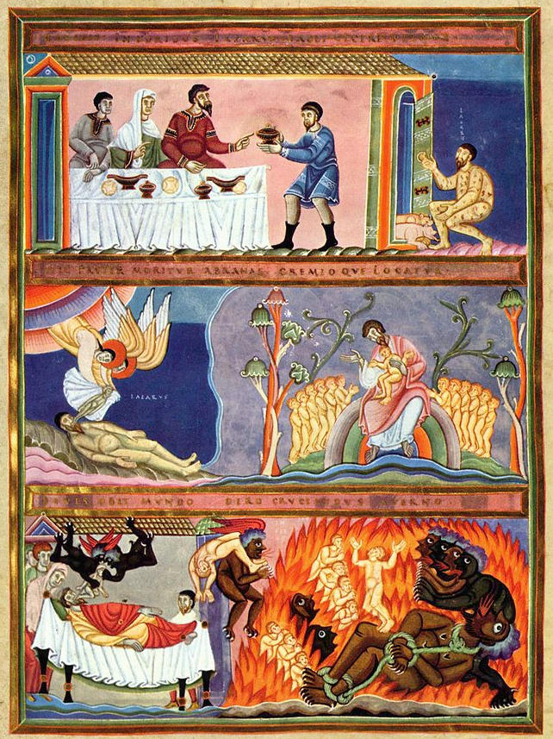
The Parable of the Rich Man and Lazarus, Illumination from the Codex Aureus of Echternach, 1035-1040, German National Museum, Nürnberg.
Top panel: Lazarus at the rich man's door
Middle panel: Lazarus' soul is carried to Paradise by two angels; Lazarus in Abraham's bosom
Bottom panel: Dives' soul is carried off by two devils to Hell; Dives is tortured in Hades.
MASS TIMES (insert your Parish notices here)

26th Sunday in Ordinary Time
Sunday Bulletin
Year C
Page 4

Communion Antiphon ‡ Psalm 119 (118): 49-50
Remember your word to your servant, O Lord, by which you have given me hope. This is my comfort when I am brought low.

Commentary (continued). community, or their own community of faith.
Jesus words were prophetic. As it turns out, the wealthy of Jerusalem are not persuaded by the resurrection of Lazarus (!) in the Gospel of John, just as they were not moved to repentance by the Scriptures. John records the aftermath of the resurrection of Lazarus:
John 11: 46 but some of [the Judeans] went to the Pharisees and told them what Jesus had done. 47 So the chief priests and the Pharisees gathered the council, and said, “What are we to do? For this man performs many signs. 48 If we let him go on thus, everyone will believe in him, and the Romans will come and destroy both our holy place and our nation.” …. 53 So from that day on they took counsel how to put him to death.
Sometimes we are tempted to think, “If only God would pour out manifestations of His power, then evangelism would be easier. We would convert the nation.” But Jesus teaches us to think more realistically about miracles. After three years of the most remarkable miracle ministry in the history of the human race, Jesus still found himself abandoned by even his closest followers at the time of his greatest need. Even after his resurrection, the officials to whom that miracle was reported paid the guards to suppress the news (Matt 28:11-15)!
Miracles gather crowds, but they only occasionally lead to the conversion of heart that Jesus seeks. Those that are hardened by greed, lust, or other passions can always find a way to explain a miracle away, and even if they can’t, they will simply ignore it or regard it as an inexplicable fluke. There have been public miracles in modern times witnessed by thousands (like the apparitions in Zeitoun, Egypt) that still haven’t led to mass conversion.
So what do the Readings say to us this Lord’s Day? Firstly, to repent of any self-indulgence in our own lifestyle, and any lack of generosity toward the poor, especially those closest to us. Secondly, to start paying heed to the Scriptures today by turning to God in conversion, rather than waiting for some sign, some apparition, some “act of God” to wake us up.

Entrance Antiphon ‡ Dn 3:31, 29, 30, 43, 42.
O Lord, you had just cause to judge men as you did: because we sinned against you and disobeyed your will. But now show us your greatness of heart, and treat us with your unbounded kindness.

First Reading ‡ Amos 6:1, 4-7.
You who give yourself to licentiousness and revelry will be exiled.
The almighty Lord says this:
Woe to those ensconced so snugly in Zion
and to those who feel so safe on the mountain of Samaria.
Lying on ivory beds
and sprawling on their divans,
they dine on lambs from the flock,
and stall-fattened veal;
they bawl to the sound of the harp,

The word of the Lord.
Thanks be to God.

Gospel Acclamation ‡ 2 Corinthians 8:9
Alleluia, alleluia!
Jesus Christ was rich but he became poor,
to make you rich out of his poverty.
Alleluia!
Gospel ‡ Luke 16:19-31
During your life good things came your way just as bad things came the way of Lazarus. Now he is being comforted while you are in agony.
Jesus said to the Pharisees: ‘There was a rich man who used to dress in purple and fine linen and feast magnificently every day. And at his gate there lay a poor man called Lazarus, covered with sores, who longed to fill himself with the scraps that fell from the rich man’s table. Dogs even came and licked his sores. Now the poor man died and was carried away by the angels to the bosom of Abraham. The rich man also died and was buried.
‘In his torment in Hades he looked up and saw Abraham a long way off with Lazarus in his bosom. So he cried out, “Father Abraham, pity me and send Lazarus to dip the tip of his finger in water and cool my tongue, for I am in agony in these flames.” “My son,” Abraham replied “remember that during your life good things came your way, just as bad things came the way of Lazarus. Now he is being comforted here while you are in agony. But that is not all: between us and you a great gulf has been fixed, to stop anyone, if he wanted to, crossing from our side to yours, and to stop any crossing from your side to ours.”
‘The rich man replied, “Father, I beg you then to send Lazarus to my father’s house, since I have five brothers, to give them warning so that they do not come to this place of torment too.” “They have Moses and the prophets,” said Abraham, “let them listen to them.” “Ah, no, father Abraham,” said the rich man “but if someone comes to them from the dead, they will repent.” Then Abraham said to him, “If they will not listen either to Moses or to the prophets, they will not be convinced even if someone should rise from the dead.”’
The Gospel of the Lord.
Praise to you, Lord Jesus Christ!
they invent new instruments of music like David,
they drink wine by the bowlful,
and use the finest oil for anointing themselves,
but about the ruin of Joseph they do not care at all.
That is why they will be the first to be exiled;
the sprawlers’ revelry is over.
The word of the Lord.
Thanks be to God.

Responsorial Psalm ‡ Psalm 145:6-10 R. v.2
R. Praise the Lord my soul!

It is the Lord who keeps faith for ever,
who is just to those who are oppressed.
It is he who gives bread to the hungry,
the Lord, who sets prisoners free. R.

It is the Lord who gives sight to the blind,
who raises up those who are bowed down,
It is the Lord who loves the just,
the Lord, who protects the stranger. R.

He upholds the widow and orphan.
but thwarts the path of the wicked.
The Lord will reign for ever,
Zion’s God, from age to age. R.

Second Reading ‡ 1 Timothy 6:11-16
Obey the commandments until the coming of the Lord.
As a man dedicated to God, you must aim to be saintly and religious, filled with faith and love, patient and gentle. Fight the good fight of the faith and win for yourself the eternal life to which you were called when you made your profession and spoke up for the truth in front of many witnesses. Now, before God the source of all life and before Jesus Christ, who spoke up as a witness for the truth in front of Pontius Pilate, I put to you the duty of doing all that you have been told, with no faults or failures, until the Appearing of our Lord Jesus Christ,
who at the due time will be revealed
by God, the blessed and only Ruler of all,
the King of kings and the Lord of lords,
who alone is immortal,
whose home is in inaccessible light,
whom no man has seen and no man is able to see:
to him be honour and everlasting power. Amen.
Page 3
Page 2

Commentary on the Gospel by John Bergsma, extract from http://www.thesacredpage.com/2016/09/does-it-matter-how-we-treat-others-26th.html#more
The Rich Man is receiving punishment in the afterlife because of his sins, and the parable implies that his primary sin was his utter disregard for the welfare of a fellow Israelite, Lazarus, who begged at the door of his house in utter squalor, lacking even basic necessities. In this attitude he parallels the wealthy elite of Jerusalem from the First Reading, who were not in the least distressed by the decimation of their cousins to the north. Jesus is condemning the callousness of those who live lives of self-indulgence while ignoring the needs of the poor, especially the poor of their own

