20th Sunday in Ordinary Time
MASS TIMES
Weekend Masses: YANCHEP: 6 p.m. Saturday Vigil, Yanchep Community Centre,
7 Lagoon Drive. GUILDERTON: 8 a.m. Sunday, Guilderton Community Hall, Wedge Street. LANCELIN: 9.45 a.m. Sunday, CWC Community Hall, 63 Gingin Road.
Confessions: before Mass on request
Weekday Masses: Tuesday, Thursday, Friday 9 a.m. at the presbytery,
Wednesdays 3 p.m. at Bethanie Beachside Aged Care.
Priest: Fr Augustine Puthota, Presbytery: 3 Blaxland Avenue, Two Rocks, Western Australia 6037. Telephone: +61-8-9561 2172 Website: http://yanchepcatholic.org/ Email: yanchep@perthcatholic.org.au.
Please like us on Facebook: https://www.facebook.com/yanchepcatholicchurch

Sunday Bulletin
Year C
Page 4
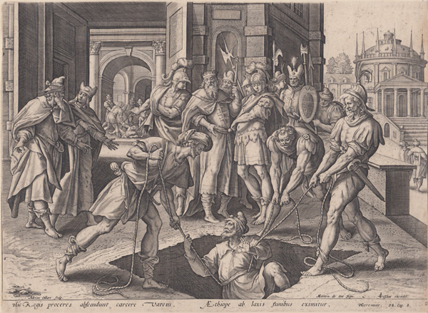

We pray for the sick of our community, especially:
Pat Murphy, Ken and Toni Meek, Michael Ford, Jim Walsh, Paula Cope, Pat Barone, Josephine del Bene, Margaret Johnson, Ann Mazzella, Jeanette Heaton and Stou Peggy.

Our deepest sympathies to Christina and Peter Even on the loss of their daughter Ruth Anne-Mary Even. Condolences also to Elvira, John, Ingrid, Ben, Maree and Gloria and their families.
Revelation 21:4 “He will wipe away every tear from their eyes, and death shall be no more, neither shall there be mourning, nor crying, nor pain anymore, for the former things have passed away.”

Communion Antiphon ‡ Psalm 130 (129): 7.
With the Lord there is mercy; in him is plentiful redemption.

(contined) “My mother and my brothers are those who hear the word of God and do it.” (Luke 8:21)
In hindsight, we realize that salvation history is full of familial conflict that has its origins in differing relationships to God. Cain envied Abel’s intimacy with God, and slew him. Jacob wanted the promises of the covenant whereas Esau despised them. Joseph’s brothers sought to kill him out of offense at his prophetic dreams. Moses’ own brother and sister tried to remove him from leadership over Israel out of envy of his prophetic status. And many other examples could be cited, including Jeremiah as discussed above (Jer 12:6).
This Sunday’s Gospel reminds us that, as good as peace is, Jesus’ primary mission was not to establish social peace in this world and in this life. If that had been his mission—and many think it was!—he obviously has failed. Instead, Jesus’ mission was to reveal, to those who desire it, the “narrow way” that leads to salvation (Matt 7:13-14), the Way that is Himself (John 14:6). There is a price too high to pay for peace. And that price is infidelity to Christ. So while it is good and proper to work for legislation and social support for marriage and the family, and to love our family members and build “cheerful Christian homes,” as St. Josemaría described it; nonetheless, we also need to be prepared to endure the strife and conflict that may ensue when we follow the path of truth to its destination, which is a Person.

Jeremiah drawn out from the dungeon, Adriaen Collaert after Maarten de Vos, c.1606, copper engraving, C.J. Visscher excudit.

Entrance Antiphon ‡ Psalm 84 (83): 10-11.
Turn your eyes, O God, our shield; and look on the face of your anointed one; one day within your courts is better than a thousand elsewhere.

First Reading ‡ Jeremiah 38: 4-6, 8-10
You bore me to be a man of strife for the whole world.
The king’s leading men spoke to the king. ‘Let Jeremiah be put to death: he is unquestionably disheartening the remaining soldiers in the city, and all the people too, by talking like this. The fellow does not have the welfare of this people at heart so much as its ruin.’ ‘He is in your hands as you know,’ King Zedekiah answered ‘for the king is powerless against you.’ So they took Jeremiah and threw him into the well of Prince

The word of the Lord.
Thanks be to God.

Gospel Acclamation ‡ John 10:27
Alleluia, alleluia!
My sheep listen to my voice, says the Lord;
I know them, and they follow me.
Alleluia!
Gospel ‡ Luke 12:49-53.
I have come not to give peace, but discord.
Jesus said to his disciples: ‘I have come to bring fire to the earth, and how I wish it were blazing already! There is a baptism I must still receive, and how great is my distress till it is over!
‘Do you suppose that I am here to bring peace on earth? No, I tell you, but rather division. For from now on a household of five will be divided: three against two and two against three; the father divided against the son, son against father, mother against daughter, daughter against mother, mother-in-law against daughter-in-law, daughter-in-law against mother-in-law.’
The Gospel of the Lord.
Praise to you, Lord Jesus Christ!

Malchiah in the Court of the Guard, letting him down with ropes. There was no water in the well, only mud, and into the mud Jeremiah sank.
Ebed-melech came out from the palace and spoke to the king. ‘My lord king,’ he said, ‘these men have done a wicked thing by treating the prophet Jeremiah like this: they have thrown him into the well where he will die.’ At this the king gave Ebed-melech the Cushite the following order: ‘Take three men with you from here and pull the prophet Jeremiah out of the well before he dies.’
The word of the Lord.
Thanks be to God.

Responsorial Psalm ‡ Psalm 39: 2-4, 18.
R. Lord, come to my aid!

I waited, I waited for the Lord
and he stooped down to me;
he heard my cry. R.

He drew me from the deadly pit,
from the miry clay.
He set my feet upon a rock
and made my footsteps firm. R.

He put a new song into my mouth,
praise of our God.
Many shall see and fear
and shall trust in the Lord. R.

As for me, wretched and poor,
the Lord thinks of me.
You are my rescuer, my help,
O God, do not delay! R.

Second Reading ‡ Hebrews 12:1-4.
Let us bear patiently the struggle placed upon us.
With so many witnesses in a great cloud on every side of us, we too, then, should throw off everything that hinders us, especially the sin that clings so easily, and keep running steadily in the race we have started. Let us not lose sight of Jesus, who leads us in our faith and brings it to perfection: for the sake of the joy which was still in the future, he endured the cross, disregarding the shamefulness of it, and from now on has taken his place at the right of God’s throne. Think of the way he stood such opposition from sinners and then you will not give up for want of courage. In the fight against sin, you have not yet had to keep fighting to the point of death.

Page 3
Page 2

Reflection by Dr John Bergsma at http://www.thesacredpage.com/2016/08/jesus-take-on-family-values-20th-sunday.html#more
In this Gospel, Jesus reminds us that there is a commitment higher than family bonds: the commitment to God Himself.
Sometimes the commitment to God and family are mutually supporting. The Fourth Commandment is “Honour your father and your mother.” The son who repents of his selfishness and turns to God will be instructed by the Ten Commandments to show honour to his parents, and will then become a better son. Likewise, St. Paul commands husbands: “Love your wives as Christ loved the Church.” And to fathers: “Do not provoke your children to anger.” So the married man and father who repents and turns to God will be instructed by these verses and become a better husband and parent.
However, there are also occasions where commitment to God, and specifically Jesus Christ, is in conflict with expectations that family members have for us, and then the resulting conflict is very difficult to bear. However, the truth of the faith and the call of God on one’s life are not things that can be negotiated in order to avoid family friction:
He who loves father or mother more than me is not worthy of me; and he who loves son or daughter more than me is not worthy of me… (Matt 10:37)
Despite growing up in the same household, different children often embrace (or reject!) the faith to varying degrees, leading to aggravation at family reunions between a sister who lives all the Church’s teachings and her brothers who selectively reject the more “politically incorrect” ones.
All these forms of conflict need to be borne in union with Christ, who suffered the cross for us. Ultimately, the Family of God trumps the natural family:

