18th Sunday in Ordinary Time
MASS TIMES
Weekend Masses: YANCHEP: 6 p.m. Saturday Vigil, Yanchep Community Centre,
7 Lagoon Drive. GUILDERTON: 8 a.m. Sunday, Guilderton Community Hall, Wedge Street. LANCELIN: 9.45 a.m. Sunday, CWC Community Hall, 63 Gingin Road.
Confessions: before Mass on request
Weekday Masses: Tuesday, Thursday, Friday 9 a.m. at the presbytery,
Wednesdays 3 p.m. at Bethanie Beachside Aged Care.
Priest: Fr Augustine Puthota, Presbytery: 3 Blaxland Avenue, Two Rocks, Western Australia 6037. Telephone: +61-8-9561 2172 Website: http://yanchepcatholic.org/ Email: yanchep@perthcatholic.org.au.
Please like us on Facebook: https://www.facebook.com/yanchepcatholicchurch

Sunday Bulletin
Year C
Page 4
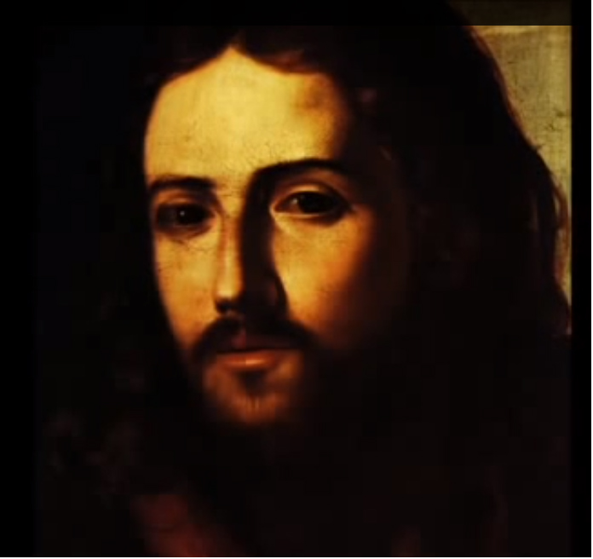

Christ Blessing Children (detail), Pacecco de Rosa, 1600-1654, Metro-politan Museum of Art, New York.
We pray for the sick of our community, especially:
Pat Murphy, Ken and Toni Meek, Michael Ford, Jim Walsh, Paula Cope, Pat Barone, Josephine del Bene, Margaret Johnson, Ann Mazzella, Jeanette Heaton and Stou Peggy.

Communion Antiphon ‡ Wisdom 16:20
You have given us, O Lord, bread from heaven, endowed with all delights and sweetness in every taste.

(continued) or incompetence. Likewise, the production of wealth through virtuous work is a good in itself, as the wisdom literature emphasizes. “A slack hand causes poverty, but the hand of the diligent makes rich” (Prov 10:4). The sin comes in spending the gained wealth on our pleasure and comfort, rather than spending it for the sake of love: for the love of others and of God. Thus, the hard-working Woman of Noble Character (Prov 31) creates a great deal of wealth, but uses it to provide for her family, her employees, and the poor (Prov. 31:20). Without persons who create wealth, society lacks the resources to alleviate poverty. Even socialist governments need some wealthy persons in order to redistribute their property to the poor. When all the wealthy are gone, socialism can only establish the equality of shared destitution.
Wealth is given to us to be spent for love, which often means for the alleviation of the suffering of the poor. But we also remember that the greatest poverty is spiritual poverty, and that man does not live by bread alone but by the word of God (Mt. 4:4). Moreover, bread that perishes is not as necessary as bread “which endures to eternal life,” which is the flesh of Christ (John 6:27,51). So we also spend our wealth to support the material needs of the Church, which is the one institution capable of alleviating spiritual poverty. “He who is kind to the poor lends to the LORD, and he will repay him for his deed” (Prov. 19:17), but let’s not forget that profound spiritual poverty is everywhere, and therefore it is not right for the Church to “give up preaching the word of God to wait on tables” (Acts 6:2). The early Church inspires us, who “were together and had all things in common; and they sold their possessions and goods and distributed them to all, as any had need … And the Lord added to their number day by day those who were being saved” (Acts 2:44-47). Concern for material need was not separated from preaching the Gospel of eternal salvation through faith in Jesus Christ, the Son of God.

Entrance Antiphon ‡ Psalm 70 (69): 2, 6.
O God, come to my assistance; O Lord, make haste to help me! You are my rescuer, my help; O Lord, do not delay.

First Reading ‡ Ecclesiastes 1: 2, 2:21-23
What do people gain by all their work?
Vanity of vanities, the Preacher says. Vanity of vanities. All is vanity!
For so it is that a man who has laboured wisely, skilfully and successfully must leave what is his own to someone who has not toiled for it at all. This, too, is vanity and great injustice; for what does he gain for all the toil and strain that he has undergone under the sun? What of all his laborious days, his cares of office, his restless nights? This, too, is vanity.
The word of the Lord.
Thanks be to God.

Gospel Acclamation ‡ Matthew 5:3
Alleluia, alleluia!
Happy the poor in spirit;
the kingdom of heaven is theirs!
Alleluia!

Gospel ‡ Luke 12:13-21
To whom will all this wealth of yours go?
A man in the crowd said to. Jesus, ‘Master, tell my brother to give me a share of our inheritance.’ ‘My friend,’ he replied ‘who appointed me your judge, or the arbitrator of your claims?’ Then he said to them, ‘Watch, and be on your guard against avarice of any kind, for a man’s life is not made secure by what he owns, even when he has more than he needs.’
Then he told them a parable: ‘There was once a rich man who, having a good harvest from his land, thought to himself, “What am I to, do? I have not enough room to store my crops.” Then he said, “This is what I will do: I will pull down my barns and build bigger ones, and store all my grain and my goods in them, and I will say, to my soul: ‘My soul, you have plenty of good things laid by for many years to come; take things easy, eat, drink, have a good time.” But God said to him, “Fool! This very night the demand will be made for your soul; and this hoard of yours, whose will it be then?” So it is when a man stores up treasure for himself in place of making himself rich in the sight of God.’
The Gospel of the Lord.
Praise to you, Lord Jesus Christ!

Responsorial Psalm ‡ Psalm 89: 3-6, 12-14, 17.
R. In every age, O Lord, you have been our refuge.

You turn men back into dust
and say: ‘Go back, sons of men.’
To your eyes a thousand years
are like yesterday, come and gone,
no more than a watch in the night. R.

You sweep men away like a dream,
like grass which springs up in the morning.
In the morning it springs up and flowers:
by evening it withers and fades. R.

Make us know the shortness of our life
that we may gain wisdom of heart.
Lord, relent! Is your anger for ever?
Show pity to your servants. R.

In the morning, fill us with your love;
we shall exult and rejoice all our days.
Let the favour of the Lord be upon us:
give success to the work of our hands. R.

Second Reading ‡ Colossians 3:1-5, 9-11
Seek the things that are above where Christ is.
Since you have been brought back to true life with Christ, you must look for the things that are in heaven, where Christ is, sitting at God’s right hand. Let your thoughts be on heavenly things, not on the things that are on the earth, because you have died, and now the life you have is hidden with Christ in God. But when Christ is revealed — and he is your life — you too will be revealed in all your glory with him.
That is why you must kill everything in you that belongs only to earthly life: fornication, impurity, guilty passion, evil desires and especially greed, which is the same thing as worshipping a false god; and never tell each other lies. You have stripped off your old behaviour with your old self, and you have put on a new self which will progress towards true knowledge the more it is renewed in the image of its creator; and, in that image there is no room for distinction between Greek and Jew, between the circumcised or the uncircumcised, or between barbarian and Scythian, slave and free man. There is only Christ: he is everything and he is in everything.
The word of the Lord.
Thanks be to God.
Page 3
Page 2

Reflection by John Bergsma at http://www.thesacredpage.com/2016/07/wealth-and-poverty-18th-sunday-of-ot.html#more
We notice that the attitude of the rich man in the parable is strikingly similar to that of Solomon in Ecclesiastes. Recognizing that he has enormous wealth, Solomon begins an experiment in pleasures of various kinds in an attempt to find meaning. Instead he finds vanity. Interestingly, though, it never occurs to Solomon in Ecclesiastes to expend his money in the alleviation of poverty or in other investments in the human community.
We also notice that it is not the production of wealth per se that merits this man’s condemnation, but his plan to hoard it for his own comfort. This is an important point. The production of wealth in itself can be good. The productivity of the land of the wealthy man could have been an indication of natural virtues: prudence, self-discipline, hard work, as it is in the case of the Woman of Noble Character (Prov 31). Rather, it is the intent to consume the wealth in self-indulgence that is vicious.
Material poverty in itself is not virtuous, because material poverty may be the result of laziness, imprudence, addiction, or some other vice. That is why Jesus teaches that “blessed are the poor in spirit,” which may be interpreted as “those who are poor for the sake of the Spirit,” that is, for spiritual ends, not simply because of laziness or

