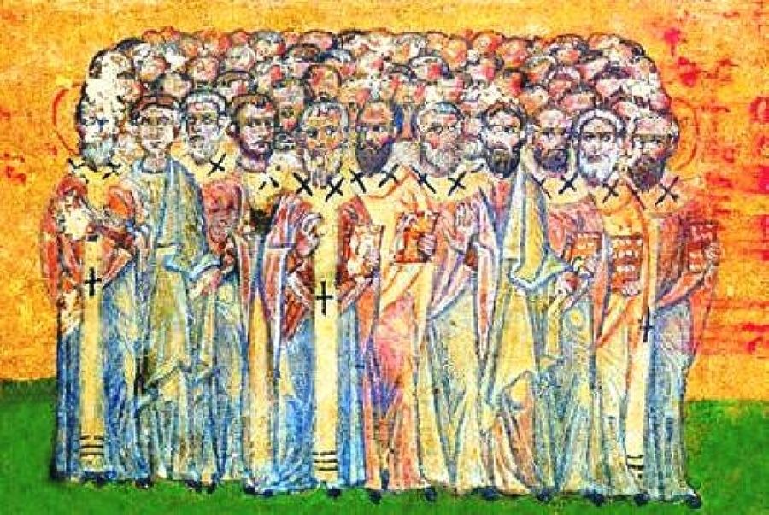
14th Sunday in Ordinary Time
MASS TIMES
Weekend Masses: YANCHEP: 6 p.m. Saturday Vigil, Yanchep Community Centre,
7 Lagoon Drive. GUILDERTON: 8 a.m. Sunday, Guilderton Community Hall, Wedge Street. LANCELIN: 9.45 a.m. Sunday, 33 Gingin Road, Lancelin.
Confessions: before Mass on request
Weekday Masses: Tuesday, Thursday, Friday 9 a.m. at the presbytery,
Wednesdays 3 p.m. at Bethanie Beachside Aged Care.
Priest: Fr Augustine Puthota, Presbytery: 3 Blaxland Avenue, Two Rocks, Western Australia 6037. Telephone: +61-8-9561 2172 Website: http://yanchepcatholic.org/ Email: yanchep@perthcatholic.org.au.
Please like us on Facebook: https://www.facebook.com/yanchepcatholicchurch

Sunday Bulletin
Year C
Page 4

We pray for the sick of our community, especially:
Pat Murphy, Ken and Toni Meek, Michael Ford, Jim Walsh, Paula Cope, Pat Barone, Josephine del Bene, Margaret Johnson, Ann Mazzella, Jeanette Heaton and Stou Peggy.

Communion Antiphon ‡ Psalm 34 (33): 9
Taste and see that the Lord is good; blessed the man who seeks refuge in him.

(continued) The mission of the seventy in Luke 10 is similar to, but clearly distinct from, the mission of the Twelve in Matt 10:5-15 and Luke 9:1-6. Although the passages are similar, they refer to two distinct events. The Twelve are explicitly sent only to Jewish territory (Matt 10:5) and for that reason are given no instruction about how to deal with Gentile or Samaritan food. The Seventy, however, are sent to Gentile and Samaritan territory, so Jesus has to instruct them explicitly on how to handle conscience issues regarding the observation of Kosher laws. Gentiles did not keep kosher, and Samaritans had different kosher regulations. Jesus tells them not to be concerned about this: “eat whatever they provide” (10:7) without asking questions of conscience.
The Seventy are part of the nucleus of the Church, the “Israel of God.” Better, as office holders and official representatives, they represent the New Jerusalem of the First Reading, that is, the ministering Church that cares for her members. Their role is analogous to that of the diaconate: they serve under and in support of Christ (the great episkopos) and the Apostles (the presbuteroi). They go before to prepare the way in towns which Jesus and the Twelve would later visit. So their ministry was preparatory, focused on preaching and attending to material needs (healings). Nonetheless, they also participate in the ministry of spiritual deliverance against the demonic.
Jesus gives the Seventy specific instructions based on the time and culture in which they ministered. These specifics may be impractical elsewhere: it would be difficult to evangelize Scandinavia barefoot, for example. Nonetheless, the general principle of apostolic zeal and trust in God for material provision should continue to characterize the Church's evangelistic mission. The Church still needs people who will go without the comforts of a bourgeois lifestyle (like having health insurance and a 401K) in order to evangelize in a direct and immediate way.

Cathedral of 70 Apostles (miniature of the Greek-Georgian Manuscripts , XV century ). Собор 70 апостолов (миниатюра из греко-грузинской рукописи, XV век).

Entrance Antiphon ‡ Psalm 48 (47): 10-11
Your merciful love, O God, we have received in the midst of your temple. Your praise, O God, like your name, reaches the ends of the earth; your right hand is filled with saving justice.

First Reading ‡ Isaiah 66:10-14
I will send toward Jerusalem peace like a river.

Rejoice, Jerusalem,
be glad for her, all you who love her!
Rejoice, rejoice for her,
all you who mourned her!
That you may be suckled, filled,
from her consoling breast,
that you may savour with delight her glorious breasts.

The word of the Lord.
Thanks be to God

Gospel Acclamation ‡ Colossians 3:15, 16.
Alleluia, alleluia!
May the peace of Christ rule in your hearts,
and the fullness of his message live within you.
Alleluia!

Gospel ‡ Luke 10:1-12, 17-20
Your peace will rest upon him.
The Lord appointed seventy-two others and sent them out ahead of him, in pairs, to all the towns and places he himself was to visit. He said to them, ‘The harvest is rich but the labourers are few, so ask the Lord of the harvest to send labourers to his harvest. Start off now, but remember, I am sending you out like lambs among wolves. Carry no purse, no haversack, no sandals. Salute no one on the road. Whatever house you go into, let your first words be, “Peace to this house!” And if a man of peace lives there, your peace will go and rest on him; if not, it will come back to you. Stay in the same house, taking what food and drink they have to offer, for the labourer deserves his wages; do not move from house to house. Whenever you go into a town where they make you welcome, eat what is set before you. Cure those in it who are sick, and say, “The kingdom of God is very near to you.” But whenever you enter a town and they do not make you welcome, go out into its streets and say, “We wipe off the very dust of your town that clings to our feet, and leave it with you. Yet be sure of this: the kingdom of God is very near.” I tell you, on that day it will not go as hard with Sodom as with that town.’
The seventy-two came back rejoicing. ‘Lord,’ they said, ‘even the devils submit to us when we use your name.’ He said to them, ‘I watched Satan fall like lightning from heaven. Yes, I have given you power to tread underfoot serpents and scorpions and the whole strength of the enemy; nothing shall ever hurt you. Yet do not rejoice that the spirits submit to you; rejoice rather that your names are written in heaven.’
The Gospel of the Lord.
Praise to you, Lord Jesus Christ!
Page 2
Page 3
For thus says the Lord:
Now towards her I send flowing peace, like a river,
and like a stream in spate the glory of the nations.
At her breast will her nurslings be carried
and fondled in her lap.
Like a son comforted by his mother will I comfort you.
And by Jerusalem you will be comforted.
At the sight your heart will rejoice,
and your bones flourish like the grass.
To his servants the Lord will reveal his hand.
The word of the Lord.
Thanks be to God

Responsorial Psalm ‡ Psalm 65:1-7, 16, 20.
R. Let all the earth cry out to God with joy.

Cry out with joy to God all the earth,
O sing to the glory of his name.
O render him glorious praise.
Say to God: ‘How tremendous your deeds! R.
‘Before you all the earth shall bow:
shall sing to you, sing to your name!’
Come and see the works of God,
tremendous his deeds among men. R.

He turned the sea into dry land,
they passed through the river dry-shod.
Let our joy then be in him;
he rules for ever by his might. R.

Come and hear, all who fear God.
I will tell what he did for my soul.
Blessed be God who did not reject my prayer
nor withhold his love from me. R.

Second Reading ‡ Galatians 6:14-18
The marks I carry on my body are those of Jesus Christ.
The only thing I can boast about is the cross of our Lord Jesus Christ, through whom the world is crucified to me, and I to the world. It does not matter if a person is circumcised or not; what matters is for him to become an altogether new creature. Peace and mercy to all who follow this rule, who form the Israel of God.
I want no more trouble from anybody after this; the marks on my body are those of Jesus. The grace of our Lord Jesus Christ be with your spirit, my brothers. Amen.

Reflection on today’s readings by John Bergsma at http://www.thesacredpage.com/2016/06/gathering-new-jerusalem-14th-sunday-of.html#more
The role of the seventy (or seventy-two) disciples, in addition to the Twelve Apostles, is frequently overlooked in our study of the New Testament, but it was important. Jesus was setting up the New Israel in his ministry, and in addition to the Twelve, who were simultaneously the New Patriarchs, the New Tribal Princes (see Num 7), and the New Officers of Israel (see 1 Kgs 4), Jesus also chose seventy others, who correspond to Moses' seventy elders over the tribes (Num 11:16-30). Just as Moses had twelve tribal princes and seventy elders (Numbers 7; 11:16-30), the New Moses has the Twelve Apostles and Seventy Disciples.

