12th Sunday in Ordinary Time
MASS TIMES
Weekend Masses: YANCHEP: 6 p.m. Saturday Vigil, Yanchep Community Centre,
7 Lagoon Drive. GUILDERTON: 8 a.m. Sunday, Guilderton Community Hall, Wedge Street. LANCELIN: 9.45 a.m. Sunday, 33 Gingin Road, Lancelin.
Confessions: before Mass on request
Weekday Masses: Tuesday, Thursday, Friday 9 a.m. at the presbytery,
Wednesdays 3 p.m. at Bethanie Beachside Aged Care.
Priest: Fr Augustine Puthota, Presbytery: 3 Blaxland Avenue, Two Rocks, Western Australia 6037. Telephone: +61-8-9561 2172 Website: http://yanchepcatholic.org/ Email: yanchep@perthcatholic.org.au.
Please like us on Facebook: https://www.facebook.com/yanchepcatholicchurch

Sunday Bulletin
Year C
Page 4
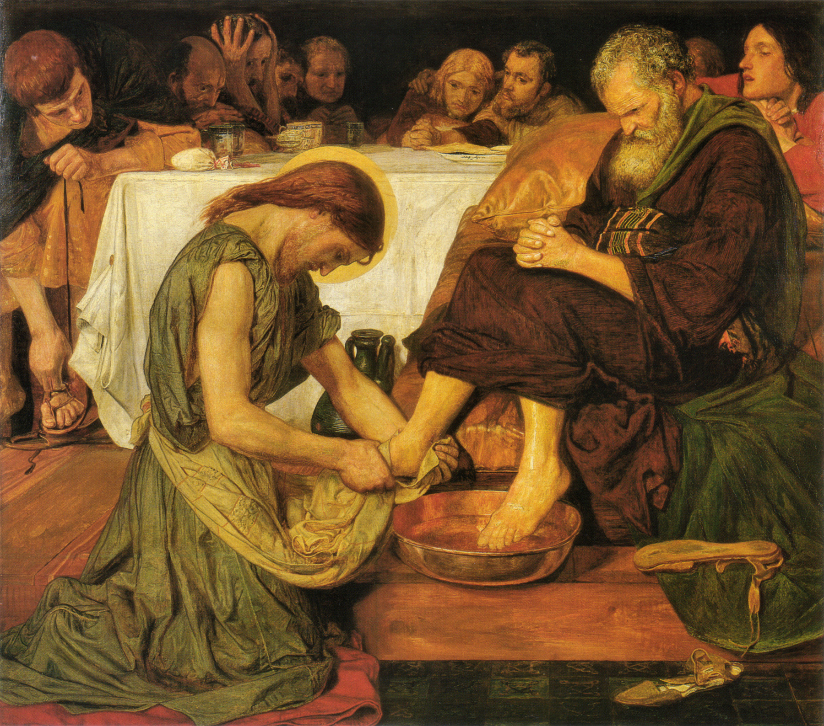

We pray for the sick of our community, especially:
Pat Murphy, Ken and Toni Meek, Michael Ford, Jim Walsh, Paula Cope, Pat Barone, Josephine del Bene, Margaret Johnson, Ann Mazzella, Jeanette Heaton and Stou Peggy.

Communion Antiphon ‡ John 10:11, 15
I am the Good Shepherd, and I lay down my life for my sheep, says the Lord.

(continued) manner.” Most people thought the Christ of God would be a supernaturally empowered political figure, a victorious king who slew his enemies supernaturally. Jesus does not want to promote that image, because it would attract too much and the wrong kind of attention, distracting from his true mission.
Jesus proceeds immediately to define what kind of “Christ of God” he is. He is the “Christ” who will suffer greatly, die, and be raised. And all who come after him must be prepared to suffer the same fate. Being a follower of Jesus of Nazareth is to have something of a “death wish”: “if anyone wishes to come after me, he must deny himself, take up his cross daily and follow me.”
We have become so accustomed to this phrase “take up his cross” that it no longer shocks us. But crucifixion was a terrible form of execution in the first century A.D. that horrified and traumatized the peoples of the Roman Empire. It was so excruciating that some Roman orators insisted that it was impolite to even mention crucifixion in the presence of decent citizens. The modern equivalent would be the electric chair: “if anyone wishes to come after me, let him take up his electric chair daily …” But the electric chair is mild compared to the cross. The only persons who carried crosses were condemned criminals on their way to execution. So Our Lord's words indicate that those who would follow him on the path of discipleship must already have reconciled themselves to the prospect of their own deaths.
So we see that Jesus was no mere teacher or philosopher who offers a lesson in return for tuition. Jesus openly calls his disciples to commit themselves to him to the point of death, and promises that such self-denial is in fact the way to eternal life.
How far we are from this radical discipleship today, when giving even one-tenth of one's income to the support of the Church and her missions is considered “radical,” and tossing out one's contraceptives is unthinkable. May the Lord help us when the real persecution hits!

Entrance Antiphon ‡ Psalm 28 (27):8-9
The Lord is the strength of his people, a saving refuge for the one he has anointed. Save your people, Lord, and bless your heritage, and govern them for ever.

Jesus Washing Peter’s Feet, Ford Madox Brown (1852-56), oil on canvas, Tate Gallery, London.

First Reading ‡ Zechariah 12:10-11, 13:1
They will look on the one whom they have pierced.
It is the Lord who speaks: ‘Over the House of David and the citizens of Jerusalem I will pour out a spirit of kindness and prayer. They will look on the one whom they have pierced; they will mourn for him as for an only son, and weep for him as people weep for a first- born child.

Gospel Acclamation ‡ John 10:27
Alleluia, alleluia!
My sheep listen to my voice, says the Lord;
I know them, and they follow me.
Alleluia!

Gospel ‡ Luke 9:18-24
You are the Messiah sent by God. It is necessary for the Son of Man to suffer much.
One day when Jesus was praying alone in the presence of his disciples he put this question to them, ‘Who do the crowds say I am?’ And they answered, ‘John the Baptist; others Elijah; and others say one of the ancient prophets come back to life.’ ‘But you,’ he said, ‘who do you say I am?’ It was Peter who spoke up. ‘The Christ of God,’ he said. But he gave them strict orders not to tell anyone anything about this.
‘The Son of Man’, he said, ‘is destined to suffer grievously, to be rejected by the elders and chief priests and scribes and to be put to death, and to be raised up on the third day.’
Then to all he said, ‘If anyone wants to be a follower of mine, let him renounce himself and take up his cross every day and follow me. For anyone who wants to save his life will lose it; but anyone who loses his life for my sake, that man will save it.’

The Gospel of the Lord.
Praise to you, Lord Jesus Christ!
Page 2
Page 3

When that day comes, there will be great mourning in Judah, like the mourning of Hadad-rimmon in the plain of Megiddo.
When that day comes, a fountain will be opened for the House of David and the citizens of Jerusalem, for sin and impurity.’
The word of the Lord.
Thanks be to God

Responsorial Psalm ‡ Psalm 62:2-6, 8-9
R. My soul is thirsting for you, O Lord my God.

O God, you are my God, for you I long;
for you my soul is thirsting.
My body pines for you
like a dry, weary land without water. R.

So I gaze on you in the sanctuary
to see your strength and your glory.
For your love is better than life,
my lips will speak your praise. R.

So I will bless you all my life,
in your name I will lift up my hands.
My soul shall be filled as with a banquet,
my mouth shall praise you with joy. R.

For you have been my help;
in the shadow of your wings I rejoice.
My soul clings to you;
your right hand holds me fast. R.

Second Reading ‡ Galatians 3:26-29
You who have been baptised have put on Christ
You are, all of you, sons of God through faith in Christ Jesus. All baptised in Christ, you have all clothed yourselves in Christ, and there are no more distinctions between Jew and Greek, slave and free, male and female, but all of you are one in Christ Jesus. Merely by belonging to Christ you are the posterity of Abraham, the heirs he was promised.
The word of the Lord.
Thanks be to God

Reflection by Dr John Bergsma at http://www.thesacredpage.com/2016/06/turning-to-face-cross-12th-sunday-of-ot.html#more
The Gospel of Luke divides roughly into four major sections: the infancy narratives (chs. 1-2), the early ministry (chs. 3-8), the “travel narrative” (chs. 9-19), and Holy Week (chs. 20-24). The first and third sections of Luke contain most of Luke's unique material. Luke 9, from which we read this Sunday, forms a transition into the “Travel Narrative,” so called because it is the account of Jesus' final journey to Jerusalem, during which the inevitability of his suffering and death looms ever larger. The “travel narrative” is like a parable of the Christian life. Like Jesus' journeying to his death in Jerusalem, each one of us is on a journey toward our own physical death, a journey that involves suffering and sacrifice if we wish to share in God's glory in the life to come.
Our passage divides into two units: the question of Jesus' identity, and the truth of Jesus mission. Jesus asks the disciples how people identify him, and how the disciples themselves view him. Peter speaks for the Twelve: “You are the Christ of God.” “Christ” translates the Hebrew “Meshiach” (i.e. Messiah), “one smeared with oil,” or “Anointed One.” The “Anointed One of God” referred to the Jewish belief in a saviour figure who would combine all the “anointed” roles (king, priest, and prophet) into one, and deliver the people of Israel in a definitive way.
One might ask, why does Jesus “rebuke” the disciples for saying this? Probably the Greek word epitimao has the sense of “to warn or charge in a solemn and/or stern

