MASS TIMES
Weekend Masses: YANCHEP: 6 p.m. Saturday Vigil, Yanchep Community Centre,
7 Lagoon Drive. GUILDERTON: 8 a.m. Sunday, Guilderton Community Hall, Wedge Street. LANCELIN: 9.45 a.m. Sunday, 33 Gingin Road, Lancelin.
Confessions: before Mass on request
Weekday Masses: Tuesday, Thursday, Friday 9 a.m. at the presbytery,
Wednesdays 3 p.m. at Bethanie Beachside Aged Care.
Priest: Fr Augustine Puthota, Presbytery: 3 Blaxland Avenue, Two Rocks, Western Australia 6037. Telephone: +61-8-9561 2172 Website: http://yanchepcatholic.org/ Email: yanchep@perthcatholic.org.au.
Please like us on Facebook: https://www.facebook.com/yanchepcatholicchurch

The Most Holy Trinity
Sunday Bulletin
Year C
Page 4
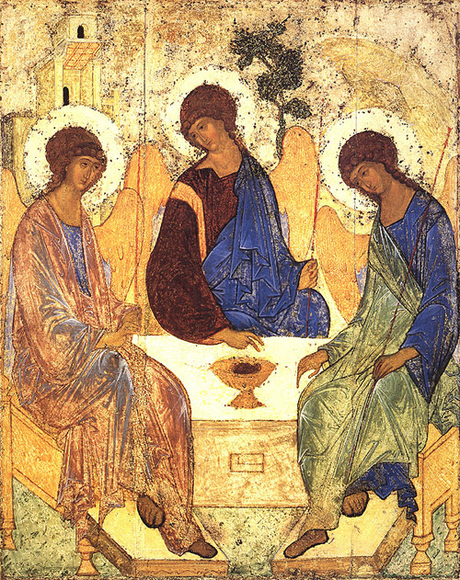
Holy Trinity Icon, Andrei Rublev, 1411-27, Tretyakov Gallery, Moscow. At the basis of the iconography is the Biblical tale (Book of Genesis, XVIII) of the appearance to Abraham of God in the form of three angels. Abraham and his wife Sarah entertained the three angels in the shade of an oak when Abraham understood that the angels were the embodiment of God in three faces. In Rublev's icon all attention is concentrated on the three angels and their silent exchange. They are depicted as seated around an altar in the center of which there is a chalice of the Eucharist with the head of a sacrificial calf which symbolises the lamb of the New Testament, i.e., Christ. The left and centre angels bless the chalice. God the Father blesses God the Son for death on the cross in the name of love for people. God the Holy Spirit (the right angel) is present here to provide comfort, confirming the high logic of sacrificial, all-forgiving love.

We pray for the sick of our community, especially:
Pat Murphy, Ken and Toni Meek, Michael Ford, Jim Walsh, Paula Cope, Pat Barone, Josephine del Bene, Margaret Johnson, Ann Mazzella, Jeanette Heaton and Stou Peggy.

Communion Antiphon ‡ Galatians 4:6
Since you are children of God, God has sent into your hearts the Spirit of his Son, the Spirit who cries out: Abba, Father.

(Reflection, continued)
And we reveal ourselves in proportion to our love. In revealing the Trinity God revealed his very nature, his most intimate life.
And he did this gradually and progressively according to our capacity and need. The Old Testament is explicitly monotheistic. “Hear, O Israel! The Lord is our God, the Lord alone.” (Deut. 6:4) The New Testament is monotheistic but it is also explicitly Trinitarian. All three persons of the Trinity are found in five of the key scenes in the Gospel: the Annunciation, the Baptism of Jesus, the Last Supper, Calvary, and the Ascension. Thus began the revelation that unaided reason would never have perceived, that the most High God is not only one, as Israel had passionately believed, but also Triune: Father, Son and Holy Spirit. The doctrine of the Trinity was refined and solemnly defined in the first four Councils of the Church and has been professed in the Creed and at Mass for centuries.
The Trinity is the model for our lives. We are made in the “image of God,” in the image of the Trinity. By contemplating the Trinity we can learn a lot about ourselves and about the way we should live. The Trinity is a COMMUNITY OF PERSONS. There are no isolated, self-sufficient, rugged individuals.
We need each other to be truly human. We are social beings. We are mutually interdependent. This is evident in the beginning of life and at the end of life. The newborn infant left to itself dies and the very old person left to himself dies. And in between the entrance and the exit we are still dependent one on another. It is through these relationships that we identify ourselves and become the person God has given us the potential to become.This community of persons is a COMMUNITY OF LOVE. The essence of the Trinity is a personal relationship of love between the Father and the Son and the Holy Spirit. Love should also be characteristic of the Christian community.

Entrance Antiphon ‡
Blest be God the Father, and the Only Begotten Son of God, and also the Holy Spirit, for he has shown us his merciful love.

First Reading ‡ Proverbs 8:22-31
Wisdom was born before the earth was made.
The Wisdom of God cries aloud:
The Lord created me when his purpose first unfolded,
before the oldest of his works.

in which we can boast about looking forward to God’s glory. But that is not all we can boast about; we can boast about our sufferings. These sufferings bring patience, as we know, and patience brings perseverance, and perseverance brings hope, and this hope is not deceptive, because the love of God has been poured into our hearts by the Holy Spirit which has been given us.
The word of the Lord.
Thanks be to God
Gospel Acclamation ‡ cf. Rev. 1:8
Alleluia, alleluia!
Glory to the Father, the Son, and the Holy Spirit:
to God who is, who was, and who is to come.
Alleluia!

Gospel ‡ John 16:12-15
Whatever the Father has is mine. The Spirit will receive what I give and tell you about it.
Jesus said to his disciples:
‘I still have many things to say to you
but they would be too much for you now.
But when the Spirit of truth comes
he will lead you to the complete truth,
since he will not be speaking as from himself
but will say only what he has learnt;
and he will tell you of the things to come.
He will glorify me
since all he tells you
will be taken from what is mine.
Everything the Father has is mine;
that is why I said:
All he tells you will be taken from what is mine.’

The Gospel of the Lord.
Praise to you, Lord Jesus Christ!

Page 3
From everlasting I was firmly set,
from the beginning, before earth came into being.
The deep was not, when I was born,
there were no springs to gush with water.
Before the mountains were settled,
before the hills, I came to birth;
before he made the earth, the countryside,
or the first grains of the world’s dust.
When he fixed the heavens firm, I was there,
when he drew a ring on the surface of the deep,
when he thickened the clouds above,
when he fixed fast the springs of the deep,
when he assigned the sea its boundaries — and the waters will not invade the shore — when he laid down the foundations of the earth,
I was by his side, a master craftsman,
delighting him day after day,
ever at play in his presence,
at play everywhere in his world,
delighting to be with the sons of men.
The word of the Lord.
Thanks be to God.

Responsorial Psalm ‡ Psalm 8:4-9.
R. O Lord, our God, how wonderful your name in all the earth!

When I see the heavens, the work of your hands,
the moon and the stars which you arranged,
what is man that you should keep him in mind,
mortal man that you care for him? R.

Yet you have made him little less than a god;
with glory and honour you crowned him,
gave him power over the works of your hand,
put all things under his feet. R.

All of them, sheep and cattle,
yes, even the savage beasts,
birds of the air, and fish
that make their way through the waters. R.

Second Reading ‡ Romans 5:1-5
To God through Christ in the love which is poured out through the Spirit.
Through our Lord Jesus Christ, by faith we are judged righteous and at peace with God, since it is by faith and through Jesus that we have entered this state of grace
Page 2



Fr Rodney Kissinger, S.J. http://www.frksj.org/homily_The_Trinity.htm
Frank Sheed, the leader of the street-corner preachers of the Catholic Evidence Guild in England, said that at the beginning of their apostolate they avoided the Trinity because they were convinced that they could not express it adequately, and the crowd, a non-captive audience, would not respond to it. But they realized that if they wish to speak about the Christian God they would have to talk about it. So with fear and trembling they began to speak about the Trinity. And to their great surprise the crowds were fascinated by it.
And well should they be because the revelation of the Trinity is one of the greatest proofs of God’s love for us. We do not reveal ourselves to those we do not love.

