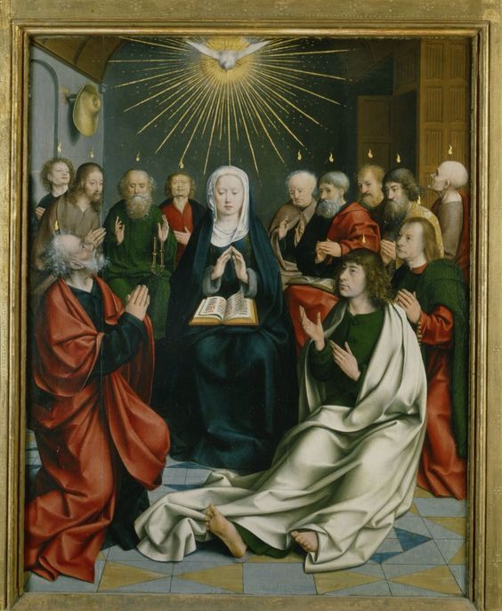
Pentecost
Sunday Bulletin
Year C
Page 4
MASS TIMES
Weekend Masses: YANCHEP: 6 p.m. Saturday Vigil, Yanchep Community Centre,
7 Lagoon Drive. GUILDERTON: 8 a.m. Sunday, Guilderton Community Hall, Wedge Street. LANCELIN: 9.45 a.m. Sunday, 33 Gingin Road, Lancelin.
Confessions: before Mass on request
Weekday Masses: Tuesday, Thursday, Friday 9 a.m. at the presbytery,
Wednesdays 3 p.m. at Bethanie Beachside Aged Care.
Priest: Fr Augustine Puthota, Presbytery: 3 Blaxland Avenue, Two Rocks, Western Australia 6037. Telephone: +61-8-9561 2172 Website: http://yanchepcatholic.org/ Email: yanchep@perthcatholic.org.au.
Please like us on Facebook: https://www.facebook.com/yanchepcatholicchurch

Pentecost (Pfingsten),
Jan Joest van Kalkar
(1505 – 1508), oil on wood, St. Nicolai's Church, (Katholische Pfarrkirche Sankt Nikolai), Kalkar, Germany

We pray for the sick of our community, especially:
Pat Murphy, Ken and Toni Meek, Michael Ford, Jim Walsh, Paula Cope, Pat Barone, Josephine del Bene, Margaret Johnson, Ann Mazzella, Jeanette Heaton and Stou Peggy.


Gospel Acclamation ‡
Alleluia, alleluia!
Come, Holy Spirit, fill the hearts of your faithful
and kindle in them the fire of your love.
Alleluia!
Gospel ‡ John 14:15-16, 23-26
The Holy Spirit will teach you everything.
Jesus said to his disciples:
‘If you love me you will keep my commandments.
I shall ask the Father
and he will give you another Advocate
to be with you for ever.
‘If anyone loves me he will keep my word,
and my Father will love him,
and we shall come to him and make our home with him.
Those who do not love me do not keep my words.
And my word is not my own;
it is the word of the one who sent me.
I have said these things to you while still with you;
but the Advocate, the Holy Spirit,
whom the Father will send in my name,
will teach you everything and remind you of all I have said to you.’

The Gospel of the Lord.
Praise to you, Lord Jesus Christ!

Entrance Antiphon ‡ Romans 5:5 cf. 8:11
The love of God has been poured into our hearts through the Spirit of God dwelling within us, alleluia.

First Reading ‡ Acts 2:1-11
They were all filled with the Holy Spirit, and began to speak different languages.
When Pentecost day came round, the apostles had all met in one room, when suddenly they heard what sounded like a powerful wind from heaven, the noise of which filled the entire house in which they were sitting; and something appeared to them that seemed like tongues of fire; these separated and came to rest on the head of each of them. They were all filled with the Holy Spirit, and began to speak foreign languages as the Spirit gave them the gift of speech.
Now there were devout men living in Jerusalem from every nation under heaven, and at this sound they all assembled, each one bewildered to hear these men speaking his own language. They were amazed and astonished.

Communion Antiphon ‡ Acts 2: 4, 11.
They were all filled with the Holy Spirit and spoke of the marvels of God, alleluia.

that we are children of God. And if we are children we are heirs as well: heirs of God and coheirs with Christ, sharing his sufferings so as to share his glory.
The word of the Lord.
Thanks be to God. Sequence
Holy Spirit, Lord of Light,
From the clear celestial height
Thy pure beaming radiance give.

Come, thou Father of the poor,
Come with treasures which endure
Come, thou light of all that live!

Thou, of all consolers best,
Thou, the soul’s delightful guest,
Dost refreshing peace bestow.

Thou in toil art comfort sweet
Pleasant coolness in the heat
Solace in the midst of woe.

Light immortal, light divine,
Visit thou these hearts of thine,
And our inmost being fill:

If thou take thy grace away,
Nothing pure in man will stay
All his good is turned to ill.

Heal our wounds, our strength renew
On our dryness pour thy dew
Wash the stains of guilt away:

Bend the stubborn heart and will
Melt the frozen, warm the chill
Guide the steps that go astray.

Thou, on us who evermore
Thee confess and thee adore,
With thy sevenfold gifts descend:

Give us comfort when we die
Give us life with thee on high
Give us joys that never end.

‘Surely’ they said ‘all these men speaking are Galileans? How does it happen that each of us hears them in his own native language? Parthians, Medes and Elamites; people from Mesopotamia, Judaea and Cappadocia, Pontus and Asia, Phrygia and Pamphylia, Egypt and the parts of Libya round Cyrene; as well as visitors from Rome — Jews and proselytes alike — Cretans and Arabs; we hear them preaching in our own language about the marvels of God.’
The word of the Lord.
Thanks be to God.

Responsorial Psalm ‡ Psalm 103: 1, 24, 29-31, 34.
R. Lord, send out your Spirit and renew the face of the earth.

Bless the Lord, my soul!
Lord God, how great you are,
How many are your works, O Lord!
The earth is full of your riches. . R.

You take back your spirit, they die,
returning to the dust from which they came.
You send forth your spirit, they are created;
and you renew the face of the earth. . R.

May the glory of the Lord last for ever!
May the Lord rejoice in his works!
May my thoughts be pleasing to him.
I find my joy in the Lord. R.

Second Reading ‡ Romans 8:8-17
Everyone moved by the Spirit is a son of God.
People who are interested only in unspiritual things can never be pleasing to God. Your interests, however, are not in the unspiritual, but in the spiritual, since the Spirit of God has made his home in you. In fact, unless you possessed the Spirit of Christ you would not belong to him. Though your body may be dead it is because of sin, but if Christ is in you then your spirit is life itself because you have been justified; and if the Spirit of him who raised Jesus from the dead is living in you, then he who raised Jesus from the dead will give life to your own mortal bodies through his Spirit living in you.
So then, my brothers, there is no necessity for us to obey our unspiritual selves or to live unspiritual lives. If you do live in that way, you are doomed to die; but if by the Spirit you put an end to the misdeeds of the body you will live.
Everyone moved by the Spirit is a son of God. The spirit you received is not the spirit of slaves bringing fear into your lives again; it is the spirit of sons, and it makes us cry out, ‘Abba, Father!’ The Spirit himself and our spirit bear witness

Page 3
Page 2

