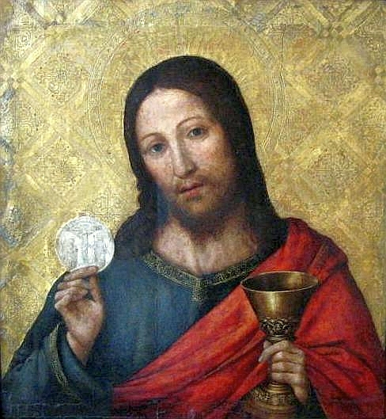
The Body and Blood of Christ
MASS TIMES
Weekend Masses: YANCHEP: 6 p.m. Saturday Vigil, Yanchep Community Centre,
7 Lagoon Drive. GUILDERTON: 8 a.m. Sunday, Guilderton Community Hall, Wedge Street. LANCELIN: 9.45 a.m. Sunday, 33 Gingin Road, Lancelin.
Confessions: before Mass on request
Weekday Masses: Tuesday, Thursday, Friday 9 a.m. at the presbytery,
Wednesdays 3 p.m. at Bethanie Beachside Aged Care.
Priest: Fr Augustine Puthota, Presbytery: 3 Blaxland Avenue, Two Rocks, Western Australia 6037. Telephone: +61-8-9561 2172 Website: http://yanchepcatholic.org/ Email: yanchep@perthcatholic.org.au.
Please like us on Facebook: https://www.facebook.com/yanchepcatholicchurch

Sunday Bulletin
Year C
Page 4
Christ with the Host, Paolo de San Leocadio (1445-1520), oil and gold on wood, National Museum in Poznań (Muzeum Narodowe w Poznaniu), Poland. [Public domain], via Wikimedia Commons.

We pray for the sick of our community, especially:
Pat Murphy, Ken and Toni Meek, Michael Ford, Jim Walsh, Paula Cope, Pat Barone, Josephine del Bene, Margaret Johnson, Ann Mazzella, Jeanette Heaton and Stou Peggy.

Gospel Acclamation ‡ John 6:51-52
Alleluia, alleluia!
I am the living bread from heaven, says the Lord;
whoever eats this bread will live for ever.
Alleluia!

Gospel ‡ Luke 9:11-17
They all ate and were filled.
Jesus made the crowds welcome and talked to them about the kingdom of God; and he cured those who were in need of healing.
It was late afternoon when the Twelve came to him and said, ‘Send the people away,
and they can go to the villages and farms round about to find lodging and food; for we are in a lonely place here.’
He replied, ‘Give them something to eat yourselves.’
But they said, ‘We have no more than five loaves and two fish, unless we are to go ourselves and buy food for all these people.’
For there were about five thousand men. But he said to his disciples, ‘Get them to sit down in parties of about fifty.’
They did so and made them all sit down. Then he took the five loaves and the two fish, raised his eyes to heaven, and said the blessing over them; then he broke them and handed them to his disciples to distribute among the crowd. They all ate as much as they wanted, and when the scraps remaining were collected they filled twelve baskets.
The Gospel of the Lord.
Praise to you, Lord Jesus Christ!

Entrance Antiphon ‡ Psalm 81 (80):17
He fed them with the finest wheat and satisfied them with honey from the rock.

First Reading ‡ Genesis 14:18-20
Melchizedek brought bread and wine.

Melchizedek king of Salem brought bread and wine; he was a priest of God Most High. He pronounced this blessing:
‘Blessed be Abraham by God Most High, creator of heaven and earth,
and blessed be God Most High for handing over your enemies to you.’
And Abraham gave him a tithe of everything.

The word of the Lord.
Thanks be to God.

Communion Antiphon ‡ John 6:57
Whoever eats my flesh and drinks my blood remains in me and I in him, says the Lord.

Not he that eateth it divides
The sacred food, which whole abides
Unbroken still, nor knows decay;
Be one, or be a thousand fed,
They eat alike the Living Bread
Which, still received, ne’er wastes away.

The good, the guilty share therein,
With sure increase of grace or sin,
The ghostly life, or ghostly death:
Death to the guilty; to the good
Immortal life. See how one food
Man’s joy or woe accomplisheth.

We break the Sacrament; but bold
And firm thy faith shall keep its hold;
Deem not the whole doth more enfold
Than in the fractured part resides
Deem not that Christ doth broken lie,
‘Tis but the sign that meets the eye,
The hidden deep reality
In all its fullness still abides.

Behold the bread of angels, sent
For pilgrims in their banishment,
The bread for God’s true children meant,
That may not unto dogs be given:
Oft in the olden types foreshadowed;
In Isaac on the altar bowed,
And in the ancient paschal food,
And in the manna sent from heaven.

Come then, good shepherd, bread divine,
Still show to us thy mercy sign;
Oh, feed us still, still keep us thine;
So may we see thy glories shine
In fields of immortality;
O thou, the wisest, mightiest, best,
Our present food, our future rest,
Come, make us each thy chosen guest,
Co-heirs of thine, and comrades blest
With saints whose dwelling is with thee.
Amen. Alleluia!
Today no theme of common praise
Forms the sweet burden of thy lays –
The living, life-dispensing food –
That food which at the sacred board
Unto the brethren twelve our Lord
His parting legacy bestowed.

Then be the anthem clear and strong,
Thy fullest note, thy sweetest song,
The very music of the breast:
For now shines forth the day sublime
That brings remembrance of the time
When Jesus first his table blessed.

Within our new King’s banquet-hall
They meet to keep the festival
That closed the ancient paschal rite:
The old is by the new replaced;
The substance hath the shadow chased;
And rising day dispels the night.

Christ willed what he himself had done
Should be renewed while time should run,
In memory of his parting hour:
Thus, tutored in His school divine,
We consecrate the bread and wine;
And lo – a Host of saving power.

This faith to Christian men is given –
Bread is made flesh by words from heaven:
Into his Blood the wine is turned.
What though it baffles nature’s powers
Of sense and sight? This faith of ours
Proves more than nature e’er discerned.

Concealed beneath the two-fold sign
Meet symbols of the gifts divine,
There lie the mysteries adored:
The living body is our food;
Our drink the ever precious blood;
In each, one undivided Lord.

Page 3
Responsorial Psalm ‡ Psalm 109:1-4.
R. You are a priest for ever, in the line of Melchizedek.

The Lord’s revelation to my Master:
‘Sit on my right:
I will put your foes beneath your feet.’ R.

The Lord will send from Zion
your sceptre of power:
rule in the midst of all your foes. R.

A prince from the day of your birth
on the holy mountains;
from the womb before the daybreak
I begot you. R.

The Lord has sworn an oath he will not change.
‘You are a priest for ever,
a priest like Melchizedek of old.’ R.

Second Reading ‡ 1 Corianthians 11:23-26.
Every time you eat this bread and drink this cup, you are proclaiming the death of the Lord.
This is what I received from the Lord, and in turn passed on to you: that on the same night that he was betrayed, the Lord Jesus took some bread, and thanked God for it and broke it, and he said, ‘This is my body, which is for you; do this as a memorial of me.’
In the same way he took the cup after supper, and said, ‘This cup is the new covenant in my blood. Whenever you drink it, do this as a memorial of me.’
Until the Lord comes, therefore, every time you eat this bread and drink this cup, you are proclaiming his death.
The word of the Lord.
Thanks be to God

SEQUENCE

Sing forth, O Zion, sweetly sing
The praises of thy Shepherd-King,
In hymns and canticles divine;
Dare all thou canst, thou hast no song
Worthy his praises to prolong,
So far surpassing powers like thine.

Page 2

