Sunday Bulletin
Fifth Sunday of Easter
Year C
Page 4
MASS TIMES
Weekend Masses: YANCHEP: 6 p.m. Saturday Vigil, Yanchep Community Centre,
7 Lagoon Drive. GUILDERTON: 8 a.m. Sunday, Guilderton Community Hall, Wedge Street. LANCELIN: 9.45 a.m. Sunday, 33 Gingin Road, Lancelin.
Confessions: before Mass on request
Weekday Masses: Tuesday, Thursday, Friday 9 a.m. at the presbytery,
Wednesdays 3 p.m. at Bethanie Beachside Aged Care.
Priest: Fr Augustine Puthota, Presbytery: 3 Blaxland Avenue, Two Rocks, Western Australia 6037. Telephone: +61-8-9561 2172 Website: http://yanchepcatholic.org/ Email: yanchep@perthcatholic.org.au.
Please like us on Facebook: https://www.facebook.com/yanchepcatholicchurch

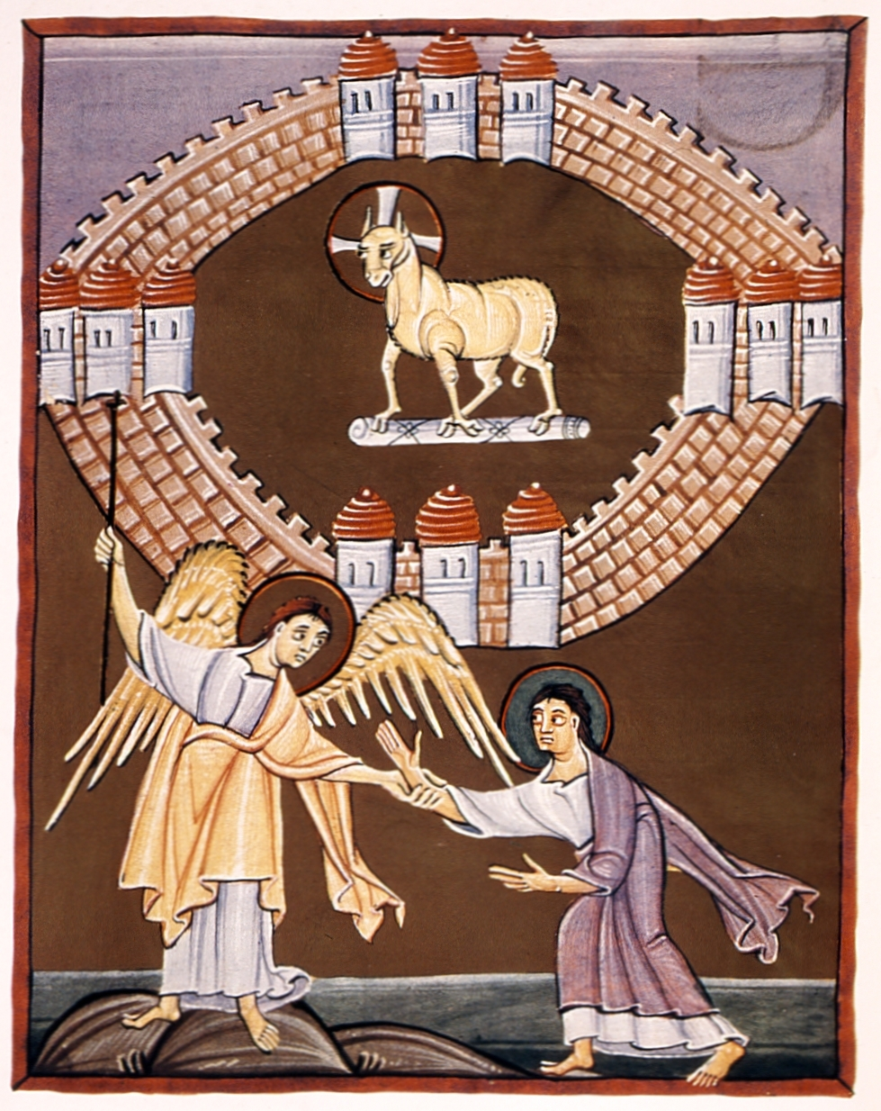
Entrance Antiphon ‡ Cf. 98 (97):1-2
O sing a new song to the Lord, for he has worked wonders; in the sight of the nations he has shown his deliverance, alleluia.
.

We pray for the sick of our community, especially:
Pat Murphy, Ken and Toni Meek, Michael Ford, Jim Walsh, Paula Cope, Pat Barone, Josephine del Bene, Margaret Johnson, Ann Mazzella and Jeanette Heaton.

For the souls of the faithful departed: We pray for the soul of Barry Righton who passed away recently.

Communion Antiphon ‡ Cf. John 15:1, 5
I am the true vine and you are the branches, says the Lord. Whoever remains in me, and I in him, bears fruit in plenty, alleluia.



(continued)
At this point, we see the logic of Jesus’ discourse, and why he moves from speaking of his glorification to the command of love:
I give you a new commandment: love one another. As I have loved you, so you also should love one another.
The Old Testament already commanded one to “love your neighbor as yourself” (Lev 19:18). What is new here is to love as Jesus has loved, which is to love more than self.
The community of disciples that Jesus has formed and is forming, which can also be called “the Church” and “the Kingdom,” should be marked by this love:
This is how all will know that you are my disciples, if you have love for one another.
We see here how love is tied to evangelism: “This how all will know … if you have love.” This is a truth we tend to forget. When we take up efforts for evangelization, we tend to think of strategies for outreach, of door-to-door canvassing, rallies, crusades, passing out brochures, parish missions, etc. All of things are fine, but more fundamental is whether the local Christian community actually demonstrates love for each other.
Is our local parish a community of love, or a religious centre where people greet each other in passing while heading in or out of worship? Is it any wonder, then, that the world doesn’t recognize us as the disciples of Jesus?
It is a hard saying. We have a great deal to do in order to implement our Lord’s command this day.
http://www.thesacredpage.com/2016/04/kingdom-of-love-fifth-sunday-of-easter.html#more

The New Jerusalem, Bamberg Apocalypse, 11th Century, Folio 55 recto, Bamberg, State Library, MS A. II. 42, commissioned by Otto III.

First Reading ‡ Acts 14:21-27
They assembled the church and gave an account of all that God had done with them.
Paul and Barnabas went back through Lystra and Iconium to Antioch. They put fresh heart into the disciples, encouraging them to persevere in the faith. ‘We all have to experience many hardships’ they said ‘before we enter the kingdom of God.’ In each of these churches they appointed elders, and with prayer and fasting they commended them to the Lord in whom they had come to believe.
They passed through Pisidia and reached Pamphylia. Then after proclaiming the word at Perga they went down to Attalia and from there sailed for Antioch, where they had originally been commended to the grace of God for the work they had now completed.
On their arrival they assembled the church and gave an account of all that God had

Gospel ‡ John 13:31-35
I give you a new commandment: love one another.

When Judas had gone Jesus said:
‘Now has the Son of Man been glorified,
and in him God has been glorified.
If God has been glorified in him,
God will in turn glorify him in himself,
and will glorify him very soon.
My little children,
I shall not be with you much longer.
I give you a new commandment:
love one another;
just as I have loved you,
you also must love one another.
By this love you have for one another,
everyone will know that you are my disciples’.

The Gospel of the Lord.
Praise to you, Lord Jesus Christ!

done with them, and how he had opened the door of faith to the pagans.
The word of the Lord.
Thanks be to God.

Responsorial Psalm ‡ Psalm 144:8-13.
R. I will praise your name for ever, my king and my God.

The Lord is kind and full of compassion,
slow to anger, abounding in love.
How good is the Lord to all,
compassionate to all his creatures. R.

All your creatures shall thank you, O Lord,
and your friends shall repeat their blessing.
They shall speak of the glory of your reign
and declare your might, O God,
to make known to men your mighty deeds
and the glorious splendour of your reign. R.

Yours is an everlasting kingdom;
your rule lasts from age to age. R.

Second Reading ‡ Revelation 21:1-5
He will wipe away all the tears from their eyes.
I, John, saw a new heaven and a new earth; the first heaven and the first earth had disappeared now, and there was no longer any sea. I saw the holy city, and the new Jerusalem, coming down from God out of heaven, as beautiful as a bride all dressed for her husband.
Then I heard a loud voice call from the throne, ‘You see this city? Here God lives among men. He will make his home among them; they shall be his people, and he will be their God; his name is God-with-them. He will wipe away all tears from their eyes; there will be no more death, and no more mourning or sadness. The world of the past has gone.’
Then the One sitting on the throne spoke:
‘Now I am making the whole of creation new’.
The word of the Lord.
Thanks be to God.

Gospel Acclamation ‡ John 13:34
Alleluia, alleluia!
I give you a new commandment:
love one another as I have loved you.
Alleluia!

Page 3
Page 2

Commentary by Dr John Bergsma at http://www.thesacredpage.com/2016/04/kingdom-of-love-fifth-sunday-of-easter.html#more
The Gospel of John is full of paradox, almost from the beginning of the Gospel, where we read:
He was in the world, and the world was made through him, yet the world knew him not.
He came to his own, and his own received him not. We would expect, of course, that when the maker comes to what he has made, he would be received with joy—but paradoxically, such is not the case. We have reached one of the darkest hours in Jesus’ ministry: Judas has just left the upper room to carry out his mission of betrayal. Judas, one of the most capable and trustworthy of the disciples, the one entrusted with the common purse, is intent on selling Jesus to those who want him dead.
So is Jesus morose at this moment? Far from it! Instead he says:
Now is the Son of Man glorified, and God is glorified in him …
Why is this moment considered the “glory” of the Son of Man? We may offer many different perspectives on that question, but perhaps it is because Jesus has just consented to the will of the Father, consented to the total act of self-gift that will lead to the cross. This is the true glory of God: not simply that he is the all-powerful creator, but that his love extends to the point of giving up his divine prerogatives and giving himself into the hands of his creatures, to make them his sons and daughters (Phil. 2:5-11).
So the “glory” of the Son of Man is the glory of the total self-gift of love.

s://yanchepcatholic.wordpress.com/wp-admin/admin.php?pag

