Sunday Bulletin
Fourth Sunday of Easter
Year C
Page 4
MASS TIMES
Weekend Masses: YANCHEP: 6 p.m. Saturday Vigil, Yanchep Community Centre,
7 Lagoon Drive. GUILDERTON: 8 a.m. Sunday, Guilderton Community Hall, Wedge Street. LANCELIN: 9.45 a.m. Sunday, 33 Gingin Road, Lancelin.
Confessions: before Mass on request
Weekday Masses: Tuesday, Thursday, Friday 9 a.m. at the presbytery,
Wednesdays 3 p.m. at Bethanie Beachside Aged Care.
Priest: Fr Augustine Puthota, Presbytery: 3 Blaxland Avenue, Two Rocks, Western Australia 6037. Telephone: +61-8-9561 2172 Website: http://yanchepcatholic.org/ Email: yanchep@perthcatholic.org.au.
Please like us on Facebook: https://www.facebook.com/yanchepcatholicchurch

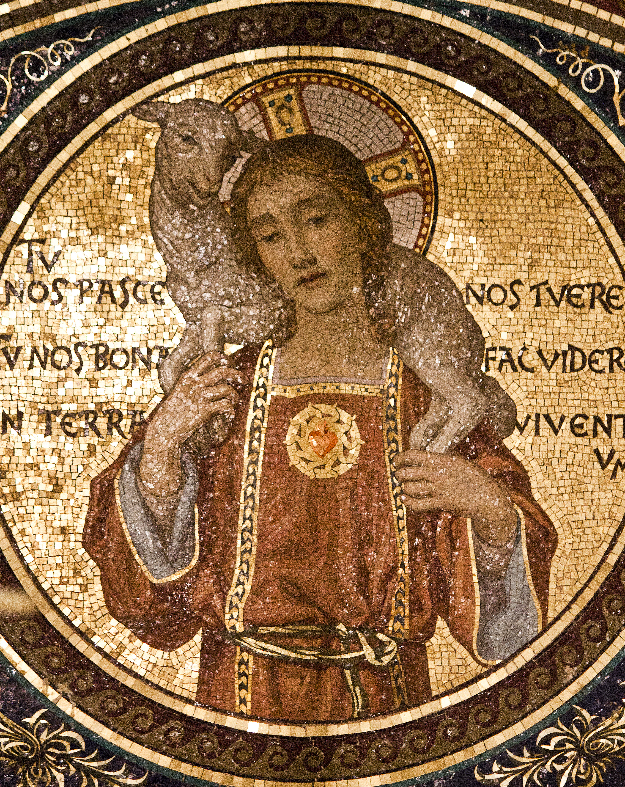
Entrance Antiphon ‡ Ps 33 (32):5-6
The merciful love of the Lord fills the earth; by the word of the Lord the heavens were made, alleluia.

We pray for the sick of our community, especially:
Pat Murphy, Ken and Toni Meek, Michael Ford, Jim Walsh, Paula Cope, Pat Barone, Josephine del Bene, Margaret Johnson, Ann Mazzella and Jeanette Heaton.

For the souls of the faithful departed: We pray for the soul of Antonio Fiaschi whose funeral occurred during the week.



Communion Antiphon ‡
The Good Shepherd has risen, who laid down his life for his sheep and willingly died for his flock, alleluia.

Christ the Good Shepherd, detail of mosaic from the Basilica of St Lawrence Outside the Walls, Rome.
(Basilica Papale di San Lorenzo fuori le Mura).
(continued)
 | Peter | Paul
Both preach Davidic covenant fulfillment | Acts 2 | Acts 13
Both perform indirect or mediated healings | Peter, by his shadow:  Acts 5:12-16 | Paul, by his handkerchief:  Acts 19:11-12
Both struggle against a magician | Peter vs. Simon Magus:  Acts 8:18-23 | Paul vs. Elymas:  Acts 13:8-12
Both dispense the Holy Spirit thru laying on of hands | Acts 8:17 | Acts 19:6
Both miraculously escape from prison | Acts 12:6-17 | Acts 16:16-34
The recalcitrance of some of the Jews is frustrating Paul and Barnabas’ attempt to restore Israel under the leadership of the anointed Son of David, Jesus of Nazareth, the “Servant of the LORD.” But the restoration of Israel was not the only mission of the Servant; the missionaries recall that the Servant was also sent to proclaim salvation to all the “nations” or “Gentiles.” They turn, then, from preaching mostly to the Jewish community, and redirect their efforts to the Gentiles. Apparently there were large numbers of these God-fearers around the Mediterranean world, because many educated Gentiles were put off by the mythology and moral degradation of pagan worship and were attracted by the coherence and moral clarity of Judaism.

First Reading ‡ Acts 13:14, 43-52
We are now turning to the gentiles.
Paul and Barnabas carried on from Perga till they reached Antioch in Pisidia. Here they went to the synagogue on the sabbath and took their seats.
When the meeting broke up, many Jews and devout converts joined Paul and Barnabas, and in their talks with them Paul and Barnabas urged them to remain faithful to the grace God has given them.
The next sabbath almost the whole town assembled to hear the word of God. When they saw the crowds, the Jews, prompted by jealousy, used blasphemies and contradicted everything Paul said. Then Paul and Barnabas spoke out boldly. ‘We had to proclaim the word of God to you first, but since you have rejected it, since you do not think yourselves worthy of eternal life, we must turn to the pagans. For this is

Gospel Acclamation
Alleluia, alleluia!
I am the good shepherd, says the Lord;
I know my sheep, and mine know me.
Alleluia!

Gospel ‡ John 10:27-30
I give my sheep eternal life.
Jesus said:
‘The sheep that belong to me listen to my voice;
I know them and they follow me.
I give them eternal life;
they will never be lost
and no one will ever steal them from me.
The Father who gave them to me is greater than anyone,
and no one can steal from the Father.
The Father and I are one.’

The Gospel of the Lord.
Praise to you, Lord Jesus Christ!

what the Lord commanded us to do when he said:
I have made you a light for the nations,
so that my salvation may reach the ends of the earth.’
It made the pagans very happy to hear this and they thanked the Lord for his message; all who were destined for eternal life became believers. Thus the word of the Lord spread through the whole countryside.
But the Jews worked upon some of the devout women of the upper classes and the leading men of the city and persuaded them to turn against Paul and Barnabas and expel them from their territory. So they shook the dust from their feet in defiance and went off to Iconium; but the disciples were filled with joy and the Holy Spirit.
The word of the Lord.
Thanks be to God.

Responsorial Psalm ‡ Psalm 99:1-3, 5.
R. We are his people, the sheep of his flock.
Cry out with joy to the Lord, all the earth.
Serve the Lord with gladness.
Come before him, singing for joy. R.

Know that he, the Lord, is God.
He made us, we belong to him,
we are his people, the sheep of his flock. R.

Indeed, how good is the Lord,
eternal his merciful love.
He is faithful from age to age. R.

Second Reading ‡ Revelation 7:9, 14-17
The Lamb who is at the throne will be their shepherd and will lead them to springs of living water.
I, John, saw a huge number, impossible to count, of people from every nation, race, tribe and language; they were standing in front of the throne and in front of the Lamb, dressed in white robes and holding palms in their hands. One of the elders said to me, ‘These are the people who have been through the great persecution, and because they have washed their robes white again in the blood of the Lamb, they now stand in front of God’s throne and serve him day and night in his sanctuary; and the One who sits on the throne will spread his tent over them. They will never hunger or thirst again; neither the sun nor scorching wind will ever plague them, because the Lamb who is at the throne will be their shepherd and will lead them to springs of living water; and God will wipe away all tears from their eyes.’
The word of the Lord.
Thanks be to God.

Page 3
Page 2

Commentary by Dr John Bergsma in http://www.thesacredpage.com/2016/04/readings-for-good-shepherd-sunday.html#more
This upcoming Lord’s Day is often known as “Good Shepherd Sunday,” since each year the Gospel reading is taken from John 10, the “Good Shepherd Discourse.” It’s also often observed as a day of prayer for vocations to the priesthood and religious life, since priests and religious are visible manifestations to us of Christ in his role as the Good Shepherd.
Most of the Readings are tied together by a shepherding theme.

1. The First Reading continues the traditional Christian practice of reading Acts during the season of Easter. We are up to Acts 13, the point in Acts where St. Luke begins to follow the career of St. Paul in a particular way.
There is a basic division of Acts into two parts: Acts 1-12 follows Peter's ministry and Acts 13-28 follows Paul's.

Luke is at pains to demonstrate that Peter and Paul are "on the same page"—they preach the same gospel. Many were accusing Paul of being an innovator in bringing the Gentiles into the Church apart from Peter. Scholars still make this accusation. Yet Luke shows that Peter and Paul are just alike in what they do and say.
This chart below shows five similarities between the two in Acts:

s://yanchepcatholic.wordpress.com/wp-admin/admin.php?pag

