Sunday Bulletin
Third Sunday of Easter
Year C
Page 4
MASS TIMES
Weekend Masses: YANCHEP: 6 p.m. Saturday Vigil, Yanchep Community Centre,
7 Lagoon Drive. GUILDERTON: 8 a.m. Sunday, Guilderton Community Hall, Wedge Street. LANCELIN: 9.45 a.m. Sunday, 33 Gingin Road, Lancelin.
Confessions: before Mass on request
Weekday Masses: Tuesday, Thursday, Friday 9 a.m. at the presbytery,
Wednesdays 3 p.m. at Bethanie Beachside Aged Care.
Priest: Fr Augustine Puthota, Presbytery: 3 Blaxland Avenue, Two Rocks, Western Australia 6037. Telephone: +61-8-9561 2172 Website: http://yanchepcatholic.org/ Email: yanchep@perthcatholic.org.au.
Please like us on Facebook: https://www.facebook.com/yanchepcatholicchurch

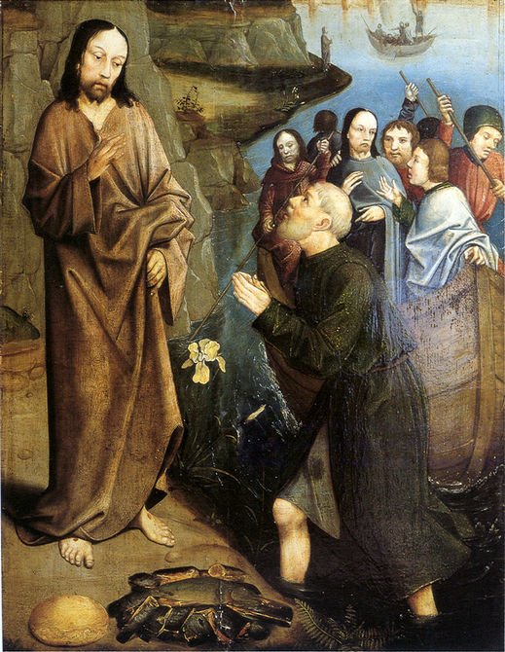
Entrance Antiphon ‡ Ps 66 (65):1-2
Cry out with joy to God, all the earth; O sing to the glory of his name. O render him glorious praise, alleluia.

We pray for the sick of our community, especially:
Pat Murphy, Ken and Toni Meek, Michael Ford, Jim Walsh, Paula Cope, Pat Barone, Josephine del Bene, Margaret Johnson, Ann Mazzella and Jeanette Heaton.

For the souls of the faithful departed: We pray for the soul of Fr Tiziano Bogoni of All Saints Chapel in Allendale Square, who died during the week.

Communion Antiphon ‡ Luke 24:35
The disciples recognised the Lord Jesus in the breaking of the bread, alleluia.



This Gospel is not only about the primacy of Peter. It is also about the primacy of love. During the “audience” between Jesus and Peter (vv. 15-19), Peter’s ritual re-confirmation as chief shepherd all revolves around his love for the Lord. First, Jesus asks Peter, “Do you love me more than these?” The question is ambiguous. Who are the “these”? Does Jesus mean:
(1) “Do you love me more than [you love] these [other men]?” I.e. Do you love me above all other persons in your life?
(2) “Do you love me more than these [fish]?” I.e. Do you love me more than you profession, your way of life, your livelihood, your “comfort zone”?
(3) “Do you love me more than these [other men do]?” I.e. Do you have greater love for me than others do? Do you excel in love, so as to be suitable to excel also in authority?
Ambiguity abounds in the Gospel of John, and I think it is intentional. All three meanings may well be meant. Jesus is eliciting from Peter a comprehensive love to correspond to the comprehensive role of shepherding that he will bestow.
Three times Jesus asks about Peter’s love; three times he affirms it. Two different words for “love” are used in the Greek. The first two times, Jesus asks Peter, “Do you agape me?” Agape is the word for divine love. Peter always answers, “I phileo you.” Phileo is the Greek word for fraternal love. The last time, Jesus adopts Peter’s term and asks, “Do you phileo me?” This gives the impression that Jesus asks twice, Do you love me with divine love? And Peter responds twice, “I love you with brotherly love.” And at last Jesus condescends to Peter’s capabilities, “Do you love me with brotherly love?”, thus implying that such love will suffice: Jesus will accept what Peter, no longer brash and now painfully cognizant of his human weakness, knows he can offer. (Read more from Dr John Bergsma at www.thesacredpage.com. )

The Third Appearance of Christ, Dieric Bouts, 1415-1475, private collection.

First Reading ‡ Acts 5: 27-32, 40-41
We are witnesses of these words, and so is the Holy Spirit.
The high priest demanded an explanation of the apostles. ‘We gave you a formal warning,’ he said ‘not to preach in this name, and what have you done? You have filled Jerusalem with your teaching, and seem determined to fix the guilt of this man’s death on us.’
In reply Peter and the apostles said, ‘Obedience to God comes before obedience to men; it was the God of our ancestors who raised up Jesus, but it was you who had him executed by hanging on a tree. By his own right hand God has now raised him up to be leader and saviour, to give repentance and forgiveness of sins through him to Israel. We are witnesses to all this, we and the Holy Spirit whom God has given to

Gospel ‡ John 21:1-19
Jesus stepped forward, took the bread and gave it to them, and did the same with the fish.
Jesus showed himself again to his disciples. It was by the Sea of Tiberias, and it happened like this: Simon Peter, Thomas called the Twin, Nathanael from Cana in Galilee, the sons of Zebedee and two more of his disciples were together. Simon Peter said, ‘I’m going fishing.’ They replied, ‘We’ll come with you.’ They went out and got into the boat but caught nothing that night.
It was light by now and there stood Jesus on the shore, though the disciples did not realise that it was Jesus. Jesus called out, ‘Have you caught anything, friends?’ And when they answered, ‘No,’ he said, ‘Throw the net out to starboard and you’ll find something.’ So they dropped the net, and there were so many fish that they could not haul it in. The disciple Jesus loved said to Peter, ‘It is the Lord.’
At these words ‘It is the Lord,’ Simon Peter, who had practically nothing on, wrapped his cloak round him and jumped into the water. The other disciples came on in the boat, towing the net and the fish; they were only about a hundred yards from land.
As soon as they came ashore they saw that there was some bread there, and a charcoal fire with fish cooking on it. Jesus said, ‘Bring some of the fish you have just caught.’ Simon Peter went aboard and dragged the net to the shore, full of big fish, one hundred and fifty-three of them; and in spite of there being so many the net was not broken. Jesus said to them, ‘Come and have breakfast.’
None of the disciples was bold enough to ask, ‘who are you?’; they knew quite well it was the Lord. Jesus then stepped forward, took the bread and gave it to them, and the same with the fish. This was the third time that Jesus showed himself to the disciples after rising from the dead.
After the meal Jesus said to Simon Peter, ‘Simon son of John, do you love me more than these others do?’ He answered, ‘Yes Lord, you know I love you.’ Jesus said to him, ‘Feed my lambs.’
A second time he said to him, ‘Simon son of John, do you love me?’ He replied ‘Yes, Lord, you know I love you.’ Jesus said to him, ‘Look after my sheep.’
Then he said to him a third time, ‘Simon son of John, do you love me?’ Peter was upset that he asked him the third time, ‘Do you love me?’ and said, ‘Lord, you know everything; you know that I love you.’ Jesus said to him, ‘Feed my sheep.
‘I tell you most solemnly,
when you were young
you put on your own belt
and walked where you liked;
but when you grow old
you will stretch out your hands,
and somebody else will put a belt around you
and take you where you would rather not go.’
In these words he indicated the kind of death by which Peter would give glory to God. After this he said, ‘Follow me.’
The Gospel of the Lord.
Praise to you, Lord Jesus Christ!

The Gospel of the Lord.
Praise to you, Lord Jesus Christ.

those who obey him.’
They warned the apostles not to speak in the name of Jesus and released them. And so they left the presence of the Sanhedrin glad to have had the honour of suffering humiliation for the sake of the name.
The word of the Lord.
Thanks be to God.

Responsorial Psalm ‡ Psalm 29:2, 4-6, 11-13.
R. I will praise you, Lord, for you have rescued me.

I will praise you, Lord, you have rescued me
and have not let my enemies rejoice over me.
O Lord, you have raised my soul from the dead,
restored me to life from those who sink into the grave. R.

Sing psalms to the Lord, you who love him,
give thanks to his holy name.
His anger lasts but a moment; his favour through life.
At night there are tears, but joy comes with dawn. R.

The Lord listened and had pity.
The Lord came to my help.
For me you have changed my mourning into dancing;
O Lord my God, I will thank you for ever. R.

Second Reading ‡ Revelation 5:11-14
The Lamb that was sacrificed is worthy to be given power, wealth, glory, and blessing.
In my vision, I, John, heard the sound of an immense number of angels gathered round the throne and the animals and the elders; there were ten thousand times ten thousand of them and thousands upon thousands, shouting, ‘The Lamb that was sacrificed is worthy to be given power, riches, wisdom, strength, honour, glory and blessing.’
Then I heard all the living things in creation — everything that lives in the air, and on the ground, and under the ground, and in the sea, crying, ‘To the One who is sitting on the throne and to the Lamb, be all praise, honour, glory and power, for ever and ever.’ And the four animals said, ‘Amen’; and the elders prostrated themselves to worship.
The word of the Lord.
Thanks be to God.
Gospel Acclamation
Alleluia, alleluia!
Christ is risen, the Lord of all creation;
he has shown pity on all people.
Alleluia!

Page 3
Page 2

https://yanchepcatholic.wordpress.com/wp-admin/admin.php?pag

