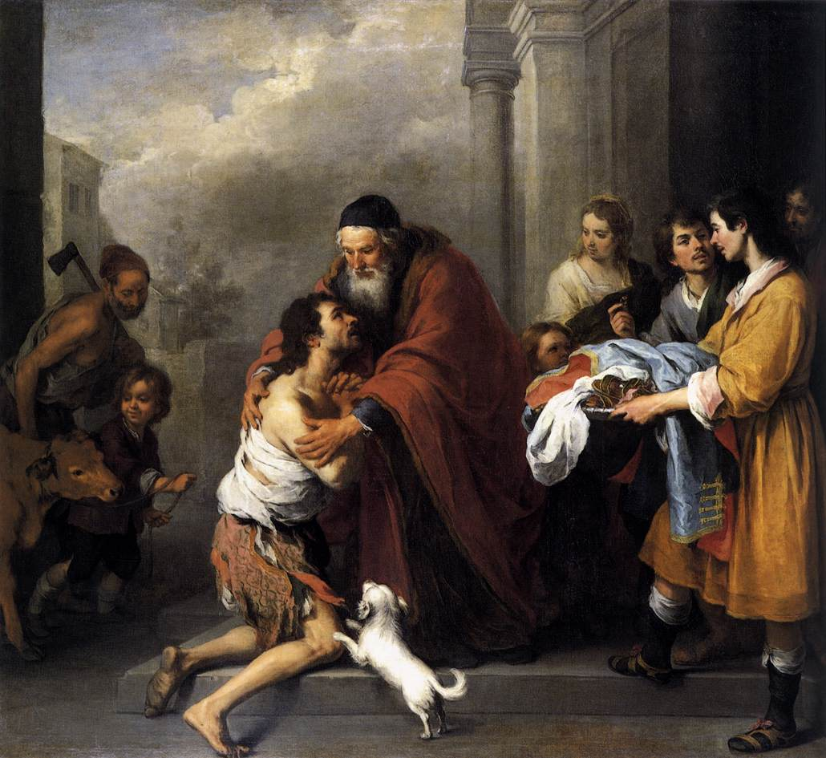
Sunday Bulletin
Fourth
Sunday of Lent
Year C
Page 4
MASS TIMES
Weekend Masses: YANCHEP: 6 p.m. Saturday Vigil, Yanchep Community Centre,
7 Lagoon Drive. GUILDERTON: 8 a.m. Sunday, Guilderton Community Hall, Wedge Street. LANCELIN: 9.45 a.m. Sunday, 33 Gingin Road, Lancelin.
Confessions: before Mass on request
Weekday Masses: Tuesday, Thursday, Friday 9 a.m. at the presbytery,
Wednesdays 3 p.m. at Bethanie Beachside Aged Care.
Priest: Fr Augustine Puthota, Presbytery: 3 Blaxland Avenue, Two Rocks, Western Australia 6037. Telephone: +61-8-9561 2172 Website: http://yanchepcatholic.org/ Email: yanchep@perthcatholic.org.au.
Please like us on Facebook: https://www.facebook.com/yanchepcatholicchurch

We pray for the sick of our community, especially:
Pat Murphy, Ken and Toni Meek, Michael Ford, Jim Walsh, Paula Cope, Pat Barone, Josephine del Bene, Margaret Johnson, Ann Mazzella and Jeanette Heaton.

For the souls of the faithful departed: We pray for the soul of Deirdre’s mother, Delores Servais, who passed away peacefully on Wednesday.
Eternal rest grant unto her, O Lord, and may perpetual light shine upon her. May she rest in peace.

Thank you to Fr John Paul from the Holy Spirit Chapel in Joondalup for filling in for Fr Augustine while he is overseas.

Communion Antiphon ‡ Luke 15:32
You must rejoice, my son, for your brother was dead and has come to life; he was lost and is found.

Prayer to the Most Holy Redeemer
Soul of Christ, sanctify me.
Body of Christ, save me.
Blood of Christ, embolden me.
Water from the side of Christ, wash me.
Passion of Christ, strengthen me.
O Good Jesus, hear me.
Within your wounds hide me.
Never permit me to be parted from you.
From the evil Enemy defend me.
At the hour of my death call me
and bid me come to you,
that with your Saints I may praise you
For age upon age.
Amen.

Entrance Antiphon ‡ Isaiah 66:10-11
Rejoice, Jerusalem, and all who love her. Be joyful, all who were in mourning; exult and be satisfied at her consoling breast.

The Return of the Prodigal Son, 1667-1670, Bartolomé Esteban Murillo, oil on canvas, National Gallery of Art, Washington.

First Reading ‡ Joshua 5:9-12
The people of God went to the promised land and there kept the passover.
The Lord said to Joshua, ‘Today I have taken the shame of Egypt away from you.’
The Israelites pitched their camp at Gilgal and kept the Passover there on the fourteenth day of the month, at evening in the plain of Jericho. On the morrow of the Passover they tasted the produce of that country, unleavened bread and roasted ears of corn, that same day. From that time, from their first eating of the produce of that

Gospel ‡ Luke 15:1-3, 11-32
Your brother here was dead and has come to life.
The tax collectors and the sinners were all seeking the company of Jesus to hear what he had to say, and the Pharisees and the scribes complained. ‘This man,’ they said, ‘welcomes sinners and eats with them.’ So he spoke this parable to them:
‘A man had two sons. The younger said to his father, “Father, let me have the share of the estate that would come to me.”
So the father divided the property between them. A few days later, the younger son got together everything he had and left for a distant country where he squandered his money on a life of debauchery.
‘When he had spent it all, that country experienced a severe famine, and now he began to feel the pinch, so he hired himself out to one of the local inhabitants who put him on his farm to feed the pigs. And he would willingly have filled his belly with the husks the pigs were eating but no one offered him anything. Then he came to his senses and said, “How many of my father’s paid servants have more food than they want, and here am I dying of hunger! I will leave this place and go to my father and say: Father, I have sinned against heaven and against you; I no longer deserve to be called your son; treat me as one of your paid servants.” So he left the place and went back to his father.
‘While he was still a long way off, his father saw him and was moved with pity. He ran to the boy, clasped him in his arms and kissed him tenderly. Then his son said, “Father, I have sinned against heaven and against you. I no longer deserve to be called your son.”
But the father said to his servants, “Quick! Bring out the best robe and put it on him; put a ring on his finger and sandals on his feet. Bring the calf we have been fattening, and kill it; we are going to have a feast, a celebration, because this son of mine was dead and has come back to life; he was lost and is found.” And they began to celebrate.
‘Now the elder son was out in the fields, and on his way back, as he drew near the house, he could hear music and dancing. Calling one of the servants he asked what it was all about, “Your brother has come” replied the servant “and your father has killed the calf we had fattened because he has got him back safe and sound.”
He was angry then and refused to go in, and his father came out to plead with him; but he answered his father, “Look, all these years I have slaved for you and never once disobeyed your orders, yet you never offered me so much as a kid for me to celebrate with my friends. But, for this son of yours, when he comes back after swallowing up your property — he and his women — you kill the calf we had been fattening.”
‘The father said, “My son, you are with me always and all I have is yours. But it was only right we should celebrate and rejoice, because your brother here was dead and has come to life; he was lost and is found.”’

The Gospel of the Lord.
Praise to you, Lord Jesus Christ.

country, the manna stopped falling. And having manna no longer, the Israelites fed from that year onwards on what the land of Canaan yielded.
The word of the Lord.
Thanks be to God.

Responsorial Psalm ‡ Psalm 33: 2-7
R. Taste and see the goodness of the Lord.

I will bless the Lord at all times,
his praise always on my lips;
In the Lord my soul shall make its boast.
The humble shall hear and be glad. R.

Glorify the Lord with me.
Together let us praise his name.
I sought the Lord and he answered me;
from all my terrors he set me free. R.

Look towards him and be radiant;
let your faces not be abashed.
This poor man called; the Lord heard him
and rescued him from all his distress. R.

Second Reading ‡ 2 Corinthians 5: 17-21
God reconciled us to himself through Christ.

For anyone who is in Christ, there is a new creation; the old creation has gone, and now the new one is here. It is all God’s work. It was God who reconciled us to himself through Christ and gave us the work of handing on this reconciliation. In other words, God in Christ was reconciling the world to himself, not holding men’s faults against them, and he has entrusted to us the news that they are reconciled. So we are ambassadors for Christ; it is as though God were appealing through us, and the appeal that we make in Christ’s name is: be reconciled to God. For our sake God made the sinless one into sin, so that in him we might become the goodness of God.
The word of the Lord.
Thanks be to God.

Gospel Acclamation ‡ Luke 15:18
Praise and honour to you, Lord Jesus Christ!
I will rise and go to my Father and tell him:
Father, I have sinned against heaven and against you.
Praise and honour to you, Lord Jesus Christ!

Page 3
Page 2

https://yanchepcatholic.wordpress.com/wp-admin/admin.php?pag

