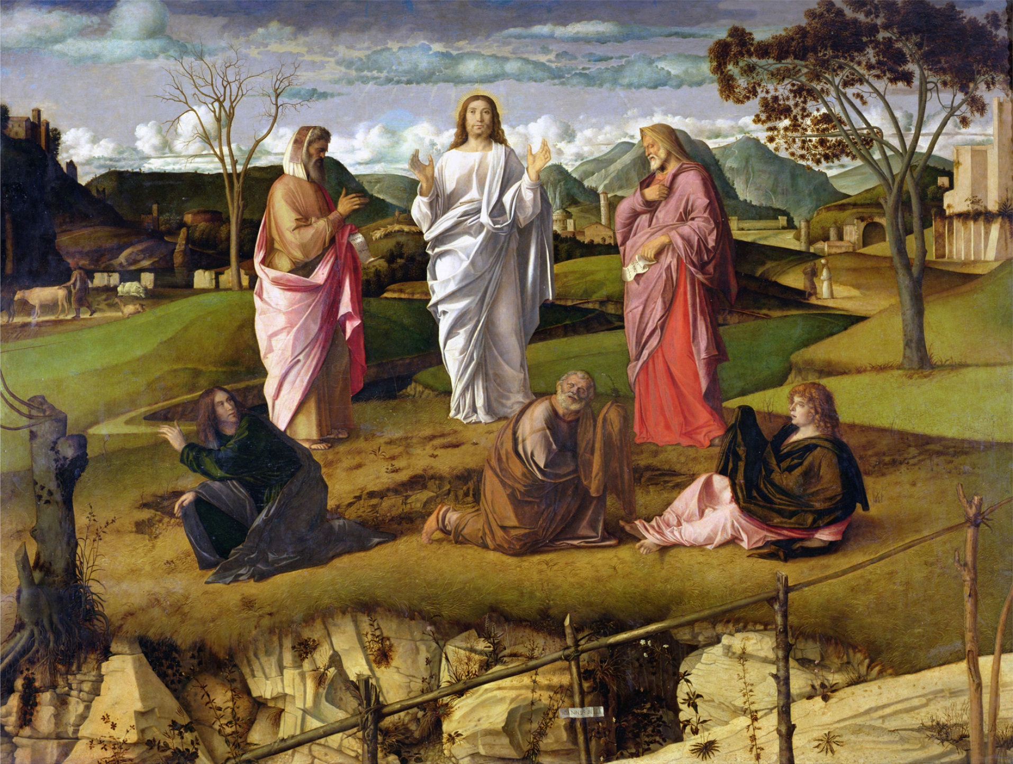
Sunday Bulletin
Second Sunday of Lent
Year C
Page 4
MASS TIMES
Weekend Masses: YANCHEP: 6 p.m. Saturday Vigil, Yanchep Community Centre,
7 Lagoon Drive. GUILDERTON: 8 a.m. Sunday, Guilderton Community Hall, Wedge Street. LANCELIN: 9.45 a.m. Sunday, 33 Gingin Road, Lancelin.
Confessions: before Mass on request
Weekday Masses: Tuesday, Thursday, Friday 9 a.m. at the presbytery,
Wednesdays 3 p.m. at Bethanie Beachside Aged Care.
Priest: Fr Augustine Puthota, Presbytery: 3 Blaxland Avenue, Two Rocks, Western Australia 6037. Telephone: +61-8-9561 2172 Website: http://yanchepcatholic.org/ Email: yanchep@perthcatholic.org.au.
Please like us on Facebook: https://www.facebook.com/yanchepcatholicchurch

We pray for the sick of our community, especially:
Pat Murphy, Ken and Toni Meek, Delores Servais, Michael Ford, Jim Walsh, Paula Cope, Pat Barone, Josephine del Bene, Margaret Johnson and Ann Mazzella.

We pray for the souls of Len Sims, Kathleen Garbutt and James Robinson of Yanchep who passed away recently. We also pray for the souls of Ian Kinner and Marion Ferguson whose anniversaries occur about this time.

Thank you to Fr John Paul from the Holy Spirit Chapel in Joondalup for filling in for Fr Augustine while he is overseas.

Communion Antiphon ‡ Matthew 17:5
This is my beloved Son, with whom I am well pleased; listen to him.

(Commentary continued) cannot except the restrictions on their gluttony, their drinking, or their sexual habits that following Jesus requires. Such folk regard unrestrained indulgence of their physical desires as “freedom,” but in fact it is a slavery to their passions, a “slavery” that St. Paul describes as a form of false religion: “Their god is their stomach.” By giving in to constant physical pleasures, they worship their appetites.
St. Paul is, of course, describing contemporary Western culture. Statistics say 77% of Americans watch internet porn at least once a month. Obesity is rampant and increasing. About one-quarter of the adult population engages in binge drinking. And why not? Since the state-funded public school system teaches all children that humans are essentially biological robots … why shouldn't we just try to have as much physical pleasure during our brief and meaningless lives?
Getting back to St. Paul and his words to the Philippians, we notice that he promises us freedom from slavery to the body by the power of Jesus. Jesus has the power to transform our lowly bodies—with all their unruly desires—to be like his glorious body. And this is a process that starts even now. Through the disciplines of Lent—prayer, fasting, and almsgiving—we learn freedom from domination by our bodily desires. We learn to be like Christ, to “bring all things into subjection” to him, including our disordered passions.

Entrance Antiphon ‡ Psalm 27 (26): 8-9
Of you my heart has spoken, Seek his face. It is your face, O Lord, that I seek; hide not your face from me.

The Transfiguration, Giovanni Bellini, c.1480, Oil on panel, Museo di Capodimonti, Naples.

First Reading ‡ Genesis 15:5-12, 17-18.
God made a covenant with Abraham, his faithful servant.
Taking Abram outside the Lord said, ‘Look up to heaven and count the stars if you can. Such will be your descendants’ he told him. Abram put his faith in the Lord, who counted this as making him justified.
‘I am the Lord’ he said to him ‘who brought you out of Ur of the Chaldaeans to make you heir to this land.’
‘My Lord, the Lord’ Abram replied ‘how am I to know that I shall inherit it?’ He said to him, ‘Get me a three-year-old heifer, a three-year-old goat, a three-year-old ram, a turtledove and a young pigeon.’
He brought him all these, cut them in half and put half on one side and half facing it

Jesus Christ, and he will transfigure these wretched bodies of ours into copies of his glorious body. He will do that by the same power with which he can subdue the whole universe.
So then, my brothers and dear friends, do not give way but remain faithful in the Lord. I miss you very much, dear friends; you are my joy and my crown.

The word of the Lord.
Thanks be to God.
Gospel Acclamation ‡ Matthew 17:5
Glory and praise to you, Lord Jesus Christ!
No one lives on bread alone,
but on every word that comes from the mouth of God.
Glory and praise to you, Lord Jesus Christ!

Gospel ‡ Luke 9:28-36
As Jesus prayed, the aspect of his face was changed,and his clothing became brilliant as lightning.
Jesus took with him Peter and John and James and went up the mountain to pray. As he prayed, the aspect of his face was changed and his clothing became brilliant as lightning. Suddenly there were two men there talking to him; they were Moses and Elijah appearing in glory, and they were speaking of his passing which he was to accomplish in Jerusalem. Peter and his companions were heavy with sleep, but they kept awake and saw his glory and the two men standing with him. As these were leaving him, Peter said to Jesus,
‘Master, it is wonderful for us to be here; so let us make three tents, one for you, one for Moses and one for Elijah.’
— He did not know what he was saying. As he spoke, a cloud came and covered them with shadow; and when they went into the cloud the disciples were afraid. And a voice came from the cloud saying, ‘This is my Son, the Chosen One. Listen to him’. And after the voice had spoken, Jesus was found alone. The disciples kept silence and, at that time, told no one what they had seen.
The Gospel of the Lord.
Praise to you, Lord Jesus Christ.

Page 3
Page 2

on the other; but the birds he did not cut in half. Birds of prey came down on the carcasses but Abram drove them off.
Now as the sun was setting Abram fell into a deep sleep, and terror seized him. When the sun had set and darkness had fallen, there appeared a smoking furnace and a firebrand that went between the halves. That day the Lord made a Covenant with Abram in these terms:
‘To your descendants I give this land,
from the wadi of Egypt to the Great River.’
The word of the Lord.
Thanks be to God.

Responsorial Psalm ‡ Psalm 26: 1, 7-9, 13-14.
R. The Lord is my light and my salvation.

The Lord is my light and my help;
whom shall I fear?
The Lord is the stronghold of my life;
before whom shall I shrink? R.

O Lord, hear my voice when I call;
have mercy and answer.
Of you my heart has spoken:
‘Seek his face.’ R.

It is your face, O Lord, that I seek;
hide not your face.
Dismiss not your servant in anger;
you have been my help. R.

I am sure I shall see the Lord’s goodness
in the land of the living.
Hope in him, hold firm and take heart.
Hope in the Lord! R.

Second Reading ‡ Phillipians 3:17 – 4:1
Christ will transfigure these bodies of ours into copies of his glorious body.
My brothers, be united in following my rule of life. Take as your models everybody who is already doing this and study them as you used to study us. I have told you often, and I repeat it today with tears, there are many who are behaving as the enemies of the cross of Christ. They are destined to be lost. They make foods into their god and they are proudest of something they ought to think shameful; the things they think important are earthly things. For us, our homeland is in heaven, and from heaven comes the saviour we are waiting for, the Lord

https://yanchepcatholic.wordpress.com/wp-admin/admin.php?pag

Commentary on the Second Reading by Dr John Bergsma at http://www.thesacredpage.com/2016/02/beginning-new-exodus-2nd-sunday-of-lent.html#more.
In keeping with the theme of slavery and liberation from it, St. Paul here describes people who live in slavery to their physical desires: “many .. conduct themselves as enemies of the cross... their god is their stomach, their glory is their shame.”
These people are “enemies of the cross.” This means, among other things, they resist any form of suffering or self-denial. They do not embrace Jesus teaching that “Whoever would come after me, must take up his cross daily and follow me.” They

