Fifth Sunday in Ordinary Time
Year C
Sunday Bulletin
Page 4
MASS TIMES
Weekend Masses: YANCHEP: 6 p.m. Saturday Vigil, Yanchep Community Centre,
7 Lagoon Drive. GUILDERTON: 8 a.m. Sunday, Guilderton Community Hall, Wedge Street. LANCELIN: 9.45 a.m. Sunday, 33 Gingin Road, Lancelin.
Confessions: before Mass on request
Weekday Masses: Tuesday, Thursday, Friday 9 a.m. at the presbytery,
Wednesdays 3 p.m. at Bethanie Beachside Aged Care.
Priest: Fr Augustine Puthota, Presbytery: 3 Blaxland Avenue, Two Rocks, Western Australia 6037. Telephone: +61-8-9561 2172 Website: http://yanchepcatholic.org/ Email: yanchep@perthcatholic.org.au.
Please like us on Facebook: https://www.facebook.com/yanchepcatholicchurch

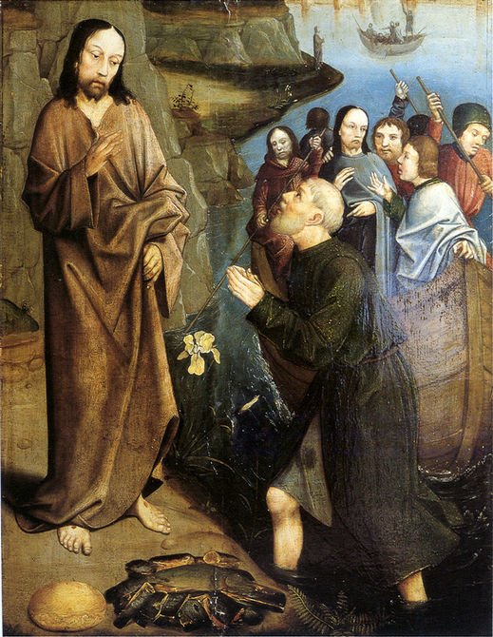
Third Appearance of Christ, Dieric Bouts, 1415-1475

We pray for the sick of our community, especially:
Pat Murphy, Ken and Toni Meek, Delores Servais, Michael Ford, Jim Walsh, Paula Cope, Pat Barone, Josephine del Bene, Margaret Johnson and Ann Mazzella.



We pray for the souls of Len Sims, Kathleen Garbutt and James Robinson of Yanchep who passed away recently. We also pray for the souls of Ian Kinner and Marion Ferguson whose anniversaries occur about this time.
V. Eternal rest grant unto them, O Lord.
R. And let perpetual light shine upon them.
And may the souls of all the faithful departed, through the mercy of God, rest in peace. Amen.

Communion Antiphon ‡ Psalm 107 (106): 8-9
Let them thank the Lord for his mercy, his wonders for the children of men, for he satisfies the thirsty soul, and the hungry he fills with good things.
Entrance Antiphon ‡ Psalm 95 (94): 6-7
O come, let us worship God and bow low before the God who made us, for he is the Lord our God.

Reflection from Dr John Bergsma at http://www.thesacredpage.com/2016/02/awe-and-apostolate-readings-for-5th.html#more. Peter is reluctant to obey Jesus’ command. Who is this rabbi from Nazareth who thinks he knows about fishing? First of all, the prime time for fishing was at night, and Simon and his co-workers had already laboured all night and there were no fish to be had. If there were no fish at night, there certainly won’t be any in broad daylight, in the afternoon. Secondly, the better places for fishing were close to the shore, where there were plenty of plants for the fish to feed on, not out in the relatively empty deep water. The rabbi from Nazareth wants them to go on a fool’s mission, getting their just-cleaned nets dirty again in a vain effort. Nonetheless, Simon defers to Jesus’ wishes. Is it the force of Jesus’ personality? A “sixth sense” that this is no ordinary rabbi? Deference for the public prestige that Jesus has gained? An unwillingness to publically oppose a clergyman renowned for his healings and teachings?
When he sees the catch of fish, Simon realizes he is in the presence of no ordinary teacher. This man has control over the forces of nature: he seems to have compelled to the fish to swarm in a place in the lake and at a time that was contrary to their natural habits. No one can wield such power unless he has received it from God. In the face of God’s presence in the person of this rabbi Jesus, Peter is overcome with a sense of his own smallness, and perhaps also with shame for having doubted Jesus’ wisdom and abilities just a few moments before.

First Reading ‡ Isaiah 6:1-8
Here am I! Send me.
In the year of King Uzziah’s death I saw the Lord seated on a high throne; his train filled the sanctuary; above him stood seraphs, each one with six wings.
And they cried out one to another in this way,
‘Holy, holy, holy is the Lord of hosts.
His glory fills the whole earth.’

you received and in which you are firmly established; because the gospel will save you only if you keep believing exactly what I preached to you — believing anything else will not lead to anything.
Well then, in the first place, I taught you what I had been taught myself, namely that Christ died for our sins, in accordance with the scriptures; that he was buried; and that he was raised to life on the third day, in accordance with the scriptures; that he appeared first to Cephas and secondly to the Twelve. Next he appeared to more than five hundred of the brothers at the same time, most of whom are still alive, though some have died; then he appeared to James, and then to all the apostles; and last of all he appeared to me too; it was as though I was born when no one expected it.
I am the least of the apostles; in fact, since I persecuted the Church of God, I hardly deserve the name apostle; but by God’s grace that is what I am, and the grace that he gave me has not been fruitless. On the contrary, I, or rather the grace of God that is with me, have worked harder than any of the others; but what matters is that I preach what they preach, and this is what you all believed.
The word of the Lord.
Thanks be to God.
Gospel Acclamation ‡ Matthew 4:19
Alleluia, alleluia!
Come follow me, says the Lord,
and I will make you fishers of my people.
Alleluia!
Gospel ‡ Luke 5:1-11
They left everything and followed him.
Jesus was standing one day by the Lake of Gennesaret, with the crowd pressing round him listening to the word of God, when he caught sight of two boats close to the bank. The fishermen had gone out of them and were washing their nets. He got into one of the boats — it was Simon’s — and asked him to put out a little from the shore. Then he sat down and taught the crowds from the boat.
When he had finished speaking he said to Simon, ‘Put out into deep water and pay out your nets for a catch.’ ‘Master,’ Simon replied ‘we worked hard all night long and caught nothing, but if you say so, I will pay out the nets.’ And when they had done this they netted such a huge number of fish that their nets began to tear, so they signalled to their companions in the other boat to come and help them; when these came, they filled the two boats to sinking point.
When Simon Peter saw this he fell at the knees of Jesus saying, ‘Leave me, Lord; I am a sinful man.’ For he and all his companions were completely overcome by the catch they had made; so also were James and John, sons of Zebedee, who were Simon’s partners.
But Jesus said to Simon, ‘Do not be afraid; from now on it is men you will catch.’ Then, bringing their boats back to land, they left everything and followed him.
The Gospel of the Lord.
Praise to you, Lord Jesus Christ.

Page 3
Page 2

The foundations of the threshold shook with the voice of the one who cried out, and the Temple was filled with smoke. I said:
‘What a wretched state I am in! I am lost,
for I am a man of unclean lips
and I live among a people of unclean lips,
and my eyes have looked at the King, the Lord of hosts.’
Then one of the seraphs flew to me, holding in his hand a live coal which he had taken from the altar with a pair of tongs. With this he touched my mouth and said:
‘See now, this has touched your lips,
your sin is taken away,
your iniquity is purged.’
Then I heard the voice of the Lord saying:
‘Whom shall I send? Who will be our messenger?’
I answered, ‘Here I am, send me.’
The word of the Lord.
Thanks be to God.

Responsorial Psalm ‡ Psalm 137: 1-5, 7-8
R. In the sight of the angels I will sing your praises, Lord.

I thank you, Lord, with all my heart,
you have heard the words of my mouth.
Before the angels I will bless you.
I will adore before your holy temple. R.

I thank you for your faithfulness and love
which excel all we ever knew of you.
On the day I called, you answered;
you increased the strength of my soul. R.

All earth’s kings shall thank you
when they hear the words of your mouth.
They shall sing of the Lord’s ways:
‘How great is the glory of the Lord!’ R.

You stretch out your hand and save me,
your hand will do all things for me.
Your love, O Lord, is eternal,
discard not the work of your hands. R.

Second Reading ‡ 1 Corinthians 15:1-11
I preach what they preach, and this is what you believe.
Brothers, I want to remind you of the gospel I preached to you, the gospel that

https://yanchepcatholic.wordpress.com/wp-admin/admin.php?pag

