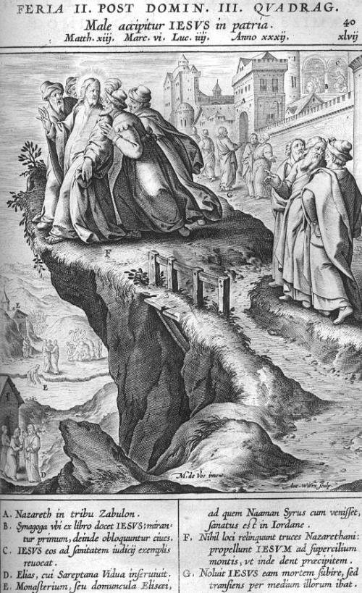
Male accipitur Jesus in patria (Jesus is rejected in his hometown), Jerome Nadal, S.J., first published in Evangeliae Historiae Imagines (1593), woodcut.
Fourth Sunday in Ordinary Time Year C
Page 4
MASS TIMES
Weekend Masses: YANCHEP: 6 p.m. Saturday Vigil, Yanchep Community Centre,
7 Lagoon Drive. GUILDERTON: 8 a.m. Sunday, Guilderton Community Hall, Wedge Street. LANCELIN: 9.45 a.m. Sunday, 33 Gingin Road, Lancelin.
Confessions: before Mass on request
Weekday Masses: Tuesday, Thursday, Friday 9 a.m. at the presbytery,
Wednesdays 3 p.m. at Bethanie Beachside Aged Care.
Priest: Fr Augustine Puthota, Presbytery: 3 Blaxland Avenue, Two Rocks, Western Australia 6037. Telephone: +61-8-9561 2172 Website: http://yanchepcatholic.org/ Email: yanchep@perthcatholic.org.au.
Please like us on Facebook: https://www.facebook.com/yanchepcatholicchurch

Sunday Bulletin

We pray for the sick of our community, especially:
Pat Murphy, Ken and Toni Meek, Delores Servais, Michael Ford, Jim Walsh, Paula Cope, Pat Barone, Josephine del Bene and Margaret Johnson.

Entrance Antiphon ‡ Psalm 106 (105): 47
Save us, O Lord our God! And gather us from the nations, to give thanks to your holy name, and make it our glory to praise you.

We pray for the souls of Len Sims, Kathleen Garbutt and James Robinson of Yanchep who passed away recently. We also pray for the souls of Ian Kinner and Marion Ferguson whose anniversaries occur about this time.
V. Eternal rest grant unto them, O Lord.
R. And let perpetual light shine upon them.
And may the souls of all the faithful departed, through the mercy of God, rest in peace. Amen.

Communion Antiphon ‡ Psalm 31 (30): 17-18
Let your face shine on your servant. Save me in your merciful love. O Lord, let me never be put to shame, for I call on you.

First Reading ‡ Jeremiah 1:4-5, 17-19
I have appointed you as prophet to the nations.
In the days of Josiah, the word of the Lord was addressed to me, saying,
‘Before I formed you in the womb I knew you;
before you came to birth I consecrated you;
I have appointed you as prophet to the nations.
So now brace yourself for action.
Stand up and tell them all I command you.

Reflection from Dr John Bergsma at http://www.thesacredpage.com/2016/01/why-good-person-is-rejected-4th-sunday.html#more
This Reading from St. Paul offers an important balancing perspective to the lessons on persecution from the First Reading and Gospel. In the face of persecution, it is easy to become bitter, self-righteous, and hateful toward the persecutors. St. Paul reminds us “love does not brood over injury … Love bears all things … endures all things.” The Christian who simply gives into self-righteous indignation and condemnation of the “wicked” in society can become like “a resounding gong or clashing cymbal”—a harsh, unpleasant sound that does not speak to the heart. The challenge for the Christian is to learn to suffer persecution while still practicing and showing love. Pope Francis makes this point in his recent letter for the start of Lent.
“Love never fails,” because it is the one virtue that will operate for eternity. Faith and hope only operate in this life, where we do not yet “see” (so we have to have faith) and we have not yet “obtained” (so we have to hope). When we see God face to face in the next life, and obtain the good things He has promised us, faith and hope will no longer be necessary—nor prophecy, nor prophetic knowledge—yet we will continue to love God and one another for all eternity.



Do not be dismayed at their presence,
or in their presence I will make you dismayed.
I, for my part, today will make you into a fortified city,
a pillar of iron,

Love is always patient and kind; it is never jealous; love is never boastful or conceited; it is never rude or selfish; it does not take offence, and is not resentful. Love takes no pleasure in other people’s sins but delights in the truth; it is always ready to excuse, to trust, to hope, and to endure whatever comes.
Love does not come to an end. But if there are gifts of prophecy, the time will come when they must fail; or the gift of languages, it will not continue for ever; and knowledge — for this, too, the time will come when it must fail. For our knowledge is imperfect and our prophesying is imperfect; but once perfection comes, all imperfect things will disappear. When I was a child, I used to talk like a child, and think like a child, and argue like a child, but now I am a man, all childish ways are put behind me. Now we are seeing a dim reflection in a mirror; but then we shall be seeing face to face. The knowledge that I have now is imperfect; but then I shall know as fully as I am known.
In short, there are three things that last: faith, hope and love; and the greatest of these is love.
The word of the Lord.
Thanks be to God.

Gospel Acclamation ‡ cf. Luke 4:18
Alleluia, alleluia!
The Lord sent me to bring Good News to the poor and freedom to prisoners.
Alleluia!

Gospel ‡ Luke 4:21-30
Jesus, like Elijah and Elisha, was not sent only to the Jews.
Jesus began to speak in the synagogue, ‘This text is being fulfilled today even as you listen.’ And he won the approval of all, and they were astonished by the gracious words that came from his lips.
They said, ‘This is Joseph’s son surely?’ But he replied, ‘No doubt you will quote me the saying, “Physician, heal yourself” and tell me, “We have heard all that happened in Capernaum, do the same here in your own countryside.”’ And he went on, ‘I tell you solemnly, no prophet is ever accepted in his own country.
‘There were many widows in Israel, I can assure you, in Elijah’s day, when heaven remained shut for three years and six months and a great famine raged throughout the land, but Elijah was not sent to any one of these: he was sent to the widow at Zarephath, a Sidonian town. And in the prophet Elisha’s time there were many lepers in Israel, but none of these was cured, except the Syrian, Naaman.’
When they head this everyone in the synagogue was enraged. They sprang to their feet and hustled him out of the town; and they took him up to the brow of the hill their town was built on, intending to throw him down the cliff, but he slipped through the crowd and walked away.
The Gospel of the Lord.
Praise to you, Lord Jesus Christ.

Page 3
Page 2

and a wall of bronze to confront all this land:
the kings of Judah, its princes,
its priests and the country people.
They will fight against you but shall not overcome you,
for I am with you to deliver you —
it is the Lord who speaks.’
The word of the Lord.
Thanks be to God.

Responsorial Psalm ‡ Psalm 70:1-6, 15, 17.

R. I will sing of your salvation.

In you, O Lord, I take refuge;
let me never be put to shame.
in your justice rescue me, free me:
pay heed to me and save me. R.

Be a rock where I can take refuge,
a mighty stronghold to save me;
for you are my rock, my stronghold.
Free me from the hand of the wicked. R.

It is you, O Lord, who are my hope,
my trust, O Lord, since my youth.
On you I have leaned from my birth,
from my mother’s womb you have been my help. R.

My lips will tell of your justice
and day by day of your help.
O God, you have taught me from my youth
and I proclaim your wonders still. R.

Second Reading ‡ 1 Corinthians 12:31 – 13:13
There are three things that last: faith, hope and love; and the greatest of these is love.
Be ambitious for the higher gifts. And I am going to show you a way that is better than any of them.
If I have all the eloquence of men or of angels, but speak without love, I am simply a gong booming or a cymbal clashing. If I have the gift of prophecy, understanding all the mysteries there are, and knowing everything, and if I have faith in all its fullness, to move mountains, but without love, then I am nothing at all. If I give away all that I possess, piece by piece, and if I even let them take my body to burn it, but am without love, it will do me no good whatever.

https://yanchepcatholic.wordpress.com/wp-admin/admin.php?pag

