Epiphany Year C
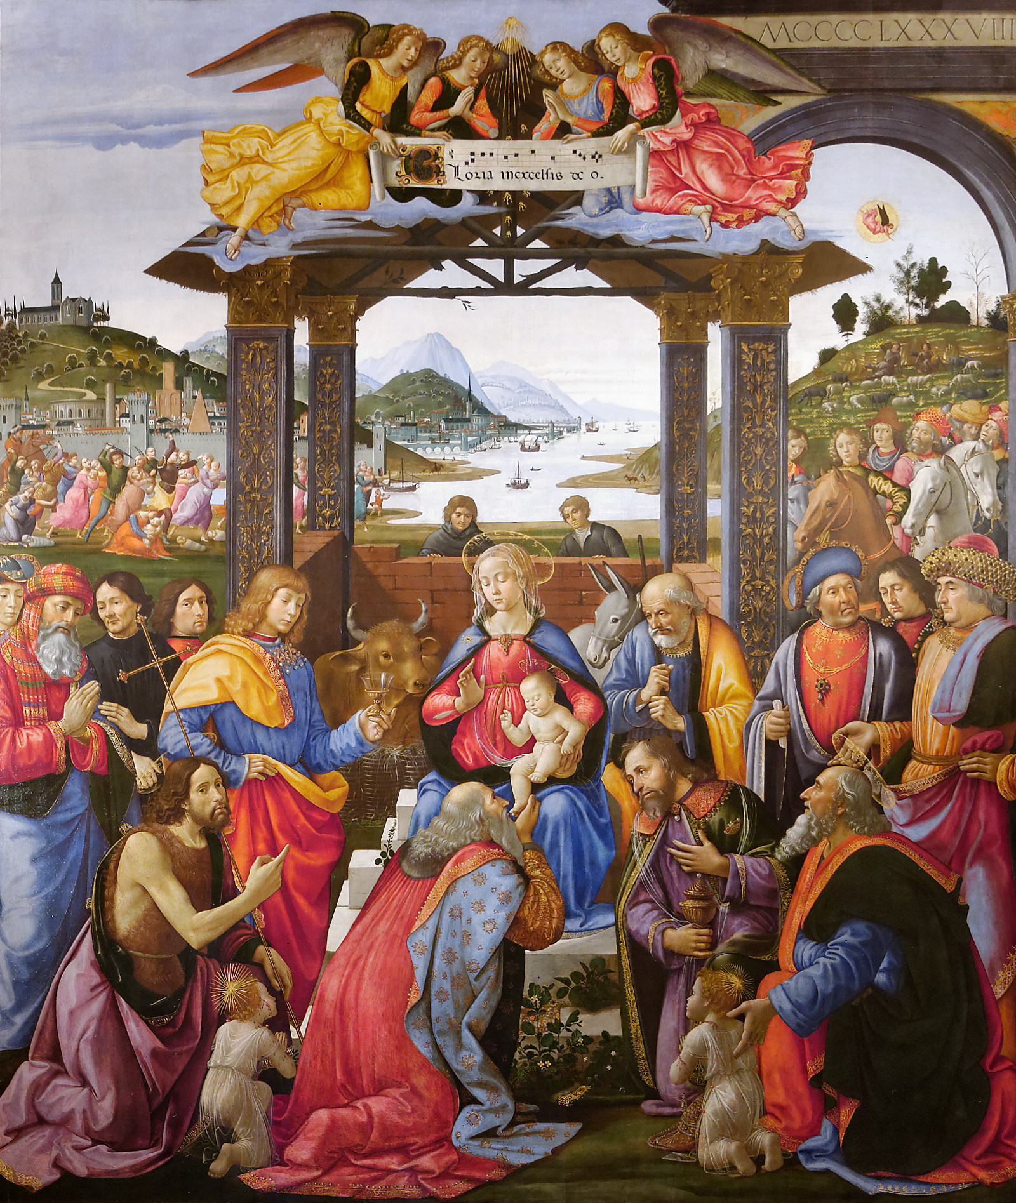
Page 4
MASS TIMES
Weekend Masses: YANCHEP: 6 p.m. Saturday Vigil, Yanchep Community Centre,
7 Lagoon Drive. GUILDERTON: 8 a.m. Sunday, Guilderton Community Hall, Wedge Street. LANCELIN: 9.45 a.m. Sunday, 33 Gingin Road, Lancelin.
Confessions: before Mass on request
Weekday Masses: Tuesday, Thursday, Friday 9 a.m. at the presbytery,
Wednesdays 3 p.m. at Bethanie Beachside Aged Care.
Priest: Fr Augustine Puthota, Presbytery: 3 Blaxland Avenue, Two Rocks, Western Australia 6037. Telephone: +61-8-9561 2172 Website: http://yanchepcatholic.org/ Email: yanchep@perthcatholic.org.au.
Please like us on Facebook: https://www.facebook.com/yanchepcatholicchurch

Sunday Bulletin
Entrance Antiphon | Cf. Mal. 3:1; 1 Chr. 29:12.
Behold, the Lord, the Mighty One, has come; and kingship is in his grasp, and power and dominion.

ICEL (2014-01-11T04:16:54+00:00). Roman Missal 3m (Kindle Locations 3578-3579). Fr Richard Healey. Kindle Edition.

We pray for the sick of our community, especially:
Pat Murphy, Ken and Toni Meek, Delores Servais, Michael Ford, Jim Walsh, Paula Cope, Pat Barone, Josephine del Bene, Len Sims and Margaret Johnson.

We pray for all departed souls from this Pastoral area, and we ask them to pray for us.
Mary Crawford, Des Elliot, Barry Murphy, Jim and Marion Ferguson, Pat O’Prey, John Sheahan, Carmen Germann, Yvonne Wytenburg, Frank and Netje Walser, Ian Kinner, Dennis Galora, Tom Cox, Alice Greig, John Bird, Ray Knapp, Giuseppe Del Bene, Bruno Rogalski, Bill Fleming, Ronnie Spratling and Karl and Mavis Gagiano.

First Reading ‡ Isaiah 60: 1-6.
Arise, shine out Jerusalem, for your light has come,
the glory of the Lord is rising on you,
though night still covers the earth and darkness the peoples.
Above you the Lord now rises and above you his glory appears.
The nations come to your light and

Communion Antiphon ‡ cf. Mt 2:2
We have seen his star in the East, and have come with gifts to adore the Lord.

ICEL (2014-01-11T04:16:54+00:00). Roman Missal 3m (Kindle Locations 3605-3606). Fr Richard Healey. Kindle Edition.

Reflection by Fr John Speekman (continued) and some become his disciples; some hate him and some worship him. Jesus is not often ignored! Take any group of people and put Jesus in their midst and soon, very soon, there is a rearrangement of relationships. Not only will some hate him but they will also begin to hate those who love him.
The wise men were pagans, gentiles, dogs (as some Jews called the gentiles). They came from far away, from the distant east. They were open-hearted, truth-seeking, adventurous. They longed to know the true God. St Augustine says in his writings: You would not be looking for him if you had not already found him. These men had already surrendered to the Lord even before they met him. No wonder they brought with them extravagant gifts of gold, frankincense and myrrh. The wise men are instantly loveable. Their trust in the guidance of the star, their humble readiness to ask for directions, their courageous journey and their generous gifts to the one they were seeking. These men were hungry for worship. They longed to see the face of the One who had been foretold and their longing was satisfied. So I say to you: Ask, and it will be given to you; search, and you will find; knock, and the door will be opened to you. (Luke 11:9)Perhaps we can conclude with another question, a question only each of us can answer for himself or herself: Where am I in my spiritual life? Am I like Herod - frightened to let go and fearful of Jesus? Am I like the elders - knowing my faith but not really letting it touch me? Am I like the wise men - thirsting to know the Lord and setting out afresh every day to draw closer to him?

Adoration of the Magi, Domenico Ghirlandaio, 1485-1488, Tempera on Panel, Ospedale degli Innocenti, Florence.

kings to your dawning brightness.
Lift up your eyes and look round:
all are assembling and coming towards you,
your sons from far away and daughters being tenderly carried.
At this sight you will grow radiant,
your heart throbbing and full;
since the riches of the sea will flow to you;
the wealth of the nations come to you;
camels in throngs will cover you,

Gospel Acclamation ‡ Matthew 2:2
Alleluia, alleluia!
We have seen his star in the East;
and have come to adore the Lord.
Alleluia!
Gospel ‡ Matthew 2: 1-12.
We have come from the East to worship the king.

After Jesus had been born at Bethlehem in Judaea during the reign of King Herod, some wise men came to Jerusalem from the east.
‘Where is the infant king of the Jews?’ they asked. ‘We saw his star as it rose and have come to do him homage.’
When King Herod heard this he was perturbed, and so was the whole of Jerusalem. He called together all the chief priests and the scribes of the people, and enquired of them where the Christ was to be born. ‘At Bethlehem in Judaea,’ they told him ‘for this is what the prophet wrote:
And you, Bethlehem, in the land of Judah you are by no means least among the leaders of Judah, for out of you will come a leader who will shepherd my people Israel.’
Then Herod summoned the wise men to see him privately. He asked them the exact date on which the star had appeared, and sent them on to Bethlehem. ‘Go and find out all about the child,’ he said ‘and when you have found him, let me know, so that I too may go and do him homage.’
Having listened to what the king had to say, they set out. And there in front of them was the star they had seen rising; it went forward and halted over the place where the child was. The sight of the star filled them with delight, and going into the house they saw the child with his mother Mary, and falling to their knees they did him homage. Then, opening their treasures, they offered him gifts of gold and frankincense and myrrh. But they were warned in a dream not to go back to Herod, and returned to their own country by a different way.

The Gospel of the Lord.
Praise to you, Lord Jesus Christ!
Page 2
Page 3

and dromedaries of Midian and Ephah;
everyone in Sheba will come,
bringing gold and incense and singing the praise of the Lord.

The word of the Lord.
Thanks be to God.

Responsorial Psalm ‡ Psalm 71: 1-2, 7-8, 10-13.

R. Lord, every nation on earth will adore you.

O God, give your judgment to the king,
to a king’s son your justice,
that he may judge your people in justice
and your poor in right judgment. R.

In his days justice shall flourish
and peace till the moon fails.
He shall rule from sea to sea,
from the Great River to earth’s bounds. R.

The kings of Tarshish
and the sea coasts shall pay him tribute.
The kings of Sheba and Seba shall bring him gifts.
Before him all kings shall fall prostrate,
all nations shall serve him. R.

For he shall save the poor when they cry
and the needy who are helpless.
He will have pity on the weak
and save the lives of the poor. R.

Second Reading ‡ Ephesians 3: 2-3, 5-6.
The revelation means that pagans now share the same inheritance, that they are parts of the same body.
You have probably heard how I have been entrusted by God with the grace he meant for you, and that it was by a revelation that I was given the knowledge of the mystery. This mystery that has now been revealed through the Spirit to his holy apostles and prophets was unknown to any men in past generations; it means that pagans now share the same inheritance, that they are parts of the same body, and the same promise has been made to them, in Christ Jesus, through the gospel.
The word of the Lord.
Thanks be to God.

https://yanchepcatholic.wordpress.com/wp-admin/admin.php?pag

Reflections on the Epiphany by Fr John Speekman.
http://awestruck.tv/bloggers/?p=1184331 Strange, isn't it, the way people can react so differently to the same news! Mary and Joseph put themselves totally at the service of the Child; the angels announce his birth with jubilation; the shepherds leave their sheep and go to see him for themselves; the wise men react with great excitement and joy and undertake a long and arduous journey to find him. On the other hand we have Herod who is afraid and on guard and ready to kill, while the Jewish elders, astonishingly, are not terribly interested in Jesus at all - they have something far more manageable than a Messiah: the Law and the Prophets. Yes, indeed, it is very strange the way people react to Jesus. Some run away and some follow him; some oppose him

