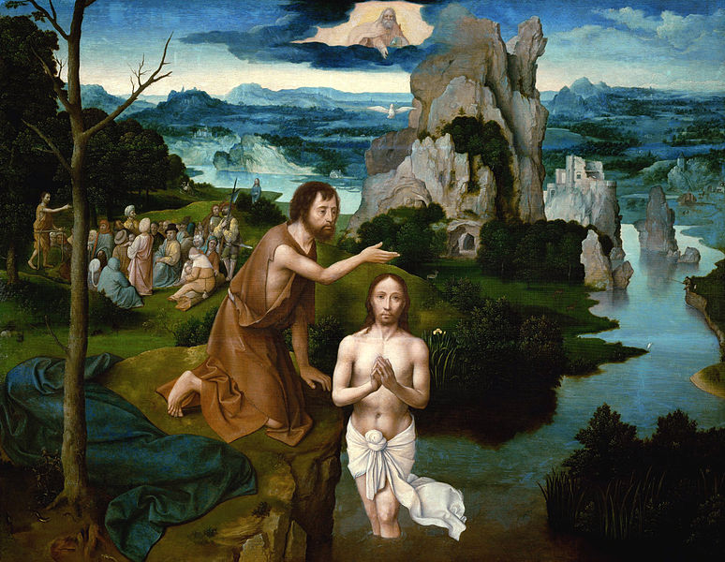
The Baptism of the Lord First Sunday of the Year Year C
Page 4
MASS TIMES
Weekend Masses: YANCHEP: 6 p.m. Saturday Vigil, Yanchep Community Centre,
7 Lagoon Drive. GUILDERTON: 8 a.m. Sunday, Guilderton Community Hall, Wedge Street. LANCELIN: 9.45 a.m. Sunday, 33 Gingin Road, Lancelin.
Confessions: before Mass on request
Weekday Masses: Tuesday, Thursday, Friday 9 a.m. at the presbytery,
Wednesdays 3 p.m. at Bethanie Beachside Aged Care.
Priest: Fr Augustine Puthota, Presbytery: 3 Blaxland Avenue, Two Rocks, Western Australia 6037. Telephone: +61-8-9561 2172 Website: http://yanchepcatholic.org/ Email: yanchep@perthcatholic.org.au.
Please like us on Facebook: https://www.facebook.com/yanchepcatholicchurch

Sunday Bulletin

We pray for the sick of our community, especially:
Pat Murphy, Ken and Toni Meek, Delores Servais, Michael Ford, Jim Walsh, Paula Cope, Pat Barone, Josephine del Bene, Len Sims and Margaret Johnson.

We pray for the souls of Kathleen Garbutt and James Robinson from Bethanie Beachside who passed away peacefully during the week. Funeral arrangements have not yet been announced.

(Gospel continued) like a dove. And a voice came from heaven, ‘You are my Son, the Beloved; my favour rests on you.’
The Gospel of the Lord.
Praise to you, Lord Jesus Christ!

Communion Antiphon ‡ Psalm 36 (35): 10
With you, O Lord, is the fountain of life, and in your light we see light.
The Oration on Holy Baptism, St Gregory of Nazianzus, preached at Constantinople Jan. 6, 381, being the day following the delivery of that on the Holy Lights. The Word recognizes three Births for us; namely, the natural birth, that of Baptism, and that of the Resurrection … Concerning two of these births, the first and the last, we have not to speak on the present occasion. Let us discourse upon the second, which is now necessary for us, and which gives its name to the Feast of the Lights. Illumination is the splendour of souls, the conversion of the life, the question put to the Godward conscience. It is the aid to our weakness, the renunciation of the flesh, the following of the Spirit, the fellowship of the Word, the improvement of the creature, the overwhelming of sin, the participation of light, the dissolution of darkness. It is the carriage to God, the dying with Christ, the perfecting of the mind, the bulwark of Faith, the key of the Kingdom of heaven, the change of life, the removal of slavery, the loosing of chains, the remodelling of the whole man. Why should I go into further detail? Illumination is the greatest and most magnificent of the Gifts of God. For just as we speak of the Holy of Holies, and the Song of Songs, as more comprehensive and more excellent than others, so is this called Illumination, as being more holy than any other illumination which we possess. http://www.newadvent.org/fathers/310240.htm

The Baptism of Christ, Joachim Patinir, 1510-20, oil on oak, Kunsthistorisches Museum, Vienna.

Entrance Antiphon ‡ cf. Isaiah 6:1
Upon a lofty throne, I saw a man seated, whom a host of angels adore, singing in unison: Behold him, the name of whose empire is eternal.

First Reading ‡ Isaiah 40:1-5, 9-11
The glory of the Lord shall be revealed, and all people shall see it.
‘Console my people, console them,’ says your God.
‘Speak to the heart of Jerusalem and call to her that her time of service is ended, that her sin is atoned for, that she has received from the hand of the Lord double punishment for all her crimes.’

All of these look to you to give them their food in due season.
You give it, they gather it up:
you open your hand, they have their fill. R.

You take back your spirit, they die,
returning to the dust from which they came.
You send forth your spirit, they are created;
and you renew the face of the earth. R.

Second Reading ‡ Titus 2:11-14, 3:4-7
He saved us through the water of rebirth and renewal in the Holy Spirit.
God’s grace has been revealed, and it has made salvation possible for the whole human race and taught us that what we have to do is to give up everything that does not lead to God, and all our worldly ambitions; we must be self-restrained and live good and religious lives here in this present world, while we are waiting in hope for the blessing which will come with the Appearing of the glory of our great God and saviour Christ Jesus. He sacrificed himself for us in order to set us free from all wickedness and to purify a people so that it could be his very own and would have no ambition except to do good.
When the kindness and love of God our saviour for mankind were revealed, it was not because he was concerned with any righteous actions we might have done ourselves; it was for no reason except his own compassion that he saved us, by means of the cleansing water of rebirth and by renewing us with the Holy Spirit which he has so generously poured over us through Jesus Christ our saviour.
He did this so that we should be justified by his grace, to become heirs looking forward to inheriting eternal life.
The word of the Lord.
Thanks be to God.

Gospel Acclamation ‡ cf. Luke 3:16
Alleluia, alleluia!
John said: He who is to come is mightier than I;
he will baptise you with the Holy Spirit and with fire.
Alleluia!

Gospel ‡ Luke 3:15-16, 21-22
When Jesus had been baptised and had been praying,
the heavens were opened and the Holy Spirit came upon him.
A feeling of expectancy had grown among the people, who were beginning to think that John might be the Christ, so John declared before them all, ‘I baptise you with water, but someone is coming, someone who is more powerful than I am, and I am not fit to undo the strap of his sandals; he will baptise you with the Holy Spirit and fire.’
Now when all the people had been baptised and while Jesus after his own baptism was
at prayer, heaven opened and the Holy Spirit descended on him in bodily shape,

Page 3
Page 2
A voice cries, ‘Prepare in the wilderness a way for the Lord.
Make a straight highway for our God across the desert.
Let every valley be filled in,
every mountain and hill be laid low,
let every cliff become a plain,
and the ridges a valley;
then the glory of the Lord shall be revealed and all mankind shall see it;
for the mouth of the Lord has spoken.’
Go up on a high mountain, joyful messenger to Zion.
Shout with a loud voice, joyful messenger to Jerusalem.
Shout without fear, say to the towns of Judah, ‘Here is your God.’
Here is the Lord coming with power,
his arm subduing all things to him.
The prize of his victory is with him,
his trophies all go before him.
He is like a shepherd feeding his flock,
gathering lambs in his arms,
holding them against his breast and leading to their rest the mother ewes.
The word of the Lord.
Thanks be to God.

Responsorial Psalm ‡ Psalm 103:1-2, 3-4, 24-25, 27-30.

R. O bless the Lord, my soul.

Lord God, how great you are,
clothed in majesty and glory,
wrapped in light as in a robe!
You stretch out the heavens like a tent. R.

Above the rains you build your dwelling.
You make the clouds your chariot,
you walk on the wings of the wind,
you make the winds your messengers
and flashing fire your servants. R.

How many are your works, O Lord!
In wisdom you have made them all.
The earth is full of your riches.
There is the sea, vast and wide,
with its moving swarms past counting,
living things great and small. R.

https://yanchepcatholic.wordpress.com/wp-admin/admin.php?pag

