2nd Sunday of Advent Year C
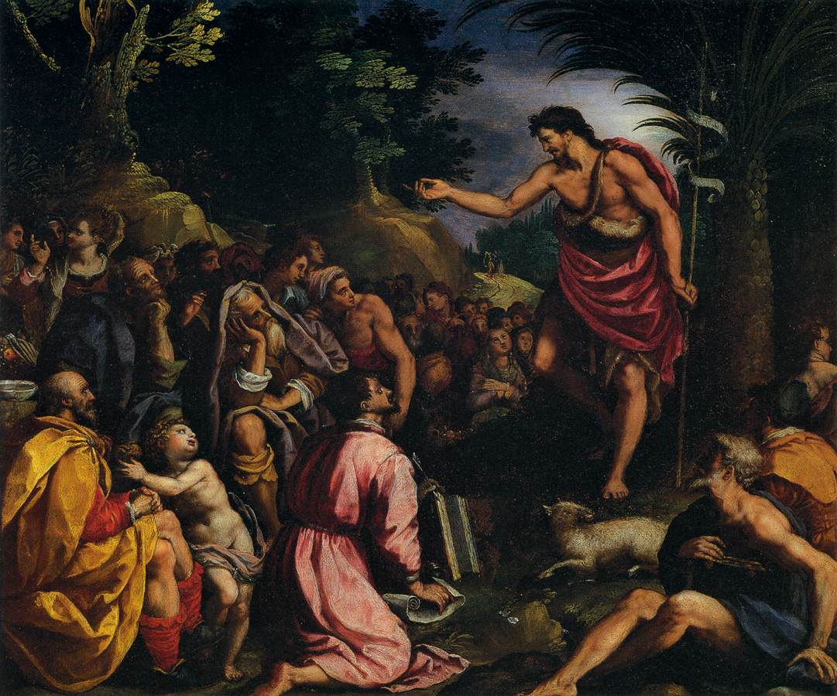
Sunday Bulletin
MASS TIMES
Weekend Masses: YANCHEP: 6 p.m. Saturday Vigil, Yanchep Community Centre,
7 Lagoon Drive. GUILDERTON: 8 a.m. Sunday, Guilderton Community Hall, Wedge Street. LANCELIN: 9.45 a.m. Sunday, 33 Gingin Road, Lancelin.
Confessions: before Mass on request
Weekday Masses: Tuesday, Thursday, Friday 9 a.m. at the presbytery,
Wednesdays 3 p.m. at Bethanie Beachside Aged Care.
Priest: Fr Augustine Puthota, Presbytery: 3 Blaxland Avenue, Two Rocks, Western Australia 6037. Telephone: +61-8-9561 2172
Website: http://yanchepcatholic.org/ Email: yanchep@perthcatholic.org.au.
Please like us on Facebook: https://www.facebook.com/yanchepcatholicchurch
Page 4
Page 1

We pray for the sick of our community, especially:
Pat Murphy, Ken and Toni Meek, Delores Servais, Michael Ford, Jim Walsh, Paula Cope, Pat Barone, Josephine del Bene, Len Sims and Margaret Johnson.

Communion Antiphon ‡ Baruch 5:5, 4:36
Jerusalem, arise and stand upon the heights, and behold the joy which comes to you from God.

Reflection on the Gospel by Dr John Bergsma at http://www.thesacredpage.com/2012/12/make-straight-paths-second-sunday-of.html#more.
… So the primary problem of God’s people was not a lack of roads, or their distance from their ancestral land. The problem was their sins: their spiritual estrangement from God. For this reason, the “road” that John the Baptist offers is repentance, expressed through water baptism. The description of the road-building lends itself to a spiritual interpretation, one that has a basis in the New Testament itself, in texts like the Magnificat and the Sermon on the Mount. “Every valley shall be filled” refers to hope, encouragement, and new life being granted to the poor, the oppressed, the lowly—people who feel they have been forgotten by God or are not worthy of God’s attention. “Every hill made low,” refers to the humbling of the proud, the repentance that the strong and arrogant must undergo in order to receive God’s salvation.
The “winding roads” and “rough places” refer to the twists and turns of the human heart, contorted by sin (Jer 17:9). The human heart needs to be “simplified” or “straightened” by honest and truthful confession of sin. This is what the Church is calling us to do in this preparatory season of Advent. Those of us who feel lowly and downtrodden by life need to exercise some faith and hope, lift up our heads, remember that this life is temporary, and look to Jesus. Those of us who think we have it all together need to exercise some humility and do an examination of conscience. But most of all, we need to straighten out our interior crookedness. So in this second week of Advent, it would be highly appropriate to take the time right now to schedule a date for Confession this week. This is the sacrament where we speak the simple truth, the twisted becomes straight, and the rough smooth.



The Preaching of St John the Baptist, Allesandro Allori (1527-1607), oil on copper, Palazzo Pitti, Florence, Italy.

Entrance Antiphon ‡ Cf. Isaiah 30: 19, 30.
O people of Sion, behold, the Lord will come to save the nations, and the Lord will make the glory of his voice heard in the joy of your heart.

First Reading ‡ Baruch 5:1-9
Jerusalem – God will show you splendour.
Jerusalem, take off your dress of sorrow and distress,
put on the beauty of the glory of God for ever,
wrap the cloak of the integrity of God around you,
put the diadem of the glory of the Eternal on your head:
since God means to show your splendour to every nation under heaven,
since the name God gives you for ever will be,
‘Peace through integrity, and honour through devotedness’.

Second Reading ‡ Philippians 1:3-6, 8-11
Show yourself sinless and without blame in the day of Christ.
Every time I pray for all of you, I pray with joy, remembering how you have helped to spread the Good News from the day you first heard it right up to the present. I am quite certain that the One who began this good work in you will see that it is finished when the Day of Christ Jesus comes. God knows how much I miss you all, loving you as Christ Jesus loves you. My prayer is that your love for each other may increase more and more and never stop improving your knowledge and deepening your perception so that you can always recognise what is best. This will help you to become pure and blameless, and prepare you for the Day of Christ, when you will reach the perfect goodness which Jesus Christ produces in us for the glory and praise of God.

The Word of the Lord.
Thanks be to God.

Gospel Acclamation ‡ Luke 3: 4, 6
Alleluia, alleluia!
Prepare the way of the Lord, make straight his paths:
all people shall see the salvation of God.
Alleluia!

Gospel ‡ Luke 3:1-6.
All people shall see the salvation of God.
In the fifteenth year of Tiberius Caesar’s reign, when Pontius Pilate was governor of Judaea, Herod tetrarch of Galilee, his brother Philip tetrarch of the lands of Ituraea and Trachonitis, Lysanias tetrarch of Abilene, during the pontificate of Annas and Caiaphas, the word of God came to John son of Zechariah, in the wilderness. He went through the whole Jordan district proclaiming a baptism of repentance for the forgiveness of sins, as it is written in the book of the sayings of the prophet Isaiah:
A voice cries in the wilderness:
Prepare a way for the Lord,
make his paths straight.
Every valley will be filled in,
every mountain and hill be laid low,
winding ways will be straightened
and rough roads made smooth.
And all mankind shall see the salvation of God.

The Gospel of the Lord.
Praise to you, Lord Jesus Christ!
Arise, Jerusalem, stand on the heights
and turn your eyes to the east:
see your sons reassembled from west and east
at the command of the Holy One,
jubilant that God has remembered them.
Though they left you on foot,
with enemies for an escort,
now God brings them back to you
like royal princes carried back in glory.
For God has decreed the flattening of each high mountain,
of the everlasting hills, the filling of the valleys
to make the ground level so that Israel can walk in safety
under the glory of God.
And the forests and every fragrant tree
will provide shade for Israel at the command of God;
for God will guide Israel in joy by the light of his glory
with his mercy and integrity for escort.
The Word of the Lord.
Thanks be to God.

Responsorial Psalm ‡ Psalm 125
R. The Lord has done great things for us; we are filled with joy.

When the Lord delivered Zion from bondage,
it seemed like a dream.
Then was our mouth filled with laughter,
on our lips there were songs. R.

The heathens themselves said:
‘What marvels the Lord worked for them!’
What marvels the Lord worked for us!
Indeed we were glad. R.

Deliver us, O Lord, from our bondage
as streams in dry land.
Those who are sowing in tears
will sing when they reap. R.

They go out, they go out, full of tears
carrying seed for the sowing:
they come back, they come back, full of song,
carrying their sheaves. R.

Page 2
Page 3

