33rd Sunday in Ordinary Time Year B
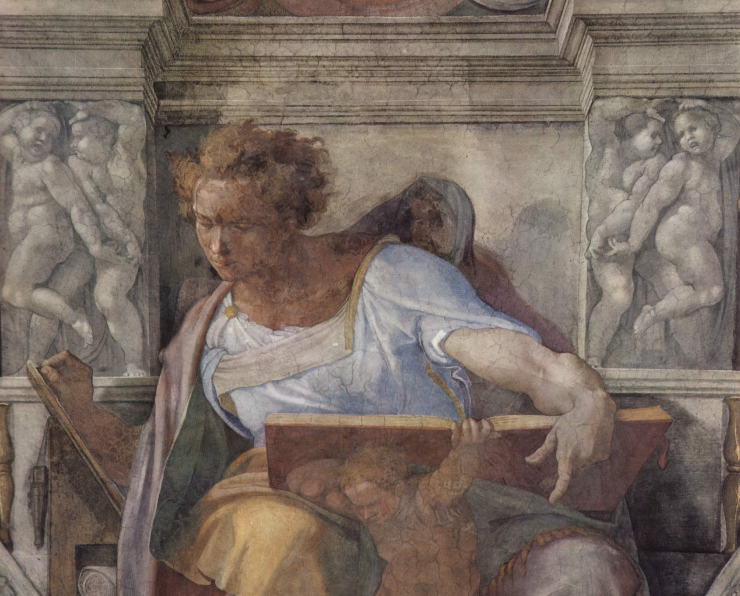
Sunday Bulletin
MASS TIMES
Weekend Masses: YANCHEP: 6 p.m. Saturday Vigil, St James Anglican Church,
2 Lagoon Drive. GUILDERTON: 8 a.m. Sunday, Guilderton Community Hall, Wedge Street. LANCELIN: 9.45 a.m. Sunday, 33 Gingin Road, Lancelin.
Confessions: before Mass on request
Weekday Masses: Tuesday, Thursday, Friday 9 a.m. at the presbytery,
Wednesdays 3 p.m. at Bethanie Beachside Aged Care.
Priest: Fr Augustine Puthota, Presbytery: 3 Blaxland Avenue, Two Rocks, Western Australia 6037. Telephone: +61-8-9561 2172
Website: http://yanchepcatholic.org/ Email: yanchep@perthcatholic.org.au.
Please like us on Facebook: https://www.facebook.com/yanchepcatholicchurch
Page 4
Page 1

We pray for the sick of our community, especially:
Pat Murphy, Ken and Toni Meek, Delores Servais, Michael Ford, Jim Walsh, Paula Cope, Pat Barone, Josephine del Bene, Len Sims and Nina Campbell.

Communion Antiphon ‡ Ps 73 (72): 28
To be near God is my happiness, to place my hope in God the Lord.

LIFELINK: Don’t forget the Archbishop’s Christmas Appeal. Please go to https://lifelink.com.au/2015christmasappeal/ to donate to people in need!

PRAYER FOR OUR CHURCH IN YANCHEP-TWO ROCKS
Heavenly Father, we the people of Yanchep and Two Rocks know that where two or three are gathered in your name, there you are in the midst of them (Matthew 18:20). We know that we are the living stones of your church and that you, Jesus Christ, are our foundation stone (1 Peter 2:5). We know that “the God who made the world and everything in it is the Lord of heaven and earth and does not need to live in temples built by human hands” (Acts 17:24).
Yet we still desire to have a visible, permanent, outward presence in the Yanchep-Two Rocks community.
We desire to have a public place where we can reserve your Precious Body and Blood and give you honour.
Lord, we ask that you help us to acquire the land and church building that will be a sign of your presence amongst us.
Lord, we ask that you break down any spiritual barriers that are preventing us from building a church.
Lord please bless and strengthen all those members of our Pastoral Area who have faithfully helped us in the time that they have lived here. But Lord, we ask also that you send into our area people who will evangelise our community and boldly proclaim your wonderful plan for humanity. Revitalise our pastoral area through the power of your Holy Spirit.
We pray this in the name of the Father, and of the Son and of the Holy Spirit.
Amen.


The Prophet Daniel, Michelangelo Buonarotti, c. 1508-1512, fresco, detail from the Sistine Chapel ceiling, Vatican Palace, Vatican City.

Entrance Antiphon ‡ Jer. 29:11, 12, 14.
The Lord said: I think thoughts of peace and not of affliction. You will call upon me, and I will answer you, and I will lead back your captives from every place.

First Reading ‡ Daniel 12:1-3
When that time comes your own people will be spared.
‘At that time Michael will stand up, the great prince who mounts guard over your people. There is going to be a time of great distress, unparalleled since nations first came into existence. When that time comes, your own people will be spared, all those whose names are found written in the Book. Of those who lie sleeping in the dust of the earth many will awake, some to everlasting life, some to shame and everlasting disgrace. The learned will shine as brightly as the vault of heaven, and those who have instructed many in virtue, as bright as stars for all eternity.’
The Word of the Lord.
Thanks be to God.

‘Take the fig tree as a parable: as soon as its twigs grow supple and its leaves come out, you know that summer is near. So with you, when you see these things happening: know that he is near, at the very gates. I tell you solemnly, before this generation has passed away all these things will have taken place. Heaven and earth will pass away, but my words will not pass away.
‘But as for that day or hour, nobody knows it, neither the angels of heaven, nor the Son; no one but the Father.’
The Gospel of the Lord.
Praise to you, Lord Jesus Christ!

Responsorial Psalm ‡ Psalm 15: 5, 8-11
R. Keep me safe, O God; you are my hope.

O Lord, it is you who are my portion and cup;
it is you yourself who are my prize.
I keep the Lord ever in my sight:
since he is at my right hand, I shall stand firm. R.

And so my heart rejoices, my soul is glad;
even my body shall rest in safety.
For you will not leave my soul among the dead,
nor let your beloved know decay. R.

You will show me the path of life,
the fullness of joy in your presence,
at your right hand happiness for ever. R.

Second Reading ‡ Hebrews 10:11-14, 18.
By a single offering he has achieved the eternal perfection of those who are sanctified.
All the priests stand at their duties every day, offering over and over again the same sacrifices which are quite incapable of taking sins away. Christ, on the other hand, has offered one single sacrifice for sins, and then taken his place for ever, at the right hand of God, where he is now waiting until his enemies are made into a footstool for him. By virtue of that one single offering, he has achieved the eternal perfection of all whom he is sanctifying. When all sins have been forgiven, there can be no more sin offerings.

The Word of the Lord.
Thanks be to God.

Gospel Acclamation ‡ Luke 21:36
Alleluia, alleluia!
Be watchful and pray constantly,
that you may be worthy to stand before the Son of Man.
Alleluia!
Gospel ‡ Mark 13:24-32
He shall gather his elect from the four winds.
Jesus said to his disciples: ‘In those days, after the time of distress, the sun will be darkened, the moon will lose its brightness, the stars will come falling from heaven and the powers in the heavens will be shaken. And then they will see the Son of Man coming in the clouds with great power and glory; then too he will send the angels to gather his chosen from the four winds, from the ends of the world to the ends of heaven.

Page 2
Page 3

Commentary by Dr John Bergsma on the Second Reading.
Hebrews continues here in its description of Jesus as priest-king after the pattern of Melchizedek. Although the word “king” does not occur in this passage, one may note in this passage that after offering “one sacrifice for sins,” Jesus Christ “took his seat forever at the right hand of God.” Now “taking his seat … at the right hand of God,” is a kingly act. It is a royal enthronement.
In this passage, we see that Christ’s priestly sacrifice precedes and merits his kingly enthronement. This is also a spiritual pattern for us: in a sense, in this life we make our priestly sacrifice, in the next we receive our kingly enthronement.
The line in the passage about offering “one sacrifice for sins” is often employed as an apologetic text by non-Catholics against Catholics, with reference to the daily “sacrifice of the Mass.” Since Jesus sacrifice on the cross was a “once-for-all event,” why does the Church continually “repeat” it?
The basic answer is that the Mass is not a historical repetition of Christ’s sacrifice, but a participation in it and a re-presentation of it (a “making-it-present-again”). At Mass, time and space are pealed back and we step right up to the foot of the cross, the once-for-all sacrifice that fills all time and never ends. The Catechism says:
1545 The redemptive sacrifice of Christ is unique, accomplished once for all; yet it is made present in the Eucharistic sacrifice of the Church. The same is true of the one priesthood of Christ; it is made present through the ministerial priesthood without diminishing the uniqueness of Christ's priesthood: "Only Christ is the true priest, the others being only his ministers."
1366 The Eucharist is thus a sacrifice because it re-presents (makes present) the sacrifice of the cross, because it is its memorial and because it applies its fruit:
[Christ], our Lord and God, was once and for all to offer himself to God the Father by his death on the altar of the cross, to accomplish there an everlasting redemption. But because his priesthood was not to end with his death, at the Last Supper "on the night when he was betrayed," [he wanted] to leave to his beloved spouse the Church a visible sacrifice (as the nature of man demands) by which the bloody sacrifice which he was to accomplish once for all on the cross would be re-presented, its memory perpetuated until the end of the world, and its salutary power be applied to the forgiveness of the sins we daily commit.
Anyone, of course, is free to disagree with the Catholic Church on this doctrine, but it’s just not the case that the Church teaches that Jesus dies again every time Mass is celebrated.

