Our Lord Jesus Christ, King of the Universe Year B
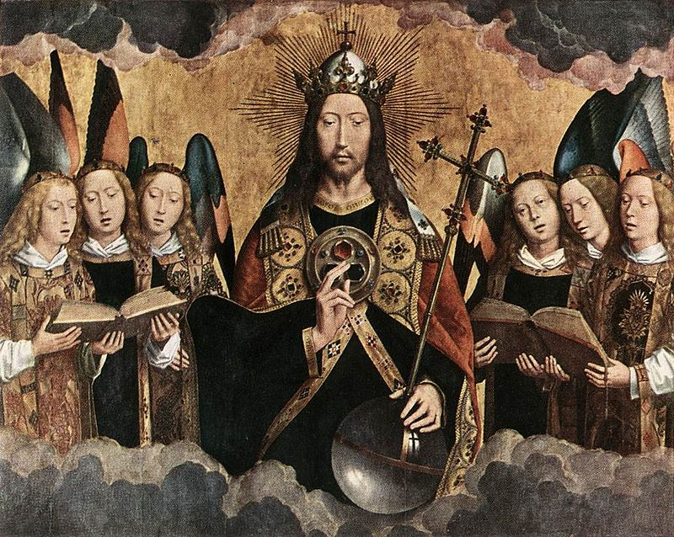
Sunday Bulletin
MASS TIMES
Weekend Masses: YANCHEP: 6 p.m. Saturday Vigil, St James Anglican Church,
2 Lagoon Drive. GUILDERTON: 8 a.m. Sunday, Guilderton Community Hall, Wedge Street. LANCELIN: 9.45 a.m. Sunday, 33 Gingin Road, Lancelin.
Confessions: before Mass on request
Weekday Masses: Tuesday, Thursday, Friday 9 a.m. at the presbytery,
Wednesdays 3 p.m. at Bethanie Beachside Aged Care.
Priest: Fr Augustine Puthota, Presbytery: 3 Blaxland Avenue, Two Rocks, Western Australia 6037. Telephone: +61-8-9561 2172
Website: http://yanchepcatholic.org/ Email: yanchep@perthcatholic.org.au.
Please like us on Facebook: https://www.facebook.com/yanchepcatholicchurch
Page 4
Page 1

We pray for the sick of our community, especially:
Pat Murphy, Ken and Toni Meek, Delores Servais, Michael Ford, Jim Walsh, Paula Cope, Pat Barone, Josephine del Bene, Len Sims and Nina Campbell.

Communion Antiphon ‡ Ps 29 (28): 10-11
The Lord sits as King for ever. The Lord will bless his people with peace.

LIFELINK: Don’t forget the Archbishop’s Christmas Appeal. Please go to https://lifelink.com.au/2015christmasappeal/ to donate to people in need!

The Responsorial Psalm
We should note that Psalm 93 is just four psalms into Book IV of the Psalter. Book IV tells the people of Judah in exile: even when things are falling apart, our God is still in ultimate control!
Everyone knows that the Catholic Church is facing various forms of persecution, some blatant, some subtle, in almost every country of the world. Whether the national government is militantly secular in the developed West; or Islamic in north Africa, the Middle East, and Southeast Asia; or Communist (still!) in China and Cuba; there are few places on the globe where the political powers are sympathetic to the Church. This can lead us to feeling that history is out of control, and God has vacated his role as king.
It’s helpful to remember, however, that this phenomenon is nothing new. St. Augustine, for example, was on his deathbed in AD 430 when the Vandals were besieging his beloved city of Hippo, and it looked like Latin Christian civilization was going to be completely, violently destroyed. More recently, many believers met their ends in the Cristeros rebellion in Mexico (1926-29) or the Spanish Civil War (1936-39) under conditions where it was not at all clear the Church would survive at all. Yet these saints and martyrs did not give up their confidence that “The LORD is king! He is robed in majesty!” This is always a cry of faith, not sight, while we sojourn in this “valley of tears.”
Read more at http://www.thesacredpage.com/2015/11/jose-luis-sanchez-del-rio-this-sunday.html#more.


Christ surrounded by Musician Angels, Hans Memling (c.1480), Royal Museum of Fine Arts, Antwerp, Belgium.

Entrance Antiphon ‡ Rev. 5:12, 1:6
How worthy is the Lamb who was slain, to receive power and divinity, and wisdom and strength and honour. To him belong glory and power for ever and ever.

First Reading ‡ Daniel 7:13-14
His sovereignty is eternal.
I gazed into the visions of the night.
And I saw, coming on the clouds of heaven,
one like a son of man.
He came to the one of great age
and was led into his presence.
On him was conferred sovereignty,
glory and kingship,
and men of all peoples, nations and languages
became his servants.

what have you done?’ Jesus replied, ‘Mine is not a kingdom of this world; if my kingdom were of this world, my men would have fought to prevent my being surrendered to the Jews. But my kingdom is not of this kind.’ ‘So you are a king then?’ said Pilate. ‘It is you who say it’ answered Jesus. ‘Yes, I am a king. I was born for this, I came into the world for this: to bear witness to the truth; and all who are on the side of truth listen to my voice.’
The Gospel of the Lord.
Praise to you, Lord Jesus Christ!
His sovereignty is an eternal sovereignty
which shall never pass away,
nor will his empire be destroyed.
The Word of the Lord.
Thanks be to God.

Responsorial Psalm ‡ Psalm 92: 1-2, 5.
R. The Lord is King; he is robed in majesty.

The Lord is king, with majesty enrobed;
the Lord has robed himself with might,
he has girded himself with power. R.

The world you made firm, not to be moved;
your throne has stood firm from of old.
From all eternity, O Lord, you are. R.

Truly your decrees are to be trusted.
Holiness is fitting to your house,
O Lord, until the end of time. R.

Second Reading ‡ Rev. 1: 5-8.
The ruler of the kings of the earth … made us a line of kings, priests to serve his God.
Jesus Christ is the faithful witness, the First-born from the dead, the Ruler of the kings of the earth. He loves us and has washed away our sins with his blood, and made us a line of kings, priests to serve his God and Father; to him, then, be glory and power for ever and ever. Amen. It is he who is coming on the clouds; everyone will see him, even those who pierced him, and all the races of the earth will mourn over him. This is the truth. Amen. ‘I am the Alpha and the Omega’ says the Lord God, who is, who was, and who is to come, the Almighty.

The Word of the Lord.
Thanks be to God.

Gospel Acclamation ‡ Mark 11: 9, 10
Alleluia, alleluia!
Blessed is he who inherits the kingdom of David our Father;
blessed is he who comes in the name of the Lord.
Alleluia!
Gospel ‡ John 18: 33-37
You say that I am a king.
‘Are you the king of the Jews?’ Pilate asked. Jesus replied, ‘Do you ask this of your own accord, or have others spoken to you about me?’ Pilate answered, ‘Am I a Jew? It is your own people and the chief priests who have handed you over to me:
Page 2
Page 3

Commentary by Dr John Bergsma on today’s readings http://www.thesacredpage.com/2015/11/jose-luis-sanchez-del-rio-this-sunday.html#more.

This passage of Daniel 7 is a famous and controversial one in biblical studies, because in it appear two figures or persons, both of whom have divine characteristics. The “Ancient One” or “Ancient of Days” mentioned in 7:13 is clearly an image of the LORD God. Yet the “one like a Son of man” who comes “on the clouds of heaven” is also a divine figure, because “riding on the clouds” is a divine prerogative (see Psalm 18:7-15). Many scholars have noted this, and some, like Jewish bible scholar Daniel Boyarin, have freely admitted that in late Judaism there was already a notion of more than one person in the Godhead.

As Christians, we read this prophetic text and recognize progressive revelation. That is, as biblical revelation proceeds toward the coming of Christ, the truths of faith begin to become clearer. So here already in Daniel 7, an Old Testament text, we have an early vision of at least two persons of the Holy Trinity, God the Father and God the Son.

It is not accidental, by the way, that Jesus’ favourite form of self-reference in the Gospels is “Son of Man.” When Jesus calls himself that title, I am convinced he has in mind two OT texts in particular: our text here, Daniel 7, where the “Son of Man” receives all authority at the final judgment, and Psalm 8, where the Son of Man is made “a little less than God” or “for a little while, less than God”, but then has “all things put under his feet.” People think that Jesus’ title “Son of Man” refers to his mortality or his human nature, but in fact it is a reference to his eschatological role as king and judge. This becomes most clear at Jesus’ final trial, when he is asked point-blank if he is the Christ:
Mark 14:61 But he was silent and made no answer. Again the high priest asked him, “Are you the Christ, the Son of the Blessed?” 62 And Jesus said, “I am; and you will see the Son of man seated at the right hand of Power, and coming with the clouds of heaven.”
So at this dramatic point in his earthly ministry, Jesus refers to our First Reading to define his identity, and point to his role as eschatological judge.

