30th Sunday in Ordinary Time Year B
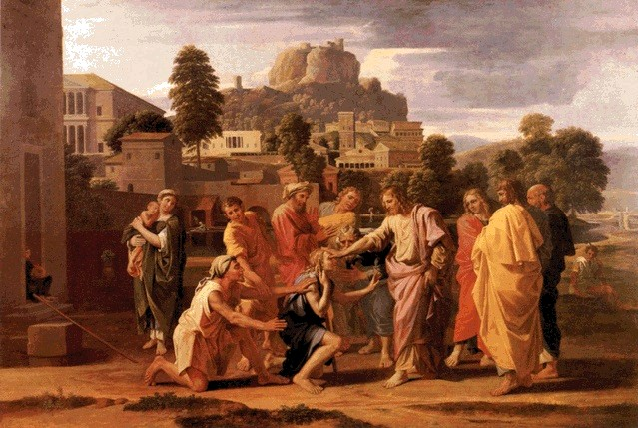
Sunday Bulletin
MASS TIMES
Weekend Masses: YANCHEP: 6 p.m. Saturday Vigil, St James Anglican Church,
2 Lagoon Drive. GUILDERTON: 8 a.m. Sunday, Guilderton Community Hall, Wedge Street. LANCELIN: 9.45 a.m. Sunday, 33 Gingin Road, Lancelin.
Confessions: before Mass on request
Weekday Masses: Tuesday, Thursday, Friday 9 a.m. at the presbytery,
Wednesdays 3 p.m. at Bethanie Beachside Aged Care.
Priest: Fr Augustine Puthota, Presbytery: 3 Blaxland Avenue, Two Rocks, Western Australia 6037. Telephone: +61-8-9561 2172
Website: http://yanchepcatholic.org/ Email: yanchep@perthcatholic.org.au.
Please like us on Facebook: https://www.facebook.com/yanchepcatholicchurch
Page 4
Page 1

We pray for the sick of our community, especially:
Pat Murphy, Ken and Toni Meek, Delores Servais, Michael Ford, Jim Walsh, Paula Cope, Pat Barone, Josephine del Bene, Len Sims, Peter Even and Nina Campbell.

Communion Antiphon ‡ cf. Ps 20 (19): 6
We will ring out our joy at your saving help and exult in the name of our God.

Yanchep Reading Roster: October 24th Christina; October 31st and November 7th Sarah; November 14th and 21st, Janie.
Rosary Group 10 a.m. Tuesday at Pat Elliot’s, 230/76 Ridgewood Boulevard. Phone Christina on 9561 5335 if you would like a lift.

PRAYER FOR OUR CHURCH IN YANCHEP-TWO ROCKS
Heavenly Father, we the people of Yanchep and Two Rocks know that where two or three are gathered in your name, there you are in the midst of them (Matthew 18:20). We know that we are the living stones of your church and that you, Jesus Christ, are our foundation stone (1 Peter 2:5). We know that “the God who made the world and everything in it is the Lord of heaven and earth and does not need to live in temples built by human hands” (Acts 17:24).
Yet we still desire to have a visible, permanent, outward presence in the Yanchep-Two Rocks community.
We desire to have a public place where we can reserve your Precious Body and Blood and give you honour.
Lord, we ask that you help us to acquire the land and church building that will be a sign of your presence amongst us.
Lord, we ask that you break down any spiritual barriers that are preventing us from building a church.
Lord please bless and strengthen all those members of our Pastoral Area who have faithfully helped us in the time that they have lived here. But Lord, we ask also that you send into our area people who will evangelise our community and boldly proclaim your wonderful plan for humanity. Revitalise our pastoral area through the power of your Holy Spirit.
We pray this in the name of the Father, and of the Son and of the Holy Spirit.
Amen.


The Healing of the Blind Man of Jericho, Nicholas Poussin, 1650, oil on canvas, Musée du Louvre, Paris.

Entrance Antiphon ‡ Ps 105 (104): 3-4
Let the hearts that seek the Lord rejoice; turn to the Lord and his strength; constantly seek his face.

First Reading ‡ Jeremiah 31: 7-9
I shall lead them back in mercy — both the blind and the lame.
The Lord says this:
Shout with joy for Jacob!
Hail the chief of nations!
Proclaim! Praise! Shout!
‘The Lord has saved his people,
the remnant of Israel!’
See, I will bring them back from the land of the North
and gather them from the far ends of earth;
all of them: the blind and the lame,
women with child, women in labour:
a great company returning here.

The Word of the Lord.
Thanks be to God.
Gospel Acclamation ‡ cf. Timothy 1:10
Alleluia, alleluia!
Our Saviour Jesus Christ has done away with death,
and brought us life through his Gospel.
Alleluia!

Gospel ‡ Mark 10:46-52
Master, grant that I may see.
As Jesus left Jericho with his disciples and a large crowd, Bartimaeus (that is, the son of Timaeus), a blind beggar, was sitting at the side of the road. When he heard that it was Jesus of Nazareth, he began to shout and to say, ‘Son of David, Jesus, have pity on me.’ And many of them scolded him and told him to keep quiet, but he only shouted all the louder, ‘Son of David, have pity on me.’ Jesus stopped and said, ‘Call him here.’ So they called the blind man. ‘Courage,’ they said ‘get up; he is calling you.’ So throwing off his cloak, he jumped up and went to Jesus. Then Jesus spoke, ‘What do you want me to do for you?’ ‘Rabbuni,’ the blind man said to him ‘Master, let me see again.’ Jesus said to him, ‘Go; your faith has saved you.’ And immediately his sight returned and he followed him along the road.
The Gospel of the Lord.
Praise to you, Lord Jesus Christ!

They had left in tears,
I will comfort them as I lead them back;
I will guide them to streams of water,
by a smooth path where they will not stumble.
For I am a father to Israel,
and Ephraim is my first-born son.
The Word of the Lord.
Thanks be to God.

Responsorial Psalm ‡ Psalm 125
R. The Lord has done great things for us; we are filled with joy.

When the Lord delivered Zion from bondage,
it seemed like a dream.
Then was our mouth filled with laughter,
on our lips there were songs. R.

The heathens themselves said:
‘What marvels the Lord worked for them!’
What marvels the Lord worked for us!
Indeed we were glad. R.

Deliver us, O Lord, from our bondage
as streams in dry land.
Those who are sowing in tears
will sing when they reap. R.

They go out, they go out, full of tears,
carrying seed for the sowing:
they come back, they come back, full of song,
carrying their sheaves. R.

Second Reading ‡ Hebrews 5:1-6
You are a priest forever, in the line of Melchizedek.
Every high priest has been taken out of mankind and is appointed to act for men in their relations with God, to offer gifts and sacrifices for sins; and so he can sympathise with those who are ignorant or uncertain because he too lives in the limitations of weakness. That is why he has to make sin offerings for himself as well as for the people. No one takes this honour on himself, but each one is called by God, as Aaron was. Nor did Christ give himself the glory of becoming high priest, but he had it from the one who said to him: You are my son, today I have become your father, and in another text: You are a priest of the order of Melchizedek, and for ever.
Page 2
Page 3

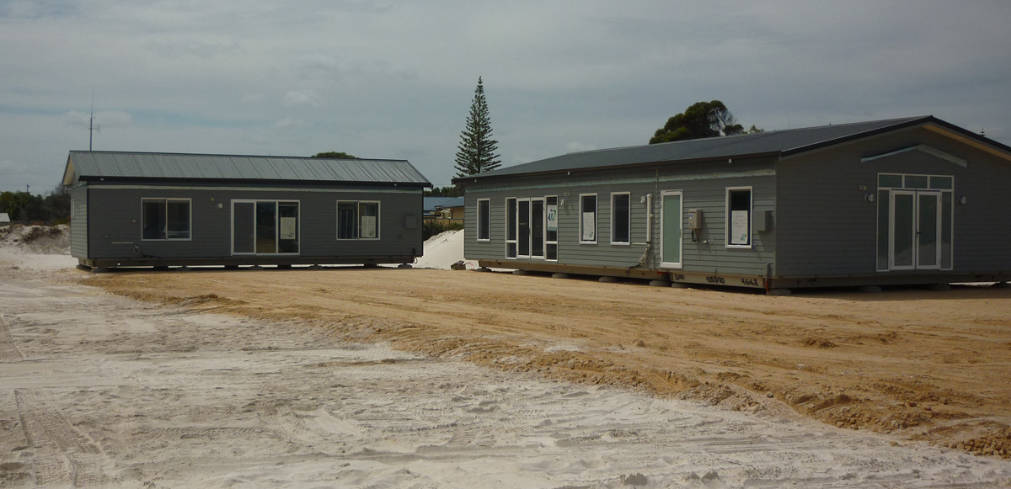
Thanks be to God, Lancelin’s new Church (right) and Priest’s House (left) were delivered at the beginning of October. Work will continue on these over the next few months. Please pray for the building supervisor Padraig Foley, who had emergency heart bypasses while overseas.

Bishop Don Sproxton will be visiting our Pastoral Area on the weekend of 14-15 November. Please would volunteers in Guilderton, Lancelin and Yanchep-Two Rocks organise a welcome for him after your respective Masses on that weekend. Fr Augustine may have to make the Lancelin Mass later to allow for the Bishop to have time to meet the people of Guilderton.

Yanchep-Two Rocks parishioners, we will have a gathering after Mass on 31 October to discuss the latest developments with our Church and talk about our plans for the future. The Community Centre has been booked for 14 November after Mass. Please bring a small plate of finger food for both occasions.

