29th Sunday in Ordinary Time Year B
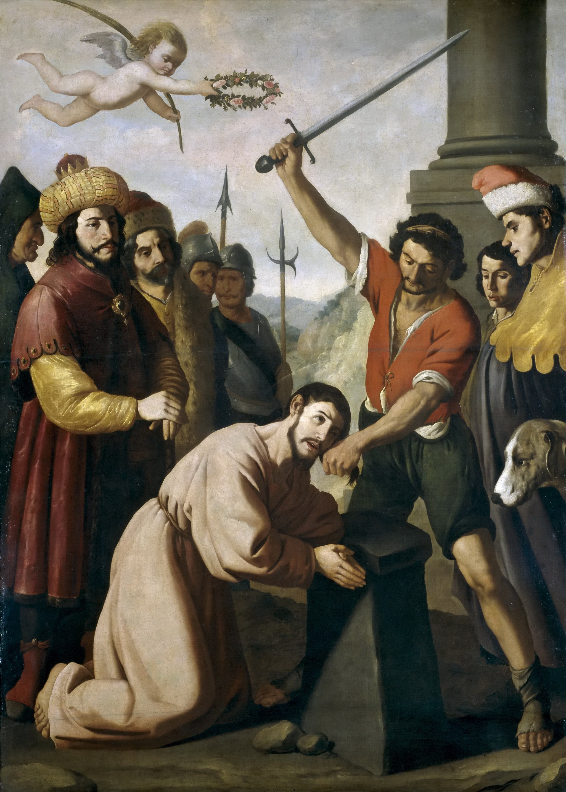
The Martyrdom of St James, Francisco di Zurbaran, 1639, Museo Nacional del Prado, Madrid.

MASS TIMES
Weekend Masses: YANCHEP: 6 p.m. Saturday Vigil, St James Anglican Church,
2 Lagoon Drive. GUILDERTON: 8 a.m. Sunday, Guilderton Community Hall, Wedge Street. LANCELIN: 9.45 a.m. Sunday, 33 Gingin Road, Lancelin.
Confessions: before Mass on request
Weekday Masses: Tuesday, Thursday, Friday 9 a.m. at the presbytery,
Wednesdays 3 p.m. at Bethanie Beachside Aged Care.
Priest: Fr Augustine Puthota, Presbytery: 3 Blaxland Avenue, Two Rocks, Western Australia 6037. Telephone: +61-8-9561 2172
Website: http://yanchepcatholic.org/ Email: yanchep@perthcatholic.org.au.
Please like us on Facebook: https://www.facebook.com/yanchepcatholicchurch
Page 4
Page 1
Sunday Bulletin

We pray for the sick of our community, especially:
Pat Murphy, Ken and Toni Meek, Delores Servais, Michael Ford, Jim Walsh, Paula Cope, Pat Barone, Josephine del Bene, Len Sims and Nina Campbell.


Communion Antiphon ‡ cf. Ps 33 (32): 18-19
Behold, the eyes of the Lord are on those who fear him, who hope in his merciful love, to rescue their souls from death, to keep them alive in famine.

Please remember to pray a Rosary Novena during October for our Pastoral Area to acquire land for our Church in Yanchep.

Entrance Antiphon ‡ Ps 17 (16): 6, 8
To you I call; for you will surely heed me, O God; turn your ear to me; hear my words. Guard me as the apple of your eye; in the shadow of your wings protect me.

(continued) very nature of God, therefore, would be to imply that sin exists within God himself, which is absurd.
Now this is important, for many receive the message of divine mercy as tantamount to a denial of the reality of sin, as though sin no longer matters. But just the contrary is the case. To speak of mercy is to be intensely aware of sin and its peculiar form of destructiveness. Or to shift to one of the Pope’s favourite metaphors, it is to be acutely conscious that one is wounded so severely that one requires, not minor treatment, but the emergency and radical attention provided in a hospital on the edge of a battlefield. Recall that when Francis was asked, in a famous interview two years ago, to describe himself, he responded, “a sinner.” Then he added, “who has been looked upon by the face of mercy.” That’s getting the relationship right. Remember as well that the teenaged Jorge Mario Bergoglio came to a deep and life-changing relationship to Christ precisely through a particularly intense experience in the confessional. As many have indicated, Papa Francesco speaks of the devil more frequently than any of his predecessors of recent memory, and he doesn’t reduce the dark power to a vague abstraction or a harmless symbol. He understands Satan to be a real and very dangerous person.
When Pope Francis speaks of those on the margins, he does indeed mean people who are economically and politically disadvantaged, but he also means people who are cut off from the divine life, spiritually poor. And just as he reaches out to the materially marginalized in order to bring them to the center, so he reaches out to those on the existential periphery in order to bring them to a better place. (Read the rest online …)

First Reading ‡ Isaiah 53:10-11
If he offers his life in atonement, he shall see his heirs and have long life.
The Lord has been pleased to crush his servant with suffering.
If he offers his life in atonement,
he shall see his heirs, he shall have a long life
and through him what the Lord wishes will be done.
His soul’s anguish over
he shall see the light and be content.
By his sufferings shall my servant justify many,

‘we want you to do us a favour.’ He said to them, ‘What is it you want me to do for you?’ They said to him, ‘Allow us to sit one at your right hand and the other at your left in your glory.’ ‘You do not know what you are asking’ Jesus said to them. ‘Can you drink the cup that I must drink, or be baptised with the baptism with which I must be baptised?’ They replied, ‘We can.’ Jesus said to them, ‘The cup that I must drink you shall drink, and with the baptism with which I must be baptised you shall be baptised, but as for seats at my right hand or my left, these are not mine to grant; they belong to those to whom they have been allotted.’
When the other ten heard this they began to feel indignant with James and John, so Jesus called them to him and said to them, ‘You know that among the pagans their so-called rulers lord it over them, and their great men make their authority felt. This is not to happen among you. No; anyone who wants to become great among you must be your servant, and anyone who wants to be first among you must be slave to all. For the Son of Man himself did not come to be served but to serve, and to give his life as a ransom for many.’
The Gospel of the Lord.
Praise to you, Lord Jesus Christ!

taking their faults on himself.
The Word of the Lord.
Thanks be to God.

Responsorial Psalm ‡ Psalm 32:4-5, 18-20, 32.
R. Lord, let your mercy be on us, as we place our trust in you.

The word of the Lord is faithful
and all his works to be trusted.
The Lord loves justice and right
and fills the earth with his love. R.

The Lord looks on those who revere him,
on those who hope in his love,
to rescue their souls from death,
to keep them alive in famine. R.

Our soul is waiting for the Lord.
The Lord is our help and our shield.
May your love be upon us, O Lord,
as we place all our hope in you. R.

Second Reading ‡ Hebrews 4:14-16
Let us be confident in approaching the throne of grace.

Since in Jesus, the Son of God, we have the supreme high priest who has gone through to the highest heaven, we must never let go of the faith that we have professed. For it is not as if we had a high priest who was incapable of feeling our weaknesses with us; but we have one who has been tempted in every way that we are, though he is without sin. Let us be confident, then, in approaching the throne of grace, that we shall have mercy from him and find grace when we are in need of help.
The Word of the Lord.
Thanks be to God.
Gospel Acclamation ‡ Mark 10:45
Alleluia, alleluia!
The Son of Man came to serve and to give his life as a ransom for all.
Alleluia!

Gospel ‡ Mark 10:35-45
The Son of Man came to give his life as a ransom for all.
James and John, the sons of Zebedee, approached Jesus. ‘Master,’ they said to him
Page 2
Page 3

Commentary by Bishop Robert Barron at http://www.wordonfire.org/resources/article/pope-francis-and-true-mercy/4948/
Having just returned from a week covering Pope Francis’s triumphant journey to the United States, I can confidently tell you that the news media are in love with the Vicar of Christ. Time and again, commentators, pundits, anchorpersons, and editorialists opined that Pope Francis is the bomb. They approved, of course, of his gentle way with those suffering from disabilities and his proclivity to kiss babies, but their approbation was most often awakened by this Pope’s “merciful” and “inclusive” approach, his willingness to reach out to those on the margins. More often than not, they characterized this tenderness as a welcome contrast to the more rigid and dogmatic style of Benedict XVI. Often, I heard words such as “revolutionary” and “game-changing” in regard to Pope Francis, and one commentator sighed that she couldn’t imagine going back to the Church as it was before the current pontiff.
Well, I love Pope Francis too, and I certainly appreciate the novelty of his approach and his deft manner of breathing life into the Church. In fact, a number of times on the air I commented that the Pope’s arrival to our shores represented a new springtime after the long winter of the sex abuse scandals. But I balk at the suggestion that the new Pope represents a revolution or that he is dramatically turning away from the example of his immediate predecessors. And I strenuously deny that he is nothing but a soft-hearted powder-puff, indifferent to sin.
A good deal of the confusion stems from a misinterpretation of Francis’s stress on mercy. In order to clear things up, a little theologizing is in order. It is not correct to say that God’s essential attribute is mercy. Rather, God’s essential attribute is love, since love is what obtains among the three divine persons from all eternity. Mercy is what love looks like when it turns toward the sinner. To say that mercy belongs to the

