26th Sunday in Ordinary Time Year B
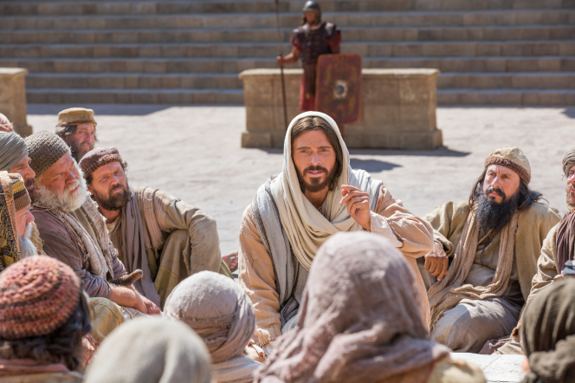
MASS TIMES
Weekend Masses: YANCHEP: 6 p.m. Saturday Vigil, St James Anglican Church,
2 Lagoon Drive. GUILDERTON: 8 a.m. Sunday, Guilderton Community Hall, Wedge Street. LANCELIN: 9.45 a.m. Sunday, 33 Gingin Road, Lancelin.
Confessions: before Mass on request
Weekday Masses: Tuesday, Thursday, Friday 9 a.m. at the presbytery,
Wednesdays 3 p.m. at Bethanie Beachside Aged Care.
Priest: Fr Augustine Puthota, Presbytery: 3 Blaxland Avenue, Two Rocks, Western Australia 6037. Telephone: +61-8-9561 2172
Website: http://yanchepcatholic.org/ Email: yanchep@perthcatholic.org.au.
Please like us on Facebook: https://www.facebook.com/yanchepcatholicchurch
Page 4
Page 1
Sunday Bulletin

We pray for the sick of our community, especially:
Pat Murphy, Ken and Toni Meek, Delores Servais, Michael Ford, Jim Walsh, Paula Cope, Pat Barone, Josephine del Bene, Len Sims and Nina Campbell.

Communion Antiphon ‡ Cf. Ps 118:49-50
Remember your word to your servant, O Lord,
by which you have given me hope.
This is my comfort when I am brought low.

(continued) whether in kindergarten or a doctoral program, need to convey His teaching and not their own. Sadly, many "little ones who believe in me" have been taught to sin in high school and college classrooms, by persons substituting their own ideas for the teaching of Christ and the Catholic Church. Such persons will one day have to give an account of themselves before Christ.
Jesus now stresses the seriousness of sin. It is better to amputate part of one's body than to lose one's salvation through sin. "Gehenna" here is a term for hell. It comes from the Hebrew ge-hinnom, "the Valley of Hinnom," one of the valleys on the side of Jerusalem where child sacrifice to idols was practiced in ancient Israel. In later times, the Jews were so disgusted with the abhorrent worship that had taken place in the Valley of Hinnom that they used the area only for disposing trash. Fires continually burned there to consume the debris, adding to the hellish atmosphere of the place. Thus, "Gehenna" became a term for the place of final punishment. It is often said that Jesus, in describing self-amputation, is using the literary device of hyperbole, that is, exaggeration for the sake of emphasis. However, it is not quite hyperbole, because what Jesus says is literally true. It is better to enter life maimed than to go to hell with a whole body. That is not an exaggeration. Why, then, have the saints not made a practice of self-amputation? Because it is never really the case that our hand, foot, or eye causes us to sin. If they did, we should cut them off. But the cause of sin is not in our physical appendages. It is the evil in our heart that causes sin. That's why we need a cleansing of the heart if we are to follow Christ, and that cleansing comes through the Spirit. Our Lord's words in this Gospel are a very serious warning about the gravity of sin, emphasizing that we cannot tolerate or become accustomed to any sin in our lives.


Jesus teaching the disciples, royalty free image from https://www.lds.org/media-library/images/jesus-teaching-apostles-friends-1138161?lang=en.

Entrance Antiphon ‡ Dn 3:31, 29, 30, 43, 42.
All that you have done to us, O Lord,
you have done with true judgement,
for we have sinned against you
and not obeyed your commandments.
But give glory to your name
and deal with us according to the bounty of your mercy.

First Reading ‡ Numbers 11:25-29
Are you jealous on my account? Who decrees that all people may prophesy?
The Lord came down in the Cloud. He spoke with Moses, but took some of the spirit that was on him and put it on the seventy elders. When the spirit came on them they prophesied, but not again.
Two men had stayed back in the camp; one was called Eldad and the other Medad. The spirit came down on them; though they had not gone to the Tent, their names

you no resistance.
The Word of the Lord.
Thanks be to God.
Gospel Acclamation ‡ cf. John 17:17
Alleluia, alleluia!
Your word, O Lord, is truth:
make us holy in the truth.
Alleluia!
Gospel ‡ Mark 9:38-43, 45, 47-48
Anyone who is not against us is for us.
If your hand should cause you to sin, cut it off.
John said to Jesus, ‘Master, we saw a man who is not one of us casting out devils in your name; and because he was not one of us we tried to stop him.’ But Jesus said, ‘You must not stop him: no one who works a miracle in my name is likely to speak evil of me. Anyone who is not against us is for us.
‘If anyone gives you a cup of water to drink just because you belong to Christ, then I tell you solemnly, he will most certainly not lose his reward.
‘But anyone who is an obstacle to bring down one of these little ones who have faith, would be better thrown into the sea with a great millstone round his neck. And if your hand should cause you to sin, cut it off; it is better for you to enter into life crippled, than to have two hands and go to hell, into the fire that cannot be put out. And if your foot should cause you to sin, cut it off; it is better for you to enter into life lame, than to have two feet and be thrown into hell. And if your eye should cause you to sin, tear it out; it is better for you to enter into the kingdom of God with one eye, than to have two eyes and be thrown into hell where their worm does not die nor their fire go out.’
The Gospel of the Lord.
Praise to you, Lord Jesus Christ!

were enrolled among the rest. These began to prophesy in the camp. The young man ran to tell this to Moses, ‘Look,’ he said ‘Eldad and Medad are prophesying in the camp.’ Then said Joshua the son of Nun, who had served Moses from his youth, ‘My Lord Moses, stop them!’ Moses answered him, ‘Are you jealous on my account? If only the whole people of the Lord were prophets, and the Lord gave his Spirit to them all!’
The Word of the Lord.
Thanks be to God.

Responsorial Psalm ‡ Psalm 18:8, 10, 12-14
R. The precepts of the Lord give joy to the heart.

The law of the Lord is perfect,
it revives the soul.
The rule of the Lord is to be trusted,
it gives wisdom to the simple. R.

The fear of the Lord is holy,
abiding for ever.
The decrees of the Lord are truth
and all of them just. R.

So in them your servant finds instruction;
great reward is in their keeping.
But who can detect all his errors?
From hidden faults acquit me. R.

From presumption restrain your servant
and let it not rule me.
Then shall I be blameless,
clean from grave sin. R.

Second Reading ‡ James 5:1-6
Your wealth is rotting.
An answer for the rich. Start crying, weep for the miseries that are coming to you. Your wealth is all rotting, your clothes are all eaten up by moths. All your gold and your silver are corroding away, and the same corrosion will be your own sentence, and eat into your body. It was a burning fire that you stored up as your treasure for the last days. Labourers mowed your fields, and you cheated them — listen to the wages that you kept back, calling out; realise that the cries of the reapers have reached the ears of the Lord of hosts. On earth you have had a life of comfort and luxury; in the time of slaughter you went on eating to your heart’s content. It was you who condemned the innocent and killed them; they offered
Page 2
Page 3

Commentary by Dr John Bergsma, http://www.thesacredpage.com/2012/09/sin-is-no-match-for-spirit-of-god-26th.html
In this incident, the Apostles encounter a man who identifies with Christ but "does not follow us," that is, he does not yet associate publicly with Jesus and the Apostles, who constitute the visible Church. Jesus advocates a gracious approach toward such persons. They are on his side; they will have a reward for what they do in Christ's name. This incident is instructive still today, and has implications for how we deal with those who claim the name of Christ but "do not follow us," that is, are not part of the visible Church and do not acknowledge the authority of the successors of the Apostles. Their good works should be encouraged, even as we work toward the visible unity of all who follow Christ (John 17:23).
"Whoever causes one of these little ones who believe in me to sin,
it would be better for him if a great millstone
were put around his neck
and he were thrown into the sea.
Jesus' teaching here applies especially to those who would teach the faith of the Church. Teachers will be judged more strictly. Those who teach in Christ's name,

