25th Sunday in Ordinary Time Year B
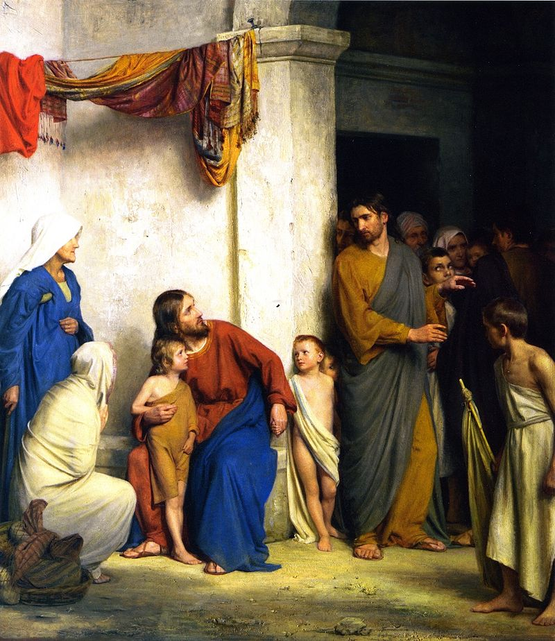
Suffer the Children, Carl Heinrich Bloch, 1834-1890, Frederiksborg Palace, Copenhagen, Denmark.
MASS TIMES
Weekend Masses: YANCHEP: 6 p.m. Saturday Vigil, St James Anglican Church,
2 Lagoon Drive. GUILDERTON: 8 a.m. Sunday, Guilderton Community Hall, Wedge Street. LANCELIN: 9.45 a.m. Sunday, 33 Gingin Road, Lancelin.
Confessions: before Mass on request
Weekday Masses: Tuesday, Thursday, Friday 9 a.m. at the presbytery,
Wednesdays 3 p.m. at Bethanie Beachside Aged Care.
Priest: Fr Augustine Puthota, Presbytery: 3 Blaxland Avenue, Two Rocks, Western Australia 6037. Telephone: +61-8-9561 2172
Website: http://yanchepcatholic.org/ Email: yanchep@perthcatholic.org.au.
Please like us on Facebook: https://www.facebook.com/yanchepcatholicchurch
Page 4
Page 1
Sunday Bulletin



We pray for the sick of our community, especially:
Pat Murphy, Ken and Toni Meek, Delores Servais, Michael Ford, Jim Walsh, Paula Cope, Pat Barone, Josephine del Bene, Len Sims and Nina Campbell.

Communion Antiphon ‡ Psalm 119 (118): 4-5
You have laid down your precepts to be carefully kept; may my ways be firm in keeping your statutes.

Entrance Antiphon ‡
I am the salvation of the people, says the Lord. Should they cry to me in any distress, I will hear them, and I will be their Lord for ever.

(continued) Why would they expect that suffering and death were a necessary part of the process? Jesus placed a child in their midst, the symbol of simplicity and powerlessness, and proceeded to teach them yet again about the meaning of his words and actions. Himself having been born a poor child to a poor family in a poor town, Jesus illustrated the value and dignity of simply being human. Just being a child of God is value enough, not what one has or one’s status. He used the child to exemplify the importance of doing what is just, not for rewards or renown, but because it is right. Serving others, doing what is right and just, is its own reward; serving a child who has nothing to give in return reinforces this notion strongly. For Jesus to ask that his good works go unrewarded, indeed unnoticed, as he did not only by trying to journey through Galilee quietly, but also in many other circumstances when he asked the people he healed not to tell anyone, would fly in the face of the ambitious of any time. All those opportunities for glory and profit would be wasted if people didn’t know about them. To the ambitious person this would be utter nonsense. Only a fool would not take advantage. There is no hint of self-centeredness in the teachings and actions of Jesus; there is no room for unselfishness in the world of power and prestige. The disciples didn’t quite get it. Not that they didn’t have many opportunities to get it, for every time Jesus encountered a person deemed worthless by his society, he was preaching the same message. Every time he engaged in conversation with a woman, a leper, a person crippled or deaf or possessed, he spoke loudly and clearly that his first priority was in the value of the person. He cured the illness, forgave the sin, but only after treating the person with compassion and respect first. How often did he remind people that their faith had saved them, and that the real healing was of their spirit.
Continue reading at http://www.augustinianfriends.org/homilies/hom_25b.pdf.

First Reading ‡ Wisdom 2:12, 17-20
Let us condemn him to a most shameful death.
The godless say to themselves,
‘Let us lie in wait for the virtuous man,
since he annoys us and opposes our way of life,
reproaches us for our breaches of the law
and accuses us of playing false to our upbringing.
Let us see if what he says is true,
let us observe what kind of end he himself will have.
If the virtuous man is God’s son,
God will take his part and rescue him
from the clutches of his enemies.
Let us test him with cruelty and with torture,
and thus explore this gentleness of his
and put his endurance to the proof.

Gospel ‡ Mark 9:30-37
The Son of Man will be delivered into the hands of humanity … All who wish to be first must make themselves the servants of all.
After leaving the mountain Jesus and his disciples made their way through Galilee; and he did not want anyone to know, because he was instructing his disciples; he was telling them, ‘The Son of Man will be delivered into the hands of men; they will put him to death; and three days after he has been put to death he will rise again.’ But they did not understand what he said and were afraid to ask him.
They came to Capernaum, and when he was in the house he asked them, ‘What were you arguing about on the road?’ They said nothing because they had been arguing which of them was the greatest. So he sat down, called the Twelve to him and said, ‘If anyone wants to be first, he must make himself last of all and servant of all.’ He then took a little child, set him in front of them, put his arms round him, and said to them, ‘Anyone who welcomes one of these little children in my name, welcomes me; and anyone who welcomes me welcomes not me but the one who sent me.’
The Gospel of the Lord.
Praise to you, Lord Jesus Christ!
Let us condemn him to a shameful death
since he will be looked after — we have his word for it.’
The Word of the Lord.
Thanks be to God.

Responsorial Psalm ‡ Psalm 53:3-6, 8
R. The Lord upholds my life.

O God, save me by your name;
by your power, uphold my cause.
O God, hear my prayer;
listen to the words of my mouth. R.

For proud men have risen against me,
ruthless men seek my life.
They have no regard for God. R.

But I have God for my help.
The Lord upholds my life.
I will sacrifice to you with willing heart
and praise your name for it is good. R.

Second Reading ‡ James 3:16 – 4:3
Justice is the harvest of peacemakers from seeds sown in a spirit of peace.
Wherever you find jealousy and ambition, you find disharmony, and wicked things of every kind being done; whereas the wisdom that comes down from above is essentially something pure; it also makes for peace, and is kindly and considerate; it is full of compassion and shows itself by doing good; nor is there any trace of partiality or hypocrisy in it. Peacemakers, when they work for peace, sow the seeds which will bear fruit in holiness.
Where do these wars and battles between yourselves first start? Isn’t it precisely in the desires fighting inside your own selves? You want something and you haven’t got it; so you are prepared to kill. You have an ambition that you cannot satisfy; so you fight to get your way by force. Why you don’t have what you want is because you don’t pray for it; when you do pray and don’t get it, it is because you have not prayed properly, you have prayed for something to indulge your own desires.
The Word of the Lord.
Thanks be to God.
Gospel Acclamation ‡ cf. 2 Thessalonians 2:14
Alleluia, alleluia!
God has called us with the Gospel
to share in the glory of our Lord Jesus Christ.
Alleluia!

Page 2
Page 3

Homily by Fr Joseph A. Genito, Order of Saint Augustine http://www.augustinianfriends.org/homilies/hom_25b.pdf.
Passion is a strong driving force. We put ourselves heart and soul into our passions, and they are a clear indication of our priorities and values. The Gospel account today comes after the account of the Transfiguration and the healing of a boy possessed by a demon. Jesus was passing through Galilee where he was well known, but did not want anyone to know about it, the reading states. Teaching his disciples that he had to die and rise after three days, a similar reference to rising after his death as he had made after the Transfiguration, Jesus was trying to impart something that was counter to what his society expected and knew so well. The kings and leaders of his day would not be speaking of suffering and death, but of glory and triumph; they would not be seen in the company of the poor and powerless, but amid adoring crowds of people clamoring to serve them. His disciples may have heard the teaching, but apparently they weren’t buying it, for their discussion about who was the greatest gives evidence that they were vying for a prestigious place with a gloriously triumphant figure, not a criminal hanging on a cross.
We can’t fault the disciples for their humanity; they were products of their time and truly believed that God rewards the just and punishes the wicked. However, being just in the eyes of God and being rewarded by society did not often coincide. The reading from Wisdom points that out quite directly. Doing justice often lands a person in hot water with those who don’t want to be inconvenienced. People want to get rid of the troublemakers who rail against injustices. Jesus knew his disciples. They went quiet when he asked them what they were talking about because they were ashamed that they had not listened to him and taken his words seriously. And who could blame them? Jesus often spoke of glory, and they had just witnessed a glimpse of his glory.

