24th Sunday in Ordinary Time Year B
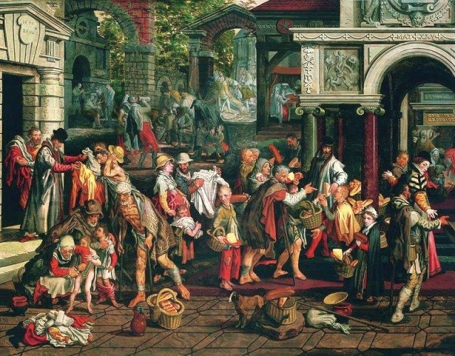
MASS TIMES
Weekend Masses: YANCHEP: 6 p.m. Saturday Vigil, St James Anglican Church,
2 Lagoon Drive. GUILDERTON: 8 a.m. Sunday, Guilderton Community Hall, Wedge Street. LANCELIN: 9.45 a.m. Sunday, 33 Gingin Road, Lancelin.
Confessions: before Mass on request
Weekday Masses: Tuesday, Thursday, Friday 9 a.m. at the presbytery,
Wednesdays 3 p.m. at Bethanie Beachside Aged Care.
Priest: Fr Augustine Puthota, Presbytery: 3 Blaxland Avenue, Two Rocks, Western Australia 6037. Telephone: +61-8-9561 2172
Website: http://yanchepcatholic.org/ Email: yanchep@perthcatholic.org.au.
Please like us on Facebook: https://www.facebook.com/yanchepcatholicchurch
Page 4
Page 1
Sunday Bulletin

We pray for the sick of our community, especially:
Pat Murphy, Ken and Toni Meek, Delores Servais, Michael Ford, Jim Walsh, Paula Cope, Pat Barone, Josephine del Bene, Len Sims and Nina Campbell.

Carl Gagiano who used to attend Mass in Yanchep, passed away on 2 September at the age of 92. His funeral will be held at St Helena Church, Cnr Strathmore Parkway and Coolamon Blvd, Ellenbrook on Monday, 14th September 2015 at 10:30am.

Communion Antiphon ‡ Psalm 36 (35): 8
How precious is your mercy, O God! The children of men seek shelter in the shadow of your wings.

(continued) James identifies is "jealousy", "selfish ambition", "covetousness", and "envy", which are all different aspects of the same sinful reality. This sin of envy causes internal spiritual struggle as well as struggle with other persons. We want what others have, and try to take it forcibly rather than receive in peace from God. We don't receive from God, however, because we ask with wrong motives, with the intention of self-indulgence. This reading from James is a good match for the Gospel Reading, where we will see the disciples themselves arguing out of "selfish ambition" and "jealousy" concerning who is the greatest. Jesus will put in their midst a child who is "peaceable, gentle, and compliant," and commend the child as an example for those who would lead in the Church. It is also characteristic of children that they ask their parents for what they need. That, too, is a model for us; to ask our heavenly Father for what we need, rather than struggle for it in anger. But here in today's Gospel, they cannot understand his literal saying, because they think he is speaking in figures. Part of the reason the disciples cannot understand Jesus here is that the their sensibilities, just like our own, are offended and repulsed by the notion that God's Chosen One should have to suffer and die. We are also offended and repulsed by the notion that we might have to suffer and die with God's Chosen One! It is all so paradoxical and counter-intuitive. We'd rather live in a world where good guys always win and bad guys always lose, rather than this world, where the good often suffer. Yet the disciples, and we ourselves, should not forget: "after his death the Son of Man will rise"! There is truth, there is vindication, there is final justice and final mercy—but it requires faith to believe in it.


Deeds of Christian Charity, Pieter Aertsen, 1575, oil on panel, National Museum in Warsaw.

Entrance Antiphon ‡ Cf Sir. 36:18
Give peace, O Lord, to those who wait for you, that your prophets be found true. Hear the prayers of your servant, and of your people Israel.

First Reading ‡ Isaiah 50:5-9
I gave my body to those who struck me.
The Lord has opened my ear.
For my part, I made no resistance,
neither did I turn away.
I offered my back to those who struck me,
my cheeks to those who tore at my beard;
I did not cover my face against insult and spittle.

these bare necessities of life, then what good is that? Faith is like that: if good works do not go with it, it is quite dead.
This is the way to talk to people of that kind: ‘You say you have faith and I have good deeds; I will prove to you that I have faith by showing you my good deeds — now you prove to me that you have faith without any good deeds to show.’
The Word of the Lord.
Thanks be to God.

Gospel Acclamation ‡ Galatians 6:14
Alleluia, alleluia!
My only glory is the cross of our Lord Jesus Christ,
which crucifies the world to me and me to the world.
Alleluia!

Gospel ‡ Mark 8:27-35
You are the Christ … the Son of Man was destined to suffer much.
Jesus and his disciples left for the villages round Caesarea Philippi. On the way he put this question to his disciples, ‘Who do people say I am?’ And they told him. ‘John the Baptist,’ they said, ‘others Elijah; others again, one of the prophets.’ ‘But you,’ he asked, ‘who do you say I am?’ Peter spoke up and said to him, ‘You are the Christ.’ And he gave them strict orders not to tell anyone about him.
And he began to teach them that the Son of Man was destined to suffer grievously, to be rejected by the elders and the chief priests and the scribes, and to be put to death, and after three days to rise again; and he said all this quite openly. Then, taking him aside, Peter started to remonstrate with him. But, turning and seeing his disciples, he rebuked Peter and said to him, ‘Get behind me, Satan! Because the way you think is not God’s way but man’s.’
He called the people and his disciples to him and said, ‘If anyone wants to be a follower of mine, let him renounce himself and take up his cross and follow me. For anyone who wants to save his life will lose it; but anyone who loses his life for my sake, and for the sake of the gospel, will save it.’
The Gospel of the Lord.
Praise to you, Lord Jesus Christ!
The Lord comes to my help,
so that I am untouched by the insults.
So, too, I set my face like flint;
I know I shall not be shamed.
My vindicator is here at hand.
Does anyone start proceedings against me?
Then let us go to court together.
Who thinks he has a case against me?
Let him approach me.
The Lord is coming to my help,
who dare condemn me?
The Word of the Lord.
Thanks be to God.

Responsorial Psalm ‡ Psalm 114:1-6, 8-9
R. I will walk in the presence of the Lord, in the land of the living.

I love the Lord for he has heard
the cry of my appeal;
for he turned his ear to me
in the day when I called him. R.

They surrounded me, the snares of death,
with anguish of the tomb;
they caught me, sorrow and distress.
I called on the Lord’s name.
O Lord my God, deliver me! R.

How gracious is the Lord, and just;
our God has compassion.
The Lord protects the simple hearts;
I was helpless so he saved me! R.

He has kept my soul from death,
my eyes from tears and my feet from stumbling.
I will walk in the presence of the Lord
in the land of the living. R.

Second Reading ‡ James 2:14-18
Faith without good works is dead.
Take the case, my brothers, of someone who has never done a single good act but claims that he has faith. Will that faith save him? If one of the brothers or one of the sisters is in need of clothes and has not enough food to live on, and one of you says to them, ‘I wish you well; keep yourself warm and eat plenty,’ without giving

Page 2
Page 3

Reflection by Dr John Bergsma at http://www.thesacredpage.com/2012/09/gentleness-in-midst-of-suffering.html.
We tend to idealize the apostolic age as a time when there were no problems in the Church, because the direct rule of the apostles supposedly solved every issue that arose. However, that's not the actual picture we see when we read the letters Paul and the other apostles wrote to the churches. The problems they address are frequently similar to those we face today.
James speaks of "wars and conflicts." He may mean internal struggles within each Christian, or struggles within the local church, or both. One of the central problems

