21st Sunday in Ordinary Time Year B
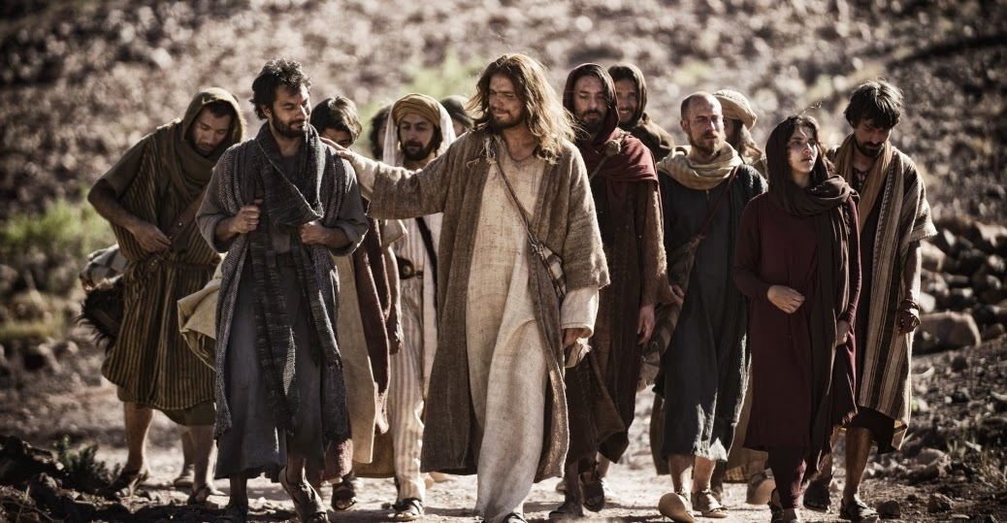
MASS TIMES
Weekend Masses: YANCHEP: 6 p.m. Saturday Vigil, St James Anglican Church,
2 Lagoon Drive. GUILDERTON: 8 a.m. Sunday, Guilderton Community Hall, Wedge Street. LANCELIN: 9.45 a.m. Sunday, 33 Gingin Road, Lancelin.
Confessions: before Mass on request
Weekday Masses: Tuesday, Thursday, Friday 9 a.m. at the presbytery,
Wednesdays 3 p.m. at Bethanie Beachside Aged Care.
Priest: Fr Augustine Puthota, Presbytery: 3 Blaxland Avenue, Two Rocks, Western Australia 6037. Telephone: +61-8-9561 2172
Website: http://yanchepcatholic.org/
Please note our email address has changed! yanchep@perthcatholic.org.au.
Please like us on Facebook: https://www.facebook.com/yanchepcatholicchurch
Page 4
Page 1
Sunday Bulletin

We pray for the sick of our community, especially:
Pat Murphy, Ken and Toni Meek, Delores Servais, Michael Ford, Jim Walsh, Paula Cope, Pat Barone, Josephine del Bene, Len Sims and Nina Campbell.

Communion Antiphon ‡ Psalm 104 (103): 13-15
The earth is replete with the fruits of your work, O Lord; you bring forth bread from the earth and wine to cheer the heart.

Lord, to whom shall we go? You have the message of eternal life.
(continued) Monotheism entailed a relational dimension--one only worships this God, namely, the God of Israel. For Joshua, then, it is not sufficient for Israel that they simply "believe" that the God of Israel is the Lord; they must worship him alone. This God demands complete devotion. Belief in the God of Israel thus is not simply about right doctrine, it is also about right relationship--indeed, it is about choosing this God over all others. Let me translate that into practical terms we can meditate on this Sunday. Being a Catholic isn't simply a matter of orthodoxy; it is also about faithfulness, i.e., living out the faith. It means choosing Jesus over all other idols, whatever they may be.
The Bread of Life discourse in John 6 has Jesus emphasize over and over again that it is necessary for believers to "eat his flesh" and "drink his blood". Is this passage about the Eucharist? There are good reasons for thinking so. First, the imagery of "eating" Jesus' "flesh" and "drinking" his "blood" seems closely linked with the Last Supper, the only other place where such language is clearly used. But what about Jesus' words at the end of the sermon: "it is the spirit that gives life, the flesh is of no avail"? In short, Jesus is not denying that his flesh gives life but he is also explaining that his flesh gives life not simply because it is human flesh. Eating human flesh in and of itself profits one nothing. His flesh, however, is the flesh of the Son of Man who will be glorified. Eat that and you receive, what Ignatius of Antioch called, "the medicine of immortality". The Gospel ends on Jesus asking the disciples if they wish to abandon him. Like the Israelites, they have seen his miracles and heard his words--and they pledge their allegiance to him. Yet Jesus' words remind us that their commitment to Jesus was not simply the result of their own determination: "no one can come to me unless it is granted him by my Father."

Entrance Antiphon
‡ cf. Ps 86 (85): 1-3
Turn your ear, O Lord, and answer me; save the servant who trusts in you, my God. Have mercy on me, O Lord, for I cry to you all the day long.


First Reading ‡ Joshua 24:1-2, 15-18
We will serve the Lord God, because he is our God.

Joshua gathered all the tribes of Israel together at Shechem; then he called the elders, leaders, judges and scribes of Israel, and they presented themselves before God. Then Joshua said to all the people: ‘If you will not serve the Lord, choose today whom you wish to serve, whether the gods that your ancestors served beyond the River, or the gods of the Amorites in whose land you are now living. As for me and my House, we will serve the Lord.’ The people answered, ‘We have no intention of deserting the Lord our God who brought us and our ancestors out of the land of Egypt, the house of slavery, who worked those great wonders before our eyes and preserved us all along the way we travelled and among all the peoples through whom we journeyed. We too will serve the Lord, for he is our God.’

The word of the Lord.
Thanks be to God.

Gospel Acclamation ‡ John 6:63, 68.
Alleluia, alleluia!
Your words, Lord, are spirit and life: you have the words of everlasting life.
Alleluia!

Gospel ‡ John 6:60-69
Lord, whom shall we go to? You have the words of everlasting life.
After hearing his doctrine many of the followers of Jesus said, ‘This is intolerable language. How could anyone accept it?’ Jesus was aware that his followers were complaining about it and said, ‘Does this upset you? What if you should see the Son of Man ascend to where he was before?
‘It is the spirit that gives life,
the flesh has nothing to offer.
The words I have spoken to you
are spirit and they are life.
‘But there are some of you who do not believe.’ For Jesus knew from the outset those who did not believe, and who it was that would betray him. He went on, ‘This is why I told you that no one could come to me unless the Father allows him.’ After this, many of his disciples left him and stopped going with him.
Then Jesus said to the Twelve, ‘What about you, do you want to go away too?’ Simon Peter answered, ‘Lord, who shall we go to? You have the message of eternal life, and we believe; we know that you are the Holy One of God.’

The Gospel of the Lord.
Praise to you, Lord Jesus Christ!

Responsorial Psalm ‡ Psalm 33:2-3, 16-23.
R. Taste and see the goodness of the Lord.

I will bless the Lord at all times,
his praise always on my lips;
in the Lord my soul shall make its boast.
The humble shall hear and be glad. R.

The Lord turns his face against the wicked
to destroy their remembrance from the earth.
The Lord turns his eyes to the just
and his ears to their appeal. R.

They call and the Lord hears
and rescues them in all their distress.
The Lord is close to the broken-hearted;
those whose spirit is crushed he will save. R.

Many are the trials of the just man
but from them all the Lord will rescue him.
He will keep guard over all his bones,
not one of his bones shall be broken. R.

Evil brings death to the wicked;
those who hate the good are doomed.
The Lord ransoms the souls of his servants.
Those who hide in him shall not be condemned. R.

Second Reading ‡ Ephesians 5:21-32
This is the great mystery, it applies to Christ and the Church.
Give way to one another in obedience to Christ. Wives should regard their husbands as they regard the Lord, since as Christ is head of the Church and saves the whole body, so is a husband the head of his wife; and as the Church submits to Christ, so should wives submit to their husbands, in everything. Husbands should love their wives just as Christ loved the Church and sacrificed himself for her to make her holy. He made her clean by washing her in water with a form of words, so that when he took her to himself she would be glorious, with no speck or wrinkle or anything like that, but holy and faultless. In the same way, husbands must love their wives as they love their own bodies; for a man to love his wife is for him to love himself. A man never hates his own body, but he feeds it and looks after it; and that is the way Christ treats the Church, because it is his body — and we are its living parts. For this reason, a man must leave his father and mother
Page 2
Page 3

Reflection on the Second Reading by Dr Michael Barber at http://www.thesacredpage.com/2015/08/the-words-i-have-spoken-to-you-are.html.
This Sunday we complete the trek through the lectionary's reading of John 6. We begin this Sunday by reading from yet another story linked to the Exodus traditions that form of the backdrop of imagery of the Bread of Life discourse. Specifically, the First Reading is drawn from the story of Joshua.
Notably, Jesus' name is essentially, "Joshua". Thus, in the First Reading we find what the tradition of the Church would see as a "type" of Jesus, a figure in the Old Testament who foreshadows the person of Christ in some significant way. (The language of "type" draws upon imagery used by Paul in Romans 5 and 1 Corinthians 15). Anyone familiar with the wider context of the story in the First Reading can't help but read it with a knowing smile. Here Joshua insists that the Israelites must decide whom they will serve: the Lord God or the pagans. They can't have it both ways.
The Israelites insist that they want to follow the Lord: "Far be it from us to forsake the Lord. . ."
*ahem
Of course, anyone familiar with the narrative knows the Israelites "doth protest too much." They have already forsaken the Lord multiple times.
What makes their rejection of God especially heinous is that they have turned to other gods even after witnessing the mighty acts of God: "He performed those great miracles before our very eyes. . ."

