20th Sunday in Ordinary Time Year B
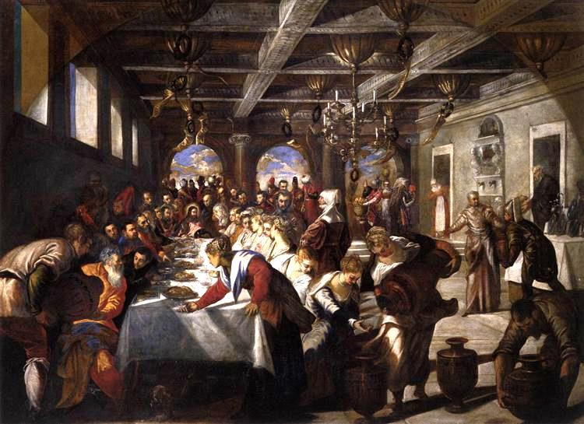
MASS TIMES
Weekend Masses: YANCHEP: 6 p.m. Saturday Vigil, St James Anglican Church,
2 Lagoon Drive. GUILDERTON: 8 a.m. Sunday, Guilderton Community Hall, Wedge Street. LANCELIN: 9.45 a.m. Sunday, 33 Gingin Road, Lancelin.
Confessions: before Mass on request
Weekday Masses: Tuesday, Thursday, Friday 9 a.m. at the presbytery,
Wednesdays 3 p.m. at Bethanie Beachside Aged Care.
Priest: Fr Augustine Puthota, Presbytery: 3 Blaxland Avenue, Two Rocks, Western Australia 6037. Telephone: +61-8-9561 2172
Website: http://yanchepcatholic.org/
Please note our email address has changed! yanchep@perthcatholic.org.au.
Please like us on Facebook: https://www.facebook.com/yanchepcatholicchurch
Page 4
Page 1
Sunday Bulletin

We pray for the sick of our community, especially:
Pat Murphy, Ken and Toni Meek, Delores Servais, Michael Ford, Jim Walsh, Paula Cope, Pat Barone, Josephine del Bene, Len Sims and Nina Campbell.

Communion Antiphon ‡ Psalm 130 (129): 7
With the Lord there is mercy; in him is plentiful redemption.

(continued)
image of David, who was remembered for spending his time playing on the lyre and inventing new songs to sing in worship, especially songs of thanksgiving (todah). St. Paul is encouraging Christians to be “little Davids”–David, after all, was also filled with the Spirit (1 Samuel 16:13).

We ought not to pass over St. Paul’s exhortation to “give thanks always and for everything” too quickly. A spirituality of gratitude and thanksgiving is essential to the Christian life. There can be a tendency for faithful Catholics to fall into a mode of constant criticism and bemoaning, the “world is going to hell in a handbasket” mentality. There is much evil in the world, to be sure, but an attitude of dourness and pessimism wins no converts and quenches the Spirit. As Pope Francis says in Evangelii Gaudium:
An evangelizer must never look like someone who has just come back from a funeral! Let us recover and deepen our enthusiasm, that “delightful and comforting joy of evangelizing, even when it is in tears that we must sow… And may the world of our time, which is searching, sometimes with anguish, sometimes with hope, be enabled to receive the good news not from evangelizers who are dejected, discouraged, impatient or anxious, but from ministers of the Gospel whose lives glow with fervour, who have first received the joy of Christ”. (EvG §10)
We must learn to transcend our present circumstances, and to suffer joyfully. When Peter and John were unjustly brought to court and later beaten, they “rejoiced that they were counted worthy to suffer disgrace for the name.” Its only that paradoxical joy-in-suffering that can change our world and cause the Church to grow once more.



The Wedding Feast at Cana, Jacopo Tintoretto, 1561, oil on canvas, the church of Santa Maria della Salute (The Virgin Mary of Good Health), Venice, Italy.

Entrance Antiphon
‡ cf. Ps 84 (83): 10-11
Turn your eyes, O God, our shield; and look on the face of your anointed one; one day within your courts is better than a thousand elsewhere.

First Reading ‡ Proverbs 9:1-6
Come and eat my bread; drink the wine I have prepared.
Wisdom has built herself a house,
she has erected her seven pillars,
she has slaughtered her beasts, prepared her wine,
she has laid her table.
She has despatched her maidservants
and proclaimed from the city’s heights:
‘Who is ignorant? Let him step this way.’ To the fool she says,

Gospel Acclamation ‡ John 6:56
Alleluia, alleluia!
All who eat my flesh and drink my blood
live in me and I in them, says the Lord.
Alleluia!
Gospel ‡ John 6:51-58
My flesh is real food and my blood is real drink.
Jesus said to the crowd:
‘I am the living bread which has come down from heaven.
Anyone who eats this bread will live for ever;
and the bread that I shall give is my flesh, for the life of the world.’
Then the Jews started arguing with one another: ‘How can this man give us his flesh to eat?’ they said. Jesus replied:
‘I tell you most solemnly,
if you do not eat the flesh of the Son of Man
and drink his blood,
you will not have life in you.
Anyone who does eat my flesh
and drink my blood has eternal life,
and I shall raise him up on the last day.
For my flesh is real food and my blood is real drink.
He who eats my flesh and drinks my blood
lives in me and I live in him.
As I, who am sent by the living Father,
myself draw life from the Father,
so whoever eats me will draw life from me.
This is the bread come down from heaven;
not like the bread our ancestors ate:
they are dead,
but anyone who eats this bread will live for ever.’

The Gospel of the Lord.
Praise to you, Lord Jesus Christ!
Page 2
Page 3

‘Come and eat my bread,
drink the wine I have prepared!
Leave your folly and you will live,
walk in the ways of perception.’
The word of the Lord.
Thanks be to God.

Responsorial Psalm ‡ Psalm 33:2-3, 10-15.
R. Taste and see the goodness of the Lord.

I will bless the Lord at all times,
his praise always on my lips;
in the Lord my soul shall make its boast.
The humble shall hear and be glad. R.

Revere the Lord, you his saints.
They lack nothing, those who revere him.
Strong lions suffer want and go hungry
but those who seek the Lord lack no blessing. R.

Come, children, and hear me
that I may teach you the fear of the Lord.
Who is he who longs for life
and many days, to enjoy his prosperity? R.

Then keep your tongue from evil
and your lips from speaking deceit.
Turn aside from evil and do good;
seek and strive after peace. R.

Second Reading ‡ Ephesians 5:15-20
Be watchful that you may know the will of God.
Be very careful about the sort of lives you lead, like intelligent and not like senseless people. This may be a wicked age, but your lives should redeem it. And do not be thoughtless but recognise what is the will of the Lord. Do not drug yourselves with wine, this is simply dissipation; be filled with the Spirit. Sing the words and tunes of the psalms and hymns when you are together, and go on singing and chanting to the Lord in your hearts, so that always and everywhere you are giving thanks to God who is our Father in the name of our Lord Jesus Christ.
The word of the Lord.
Thanks be to God.

Reflection on the Second Reading by Dr John Bergsma at
http://www.thesacredpage.com/2015/08/the-feast-of-wisdom-20th-week-of-ot.html.
Although this passage from Ephesians was not chosen intentionally to match the first reading and the Gospel, yet it is remarkable the similarity of themes that we can observe. We have the image of drinking wine, also present from the first reading, but here applied to the Spirit. And connected with the psalm, Paul instructs us to “address one another in psalms, hymns and spiritual songs, singing and playing to the Lord in your hearts, giving thanks always and for everything…” This strongly evokes the

