19th Sunday in Ordinary Time Year B
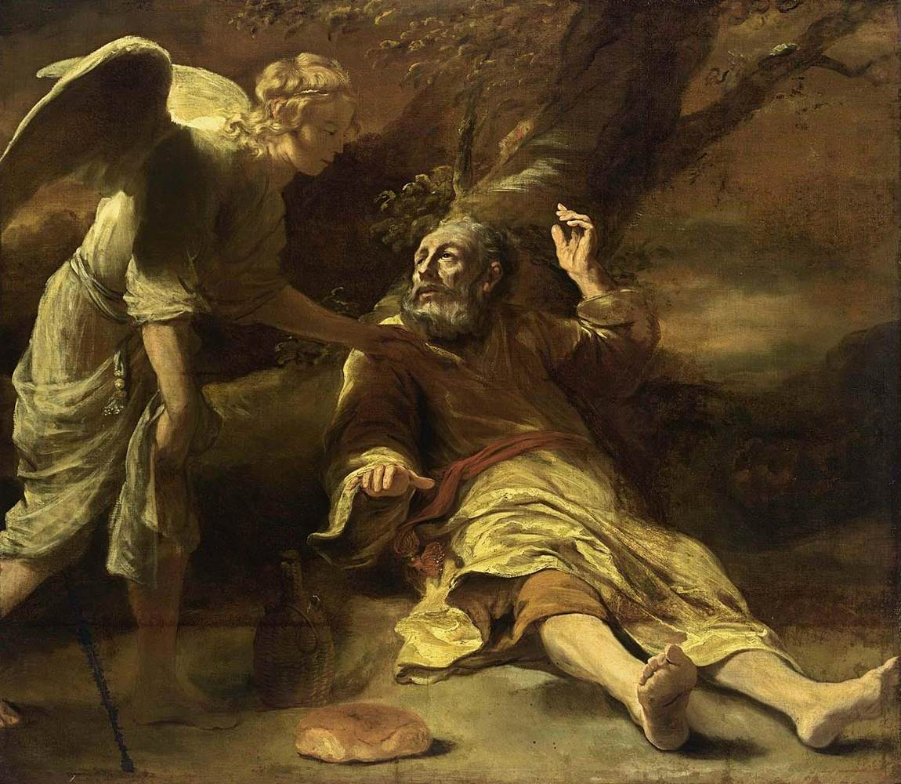
Elijah fed by an angel, Ferdinand Bol, 1660-1663, Private collection, New York.
MASS TIMES
Weekend Masses: YANCHEP: 6 p.m. Saturday Vigil, St James Anglican Church,
2 Lagoon Drive. GUILDERTON: 8 a.m. Sunday, Guilderton Community Hall, Wedge Street. LANCELIN: 9.45 a.m. Sunday, 33 Gingin Road, Lancelin.
Confessions: before Mass on request
Weekday Masses: Tuesday, Thursday, Friday 9 a.m. at the presbytery,
Wednesdays 3 p.m. at Bethanie Beachside Aged Care.
Priest: Fr Augustine Puthota, Presbytery: 3 Blaxland Avenue, Two Rocks, Western Australia 6037. Telephone: +61-8-9561 2172
Website: http://yanchepcatholic.org/ email: yanchepcatholic@gmail.com.
Please like us on Facebook: https://www.facebook.com/yanchepcatholicchurch
Page 4
Page 1
Sunday Bulletin

We pray for the sick of our community, especially:
Pat Murphy, Ken and Toni Meek, Delores Servais, Michael Ford, Jim Walsh, Paula Cope, Pat Barone, Josephine del Bene, Len Sims and Nina Campbell.

Communion Antiphon ‡ Psalm 147: 12, 14
O Jerusalem, glorify the Lord, who gives you your fill of finest wheat.

(continued) 450 prophets, and vowed to kill Elijah. When we find him in today's reading, then, Elijah is fleeing for his life. Elijah was waging a cultural and spiritual war in the kingdom of northern Israel. The war was between worship of the LORD and worship of Baal. One of the major cultural issues between these two religious was sexual practices and family life. Baal was a fertility god, and one of the ways he was worshiped was through ritual sex or "sacred" prostitution. What to do with the children that resulted? These could be sacrifice to the god (Jer 19:5). Needless to say, the standing of marriage in a culture with these practices was none too high. By contrast, the law of the LORD had no place for sex outside of a covenant bond between a man and a woman, which would insure that the child resulting would come into the world in the safety of a marriage, wherein he or she could be raised to adulthood by his/her own father and mother. This is "best practice" for human society. Marriage in Israel was modelled on God's own fidelity to his covenant with the nation (Mal 2:16 and context). "Casual" sex, "cultic" sex, promiscuity, and the killing of infants had no place in worship of the God of Israel. For all his efforts, Elijah was losing this cultural war, and now was in danger of his very life. We find him fleeing into the wilderness of Judah in order to escape from any of Jezebel's agents. There he collapses in physical and spiritual exhaustion, and prays for death. Yet God extends to Elijah a very gentle mercy in this passage. Twice he sends an angel to him, to awaken him and prod him to eat a mysterious meal: a jug of water and a cake of bread that inexplicably appears nearby. The nourishment from this food strengthens Elijah for a forty-day fast during his journey to Mt. Horeb (=Sinai), the mountain where God appeared to Moses. There at Horeb, Elijah will speak with God and his prophetic vocation will be renewed. In this passage we see God's compassion for the weakness of his prophet, expressed in the provision of this sacred meal which strengthens him for the next step in his prophetic ministry.


Entrance Antiphon
‡ cf. Ps 74 (73): 20, 19, 22, 23
Look to your covenant, O Lord, and forget not the life of your poor ones for ever. Arise, O God, and defend your cause, and forget not the cries of those who seek you.

First Reading ‡ 1 Kings 19:4-8
Strengthened by the food, he walked to the mountain of the Lord.
Elijah went into the wilderness, a day’s journey, and sitting under a furze bush wished he were dead. ‘Lord,’ he said ‘I have had enough. Take my life; I am no better than my ancestors.’ Then he lay down and went to sleep. But an angel touched him and said, ‘Get up and eat.’ He looked round, and there at his head was a scone baked on hot stones, and a jar of water. He ate and drank and then lay down again. But the angel of the Lord came back a second time and touched him and said, ‘Get up and eat, or the journey will be too long for you.’ So he got up and ate and drank, and strengthened by that food he walked for forty days and forty nights until he reached Horeb, the mountain of God.
The word of the Lord. Thanks be to God.

Gospel ‡ John 6:41-51
I am the living bread come down from heaven.
The Jews were complaining to each other about Jesus, because he had said, ‘I am the bread that came down from heaven.’ ‘Surely this is Jesus son of Joseph’ they said. ‘We know his father and mother. How can he now say, “I have come down from heaven”?’ Jesus said in reply, ‘Stop complaining to each other.
‘No one can come to me
unless he is drawn by the Father who sent me,
and I will raise him up at the last day.
It is written in the prophets:
They will all be taught by God,
and to hear the teaching of the Father,
and learn from it,
is to come to me.
Not that anybody has seen the Father,
except the one who comes from God:
he has seen the Father.
I tell you most solemnly,
everybody who believes has eternal life.
I am the bread of life.
Your fathers ate the manna in the desert and they are dead;
but this is the bread that comes down from heaven,
so that a man may eat it and not die.
I am the living bread which has come down from heaven.
Anyone who eats this bread will live for ever;
and the bread that I shall give
is my flesh, for the life of the world.’

The Gospel of the Lord.
Praise to you, Lord Jesus Christ!
Page 2
Page 3

Responsorial Psalm ‡ Psalm 33:2-9.

R. Taste and see the goodness of the Lord.

I will bless the Lord at all times,
his praise always on my lips;
in the Lord my soul shall make its boast.
The humble shall hear and be glad. R.

Glorify the Lord with me.
Together let us praise his name.
I sought the Lord and he answered me;
from all my terrors he set me free. R.

Look towards him and be radiant;
let your faces not be abashed.
This poor man called; the Lord heard him
and rescued him from all his distress. R.

The angel of the Lord is encamped
around those who revere him, to rescue them.
Taste and see that the Lord is good.
He is happy who seeks refuge in him. R.

Second Reading ‡ Ephesians 4:30 – 5:2
Walk in love, just as Christ.
Do not grieve the Holy Spirit of God who has marked you with his seal for you to be set free when the day comes. Never have grudges against others, or lose your temper, or raise your voice to anybody, or call each other names, or allow any sort of spitefulness. Be friends with one another, and kind, forgiving each other as readily as God forgave you in Christ.
Try, then, to imitate God, as children of his that he loves, and follow Christ by loving as he loved you, giving himself up in our place as a fragrant offering and a sacrifice to God.
The word of the Lord.
Thanks be to God.
Gospel Acclamation ‡ John 6:51
Alleluia, alleluia!
I am the living bread from heaven, says the Lord;
whoever eats this bread will live for ever.
Alleluia!

Reflection on the First Reading by Dr John Bergsma at http://www.thesacredpage.com/2012/08/taste-and-see-goodness-of-lord-readings.html.
The readings for this Sunday's mass encourage us to find strength and sustenance in Jesus' gift of himself to us in the Eucharist as a remedy for the spiritual weariness that can grow in the Christian life. Elijah was experiencing "ministry burnout." Just days before, he had won a great show-down with 450 prophets of the false god Baal on Mt. Carmel, calling down fire from heaven and proving, in front of a crowd of thousands, that the LORD alone was the true God (1 Kings 18). Such a public demonstration of the power of God would seem like a tremendous victory that would lead to repentance and renewal in Israel, but that's not what happened. The queen of Israel, a Gentile (Phoenician) princess by the name of Jezebel, was incensed by Elijah's victory over her

