16th Sunday in Ordinary Time Year B
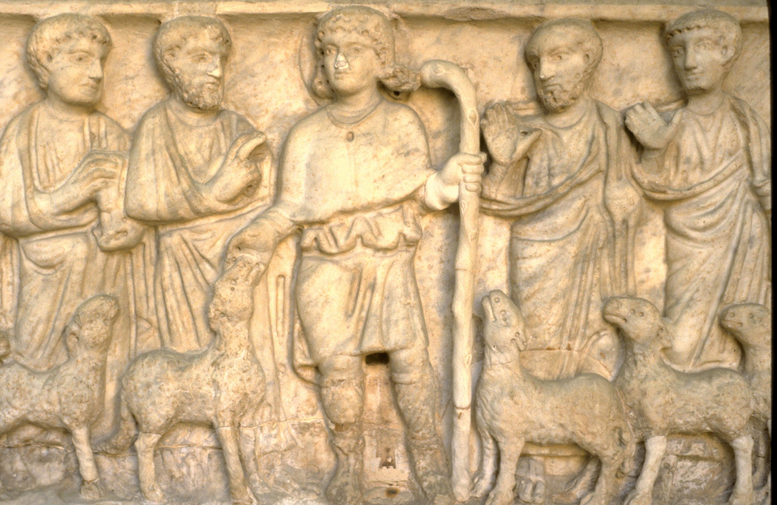
MASS TIMES
Weekend Masses: YANCHEP: 6 p.m. Saturday Vigil, St James Anglican Church,
2 Lagoon Drive. GUILDERTON: 8 a.m. Sunday, Guilderton Community Hall, Wedge Street. LANCELIN: 9.45 a.m. Sunday, 33 Gingin Road, Lancelin.
Confessions: before Mass on request
Weekday Masses: Tuesday, Thursday, Friday 9 a.m. at the presbytery,
Wednesdays 3 p.m. at Bethanie Beachside Aged Care.
Priest: Fr Augustine Puthota, Presbytery: 3 Blaxland Avenue, Two Rocks, Western Australia 6037. Telephone: +61-8-9561 2172
Website: http://yanchepcatholic.org/ email: yanchepcatholic@gmail.com.
Please like us on Facebook: https://www.facebook.com/yanchepcatholicchurch
Page 4
Page 1
Sunday Bulletin

We pray for the sick of our community, especially:
Pat Murphy, Ken and Toni Meek, Delores Servais, Michael Ford, Jim Walsh, Paula Cope, Pat Barone, Josephine del Bene, Len Sims and Nina Campbell.

Communion Antiphon ‡ Psalm 111 (110): 4-5
The sparrow finds a home, and the swallow a nest for her young: by your altars, O Lord of hosts, my King and my God. Blessed are they who dwell in your house, for ever singing your praise.

(continued) In the second part of this gospel, we see Jesus disembarking and feeling pity for the people who were “like sheep without a shepherd.” These were descendants of Israel, who were without a shepherd in many senses. For example, there was no Son of David, no legitimate king, reigning over them. A roman governor and a half-Jew named Herod were their leaders. Even the religious leaders were corrupt: the high priesthood was from an illegitimate line of descent, and was more interested in maintaining its own wealth and privilege by collaborating with the Romans than it was in leading the people to God through the liturgy. The Pharisees tried to fill the gap by providing religious instruction for the people, but their interpretations of the law were so demanding that common people could never live up to their standards of “cleanliness” and “holiness.”
So Jesus begins to teach them “many things,” which reminds us that his role as Good Shepherd encompasses the role of Teacher. He teaches them “many things,” not just a simple Gospel message (“accept me as your Lord and personal saviour!”) as important as that may be. The Christian life is an entire lifestyle, an entire way of living and being. It includes “many things,” because following Jesus has implications for how we shop, for what we do in the bedroom, how we act on the job, the way we raise our kids, etc. For this reason Jesus did not commission the Apostles simply to “Go therefore and make disciples of all nations, teaching them all a few simple principles,” but “Go, therefore, and make disciples, teaching them to observe all that I have commanded you.” In a time when so many Church institutions of learning have abandoned their mission to communicate the teachings of Christ, let’s pray fervently at this Mass for those that remain faithful, that our efforts will be effective in communicating the Good Shepherd’s teaching to the next generation.


Entrance Antiphon
‡ cf. Ps 54 (53):6, 8
See, I have God for my help. The Lord sustains my soul. I will sacrifice to you with willing heart, and praise your name, O Lord, for it is good.

Christ as Good Shepherd with Apostles and lambs, Sarcophagus, 4th century, relief, Museo Pio Cristiano, Vatican.

First Reading ‡ Jeremiah 23:1-6
The remnant of the flock I will gather to me, and bring them back to their pastures.
‘Doom for the shepherds who allow the flock of my pasture to be destroyed and scattered — it is the Lord who speaks! This, therefore, is what the Lord, the God of Israel, says about the shepherds in charge of my people: You have let my flock be scattered and go wandering and have not taken care of them. Right, I will take care of you for your misdeeds — it is the Lord who speaks! But the remnant of my flock I myself will gather from all the countries where I have dispersed them, and will bring them back to their pastures: they shall be fruitful and increase in numbers. I will raise up shepherds to look after them and pasture them; no fear, no terror for them any more; not one shall be lost — it is the Lord who speaks!

In Christ Jesus, you that used to be so far from us have been brought very close, by the blood of Christ. For he is the peace between us, and has made the two into one and broken down the barrier which used to keep them apart, actually destroying in his own person the hostility caused by the rules and decrees of the Law. This was to create one single New Man in himself out of the two of them and by restoring peace through the cross, to unite them both in a single Body and reconcile them with God. In his own person he killed the hostility. Later he came to bring the good news of peace, peace to you who were far away and peace to those who were near at hand. Through him, both of us have in the one Spirit our way to come to the Father.

The word of the Lord.
Thanks be to God.

Gospel Acclamation ‡ John 10:27
Alleluia, alleluia!
My sheep listen to my voice, says the Lord;
I know them, and they follow me.
Alleluia!

Gospel ‡ Mark 6:30-34
They were as sheep without a shepherd.
The apostles rejoined Jesus and told him all they had done and taught. Then he said to them, ‘You must come away to some lonely place all by yourselves and rest for a while’; for there were so many coming and going that the apostles had no time even to eat. So they went off in a boat to a lonely place where they could be by themselves. But people saw them going, and many could guess where; and from every town they all hurried to the place on foot and reached it before them. So as he stepped ashore he saw a large crowd; and he took pity on them because they were like sheep without a shepherd, and he set himself to teach them at some length.

The Gospel of the Lord.
Praise to you, Lord Jesus Christ!

Page 2
Page 3
‘See the days are coming
— it is the Lord who speaks —
when I will raise a virtuous Branch for David,
who will reign as true king and be wise,
practising honesty and integrity in the land.
In his days Judah will be saved
and Israel dwell in confidence.
And this is the name he will be called:
The Lord-our-integrity.’

The word of the Lord.
Thanks be to God.

Responsorial Psalm ‡ Ps 84: 9-14.

R. The Lord is my shepherd; there is nothing I shall want.

The Lord is my shepherd;
there is nothing I shall want.
Fresh and green are the pastures
where he gives me repose.
Near restful waters he leads me,
to revive my drooping spirit. R.

He guides me along the right path;
he is true to his name.
If I should walk in the valley of darkness
no evil would I fear.
You are there with your crook and your staff;
with these you give me comfort. R.

You have prepared a banquet for me
in the sight of my foes.
My head you have anointed with oil;
my cup is overflowing. R.

Surely goodness and kindness shall follow me
all the days of my life.
In the Lord’s own house shall I dwell
for ever and ever. R.

Second Reading Ephesians 2:13-18
Christ, our peace, has made us one.

Reflection on the Gospel by Dr John Bergsma at http://www.thesacredpage.com/2015/07/the-shepherd-teaches-flock-16th-sunday.html#more
In the first part of this passage, we see that Jesus is a Good Shepherd to his under-shepherds, the apostles, and makes the effort to allow them time for prayer, rest, and refreshment. This is an important reminder for those that work in some form of pastoral or religious ministry, because there can be a tendency toward burn-out. We need to be reminded that Jesus loves also us, and doesn’t will our self-destruction. We, too, need time for rest, prayer, and renewal. We, too, need to experience Jesus as our Good Shepherd before we can be good shepherds for others.

