15th Sunday in Ordinary Time Year B
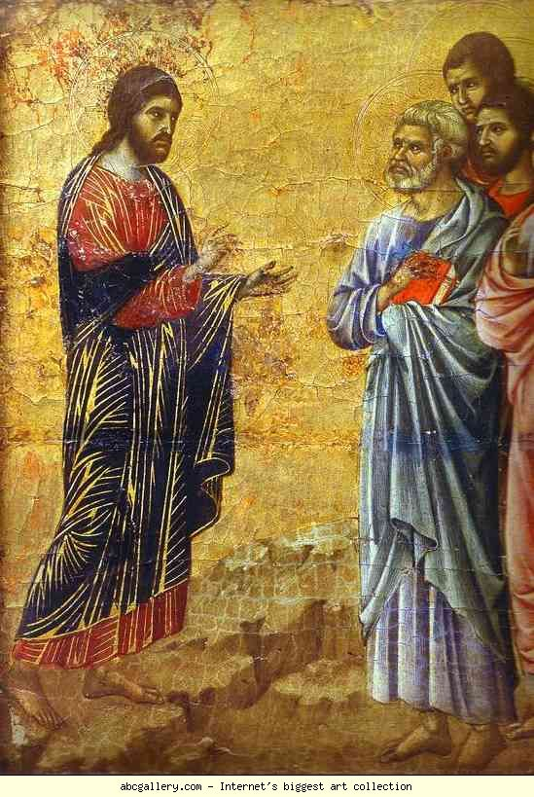
MASS TIMES
Weekend Masses: YANCHEP: 6 p.m. Saturday Vigil, St James Anglican Church,
2 Lagoon Drive. GUILDERTON: 8 a.m. Sunday, Guilderton Community Hall, Wedge Street. LANCELIN: 9.45 a.m. Sunday, 33 Gingin Road, Lancelin.
Confessions: before Mass on request
Weekday Masses: Tuesday, Thursday, Friday 9 a.m. at the presbytery,
Wednesdays 3 p.m. at Bethanie Beachside Aged Care.
Priest: Fr Augustine Puthota, Presbytery: 3 Blaxland Avenue, Two Rocks, Western Australia 6037. Telephone: +61-8-9561 2172
Website: http://yanchepcatholic.org/ email: yanchepcatholic@gmail.com.
Please like us on Facebook: https://www.facebook.com/yanchepcatholicchurch
Page 4
Page 1
Sunday Bulletin
Christ’s Appearance on the Mountain (detail), reverse surface of the Maesta, Altarpiece in Museo dell’Opera del Duomo, Siena, Duccio di Buoninsegna (ca 1255 - pre-1319), tempera on wood, 1308-1311.

We pray for the sick of our community, especially:
Pat Murphy, Ken and Toni Meek, Delores Servais, Michael Ford, Jim Walsh, Paula Cope, Pat Barone, Josephine del Bene, Len Sims and Nina Campbell.


Communion Antiphon ‡ Psalm 84 (83):4-5
The sparrow finds a home, and the swallow a nest for her young: by your altars, O Lord of hosts, my King and my God. Blessed are they who dwell in your house, for ever singing your praise.

(continued) north). Amos went to the northern kingdom and prophesied that the rich and elite would be destroyed and exiled, because they were oppressing the common people, and offering false worship. Amaziah, the priest of Bethel, was an illegitimate political appointee who served the king, Jeroboam. In the northern kingdom, the government had taken over the “church” and was using it for its own political purposes. Amaziah was in charge of the idol-temple in Bethel, and he was not pleased with Amos hanging around preaching judgment on Israel’s sins. He tells him in no very polite words to get out. Because Amos was preaching against northern Israel, Amaziah figures he must be pro-Judean, and tells him to get back south to “earn your bread.” Actually, Amos also had words of judgment for the south. Be that as it may, Amos responds by denying that he is a professional, or prophesying to make money: “I was no prophet … I was a shepherd and dresser of sycamores …” Amos was not a “professional.” He had no formal theological training—“nor have I belonged to a company of prophets.” The “company of prophets” were groups—often called “the sons of the prophets”—that probably copied, studied, and preserved sacred texts, and fostered prayer and the development of prophetic gifts. One may think of them as an early form of religious orders. But Amos was not associated with those groups. He was an unlikely candidate who got a call from God. He was compelled to go and preach, not motivated by money, but by the Spirit of God moving in him. Amos was not afraid to criticize the government of Israel in his day: a government that presumed to control religion, to tell people what was right and wrong, and set its own limits and rules for what qualified as worship. (Continue reading at http://www.thesacredpage.com/2015/07/the-readings-for-this-upcoming-sunday.html#more.

Entrance Antiphon
‡ cf. Ps 17 (16): 15
As for me, in justice I shall behold your face; I shall be filled with the vision of your glory.

First Reading ‡ Amos 7:12-15
Go, prophesy to my people.
Amaziah, the priest of Bethel, said to Amos, ‘Go away, seer; get back to the land of Judah; earn your bread there, do your prophesying there. We want no more prophesying in Bethel; this is the royal sanctuary, the national temple.’ ‘I was no prophet, neither did I belong to any of the brotherhoods of prophets.’ Amos replied to Amaziah, ‘I was a shepherd, and looked after sycamores: but it was the Lord who took me from herding the flock, and the Lord who said, “Go, prophesy to my people Israel.”’
The word of the Lord.
Thanks be to God.

chosen to be,
for his greater glory,
the people who would put their hopes in Christ before he came.
Now you too, in him,
have heard the message of the truth and the good news of your salvation,
and have believed it:
and you have been stamped with the seal of the Holy Spirit of the Promise,
the pledge of our inheritance which brings freedom for those whom God has taken for his own,
to make his glory praised.

The word of the Lord.
Thanks be to God.

Gospel Acclamation ‡ cf. Ephesians 1:17-18
Alleluia, alleluia!
May the Father of our Lord Jesus Christ enlighten the eyes of our heart that we might see how great is the hope to which we are called
Alleluia!

Gospel ‡ Mark 6:7-13
He called the twelve, and began to send them out.
Jesus summoned the Twelve and began to send them out in pairs giving them authority over the unclean spirits. And he instructed them to take nothing for the journey except a staff — no bread, no haversack, no coppers for their purses. They were to wear sandals, but, he added, ‘Do not take a spare tunic.’
And he said to them, ‘If you enter a house anywhere, stay there until you leave the district. And if any place does not welcome you and people refuse to listen to you, as you walk away shake off the dust from under your feet as a sign to them.’ So they set off to preach repentance; and they cast out many devils, and anointed many sick people with oil and cured them.

The Gospel of the Lord.
Praise to you, Lord Jesus Christ!

Page 2
Page 3
Responsorial Psalm ‡ Ps 84: 9-14.

R. Lord, show us your mercy and love, and grant us your salvation.

I will hear what the Lord God has to say,
a voice that speaks of peace,
peace for his people.
His help is near for those who fear him
and his glory will dwell in our land. R.

Mercy and faithfulness have met;
justice and peace have embraced.
Faithfulness shall spring from the earth
and justice look down from heaven. R.

The Lord will make us prosper
and our earth shall yield its fruit.
Justice shall march before him
and peace shall follow his steps. R.

Second Reading Ephesians 1:3-14.
Before the world was made, he chose us in Christ.
Blessed be God the Father of our Lord Jesus Christ,
who has blessed us with all the spiritual blessings of heaven in Christ.
Before the world was made, he chose us, chose us in Christ,
to be holy and spotless, and to live through love in his presence,
determined that we should become his adopted sons,
through Jesus Christ for his own kind purposes,
to make us praise the glory of his grace,
his free gift to us in the Beloved in whom,
through his blood, we gain our freedom,
the forgiveness of our sins.
Such is the richness of the grace
which he has showered on us in all wisdom and insight.
He has let us know the mystery of his purpose,
the hidden plan he so kindly made in Christ from the beginning to act upon when the times had run their course to the end:
that he would bring everything together under Christ, as head,
everything in the heavens and everything on earth.
And it is in him that we were claimed as God’s own,
chosen from the beginning,
under the predetermined plan
of the one who guides all things as he decides by his own will;

Reflection by Dr John Bergsma http://www.thesacredpage.com/2015/07/the-readings-for-this-upcoming-sunday.html#more.
The readings for this Sunday are united by the theme of God’s choice of his messengers. And, as is typical for God, he chooses some unlikely candidates. Our first reading is from the prophet Amos. A little background: Amos was a prophet sent to the northern kingdom of Israel, consisting of the ten tribes that had broken away from the descendants of David who ruled in Jerusalem to the south. The kings of the north prevented their people from making pilgrimages to the Temple in Jerusalem, and instead built idolatrous shrines at Bethel (in the south of their realm) and Dan (in the

