The Body and Blood of Christ Corpus Christi Year B
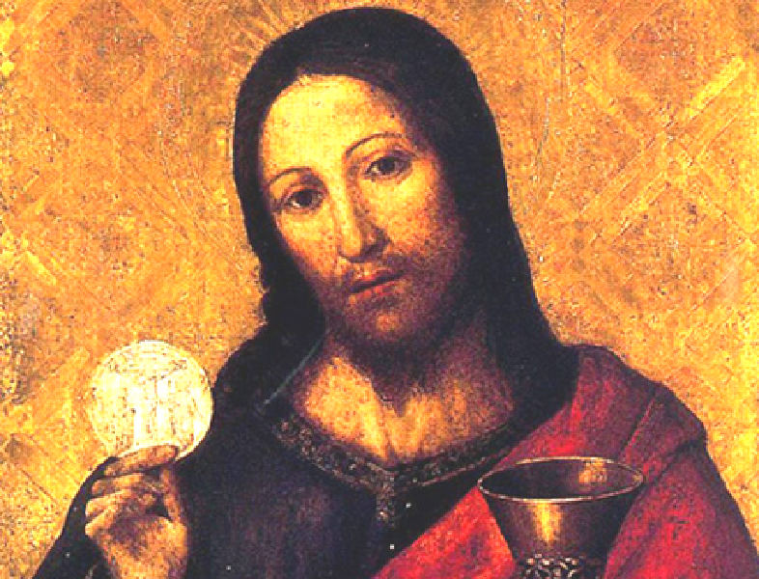

MASS TIMES
Weekend Masses: YANCHEP: 6 p.m. Saturday Vigil, St James Anglican Church,
2 Lagoon Drive. GUILDERTON: 8 a.m. Sunday, Guilderton Community Hall, Wedge Street. LANCELIN: 9.45 a.m. Sunday, 33 Gingin Road, Lancelin.
Confessions: before Mass on request
Weekday Masses: Tuesday, Thursday, Friday 9 a.m. at the presbytery,
Wednesdays 3 p.m. at Bethanie Beachside Aged Care.
Priest: Fr Augustine Puthota, Presbytery: 3 Blaxland Avenue, Two Rocks, Western Australia 6037. Telephone: +61-8-9561 2172
Website: http://yanchepcatholic.org/ email: yanchepcatholic@gmail.com.
Please like us on Facebook: https://www.facebook.com/yanchepcatholicchurch
Page 4
Page 1
Sunday Bulletin

We pray for the sick of our community, especially:
Pat Murphy, Ken and Toni Meek, Delores Servais, Michael Ford, Jim Walsh, Paula Cope, Pat Barone, Josephine del Bene, Len Sims and Nina Campbell.

We pray for all departed souls from this Pastoral area, and we ask them to pray for us.

Communion Antiphon ‡ John 6:57
Whoever eats my flesh and drinks my blood remains in me and I in him, says the Lord.

(Continued from previous page) family. But the blood has a second meaning as well: death. The blood came from slain animals, and a secondary meaning of accepting the sprinkled blood was: may my blood be shed, like these animals, if I fail to keep my covenant commitments. The sacrifices that often accompanied covenant-making rituals symbolized the consequences of covenant violation.
More positively, the sacrifices also provided food for a meal. Families eat together, so a common meal often served as part of the ceremony of covenant-making (Gen 31:44-46). Just after our First Reading, if we continue on in Exodus 24, we see that Moses and the elders of Israel have a meal with God on Mount Sinai after the blood ritual (Exod 24:11).
In the meal of the Eucharist, the blood of Christ continues to carry the same meanings as the ancient blood of the covenant: kinship and death. Because we share in the blood of Christ, we become kin to God, we are made into the family of God. We also realize we are entering a solemn commitment to keep the family bond, and the judgment of death remains for unworthy participation. So St. Paul warns very clearly,
“Whoever, therefore, eats the bread or drinks the cup of the Lord in an unworthy manner will be guilty of profaning the body and blood of the Lord. Let a man examine himself, and so eat of the bread and drink of the cup. For anyone who eats and drinks without discerning the body eats and drinks judgment upon himself. That is why many of you are weak and ill, and some have died. But if we judged ourselves truly, we should not be judged.” (1 Cor 11:27-31)

Entrance Antiphon
‡ Ps 81 (80):17
He fed them with the finest wheat and satisfied them with honey from the rock.

First Reading ‡ Exodus 24:3-8
This is the blood of the Covenant that the Lord has made with you.
Moses went and told the people all the commands of the Lord and all the ordinances. In answer, all the people said with one voice, ‘We will observe all the commands that the Lord has decreed.’
Moses put all the commands of the Lord into writing, and early next morning he built an altar at the foot of the mountain, with twelve standing-stones for the twelve tribes of Israel. Then he directed certain young Israelites to offer holocausts and to immolate bullocks to the Lord as communion sacrifices. Half of the blood Moses took up and put into basins, the other half he cast on the altar. And taking the Book of the Covenant he read it to the listening people, and they said, ‘We will observe all that the Lord has decreed; we will obey.’

Gospel Acclamation ‡ John 6:51-52
Alleluia, alleluia!
I am the living bread from heaven, says the Lord;
whoever eats this bread will live for ever.
Alleluia!

Gospel Mark 14:12-16, 22-26
This is my body. This is my blood.
On the first day of Unleavened Bread, when the Passover lamb was sacrificed, his disciples said to Jesus, ‘Where do you want us to go and make the preparations for you to eat the passover?’ So he sent two of his disciples, saying to them, ‘Go into the city and you will meet a man carrying a pitcher of water. Follow him, and say to the owner of the house which he enters, “The Master says: Where is my dining room in which I can eat the passover with my disciples?” He will show you a large upper room furnished with couches, all prepared. Make the preparations for us there.’
The disciples set out and went to the city and found everything as he had told them, and prepared the Passover.
And as they were eating he took some bread, and when he said the blessing he broke it and gave it to them. ‘Take it,’ he said ‘this is my body.’
Then he took a cup, and when he had returned thanks he gave it to them, and all drank from it, and he said to them, ‘This is my blood, the blood of the covenant, which is to be poured out for many. I tell you solemnly, I shall not drink any more wine until the day I drink the new wine in the kingdom of God.’
After psalms had been sung they left for the Mount of Olives.
The Gospel of the Lord.
Praise to you, Lord Jesus Christ!
Page 3

Then Moses took the blood and cast it towards the people. ‘This’ he said ‘is the blood of the Covenant that the Lord has made with you, containing all these rules.’
The word of the Lord.
Thanks be to God.

Responsorial Psalm ‡ Ps 115:12-13, 15-18

R. I will take the cup of salvation, and call on the name of the Lord.

How can I repay the Lord
for his goodness to me?
The cup of salvation I will raise;
I will call on the Lord’s name. R.

O precious in the eyes of the Lord
is the death of his faithful.
Your servant, Lord, your servant am I;
you have loosened my bonds. R.

A thanksgiving sacrifice I make:
I will call on the Lord’s name.
My vows to the Lord I will fulfil
before all his people. R.

Second Reading Hebrews 9:11-15
The blood of Christ will purify our inner selves.
Now Christ has come, as the high priest of all the blessings which were to come. He has passed through the greater, the more perfect tent, which is better than one made by men’s hands because it is not of this created order; and he has entered the sanctuary once and for all, taking with him not the blood of goats and bull calves, but his own blood, having won an eternal redemption for us. The blood of goats and bulls and the ashes of a heifer are sprinkled on those who have incurred defilement and they restore the holiness of their outward lives; how much more effectively the blood of Christ, who offered himself as the perfect sacrifice to God through the eternal Spirit, can purify our inner self from dead actions so that we do our service to the living God.
He brings a new covenant, as the mediator, only so that the people who were called to an eternal inheritance may actually receive what was promised: his death took place to cancel the sins that infringed the earlier covenant.

The word of the Lord.
Thanks be to God.

Page 2

Reflection on the First Reading by Dr John Bergsma
http://www.thesacredpage.com/2015/06/scandalously-close-to-god-readings-for.html#more
This is the covenant making ritual at Mount Sinai, after the LORD had given the Ten Commandments and before the people had sinned with the Golden Calf.
A “covenant” is the extension of kinship by oath. It is a way of taking a non-family member into your family. This covenant-making ceremony represents a sort of adoption of the people of Israel by the LORD (Jer 31:20); or from another perspective, a marriage of Israel to the LORD (Ezek 16:8). Adoption and marriage were the primary uses of covenant in the ancient world.
Let’s talk about the blood ceremony Moses performs. The blood is sprinkled both on the altar (representing God’s presence) and the people. This means both God and the people are entering into the covenant together. The blood has at least two symbolisms. First, kinship: God and Israel now share the same blood. When someone is related to us, we say, “He’s blood to me.” There is also the expression “Blood is thicker than water.” So to this day, we use the word “blood” to denote kinship. In ancient times it was the same. Sharing the same blood, Israel and the LORD are now

