13th Sunday in Ordinary Time Year B
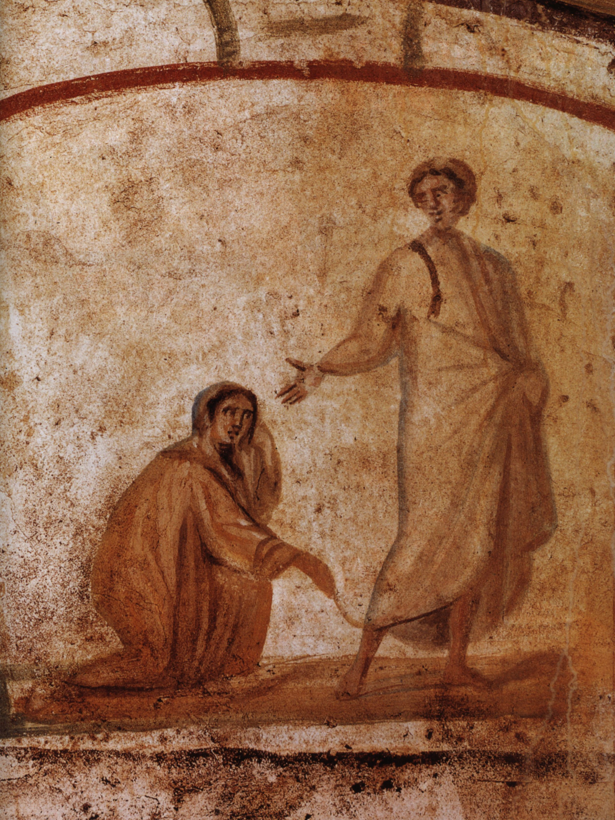
MASS TIMES
Weekend Masses: YANCHEP: 6 p.m. Saturday Vigil, St James Anglican Church,
2 Lagoon Drive. GUILDERTON: 8 a.m. Sunday, Guilderton Community Hall, Wedge Street. LANCELIN: 9.45 a.m. Sunday, 33 Gingin Road, Lancelin.
Confessions: before Mass on request
Weekday Masses: Tuesday, Thursday, Friday 9 a.m. at the presbytery,
Wednesdays 3 p.m. at Bethanie Beachside Aged Care.
Priest: Fr Augustine Puthota, Presbytery: 3 Blaxland Avenue, Two Rocks, Western Australia 6037. Telephone: +61-8-9561 2172
Website: http://yanchepcatholic.org/ email: yanchepcatholic@gmail.com.
Please like us on Facebook: https://www.facebook.com/yanchepcatholicchurch
Page 4
Page 1
Sunday Bulletin
Christ healing the woman with the haemorrhage, 3rd to 4th century, Catacombs of Marcellinus and Peter, Via Casilina, Rome.

We pray for the sick of our community, especially:
Pat Murphy, Ken and Toni Meek, Delores Servais, Michael Ford, Jim Walsh, Paula Cope, Pat Barone, Josephine del Bene, Len Sims and Nina Campbell.


Communion Antiphon ‡ Psalm 103 (102):1
Bless the Lord, O my soul, and all within me, his holy name.

Reflection on life and death by Sylvester Tan S.J. http://www.magisspirituality.org/ignatian_reflection/15-02-13/
When we hear the conversation between Eve and the serpent, we should recall that Jesus calls the devil a liar and a murderer. Nonetheless, often we listen to this conversation as if the devil has some precious truth, or, at the very least, some interesting tidbit that we would do well to know and learn from. And yet, Pope Francis insists repeatedly that we never do well to listen to the devil. With Benedict XVI, we can reflect, instead, on the fact that Jesus is the LOGOS, and thus stands at the origin of all genuine logic and rationality. The devil rejects this LOGOS, and so the devil’s every reasoning will be perverse. In spite of all this, it can seem to many people that the serpent told the truth when it insists to Eve (against God), “you certainly will not die.” Does it not seem that, even after having consumed the forbidden fruit, Adam and Eve remain in life? The fact that we think in this way shows just how profoundly our reasoning has been affected by that of the serpent. Saint Paul points out that it was the disobedience of this couple that brought death into the world. Before this, Adam and Eve knew only life. But what was the life that they knew? It was a simple, luminous communion with each other and all of creation in God’s love. If we realize that this love is life, we see how it was lost when Adam and Eve reject the life that God offers them in order to grasp after another “life” apart from God. But, in truth, there is no life apart from God. Adam and Eve have rejected the very ground of their existence; it would make metaphysical sense for the earth to swallow them up at this moment (Cf. SpEx 60). And yet, though in a very real sense we can say that Adam and Eve have experienced a spiritual death—for they have lost the simplicity and transparency in which they once stood before God, one another, and creation—God desires to bring them back to the fullness of life.
In his death on the cross, Christ—who is life—reveals to us that the fullness of the life that God desires for us cannot simply be identified with physical life. Indeed, Christ never surrenders the true life found in love alone, and the terrible death that he dies cannot destroy the true life that he reveals and offers to us once again.

Entrance Antiphon
‡ Ps 47 (46):2
All peoples, clap your hands. Cry to God with shouts of joy!

First Reading ‡ Wisdom 1:13-15; 2:23-24
It was the devil’s envy that brought death into the world.

Death was not God’s doing,
he takes no pleasure in the extinction of the living.
To be — for this he created all;
the world’s created things have health in them,
in them no fatal poison can be found,
and Hades holds no power on earth;
for virtue is undying.

Gospel Acclamation ‡ 2 Timothy 1:10
Alleluia, alleluia!
Our Saviour Jesus Christ has done away with death
and brought us life through his gospel.
Alleluia!

Gospel ‡ Mark 5:21-43
Young girl, I say to you, arise.
When Jesus had crossed in the boat to the other side, a large crowd gathered round him and he stayed by the lakeside. Then one of the synagogue officials came up, Jairus by name, and seeing him, fell at his feet and pleaded with him earnestly, saying, ‘My little daughter is desperately sick. Do come and lay your hands on her to make her better and save her life.’ Jesus went with him and a large crowd followed him; they were pressing all round him.
Now there was a woman who had suffered from a haemorrhage for twelve years; after long and painful treatment under various doctors, she had spent all she had without being any the better for it, in fact, she was getting worse. She had heard about Jesus, and she came up behind him through the crowd and touched his cloak. ‘If I can touch his clothes,’ she had told herself ‘I will be well again.’ And the source of the bleeding dried up instantly, and she felt in herself that she was cured of her complaint. Immediately aware that power had gone out of him, Jesus turned around in the crowd and said, ‘Who touched my clothes?’ His disciples said to him, ‘You see how the crowd is pressing round you and yet you say, “Who touched me?”’ But he continued to look all round to see who had done it.
Then the woman came forward, frightened and trembling because she knew what had happened to her, and she fell at his feet and told him the whole truth. ‘My daughter,’ he said ‘your faith has restored you to health; go in peace and be free from your complaint.’
While he was still speaking some people arrived from the house of the synagogue official to say, ‘Your daughter is dead: why put the Master to any further trouble?’ But Jesus had overheard this remark of theirs and he said to the official, ‘Do not be afraid; only have faith.’ And he allowed no one to go with him except Peter and James and John the brother of James.
So they came to the official’s house and Jesus noticed all the commotion, with people weeping and wailing unrestrainedly. He went in and said to them, ‘Why all this commotion and crying? The child is not dead, but asleep.’ But they laughed at him. So he turned them all out and, taking with him the child’s father and mother and his own companions, he went into the place where the child lay. And taking the child by the hand he said to her, ‘Talitha, kum!’ which means, ‘Little girl, I tell you to get up.’ The little girl got up at once and began to walk about, for she was twelve years old. At this they were overcome with astonishment, and he ordered them strictly not to let anyone know about it, and told them to give her something to eat.
The Gospel of the Lord.
Praise to you, Lord Jesus Christ!

Page 2
Page 3

Yet God did make man imperishable,
he made him in the image of his own nature;
it was the devil’s envy that brought death into the world,
as those who are his partners will discover.

The word of the Lord.
Thanks be to God.

Responsorial Psalm ‡ Ps 29:2, 4-6, 11-13.

R. I will praise you, Lord, for you have rescued me.

I will praise you, Lord, you have rescued me
and have not let my enemies rejoice over me.
O Lord, you have raised my soul from the dead,
restored me to life from those who sink into the grave. R.

Sing psalms to the Lord, you who love him,
give thanks to his holy name.
His anger lasts but a moment: his favour through life.
At night there are tears, but joy comes with dawn. R.

The Lord listened and had pity.
The Lord came to my help.
For me you have changed my mourning into dancing,
O Lord my God, I will thank you for ever. R.

Second Reading 2 Corinthians 8: 7, 9, 13-15.
Your abundance should supply their want.

You always have the most of everything — of faith, of eloquence, of understanding, of keenness for any cause, and the biggest share of our affection — so we expect you to put the most into this work of mercy too. Remember how generous the Lord Jesus was: he was rich, but he became poor for your sake, to make you rich out of his poverty. This does not mean that to give relief to others you ought to make things difficult for yourselves: it is a question of balancing what happens to be your surplus now against their present need, and one day they may have something to spare that will supply your own need. That is how we strike a balance: as scripture says: The man who gathered much had none too much, the man who gathered little did not go short.

The word of the Lord.
Thanks be to God.

