12th Sunday in Ordinary Time Year B
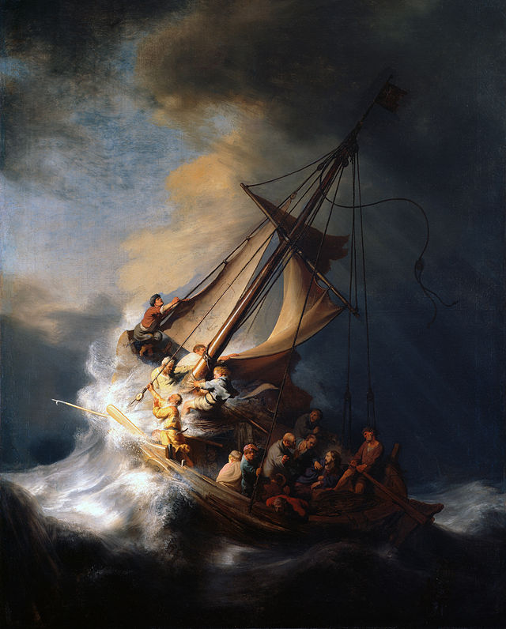
Page 4
MASS TIMES
Weekend Masses: YANCHEP: 6 p.m. Saturday Vigil, St James Anglican Church,
2 Lagoon Drive. GUILDERTON: 8 a.m. Sunday, Guilderton Community Hall, Wedge Street. LANCELIN: 9.45 a.m. Sunday, 33 Gingin Road, Lancelin.
Confessions: before Mass on request
Weekday Masses: Tuesday, Thursday, Friday 9 a.m. at the presbytery,
Wednesdays 3 p.m. at Bethanie Beachside Aged Care.
Priest: Fr Augustine Puthota, Presbytery: 3 Blaxland Avenue, Two Rocks, Western Australia 6037. Telephone: +61-8-9561 2172
Website: http://yanchepcatholic.org/ email: yanchepcatholic@gmail.com.
Please like us on Facebook: https://www.facebook.com/yanchepcatholicchurch
Page 1
Sunday Bulletin
The Storm on the Sea of Galilee, Rembrandt, 1633, Oil on canvas, location unknown, stolen from the Isabella Stuart Gardner Museum, Boston.

We pray for the sick of our community, especially:
Pat Murphy, Ken and Toni Meek, Delores Servais, Michael Ford, Jim Walsh, Paula Cope, Pat Barone, Josephine del Bene, Len Sims and Nina Campbell.


We pray for all departed souls from this Pastoral area, and we ask them to pray for us.

Communion Antiphon ‡ Psalm 145 (144):15
The eyes of all look to you, Lord, and you give them their food in due season.

Entrance Antiphon
‡ Ps 28 (27):8-9
The Lord is the strength of his people, a saving refuge for the one he has anointed. Save your people, Lord, and bless your heritage, and govern them for ever.

(Continued from previous page) and his righteousness, and the rest will be given unto you" (Matt. 6:33). When the divine is consciously acknowledged as the ground and organizing centre of one's existence, something like wholeness or holiness is the result. This same truth is indicated frequently through "soul" language. Soul is not, for Christians, some spiritual entity alongside the body; instead, it is the deepest centre and source of all that we are: body, emotions, passions, and mind. It is what the Bible calls "the heart," that place-sometimes soft and pliable, other times hard as a rock-that God most often addresses and in which he longs to dwell. It is that deepest wellspring that Saint Teresa of Ávila calls the "interior castle," that Meister Eckhart refers to as the "inner wine cellar," and that Thomas Merton knows as the point vièrge, the "virginal point" where we stand unsullied in the presence of God.
Perhaps the most powerful New Testament evocation of holiness as centeredness is the account of Jesus' calming of the storm at sea. As Jesus and his disciples make their way to the other side of the Sea of Galilee, storms blow up and the apostles panic, fearing for their lives. All this time, despite the roaring of the waves and the tumult of the screaming men, Jesus remains, improbably, asleep. The sleeping Christ stands for that place in us where we are rooted in the divine power, that soul space where, despite all of the vagaries and dangers of life, we are one with the God who governs the whole cosmos and whose intentions toward us are loving. Even when every aspect of my person is agitated and afraid, that central place is peaceful, at rest. Of course, we see that Christ, once awakened by the disciples, rebukes the winds and calms the waves. This means that the source of peacefulness in the whole of one's person, the spiritual power that can restore calm to the stormiest life, is the inner Christ, the ground of the soul.

First Reading ‡ Job 38:1, 8-11.
Here I have set the boundaries of the sea.

From the heart of the tempest the Lord gave Job his answer. He said:
Who pent up the sea behind closed doors when it leapt tumultuous out of the womb, when I wrapped it in a robe of mist and made black clouds its swaddling bands; when I marked the bounds it was not to cross and made it fast with a bolted gate? Come thus far, I said, and no farther; here your proud waves shall break.

The word of the Lord.
Thanks be to God.

Page 2

Gospel Mark 4:35-41
Who can this be? Even the wind and the sea obey him.

With the coming of evening, Jesus said to his disciples, ‘Let us cross over to the other side.’ And leaving the crowd behind they took him, just as he was, in the boat; and there were other boats with him. Then it began to blow a gale and the waves were breaking into the boat so that it was almost swamped. But he was in the stern, his head on the cushion, asleep. They woke him and said to him, ‘Master, do you not care? We are going down!’ And he woke up and rebuked the wind and said to the sea, ‘Quiet now! Be calm!’ And the wind dropped, and all was calm again. Then he said to them, ‘Why are you so frightened? How is it that you have no faith?’ They were filled with awe and said to one another, ‘Who can this be? Even the wind and the sea obey him.’

The Gospel of the Lord.
Praise to you, Lord Jesus Christ!
Page 3

Responsorial Psalm ‡ Ps 106:23-26, 28-31

R. Give thanks to the Lord, his love is everlasting.

Some sailed to the sea in ships
to trade on the mighty waters.
These men have seen the Lord’s deeds,
the wonders he does in the deep. R.

For he spoke; he summoned the gale,
tossing the waves of the sea
up to heaven and back into the deep;
their soul melted away in their distress. R.

Then they cried to the Lord in their need
and he rescued them from their distress.
He stilled the storm to a whisper:
all the waves of the sea were hushed. R.

They rejoiced because of the calm
and he led them to the haven they desired.
Let them thank the Lord for his love,
the wonders he does for men. R.

Second Reading 2 Corinthians 5:4-17
All things are made new.
The love of Christ overwhelms us when we reflect that if one man has died for all, then all men should be dead; and the reason he died for all was so that living men should live no longer for themselves, but for him who died and was raised to life for them.
From now onwards, therefore, we do not judge anyone by the standards of the flesh. Even if we did once know Christ in the flesh, that is not how we know him now. And for anyone who is in Christ, there is a new creation; the old creation has gone, and now the new one is here.

The word of the Lord.
Thanks be to God.
Gospel Acclamation ‡ Luke 7:16
Alleluia, alleluia!
A great prophet has appeared among us;
God has visited his people.
Alleluia!

You’re holier than you know, by Fr Robert Barron, extract from
http://www.uscatholic.org/church/2008/07/youre-holier-you-know
At the centre of Christian faith is the dizzying truth that God has broken open his own heart in order to allow us to share his life. The Father sent the Son into godforsakenness, into marginalization, physical suffering, psychological agony, even into death itself, and then in the Spirit he called him back. But in the return to the Father, the Son carried with him all of us whom he had embraced, showing us that nothing can finally separate us from the heartbroken love of God. When we, through Baptism, enter into the drama of Christ's mission, we are deified, made children of God, rendered holy. The holy life is not primarily about moral excellence or spiritual athleticism or any sort of human achievement; it is about being drawn, by grace, into a dignity infinitely beyond our merits or expectations. Diekmann was right: It is about deification.
First path: Finding the centre
The massive rose windows of the medieval Gothic cathedrals were not only marvels of engineering and artistry; they were also symbols of the well-ordered soul. The pilgrim coming to the cathedral for spiritual enlightenment would be encouraged to meditate upon the rose of light and colour in order to be drawn into mystical conformity with it. What would he or she see? At the centre of every rose window is a depiction of Christ (even when Mary seems to be the focus, she is carrying the Christ child on her lap), and then wheeling around him in lyrical and harmonious patterns are the hundreds of medallions, each depicting a saint or a scene from scripture.
The message of the window is clear: When one's life is centred on Christ, all the energies, aspirations, and powers of the soul fall into a beautiful and satisfying pattern. And by implication, whenever something other than Christ - money, sex, success, adulation - fills the centre, the soul falls into disharmony.
Jesus expressed this same idea when he said, "Seek ye first the kingdom of God

