11th Sunday in Ordinary Time Year B
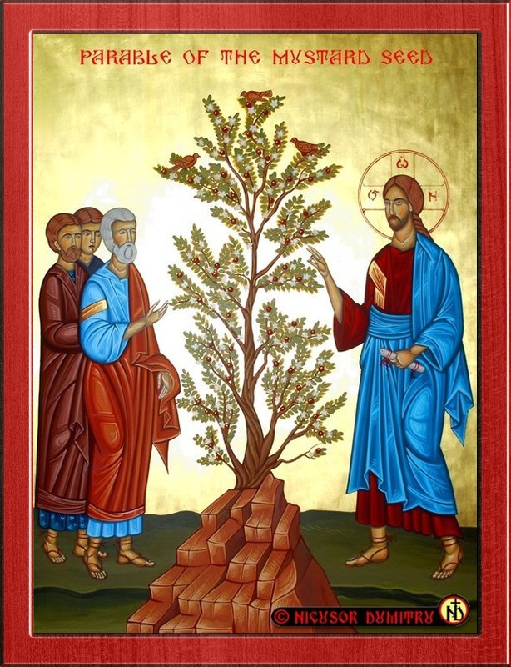

MASS TIMES
Weekend Masses: YANCHEP: 6 p.m. Saturday Vigil, St James Anglican Church,
2 Lagoon Drive. GUILDERTON: 8 a.m. Sunday, Guilderton Community Hall, Wedge Street. LANCELIN: 9.45 a.m. Sunday, 33 Gingin Road, Lancelin.
Confessions: before Mass on request
Weekday Masses: Tuesday, Thursday, Friday 9 a.m. at the presbytery,
Wednesdays 3 p.m. at Bethanie Beachside Aged Care.
Priest: Fr Augustine Puthota, Presbytery: 3 Blaxland Avenue, Two Rocks, Western Australia 6037. Telephone: +61-8-9561 2172
Website: http://yanchepcatholic.org/ email: yanchepcatholic@gmail.com.
Please like us on Facebook: https://www.facebook.com/yanchepcatholicchurch
Page 4
Page 1
Sunday Bulletin
Parable of the Mustard Seed, Byzantine Icon Studio of Nicusor Dumitru.



We pray for the sick of our community, especially:
Pat Murphy, Ken and Toni Meek, Delores Servais, Michael Ford, Jim Walsh, Paula Cope, Pat Barone, Josephine del Bene, Len Sims and Nina Campbell.

We pray for all departed souls from this Pastoral area, and we ask them to pray for us.

Communion Antiphon ‡ Psalm 27 (26):4
There is one thing I ask of the Lord, only this do I seek: to live in the house of the Lord all the days of my life.

Entrance Antiphon
‡ Ps 27 (26):7, 9
O Lord, hear my voice, for I have called to you; be my help. Do not abandon or forsake me, O God, my Saviour!

(Continued from previous page)
with grief; and as one from whom men hide their faces he was despised, and we esteemed him not. (Isa 53:1-2)
Jesus is literally planted in the ground at his burial (John 19:41-42). He is the grain of wheat that dies, but bears much fruit. The “mustard seed” of Jesus, planted in the ground in the mountain heights of Israel (Jerusalem), rises from the dead and becomes the Church, which grows and grows throughout the world, becoming so successful that even those who hate her find it necessary to imitate her and the structures she invented: schools, universities, hospitals, hospices. In Christ, the royal Son of David, Ezekiel’s prophecy did come true. The House of David was re-established in Jerusalem, and the Kingdom of David—manifest visibly in the Church on earth—has spread throughout the world, an international empire.
The readings for this Sunday encourage us to have faith in God. In a dark time of world history, it’s helpful to remember that times were frequently dark in the past as well: when Ezekiel prophesied under the oppression of the Babylonian empire; when Jesus prophesied under the oppression of the Roman empire. The Messiah and all connected with him perpetually look small and even pathetic: a mere mustard seed. Yet in ways unseen it grows. It does not die, it grows; it fills the whole earth, it brings eternal life to those that seek its shade. Messiah and all connected with him perpetually look small and even pathetic: a mere mustard seed. Yet in ways unseen it grows. It does not die, it grows; it fills the whole earth, it brings eternal life to those that seek its shade.

First Reading ‡ Ezekiel 17:22-24
I have made the small tree great.
The Lord says this:
‘From the top of the cedar,
from the highest branch I will take a shoot
and plant it myself on a very high mountain.
I will plant it on the high mountain of Israel.
It will sprout branches and bear fruit,
and become a noble cedar.
Every kind of bird will live beneath it,
every winged creature rest in the shade of its branches.
And every tree of the field will learn that I, the Lord,
am the one who stunts tall trees and makes the low ones grow,
who withers green trees and makes the withered green.
I, the Lord, have spoken, and I will do it.’
The word of the Lord.
Thanks be to God.

Gospel Mark 4:26-34
The mustard seed, the smallest of all the seeds, grows into the biggest shrub of all.

Jesus said to the crowd, ‘This is what the kingdom of God is like. A man throws seed on the land. Night and day, while he sleeps, when he is awake, the seed is sprouting and growing; how, he does not know. Of its own accord the land produces first the shoot, then the ear, then the full grain in the ear. And when the crop is ready, he loses no time; he starts to reap because the harvest has come.’
He also said, ‘What can we say the kingdom of God is like? What parable can we find for it? It is like a mustard seed which at the time of its sowing in the soil is the smallest of all the seeds on earth; yet once it is sown it grows into the biggest shrub of them all and puts out big branches so that the birds of the air can shelter in its shade.’
Using many parables like these, he spoke the word to them, so far as they were capable of understanding it. He would not speak to them except in parables, but he explained everything to his disciples when they were alone.

The Gospel of the Lord.
Praise to you, Lord Jesus Christ!
Page 3

Responsorial Psalm ‡ Ps 91:2-3, 13-16

R. Lord it is good to give thanks to you.

It is good to give thanks to the Lord
to make music to your name, O Most High,
to proclaim your love in the morning
and your truth in the watches of the night. R.

The just will flourish like the palm-tree
and grow like a Lebanon cedar. R.

Planted in the house of the Lord
they will flourish in the courts of our God,
still bearing fruit when they are old,
still full of sap, still green,
to proclaim that the Lord is just.
In him, my rock, there is no wrong. R.

Second Reading 2 Corinthians 5:6-10
Whether we are living in the body or exiled from it, we are intent on pleasing the Lord.

We are always full of confidence when we remember that to live in the body means to be exiled from the Lord, going as we do by faith and not by sight — we are full of confidence, I say, and actually want to be exiled from the body and make our home with the Lord. Whether we are living in the body or exiled from it, we are intent on pleasing him. For all the truth about us will be brought out in the law court of Christ, and each of us will get what he deserves for the things he did in the body, good or bad.

The word of the Lord.
Thanks be to God.

Gospel Acclamation ‡
Alleluia, alleluia!
The seed is the word of God, Christ is the sower;
all who come to him will live for ever.
Alleluia!

Page 2

Reflection on the First Reading by Dr John Bergsma
http://www.thesacredpage.com/2012/06/now-seeds-start-growing-trusting-god.html
There are two parables here. In both of them, the “seed” is the Word of God, in two senses: (1) the proclaimed Gospel, the “Word of God”; and (2) Jesus himself, who is the Word of God (John 1:1). In the first parable, Jesus emphasizes that the growth of God’s kingdom is something mysterious, and not something caused by human effort, any more than human effort can make something grow. This truth may remind many of us of the classic “Frog and Toad” story about the garden, when Toad gets frustrated with his plot of ground and starts yelling, “Now seeds! START GROWING!” It’s worth pondering as a parable of Church growth.
We are responsible to plant the seed—this is the proclamation of the Gospel. Beyond this, the workings of God in the human heart are ultimately not something that we can manipulate or control. It is the work of God.
The second parable takes up the tree theme from the earlier readings. The kingdom of heaven is like a mustard seed that grows into a great tree-like plant.
This “mustard seed” which is the “smallest of seeds” is in fact Christ himself, who is both the Word of God, and the “seed of David” (2 Sam 7:12, Hebrew zerah) whom God promised by covenant oath to “raise up”:
When your days are fulfilled and you lie down with your fathers, I will raise up your seed after you, who shall come forth from your body, and I will establish his kingdom.
Christ is the “smallest of seeds” because he is humble and lowly, despised by all:
For he grew up before him like a young plant, and like a root out of dry ground; he had no form or comeliness that we should look at him, and no beauty that we should desire him. He was despised and rejected by men; a man of sorrows, and acquainted

