The Most Holy Trinity Solemnity Year B
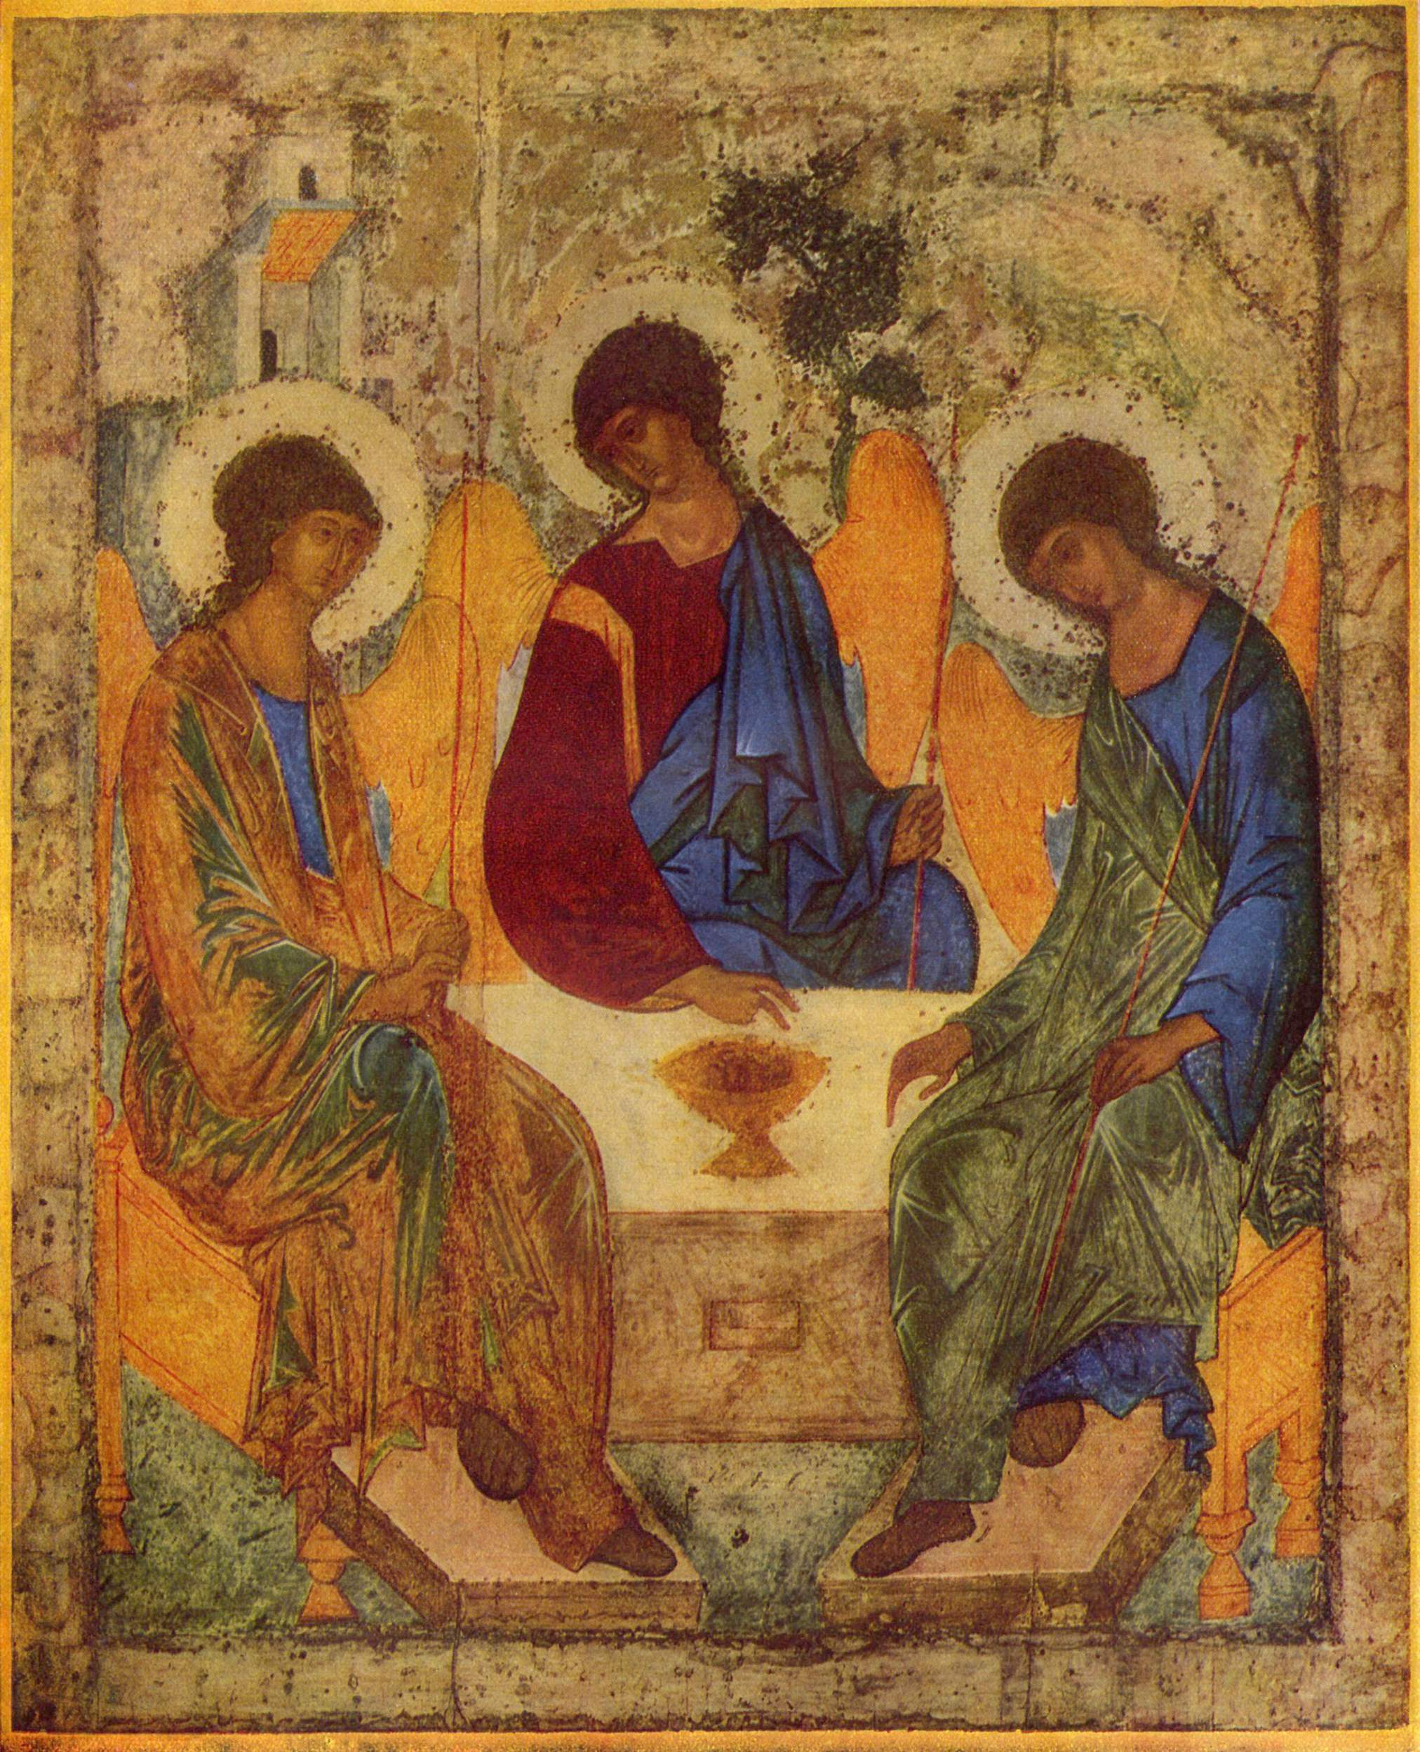

MASS TIMES
Weekend Masses: YANCHEP: 6 p.m. Saturday Vigil, St James Anglican Church,
2 Lagoon Drive. GUILDERTON: 8 a.m. Sunday, Guilderton Community Hall, Wedge Street. LANCELIN: 9.45 a.m. Sunday, 33 Gingin Road, Lancelin.
Confessions: before Mass on request
Weekday Masses: Tuesday, Thursday, Friday 9 a.m. at the presbytery,
Wednesdays 3 p.m. at Bethanie Beachside Aged Care.
Priest: Fr Augustine Puthota, Presbytery: 3 Blaxland Avenue, Two Rocks, Western Australia 6037. Telephone: +61-8-9561 2172
Website: http://yanchepcatholic.org/ email: yanchepcatholic@gmail.com.
Please like us on Facebook: https://www.facebook.com/yanchepcatholicchurch
Page 4
Page 1
Sunday Bulletin
Russian Icon of the Old Testament Trinity, Andrei Rublev, c.1360-1428, Andronikov Monastery, Moscow.

We pray for the sick of our community, especially:
Pat Murphy, Ken and Toni Meek, Delores Servais, Michael Ford, Jim Walsh, Paula Cope, Pat Barone, Josephine del Bene, Len Sims and Nina Campbell.

We pray for all departed souls from this Pastoral area, and we ask them to pray for us.

Entrance Antiphon
‡ Ps 68 (67):33, 35
Blest be God the Father, and the Only Begotten Son of God, and also the Holy Spirit, for he has shown us his merciful love.

Communion Antiphon Vigil Mass ‡ Gal. 4:6
Since you are children of God, God has sent into your hearts the Spirit of his Son, the Spirit who cries out: Abba, Father.

(Continued from previous page)
only one “what.”
Still, the Trinity is a mystery. But mysteries are not unique to theology or religion: in physics, it’s well-known that light is both a wave and a particle. How can this be? No one knows, but experiments show that it behaves like both. The doctrine Trinity is like that: it is difficult to understand, but nonetheless it is a brute fact.
The Trinity is a “Tri-unity”: God is both one and three; one essence, three persons. The first reading emphasizes the oneness or unity of God: “The LORD is God in the heavens above and on earth below, and … there is no other.”
Although the text from Deuteronomy emphasizes the oneness of God, there is a hint of the Trinity even here. Moses refers to the “voice of God” (=the Word, the Second Person) coming forth from the “midst of fire” (=sign of the Holy Spirit, the Third Person). Although God had not clearly revealed his triune nature, all three Persons were involved in God’s relationship with Israel. Finally, we note that this reading emphasizes the relational and covenantal nature of God. God reveals Himself as One who wishes to enter into relationship with the people of Israel, and through them with all humanity. The Trinity is a set of three relations: Father and Son are in a loving relationship with each other, always giving themselves to each other in a self-gift of love, and the Self that they give is the Spirit. The doctrine of the Trinity teaches us that God is personal and relational, not impersonal and isolated. God reaches out in love to draw others into the circle of love which is God’s own nature.

First Reading ‡ Deuteronomy 4:32-34, 39-40
The Lord himself is God in heaven above and on earth below: there is no other.
Moses said to the people: ‘Put this question to the ages that are past, that went before you, from the time God created man on earth: Was there ever a word so majestic, from one end of heaven to the other? Was anything ever heard? Did ever a people hear the voice of the living God speaking from the heart of the fire, as you heard it, and remain alive? Has any god ventured to take to himself one nation from the midst of another by ordeals, signs, wonders, war with mighty hand and outstretched arm, by fearsome terrors — all this that the Lord your God did for you before your eyes in Egypt? ‘Understand this today, therefore, and take it to heart: The Lord is God indeed, in heaven above as on earth beneath, he and no other. Keep his laws and commandments as I give them to you today so that you and your children may prosper and live long in the land that the Lord your God gives you for ever.’

Gospel Acclamation ‡ cf. Rev. 1:8
Alleluia, alleluia!
Glory to the Father, the Son, and the Holy Spirit:
to God who is, who was, and who is to come.
Alleluia!

Gospel Matthew 28:16-20
Baptise them in the name of the Father, and of the Son, and of the Holy Spirit.

The eleven disciples set out for Galilee, to the mountain where Jesus had arranged to meet them. When they saw him they fell down before him, though some hesitated. Jesus came up and spoke to them. He said, ‘All authority in heaven and on earth has been given to me. Go, therefore, make disciples of all the nations; baptise them in the name of the Father and of the Son and of the Holy Spirit, and teach them to observe all the commands I gave you. And know that I am with you always; yes, to the end of time.’

The Gospel of the Lord.
Praise to you, Lord Jesus Christ!

Page 3

The word of the Lord.
Thanks be to God.

Responsorial Psalm ‡ Ps 32:4-6, 9, 18-20, 22. R. v.6

R. Happy the people the Lord has chosen to be his own.

The word of the Lord is faithful
and all his works to be trusted.
The Lord loves justice and right
and fills the earth with his love. R.

By his word the heavens were made,
by the breath of his mouth all the stars.
He spoke: and they came to be.
He commanded; they sprang into being. R.

The Lord looks on those who revere him,
on those who hope in his love,
to rescue their souls from death,
to keep them alive in famine. R.

Our soul is waiting for the Lord.
The Lord is our help and our shield.
May your love be upon us, O Lord,
as we place all our hope in you. R.

Second Reading Romans 8:14-17
You have received the Spirit that makes you God’s own children, and in that Spirit we call God: Father, our Father!

Everyone moved by the Spirit is a son of God. The spirit you received is not the spirit of slaves bringing fear into your lives again; it is the spirit of sons, and it makes us cry out, ‘Abba, Father!’
The Spirit himself and our spirit bear united witness that we are children of God. And if we are children we are heirs as well: heirs of God and coheirs with Christ, sharing his sufferings so as to share his glory.

The word of the Lord.
Thanks be to God.

Page 2

Reflection on the Trinity by John Bergsma
This coming Sunday is the Solemnity of the Most Holy Trinity. While the Trinity might evoke a “Ho-hum, don’t we know that already …” response from many Catholics, the doctrine of the Trinity is essential to—and distinctive of—the Christian faith, and is vital to our daily prayer and walk with God. The doctrine of the Trinity touches on who God is; if one has this doctrine wrong, one has the wrong idea of God and may in fact be worshiping a god who does not exist.
The Trinity is by no means a dead theological issue, either. Most obviously, Jews and Muslims protest this doctrine, which they believe destroys the unity of God. For them, God is monopersonal.
Among groups that share a tradition with Christianity, Mormons, Jehovah’s Witnesses, Unitarians, and “Jesus-only” Pentecostals all dispute the doctrine of the Trinity. Mormons are not, strictly speaking, monotheists: in their view the Father and Son are different gods, and there are gods in the universe in addition to the Father and the Son. Mormonism is polytheistic. Jehovah’s Witnesses, on the other hand, are modern day Arians—they believe in one God (the Father) but deny the divinity of Jesus Christ. Unitarian Universalists are essentially post-Christian theists who believe in a divinity but reject most of the Christian doctrinal tradition. Contrary to this, the Catholic Church holds that God is three persons and one essence. This seems like a formal contradiction, but it is not: we are not claiming that God is three persons and also only one person; or three essences but one essence. Those positions would be logically impossible. I’ve heard it well-stated that we believe in three “who’s” but

