6th Sunday of Easter Year B
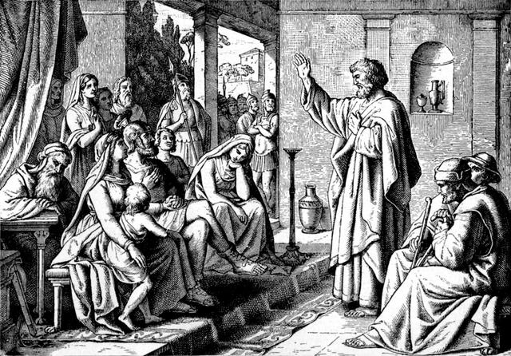
T
MASS TIMES
Weekend Masses: YANCHEP: 6 p.m. Saturday Vigil, St James Anglican Church,
2 Lagoon Drive. GUILDERTON: 8 a.m. Sunday, Guilderton Community Hall, Wedge Street. LANCELIN: 9.45 a.m. Sunday, 33 Gingin Road, Lancelin.
Confessions: before Mass on request
Weekday Masses: Tuesday, Thursday, Friday 9 a.m. at the presbytery,
Wednesdays 3 p.m. at Bethanie Beachside Aged Care.
Priest: Fr Augustine Puthota, Presbytery: 3 Blaxland Avenue, Two Rocks, Western Australia 6037. Telephone: +61-8-9561 2172
Website: http://yanchepcatholic.org/ email: yanchepcatholic@gmail.com.
Please like us on Facebook: https://www.facebook.com/yanchepcatholicchurch
Page 4
Sunday Bulletin

We pray for the sick of our community, especially:
Pat Murphy, Ken and Toni Meek, Delores Servais, Michael Ford, Jim Walsh, Paula Cope, Pat Barone, Josephine del Bene, Len Sims and Nina Campbell.

We pray for all departed souls from this Pastoral area, and we ask them to pray for us.

Communion Antiphon ‡ John 14:15-16
If you love me, keep my commandments, says the Lord, and I will ask the Father and he will send you another Paraclete, to abide with you for ever, alleluia.

(Commentary from Fr Jim Kirstein, SMA http://www.sma.ie/sunday-homilies/1698-6th-sunday-of-easter-year-b. )
In each gospel, Jesus never starts calling people in large groups. In John’s gospel, he calls Andrew and a friend. Andrew goes and calls Peter his brother. Later in ch.1 of John he calls Phillip and Phillip goes off and calls Nathanael. So the process seems to be: Jesus calls friends who, in turn call other friends. This is to underline the absolute call to friendship as part of discipleship. In Mark 1, Jesus calls 2 sets of brothers. Obviously they are not only brothers but friends and close to each other. Again, this is to underline the importance of friendship.
Would you and I describe our relationship with Jesus as one of close friendship? If not, why not? Why not ask him often for the gift of a deep friendship with him. That is what he longs for. We will certainly be the ones to benefit. So in the gospel today Jesus is emphasizing friendship, love and joy. How much does our spirituality reflect this? In many ways maybe we are better as a Lenten people than an Easter people. We have the Stations of the Cross but no Stations of Joy, a sacrament for confessing our sins and failures but no special sacrament for expressing our joy and gratitude to God, unless we name it Eucharist. And yet the main thrust of the Christ story is of Tragedy averted, Sadness overcome, Victory achieved. One of the great experiences for me when in Africa was the marvelous spirit of celebration in our Christian liturgies, often taking 2 hours. Elsewhere one hears people hoping the priest will celebrate a ‘fast mass’ on Sundays. Is this because we cannot spare more time for God? So today God is inviting us to rid ourselves of a religion of sadness and fear. We have created God in our own image - we expected a judge, an avenger, even an executioner. Instead a child was born for us. And a baby who was is stretching out his arms asking for love and friendship. And eventually as a grown man he was crucified. “Lord, why is it that many people experience your message so little as joyful news. Open up our hearts Lord to your call to friendship, sharing, joy, love. Help us to be convinced of this GOOD NEWS first in ourselves and then to invite others to the feast of your friendship and love. Amen”.

Peter in the house of Cornelius, 19th century, woodcut, artist unknown.
Entrance Antiphon | cf. Is. 48:20
Proclaim a joyful sound and let it be heard; proclaim to the ends of the earth: The Lord has freed his people, alleluia.

First Reading ‡ Acts 10: 25-26, 34-35, 44-48
The gift of the Holy Spirit was poured out upon the gentiles also.
As Peter reached the house Cornelius went out to meet him, knelt at his feet and prostrated himself. But Peter helped him up. ‘Stand up,’ he said ‘I am only a man after all!’ Then Peter addressed them: ‘The truth I have now come to realise’ he said, ‘is that God does not have favourites, but that anybody of any nationality who fears God and does what is right is acceptable to him.’
While Peter was still speaking the Holy Spirit came down on all the listeners. Jewish believers who had accompanied Peter were all astonished that the gift of the Holy Spirit should be poured out on the pagans too, since they could hear them speaking strange languages and proclaiming the greatness of God. Peter himself then said, ‘Could anyone refuse the water of baptism to these people, now they have received

Gospel Acclamation ‡ John 14:23
Alleluia, Alleluia!
All who love me will keep my words,
and my Father will love them, and we will come to them.
Alleluia!
Gospel ‡ John 15:9-17
No one can have greater love than to lay down his life for his friends.
Jesus said to his disciples:
‘As the Father has loved me,
so I have loved you.
Remain in my love.
If you keep my commandments
you will remain in my love,
just as I have kept my Father’s commandments
and remain in his love.
I have told you this
so that my own joy may be in you
and your joy be complete.
This is my commandment:
love one another, as I have loved you.
A man can have no greater love
than to lay down his life for his friends.
You are my friends,
if you do what I command you.
I shall not call you servants any more,
because a servant does not know
his master’s business;
I call you friends,
because I have made known to you
everything I have learnt from my Father.
You did not choose me:
no, I chose you;
and I commissioned you
to go out and to bear fruit,
fruit that will last;
and then the Father will give you
anything you ask him in my name.
What I command you
is to love one another.’

The Gospel of the Lord.
Praise to you Lord Jesus Christ.

the Holy Spirit just as much as we have?’ He then gave orders for them to be baptised in the name of Jesus Christ. Afterwards they begged him to stay on for some days.
The word of the Lord.
Thanks be to God.

Responsorial Psalm ‡ Ps 97:1-4 R. v.2
R. The Lord has revealed to the nations his saving power.

Sing a new song to the Lord
for he has worked wonders.
His right hand and his holy arm
have brought salvation. R.

The Lord has made known his salvation;
has shown his justice to the nations.
He has remembered his truth and love
for the house of Israel. R.

All the ends of the earth have seen
the salvation of our God.
Shout to the Lord all the earth,
ring out your joy. ’ R.

Second Reading ‡ 1 John 4:7-10
God is love.

My dear people,
let us love one another
since love comes from God
and everyone who loves is begotten by God and knows God.
Anyone who fails to love can never have known God,
because God is love.
God’s love for us was revealed
when God sent into the world his only Son
so that we could have life through him;
this is the love I mean:
not our love for God,
but God’s love for us when he sent his Son
to be the sacrifice that takes our sins away.

The word of the Lord.
Thanks be to God.
Page 2
Page 3

